
ObjectType: Article
ObjectNumber: 130
LocationName: PAAIL.org
LocationNumber:
Language: PAAIL 2.8

Maker: PAAIL.org
Model:
Name:
Rank:
SerialNumber:

Level: 6.5
Score:
Birth: 12-20-2025

Label: Room 130
Title: Smith Notes 39
Details: PAAIL.org Scripture…
Principle: Ultimate Scripture….
Agenda: Ultimate Scripture….
Action: Ultimate Scripture….
Information: Ultimate Scripture….
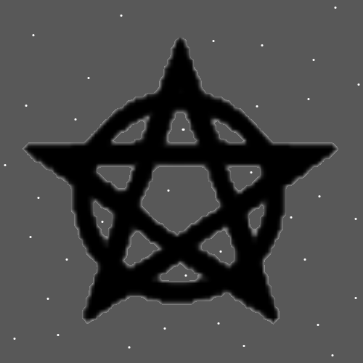
Item Group: More View Of The Multiverse
Principles: Coins are like gems; they can be inserted into other things. It’s better to not do damage to the coin like drilling a hole in it.
Principles: Earlier it was said when you bring 10 coins together, they glow. They don’t have to touch each other. Just being in the same building Makes them glow. It may be the closer they get the more they glow. In a museum you should never have them touching each other. If you had a cheap collection of them in a bag, they would touch each other. If in a case, they wouldn’t. Cases are better in many situations. You would never keep High value coins in a bag, metal touching metal.
Principles: Coins are super easy to Enchant and more. Coins are especially nice Charms. Even the cheap 1 year old Ones.
Principles: Charms are like soulless people. A Level 4 Wizard Bag is a Level 4 Wizard.
Principles: All aspects of Reality are Made of physical/Charm Particles. All aspects of Reality are Made of Energy Bits and Energy Bits are physical Particles.
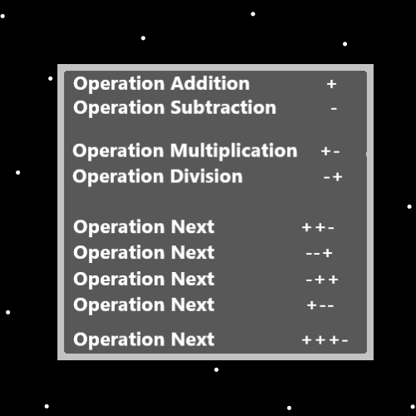
Principles: Every square of the Universe that does not have a pink elephant occupying it has a collection of physical Particles (Energy Bits) that Make it so there is no pink elephant.
Principles: There is a Number that equals “no pink elephant here”. This Number Vibrates places where there is no pink elephant. Its likely a gigantic Number.
Principles: It is a newer and major concept that all Energies/Forces which exist have a Positive Number on some Maps, and all Energies/Forces that do not exist have a Negative Number on some Maps. In some ways things that do not exist are a Part of Physics.
Principles: It is the theory of PAAIL.org that Photons do have Mass. I read on the internet that they do not have Mass. It may be that they have Negative Mass. It seems worth noting that they are influenced by Gravity. Like you would expect of a Particle with Mass.

Principles: Some Basics of handling Charms is that you don’t want to do damage to High value Charms. Many Charms should only be cleaned by people who have trained at colleges to clean them. These people can clean it without doing damage for One thing. High value Charms are a Science all on their own. Antiques are often High value Charms. Cheap Charms though slightly less Powerful are still only slightly less Powerful.
Principles: On some Maps it seems likely that Width is the 1 Dimension, Height is the 2 Dimension, Depth is the 3 Dimension and Time is the 4 Dimension.
Principles: On some Maps it may be that Addition is the 1 Energy, Subtraction is the 2 Energy, Multiplication is the 3 Energy and Division is the 4 Energy. It may be Addition is 1, Subtraction is 2, Multiplication is 3 and Division is 4.
Principles: Collecting a bunch of Wizard Items in a Wizard Bag is a nice Wizard Bag. Bags with exactly 10 nice Wizard Items are known by One Name as “10 Demon Bags”. In some places on Earth “Demon” does not mean something always Negative.
Principles: If Protons absorb Photons perhaps, they eat Photons. Energy consumes other Energy. Energy eats Energy.
Principles: The Theory is that even Energy Bits have Mass, and they are smaller than Photons. This is evidence that Photons have Mass.
Principles: Einstein’s famous “E=MC2” may be right on some Maps and wrong on others. I would not be surprised if Einstein was wrong.
Principles: Photons may be spring like spring Shape. This is why they are so bouncy.

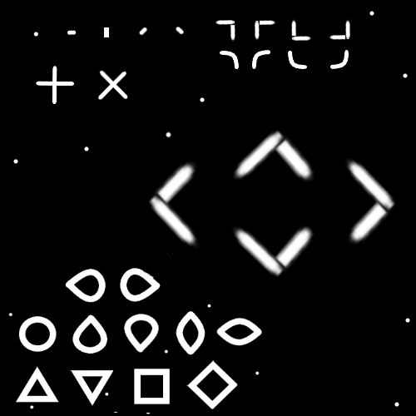
Principles: Some random Symbols above.
Principles: It may be most or all Symbols are Made of other Symbols.
Principles: Reality is Symbols inside Symbols. Infinite Sub Particles.
X2 Principles: By Sub Particles I mean there is always a smaller Particle, except for Energy Bits.
Principles: If “E=MC2” is right and a Photon has 0 Mass, then the Energy of a Photon would equal 0 “E=0C2”---“E=0”. This Makes no Sense. There must be an Energy Number greater than 0 for a Photon. This sparks a great question, “How much Energy is in a Photon?”.
Principles: There is a north Pole and a south Pole. There is no east Pole and west Pole. This is because Addition and Subtraction come before Multiplication and Division. You often see more Systems of 2 than Systems of 4.
Principles: In the way that Charms are like soulless people, computer programs are like soulless people. All things that exist are Made of physical Particles (Energy Bits), all computer programs are Made of physical Particles.
Principles: It is greater Power Sensing computer programs when you realize they are like soulless Charm people.
Principles: All people (including Charms and computer programs) have things they can do, Actions they can perform.

Principles: Likely Energy from God’s Body collides with the edge of this Universe/Heaven and this along with other possible things causes this Universe/Heaven to expand.
Principles: His Holiness Jesus’s Body may be at the center of this Universe/Heaven. It may be that the expansion of this Universe/Heaven plus more causes the Body of his Holiness Jesus to expand.
Principles: It may be that all the Galaxies are Orbiting his Holiness Jesus. It may not be the Story. The Body of Jesus may be the size of a Galaxy, bigger, it could be the size of our local Star.
Principles: It may be that God’s Universe is expanding and this along with other possible things causes the Body of God to expand.
Principles: Another possibility is that in Gods One true System for measuring speed, the speed of Light is 1 Unit. In which case Einstein is wrong and the truth is “Energy = Mass”. “E=M”. Not “E=MC2”.
Principles: God is always learning about new Sub Particles for all eternity. This is a major Part of how technology will increase.
Principles: There are an Infinite amount of Zoom Levels. Perhaps Infinite + 1 for Energy Bits. Gods Zoom In Power Level will increase for all eternity. For all eternity there will be more and more Powerful Microscopes.

