
ObjectType: Room
ObjectNumber: 153
LocationName: PAAIL.org
LocationNumber:
Language: PAAIL 2.9

Maker: PAAIL.org
Model:
Name:
Rank:
SerialNumber:

Level: 7.1955
Score:
Birth: 8-17-2026

Label: Room 153
Title: Smith Notes 60
Details: PAAIL.org Scripture…
Principle: Ultimate Scripture….
Agenda: Ultimate Scripture….
Action: Ultimate Scripture….
Information: Ultimate Scripture….
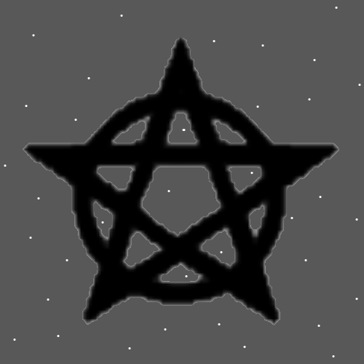
Item Group: Wizardry Laws
Principles: As One would imagine, Wizardry can be a very entertaining hobby.
Principles: When you know it all the Theories are more convincing.
Principles: Often, I do not write evidence. This would be more to write and more to read. Writing evidence is also much less entertaining.
Principles: Probably lots more visual Maps could have been done over the years.
Principles: Wizardry videos with animation and music can likely be super explosive.
Principles: Wizardry super organized and a person could likely get Level 3 Wizard in 300 pages or less. It is advised that people Make it a priority to get to Level 3 Wizard. Level 4 is something that can be gotten over Time and does not need to be a priority.
Principles: It may be that Heaven existed before Jesus just like Gods Universe existed before he did.
Principles: God lives at the bright center of Reality. The bright center of the Cosmos.
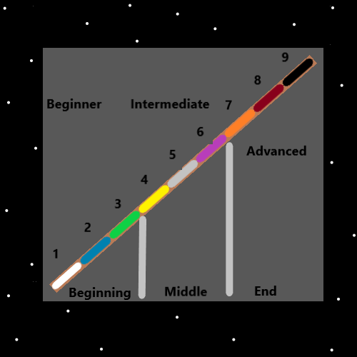
Principles: Being a Wizard is a gigantic thing. For that reason, most Wizards are Fire Wizards. Sorcery Practice training likely Makes a person more of a Fire Wizard.
Principles: Likely most Wizards are Fire Wizards. 2nd most common Air Wizards. 3rd most common Earth Wizards. And Water Wizards are the rarest.
Principles: Training medicine and Wizardry may Grow in the Water Wizard direction for a person. Cleaning mixed with Wizardry would also do so.
Principle: God is an alien.
Principles: His Holiness Origin calls himself a God because that is his Spiritual Level.
Principles: “People have entertained angels without knowing it”-The Holy Bible.
Principles: If you train Level 4 Wizard then read the Bible you will see things while you read it. It is this way with all Scripture. If you train Wizardry, then read the Scripture you will notice things.

Principles: People have a “education Level”. People with college Time tend to have slightly Higher education Levels. These days people are super advanced and all have high education Levels. Training Wizardry is super big for Growing your education Level.
Principles: The first Number of Reality is 0. The 2nd Numbers of Reality are “A” and “-A”.
Principles: It may go that Water Spells often Recharge and Fire Spells often Drain.
Principles: A person can cast Water Spells and Fire Spells on others. Not just themselves. There is likely ultimate Power in having people cast Spells on you.
Principles: Casting a Spell on someone is the same as saying an Action upon them. Guided Mediation is One ultimate Action a person can do for others. Helping people stretch another.
Principles: Teachers live casting Spells upon their students. Having Actions upon them.
Principles: You may Recharge a person if you play a musical instrument and they enjoy it. It may be a mix of Water and Fire. Water for them, Fire for you. Only Fire for you if it was work. If you enjoyed it, then it may be entirely a Water Spell. If it is work, it still may be a Earth Spell or an Air Spell.
Principles: Music flows through the Air. For that reason, it likely has a gigantic Connection to the Air Element.
Principles: The more difficult Mario Game challenge is to get to Bowser (the final boss) and do so on your last life, so that you game over at Bowser. You let Bowser kill you. Also, if you gain Score it means you did something wrong. The best Score board choice is a who has the lowest Score when they game over at Bowser. The more difficult challenge is to game over at Bowser and have the lowest Score.
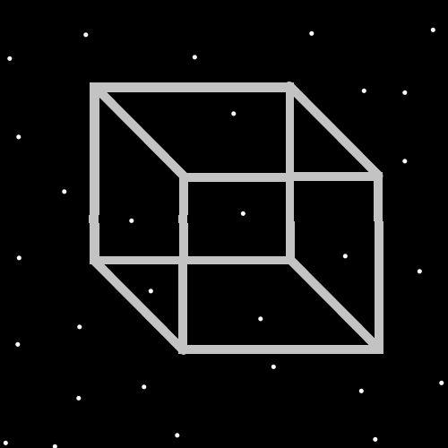
Principles: It seems like there are 12 Energy Bits in the square above.
Principles: The author here does not know how many pages all PAAIL.org Wizardry is. The guess is that its 1000 to 3000 pages. It’s a major Detail if its only around 1000 pages. That’s a super small amount of pages/knowledge for a Doctor/Sage Level achievement. Also, if its close to 1000 pages then it takes a tiny amount of Time to get to Level 4 and not much more Time to read all Wizardry.
Principles: Once upon a Time PAAIL.org Wizardry was Cosmic Laws 6. Now we are at Cosmic Laws 7. What would Cosmic Laws 8 look like. Things like Gods Detailed interactions with Heaven and Earth. The bigger moments and so forth. Gods’ history in great Detail would be Cosmic Laws 8 at this point. It would contribute enough to put us at Cosmic Laws 8.

Principles: When you get to Level 2 at thinking the Word Sorcery over and over it is Drain and training gain. When you get to Level 3 it is training gain and more Power to the moment. Its not just a training Spell. It has Power to it. The Power it gives though is mainly greater training gain per 1 Word. When you get to Level 4 it stops being a training Spell and becomes a Spell of Power. At Level 4 a person should change their Keyword/Keywords. The author here is Level 3 at think Sorcery over and over. When I get to Level 4 I intend to switch to “Water, Fire, Earth, Air”. When I get that to Level 4 I will switch again. The Spell should probably be Named and have a place in the Spell books. Let’s Name it “Word Repeat 0”. When a person has trained a bunch of Words beyond “Water, Fire, Earth, Air”, when they have Word Repeat 0 Level 4, sometimes you would use chess, and other Times a different Word. The author here has a Word Repeat 0 Level of around 2.8.
Principle: All this technology around us is massive Paranormal activity.
Principles: All Laws are Part of the big picture. On One Map all Laws are Cosmic Laws. On that same Map all Laws are Additions to Reality. All Laws are Waters of Reality. Positive has a gigantic Connection to the big picture and Negative has a gigantic Connection to the small picture.

