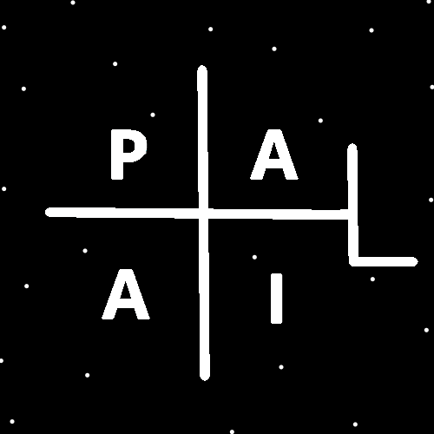
ObjectType: Article
ObjectNumber: 92
LocationName: PAAIL.org
LocationNumber:
Language: PAAIL 2.8

Maker: PAAIL.org
Model:
Name:
Rank:
SerialNumber:

Level: 6.0
Score:
Birth: 1-8-2025

Label: Room 92
Title: Smith Notes 11
Details: PAAIL.org Scripture…
Principle: Ultimate Scripture….
Agenda: Ultimate Scripture….
Action: Ultimate Scripture….
Information: Ultimate Scripture….
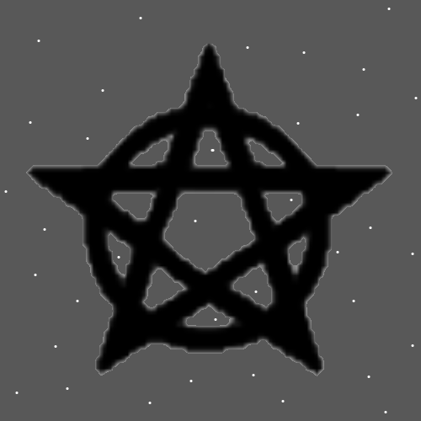
Item Group: Understanding The Multiverse 0
Principles: In the 1.0 to 6.0 Numerology rating System, 4 has a huge Connection to Expert, 5 has a huge Connection to Master, and 6 has a huge Connection to Doctorate/Sage.
Principles: In the 1.0 to 6.0 Numerology rating System, a person can have a Level 5 Spirit, a Level 6 Mind, and a Level 3 Body. Also other combinations. The 1.0 to 6.0 Numerology rating System is good for more than just Actions/Spells.
Principles: Some ultimate fluid movement is also very robotic like. Some robotic like movement is ultimate fluid movement. Fluid can be a powerful Spell Part. Fluid movement exercises can be powerful exercises.
Principles: The 1.0 to 6.0 Numerology System is a major breakthrough in Wizardry. 1 is Bad, 2 is not good, 3 is good, 4 is great, 5 is awesome, and 6 is unbelievable.
Principle: We all share a great Connection to the Force.
Principle: Sometimes when walking into a Subway, the smell will instantly trigger a ESP experience. It is a Subway Aura Sense.
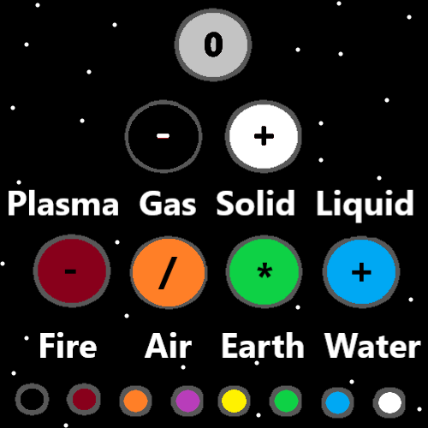
Item Group: Understanding The Multiverse 1
Principles: There be Cosmic Maps and Quantum Maps. Sometimes a Map is a Cosmic Map, sometimes a Map is a Quantum Map. Perhaps sometimes a Map is neither Cosmic or Quantum. It may be that a Map is both Quantum and Cosmic.
Principles: At the End of “Tome of the Yellow Wizard” was a Wizardry 1.0. Now with the inclusion of the 1 to 6 Numerology rating System, we are at Wizardry 6.0. The 1 to 6 Numerology rating System is a major Numerology System.
X2 Principle: A System of 1 to 9 can be to complex. Not simple enough.
X2 Principle: In Numerology 7, 8 and 9 are the Paranormal Levels. They are never seen. For this reason, again a 1 to 6 System is better.
X2 Principle: There are many reasons why the System is so good.
Principle: 1 to 6 Maps are often a good design.
Principles: There are “Main Levels” and “Sub-Levels”. Cooking is a Main Level. Cooking Soup is a Sub-Level. Cooking is also a Sub-Level of food. A Level can be both a Main Level and a Sub Level. Some things are more of a Main Level thing. Some things are more of a Sub-Level thing. Cooking is more of a Main Level thing. Cooking Soup is more of a Sub-Level thing.
X2 Principles: The Vocabulary terms “Main Level” and “Sub Level” seem new Vocabulary. Also reading about Levels can be good for the Mind/Chi/Karma.
Principles: Renewing a Connection to a thing can be a super Advanced and powerful Spell. Doing basic things is sometimes a Renewal Spell. Cooking toast for a cook may be a basic thing.
Principle: Time is still One of the biggest Spell Parts of them all. It often takes lots of Time to gain Levels in life.
Principles: It may be there are Positive, Negative and Neutral Particles everywhere. Electrons may be Negative Particles, with Negative Mass, and Negative Gravity fields. They may be bend in Particles, concave Particles.
Principle: If Energy Bits are Particles, it seems likely Protons, Neutrons, and Electrons are Particles, and all such things are Particles. Not there’s a difference between Particles and waves.
Principles: The Light Made his Holiness our God. And the Darkness Forced him unto the Beginning of Time, where the Darkness was large.

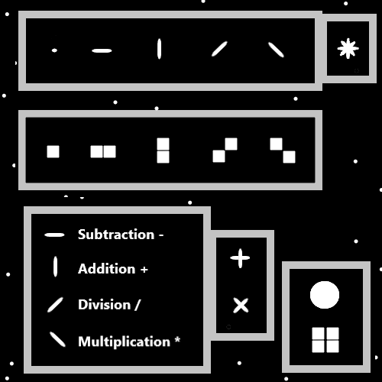
Principle: The Beginning of Time has a huge Connection to the Twilight, since the Origin moment was not long ago. You would think life would not evolve until way down the road. Instead, there was life right away.
Principles: “The father, the son, and the Holy ghost”. His Holiness Origin is the father, his Holiness Jesus is the son, and the Light is the Holy ghost. The Holy ghost is also known as the family pet. It has no soul.
Principles: Equipping gear likely causes more Energy to flow through you. Lots of gear is the Opposite of “minimalism”. Minimalism often has more of a peace and quiet Enchantment. Less gear is more likely to come with a peace and quiet Enchantment. Too much gear can become “cumbersome”, hard to move around in. Balancing gear is likely a good thing. Lots of gear has more of a Connection to the power Side of the Force.
X2 Principles: I imagine a person doing Tarot card readings as a podcast, with 4 necklaces on, 4 bracelets, 7 rings, a robe, a phone in a pocket of the robe, a pocket watch in a pocket, and a hat. This is super cumbersome, however can work fine in such situations.
Principles: If protons are alive, they may be like human cells. They may be like single cell lifeforms.
Principles: Addition has a huge Connection to Multiplication, like Subtraction has a huge Connection to Division.
Principle: It may be that a person can get from Level 0 to Level 6 Wizard in 1 year.
X2 Principle: This is One of the powerful things about Wizardry. Its not difficult to understand knowledge, and its only like reading 3 books.
Principle: Like you can “Water down a drink”, you can also Water down other things. Like Spells. Example, you can Water down your Meditation. Make it easier or simpler to do.
Principles: In computer games, sometimes its better to cast a Level 2 Energy Ball, and not the Level 5 Energy Ball, because the Level 2 Energy Ball is the right choice. Fire Spells tend to be more powerful. However, Water Spells are sometimes the right choice.
Principles: When a Level 4 Cook Cast’s a Level 3 Spell/Makes a Level 3 Item, the Item has a higher chance of being Level 3.9.
Principles: When a Level 3 Cook attempts to Cast a Level 3 Spell/Make a Level 3 Item, they have a higher chance of Making a Level 2 Item.
Principle: The Cosmic knowledge Sub-Level of Wizardry is the greatest of the Wizardry knowledge.
Principle: Robotic movement is often very fluid like. Fluid movement is often very robotic like.

