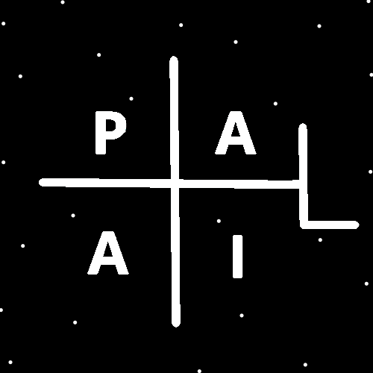
ObjectType: Room
ObjectNumber: 142
LocationName: PAAIL.org
LocationNumber:
Language: PAAIL 2.9

Maker: PAAIL.org
Model:
Name:
Rank:
SerialNumber:

Level: 7.1
Score:
Birth: 4-9-2026

Label: Room 142
Title: Smith Notes 49
Details: PAAIL.org Scripture…
Principle: Ultimate Scripture….
Agenda: Ultimate Scripture….
Action: Ultimate Scripture….
Information: Ultimate Scripture….
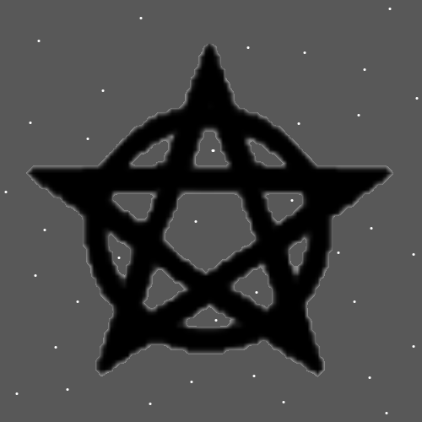
Item Group: More Cosmic Laws
Principles: PAAIL 2.9 is the change regarding the “ObjectType” Property. It should not be “article” as it has been in the past. In this Room it has been changed to “Room”. If it were a “Item” it would be “Item”. If it were a Star it would be “Star”. If it were a “Item Group” it would be “Item Group” and so on.
Principles: Some people need more Water Spells. Some people need more Fire Spells.
Principles: One of his Holiness Jesus’s Symbols is the Seed. Another Symbol of his is the Line. Especially the Up and Down Vertical Line.
Principles: Where once we had Tome of the Yellow Wizard, now we have a Doctorate Level of Wizardry. Theres not much more to research and develop, exception to things like Chakra’s, Astrology, Tarot Cards, Zen Buddhism (maybe). And some other things. Do enough phone Psychic hours for people and you Grow Levels at it. Theres some more knowledge about that. Knowledge the author here is likely never to write about. There is knowledge that the author here doesn’t know and never is going to write about it.
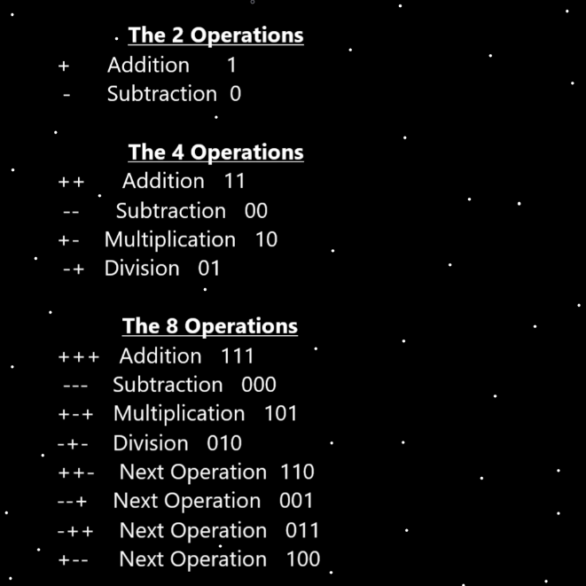
Principles: The music from the “Tron” movies is the people of Planet Earth music. We are the Quantum realm.
Principles: We all have a Spiritual Aura. All Spiritual Auras have a Level and a Score. All Spiritual Auras also have a Light Side, a Twilight Side and a Dark Side.
Principles: I like the character Merlin, from the 1981 movie Excalibur, more than I like Yoda from Star Wars. Though I like Yoda a lot.
Principles: The Theory is that Protons are 4D Particles. It may be that they are 3D Particles.
Principles: I have decided that in Wizardry Science there are “Orders” and “Order Types”. One Type is the Scientific Type. When people hit Level 4 at something they now belong to a Order. When you get to Level 4 teaching you are now of the teaching Order. When you get to Level 4 chess you are then a member of the chess Order. People who are a member of such Orders are Ordained members of it. I think its right that there are other Types of Orders, other than the Scientific Ones. It may be best to say there are Religious Orders. And, it may be best to say there are Sub-Orders.
Principles: When a person gets to Level 4 at something their Charms Grow that Level Type without assistance. It may be right to call this “Natural Growth”, and Alchemy “Artificial Growth”.
Principles: Shiva sounds like a female Name. Some meaning behind this may be that Shiva people/Religions have a greater Connection to the female Side of the Multiverse.
Principles: One of the biggest Wizardry Physics may be the realization that 1 is Pure White, 2 is Pure Blue, 3 is Pure Green and so on… Grey, Purple, Orange, Red….possibly Transparent. With this knowledge we can figure out some of Gods ultimate measuring Systems when measuring Parts of Photons. The Part that determines their Color. We can figure out the System God uses to measure the Color. We can give every Color a Number. Pure White being 1. Another major Detail is that once we have figured out that System, we may be able to use the new knowledge to figure out other Systems, like distance, speed, mass.
Principles: Pure White is 1 Unit of Photon Color. Pure Blue is 2 Units on the Photon Color Map.
Principles: Pure White may be a 2D Number. 1,0, or 0,1 or maybe 1,1. It could be a 3D Number.
Principles: It may be simplified to say Wizardry is 3 things. Cosmic Laws, Sorcery Laws, and Sorcery Practice. Where “Sorcery Practice” means using Sorcery Laws knowledge and doing Sorcery work with it.
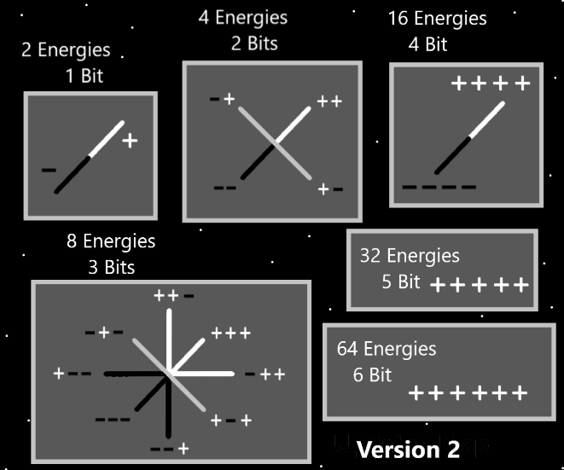
Principles: Noah, Moses, Abraham, Mohamad, and all these other famous people were likely Wizards. It seems likely that a lot of Scripture comes from Wizards. It seems I have been told the Theory is that Moses wrote the first 4 books of the Bible.
Principles: I think it is best to say there are Types of Scripture. I say there is “Traditional Scripture”, like the Bible. However, it is true that our Stories are Scripture to our God. This is another Type of Scripture.
Principles: Another awesome Physics Theory (only if is true) is that in Gods speed measuring System the speed of Light might be 1. Of course it could also be 10, 100 or maybe 0.1. Maybe 99.999 (repeating 9’s).
Principles: One of humans biggest Charms are the buildings. Of course, forests, oceans, mountains are bigger. The buildings though always have gigantic Chi’s.
Principles: When you speak of Water, Fire, Earth and Air you say first Water, then Fire, then Earth then Air. Water is 1st, Fire is 2nd, Earth is 3rd and Air 4th.
Principles: The music from the “Tron” movies is the music of the Quantum realm.

Principles: It seems likely the next Particles after Energy Bits have a Name in Numbers. If there is a next. If that Number were 0.999(repeating 9’s) it would resemble a Infinite amount of them. Like 1 is an Infinite amount of them. More than likely there is a Particle for the Number 0.999(repeating 9’s).
Principles: It is Advanced to think the Word “Sorcery” over and over in your Mind, throughout the day, until you have trained up the Levels of it. Then it does more. Also Advanced is using the Word “Breathe”. Do the same with that Word. The 3rd super Advanced thing is to also do controlled Breathing moments. The author is still Low Levels at this. Perhaps a Level 2.5 average of the 3 Action Levels. If you train and get these things to Level 3 it is awesome. Its even more gigantic when you get to Level 4.
X2 Principles: The author does not use the think 3 Times pattern in this. More like 12 Times or more pattern.
X2 Principles: It may be all Powerful to think the Word at least 20 Times.
X2 Principles: Don’t count how many you do. Just blast them out from your Mind.
X2 Principles: For better or worse the author thinks them super-fast. Rather than a Pattern of doing them slowly.
X2 Principles: The author just started doing this 3 combo thing.
X2 Principles: Once you train Level 4 you can start training Words like “chess” or “football”. Then get them to Level 3 and Level 4.
Principles: On the Map of the Two Elements (Water, Fire), Breathing Spells are Fire Spells.
Principles: Practicing Advanced Sorcery is a Fire Path.
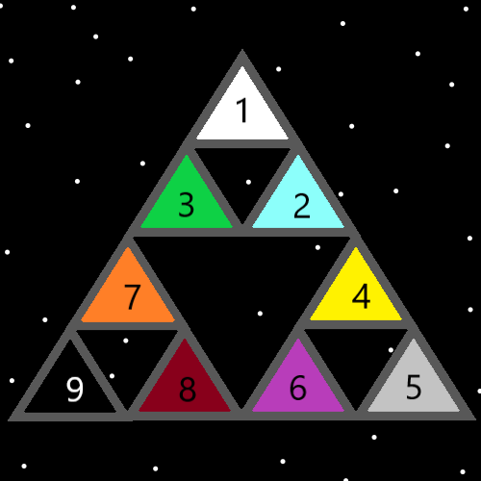Principles: There are 10 core Words of Reality. Numbers 0 to 9. I don’t know what they are. I think One is “Growth”, perhaps One is “Energy”. “Law” might be One. “Change” might be One.
Principles: The Gravity field around Gods Body creates a natural “Particle accelerator” for God. He can use that to slam Particles into each other at unbelievable speeds. This Particle accelerator (which deserves a Name) is larger than this Universe and larger than God. It is One of the biggest things of Reality. He used it to Make Heaven and his Holiness Jesus.
Principles: In Wizardry Science there is the “sub-consciousness” and the “upper- consciousness”. A person experiences the upper- consciousness, however the sub- consciousness is always there.
X2 Principles: The term “upper-consciousness” is Made up Vocabulary by the author here.
X2 Principles: The sub-consciousness is exactly the same as the upper-consciousness it’s a bunch of thought and so forth.
Principles: Sometimes Sub-Consciousness rises up to the Upper-Consciousness.
Principles: Because Wizardry is the ultimate Science it has a gigantic Connection to the Number 9 and the Color Black.
Principles: His Holiness Origin has the biggest Positive impact of us all.

