
ObjectType: Room
ObjectNumber: 157
LocationName: PAAIL.org
LocationNumber:
Language: PAAIL 2.9

Maker: PAAIL.org
Model:
Name:
Rank:
SerialNumber:

Level: 7.21
Score:
Birth: 10-8-2026

Label: Room 157
Title: Smith Notes 63
Details: PAAIL.org Scripture…
Principle: Ultimate Scripture….
Agenda: Ultimate Scripture….
Action: Ultimate Scripture….
Information: Ultimate Scripture….
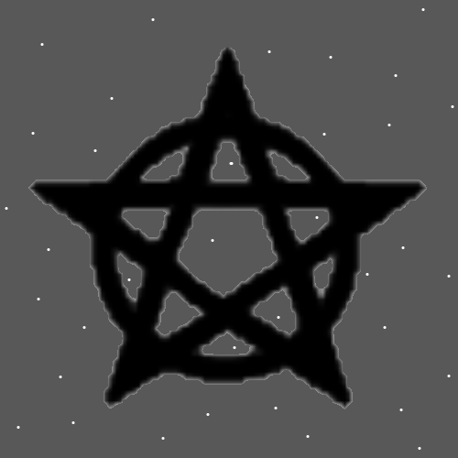
Item Group: Greater Multiverse Laws
Principles: The first Map, the first layer is 1D Energy Bits. The 2nd layer is the 2D Energy Bit layer, 2D Energy Strands. The 3rd layer is the 3D Energy Bits, 3D Energy Strands. This pattern is Infinite. The next layer is 4, then the next is 5, and so on.
Principles: There is an Infinite amount of layers between “A” and 1 and there are an Infinite amount of layers between 1 and “A”.
Principles: On some Maps it may be that there are (Infinity * 2) amount of layers.
Principles: Oddly as it is. We may be around Cosmic Laws 7.21 these days. At the End of “Tome of the Yellow Wizard” it may have been Cosmic Laws 4 or 5.
Principle: His Holiness Origin is “patient Zero”.
Principle: It may be that in Heaven One of his Holiness Light’s Names is “Joseph”. Another, Josephine.

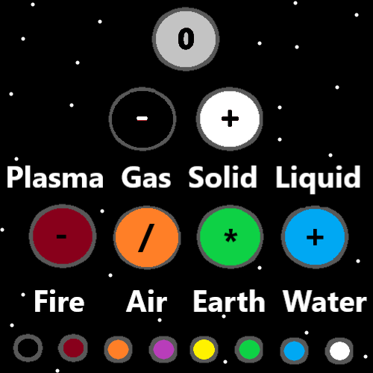
Principles: Saying it again… At the End of “Tome Of The Yellow Wizard” you had to do both the reading and Sorcery Practice to get to Level 4 Wizard. Now you can get to Level 4 just doing the reading.
Principles: One possibility is that there are 4 “states of Matter” (Liquid, Plasma, Solid, and Gas). One possibility is there are 8, and another possibility is there are 16. Or 32, or 64, or Infinity.
Principles: When using the Spell “Words Repeat 0”, in the moment, most of the Time it decreases Dexterity. One reason why it is so dangerous. On the long term and never in the moment, it gives a person more Dexterity.
X2 Principles: The fact that the Spell “Words Repeat 0” decreases Dexterity is a Dexterity Drain and from that comes Dexterity Level Gain.
Principles: When it comes to Batteries, the Laws of Gain and Drain are a major Part. This is also true of Levels and Score. Its all about Drain and Gain.

Principles: “Practice, practice, practice…”-Unknown. You only need to do the practice, practice, until you get the Levels. Then the practice, practice doesn’t matter as much. Often the best Path is to get the Levels, then Change the practice. Do different exercises. Stretch yourself in different directions. When doing Body stretching exercises, sometimes you want to Change the pattern. Instead of 10 minutes of a stretch, switch to 5 minutes of that stretch, then use the other 5 minutes for something else. Once you have achieved Higher Levels.
Principles: The Light Side of the Multiverse Made life. The Dark Side Forced it to be Born at the Beginning. A Time when the Darkness is huge and the Light small.
Principles: It is unnatural that life exists at the Beginning of Time. You would think it would take huge amounts of Time for life to appear. Physics is backwards at the Beginning of Time. It is a Twilight zone being so close to the Zero moment.
Principles: Another dangerous Spell is to Breathe in and out fast. You can even black out. It can be good in small amounts, and super controlled environments, for Breathing beginners. It’s a Spell for people with Low Level Breathing. It is for early training. Each Time you Breathe in and out counts as at least 1 point of Score. Since you’re doing some fast Breathing it’s a lot of Score per second. It may be best to only do for 5 seconds at a Time. Never do unless you are seated.
Principles: Dexterity, Strength, Intelligence, Wisdom, Charm, and Constitution. These are likely some of the biggest Virtues. They are super famous. Wizardry likely also Grows on these Virtues. It likely Makes you Grow them a lot.

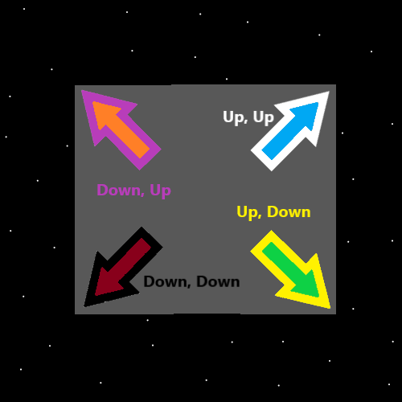
Principles: Remember “Drain” when trying to Grow Virtue Levels. Remember “Drain” when trying to Gain any Levels.
Principles: Reading Wizardry is likely a huge Drain on the brain/Mind. This is a good thing.
Principles: There are super famous “short music clips” in the Multiverse. NBC the channel has a short 5 second or 10 seconds One. Many companies have them. They hold great Power.
Principles: The latest Theory is that there are Infinitely small “Energy Bits” and Infinitely small “Energy Strands”. Likely then On some Maps there are only those Two things. The Theory is that Energy Bits and Energy Strands are the End of the road in Particle Physics.
Principles: The Words “On” and “Off” are major Vocabulary to a Wizard. “On” is a major Word of the Multiverse and so is “Off”.
Principles: The Theory is still that a Energy Bit equals an “A” amount of Energy, and a Energy Strand also equals a “A” amount of Energy. The Theory is that they both possess an Infinitely small amount of Energy. Exception to when you have an Infinite amount of them.
Principles: The Zero moment may have been the “Zero Energy Strand” Made of the Two Zero Energy Bits.
Principles: “Resurrection Day” will be a new book, and Chapter 0 is “The Hospital”.
Principles: Knowing the future can be more Enlightenment. It is the same with the past and the present.
Principles: Like many things there are Levels of Enlightenment. Some people are more Enlightened than others. They have a Higher Level of Enlightenment.
Principles: There is Breathing Levels which everyone has a lot of and there is improved Breathing Levels, which only people who have done Breathing exercises have.
Principles: Breathing exercises is One of the biggest when it comes to Sorcery Practice. Maybe the biggest. Improved Breathing Levels is a gigantic thing.
Principles: The technology of ships to other Stars may resemble the technology of current planes. It could be all about generating enough lift and so forth.
Principles: One of my favorite lines from the Bible is, “….he who is, and was, and is yet to come.”. God is he who is and who was, and who is yet to come.
