ObjectType: Article  
ObjectNumber: 97

LocationName: PAAIL.org

LocationNumber:

Language: PAAIL 2.8

Maker: PAAIL.org  
Model:   
  
Name:

Rank:

SerialNumber:

Level: 6.0

Score:   
Birth: 2-9-2025

Label: Room 97

Title: Smith Notes 14

Details: PAAIL.org Scripture…

Principle: Ultimate Scripture….

Agenda: Ultimate Scripture….

Action: Ultimate Scripture….

Information: Ultimate Scripture….

Item Group: Understanding The Multiverse 0

Principles: We(W) roll the dice(i) all(a) day long. We roll(r) the dice(d) on whether we will be struck by lightning every day.

X2 Principle: We dice all roll dice. Divination using the letters “wiard” – From the Word “Wizard”. Z never shows up, so skipped that letter.

Principle: We are dice.

X2 Principle: This Principle was inspired by Divination.

Principle: We roll dice.

X2 Principle: This Principle was inspired by Divination.

Principles: We roll the dice on every Action we do. Higher Levels can give better dice rolls.

Principles: Better Divination Levels give(i) better luck with Divination(a). They give better(r) dice(d) rolls.

Principles: Energies, Powers, Forces, Elements, Properties… these Words are all very Connected to each other. There are more Words as well. Words that would fit in this Map.

Principles: Everyone is “Force sensitive”, like in Star Wars. Everyone has a Force sensitive Level, at least Level 1. The Force sensitive Level is the same thing as the ESP Level. Everyone has at least Level 1 ESP.

Principles: Reading Wizardry Vocabulary is great for the Mind. It is all powerful Words. Like the Words Origin and Levels. The Word Force is good on the Mind.

Principles: It is possible that Divination trains ESP Levels. It may be that a person can gain significant ESP Levels from Divination. Divination can Force a person to think. It does things beyond just inspiration. Perhaps it does many things.

X2 Principles: Body exercise is still a greater way for ESP Levels. As is Breathing exercise and Meditation.

X2 Principles: Perhaps Divination is 4th place on Growing ESP Levels. Its reaching out and trying to Sense the Multiverse.

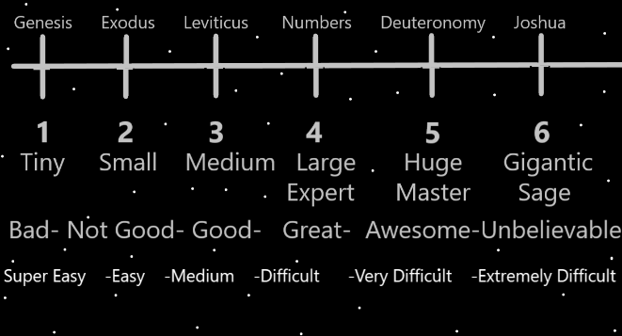

Item Group: The Footstool Philosophy

Principles: A chair can be a wonderful seat without a foot stool. Sometimes a foot stool improves the situation, even though the seat is great without it.

Principles: It seems somewhere in the Bible, his Holiness Origin commands humans to go forth and Tame the world. If I remember right he says something like “go forth and make a footstool of Earth. The animals and the plants.” The foot stool philosophy comes from this Part in the Bible. The belief is that its good to fish all the fish, cut down the forests, mine the wilderness, drill for the oil/gas, pump gas into the air, hunt animals for sport, even slash and burn the jungles to Make more farmland. All these things, even if its for a footstool that’s not needed. A nice lion hide footstool maybe… with lots of elephant ivory. Its ok to cut down the forests and Make footstools out of the trees. If you have a permit anyway.

Principles: Because his Holiness Origin would likely agree or disagree with the Footstool Philosophy, that Makes it theology. The “Footstool Theology”. This is what happens with all philosophy. It turns out that it is all truly more theology. Except maybe if you’re an atheist.

Item Group: Understanding The Multiverse 1

Principles: The Light Made our God, and the Darkness Forced him unto the Beginning of Time. At the Beginning of Time the Light is small, and the Darkness is gigantic. Since Light Grows and Darkness shrinks, eventually the Light will be large, and the Darkness small. Eventually the Light will be gigantic, and the Darkness tiny. The Light forever Grows, and the Darkness forever shrinks.

Principles: There is glory in Levels and there is glory in Scores. A chef getting to spend a hour with a famous chef will only give a tiny amount of Level gain. It will give a gigantic amount of Score though. Score 1 point got to meet a famous chef, and Score 10,000 points general cooking Score. Anyone can get Score 1 point met a famous chef. Only chefs/cooks can get the 10,000 points general cooking Score.

Principles: Spiritually there is glory in Levels and glory in Scores.

Principles: All Science has glory in Levels and glory in Scores. Get to a high Level in medicine is glory. Use a high Level of medicine is Score and glory. If you cured cancer, it would be a gigantic Score.

Principles: Winning a major chess tournament is gigantic Score. Its accomplished by High Levels.

Principles: Numerology is major Wizardry and awesome on the Mind.

Principles: It turns out that the Multiverse is Made of Fire, Water, Earth and Air. Its not a myth at all.

Principles: I suspect that many “myths” aren’t myths at all. I suspect some are true.

