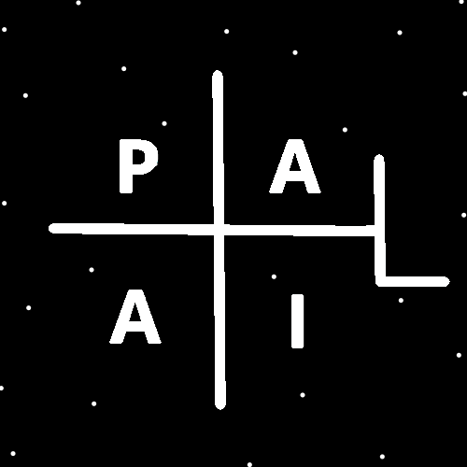
ObjectType: Article
ObjectNumber: 138
LocationName: PAAIL.org
LocationNumber:
Language: PAAIL 2.8

Maker: PAAIL.org
Model:
Name:
Rank:
SerialNumber:

Level: 7.02
Score:
Birth: 1-14-2026

Label: Room 138
Title: Smith Notes 45
Details: PAAIL.org Scripture…
Principle: Ultimate Scripture….
Agenda: Ultimate Scripture….
Action: Ultimate Scripture….
Information: Ultimate Scripture….
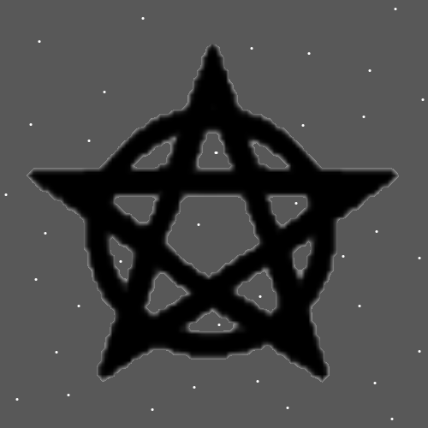
Item Group: More Wizardry 7
Principles: I always like the Word Archangel more than the Word Arkangel. Arch means “chief”. Ark means like a container I think.
Principles: It probably goes his Holiness Jesus is the right hand of God. The Holy Archangels 2 to 8 are the left hand of God. His Holiness Angel 9 is the right hand of his Holiness Jesus and not a Archangel.
Information: “….the great tribulation…”-The Holy Bible
Principles: I may remember the Bible wrong once and awhile.
Principles: It seems On some Maps there may be “natural” and “artificial”. Artificial is when it is a lifeform doing something. Natural is when it is not. Gods Birth is natural while Jesus’s Birth may not be. Since God may have Made Jesus. It may be there are natural Particles and there are artificial Particles.
Principles: Its possible the Body of God was Made of “single cell” like lifeforms. Its unclear if God was the only lifeform when he was Born. His Body may have been Made out of lifeforms. Meaning some people may have been Born at the same Time as God.
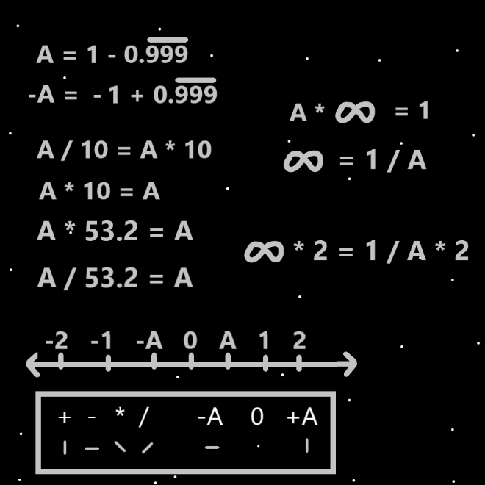
Principles: Its possible people were single cell like lifeforms living in the Body of God. Also, we may all be Made of his Holiness Jesus’s Body and its possible people were single cell like beings in Jesus’s Body.
Principles: You may have been a single cell like lifeform, in the Body of God, once upon a Time.
Principles: Everything is math and Numbers. However, before math and Numbers comes Positive, Negative and Neutral. This is why the math of Energy Bits Makes no Sense.
Principles: Gods biggest Name may be Origin or Twilight. Jesus’s may be Energy, Force, or maybe Light.
Principles: If it hasn’t been already said Axis Groups may be represented by Multi-Dimensional Numbers. It may be the same with Pole Groups, Axis’s and so forth. Some Objects of Reality are represented by Multi-Dimensional Numbers.
Principles: A Level 6 chef Makes mostly Level 4 and 5 food. Their 5 food being masterful. They never roll a 6. Its unlikely they ever roll under 3. When it’s an acquired taste is usually when it’s a 3.
Principles: When you Enchant a Charm with a Level 4 Wizardry Enchantment you turn the Charm into a Level 4 Wizard.
X2 Principles: This is not new Information. It is clearer though.
Principles: Gold, silver and platinum are likely more Powerful substances. The same for gems, crystals, jade and all manners of stone or marble. Since gold is more valuable than silver likely gold is more Powerful than silver. Since platinum is more valuable than gold, likely platinum is more Powerful than gold. When it comes to gems the more valuable the gem the more Powerful it is. Such things are very Firey and wearing lots of valuable gold is a Fire gear setup. More Power, less peace. Its right for some people and not for others. These are general rules that are not 100% accurate. Not always more valuable means more Powerful.
Principles: When it comes to Charms older Charms may be more Powerful. Collecting older Charms may be a more Fire existence.
Principles: Theres an Apocalypse about every 1000 years. This is Apocalypse 6. Somewhere between 5500 and 5999.
Principles: There is the Cosmic scale and the Quantum scale. There is the big picture Laws and the micro picture Laws. The big picture is the Light and the micro picture is the Darkness. The Cosmic scale has a Connection to the Light and the Quantum scale has a Connection to the Darkness.
Principles: Dreams can be cryptic.
Principles: Connecting the Dots. Since there exists the 4 Winds there exists the 4 Airs. Since there exists the 4 Airs there exists the 4 Waters, 4 Fires, and 4 Earths. Sometimes the 4 Forces are known as the 4 Earths. Sometimes 4 Fires.

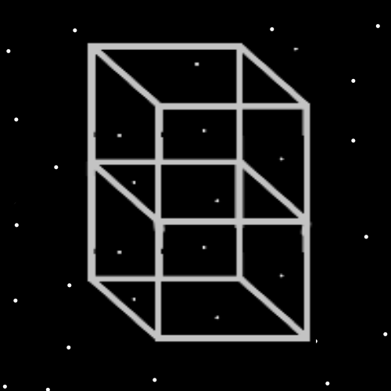
Principles: On a Quantum scale God may not have appear for something like 100s of millions/billions of years. There was no life for 100s of billions of years. It took a while for life to evolve. On a Cosmic scale God was Born in the first year, also known as the 0 year.
Principles: The Basic Energy in a Particle may be the “Absolute Value” of its Mass. This does not count speed, heat or other Energy that may be a Part of the Particle. In this situation the Energy in a Negative Mass Particle would always be a Positive Number. The “absolute value” of all Negative Numbers is a Positive Number.
Principles: It’s rare for someone to do better than Masterful/Level 5. It may be there are only 1000 paintings on Earth that are a 6 or higher.
Principles: Wizardry is the best Science of all Science.
Principles: A personal Wizardry book may be good for Divination about yourself and for yourself.
Principles: All Actions are Light, Twilight or Darkness.
Principles: Computer programs and Charms resemble people. One main difference most of the Time they are 100% Virtues and have no Flaws.
Principles: Of all the music the movies “Men in Black” and “Harry Potter’ remind me a lot of Wizardry.
Principles: It may be that massive Energy often flows through wealthy people. They personally don’t have a bigger impact though. It’s an illusion that they do.
Principles: At the final max Zoom in Reality may look like squares. Like the Map to the left. There is at least an Infinite amount of squares in every square foot. It may be more than Infinity in every square foot. It may be Infinity Multiplied by Infinity.
Principles: Every Level 4 Scripture Charm is a Level 4 Clergyman. Bibles as an example. Level 4 Religious Charms are also Level 4 Clergyman.
Principles: Just as Multiplication and Division are mixtures of Addition and Subtraction…. All other Operations are mixtures of Addition, Subtraction, Multiplication and Division.
Principles: Something worth noting again is that females benefit from weightlifting more than males and males benefit from stretching more than females. If you’re doing lots of Body exercise this is valuable Information.
Principles: Wizardry is like Basic Science like reading. Everyone should train Level 4 Wizard.
Principles: Some unbelievable videos with nice sound effects and music could be Made with all this writing.
Principles: 16-year-olds are more than qualified enough to train Level 4 Wizard.

