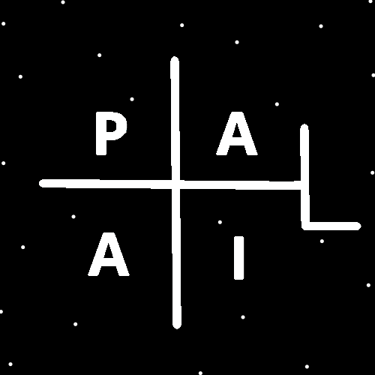
ObjectType: Article
ObjectNumber: 103
LocationName: PAAIL.org
LocationNumber:
Language: PAAIL 2.8

Maker: PAAIL.org
Model:
Name:
Rank:
SerialNumber:

Level: 6.1
Score:
Birth: 5-2-2025

Label: Room 103
Title: Smith Notes 18
Details: PAAIL.org Scripture…
Principle: Ultimate Scripture….
Agenda: Ultimate Scripture….
Action: Ultimate Scripture….
Information: Ultimate Scripture….
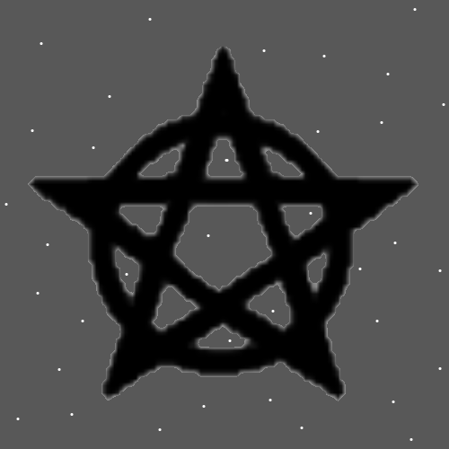
Item Group: Understanding The Multiverse 0
Principles: The new Meditation helmet invention is a major evolution in Meditation Sorcery. It was described in the Room before this One. It is at least a 10% increase and its awesome for both Fire and Water Meditation.
X2 Principle: There are many reasons why it is so great. For One thing it shifts brain power from your eye’s unto other things.
X2 Principle: Likely closing your eyes while using this gear is wrong to do. Don’t close your eyes.
Principle: Wizards have a Connection to the fiction Wizard like characters of movies and books. They have a Connection to Jedi from Star Wars.
Principles: The core thought is that perhaps all Negative particles are wave particles and all Positive particles are Sphere particles.
Principle: All Wizards should understand that they are a Part of the Force.
Principle: Reading things about the Force is good for a persons Chi/Karma.
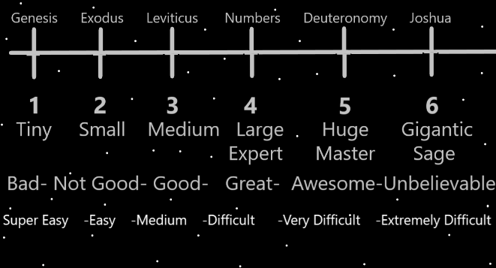
Principles: Often it should look right. Often when it is right, it looks right.
Principles: When someone says something is brilliant, it then can be asked whether it’s a 4, a 5, or a 6.
Principles: One theory is that protons may not have the same mass. Some protons may have more mass than others. Perhaps all protons have a unique amount of mass. It could be that no Two protons are alike. These Principles could be true of other particles, not just protons.
Principles: A person can dock with the Zero moment. Visualize it in front of you. It’s an event that was not long ago, and is easy to Connect to. The distance from here to there is tiny.
Principles: A person can write Words in their Minds. A person can fall into a trance doing it. Writing in cursive may be better. Normal writing will for sure work. One pattern is to write the same Word over and over in your Mind. Also, a person can write Words with their hand. Write Words In the air.
Principles: Structure, organization and routine can be great. Though often they are not an option.
Principles: Being a Level 3 Wizard gives better dice rolls in life’s Actions. Being a Level 4 Wizard gives even better dice rolls.
Principles: All things are Science. All knowledge is Science.

