
ObjectType: Article
ObjectNumber: 85
LocationName: PAAIL.org
LocationNumber:
Language: PAAIL 2.8

Maker: PAAIL.org
Model:
Name:
Rank:
SerialNumber:

Level: 5.5
Score:
Birth: 10-4-2024

Label: Room 85
Title: Smith Notes 7
Details: PAAIL.org Scripture…
Principle: Ultimate Scripture….
Agenda: Ultimate Scripture….
Action: Ultimate Scripture….
Information: Ultimate Scripture….
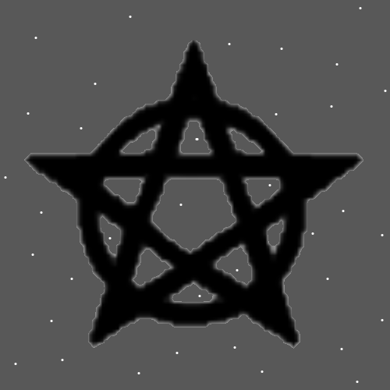
Item Group: Understanding The Multiverse 0
Principles: We are all super famous to his Holiness, our God. We are all super famous to his Holiness, our father, king of Heaven, Jesus. We are all super famous to the Angels of Heaven.
Principles: When you can speak and read English, you can see coincidences in things. Example: The Circle Symbol in the Words “God”, “Origin”, “Zero”, “good”, and “Holy”. When you can speak and read Spanish you can see coincidences there. When you Fuse them together you can see things too. Example: In Spanish “dose” means “Two”. In English “dose” means a “dose” of something. The Word “dose” is a Numerology category 2 Word.
Principles: We farm statistics all day long. When you breathe you gain 1 point of Breathing Score. You farm 1 point of Breathing Score.

Principles: Normal Breathing can be 1 point of Breathing Score. A Breathing Exercise can be 5 points of Breathing Score. A person with High Levels of Breathing may be able to get 5 points Score when they do normal Breathing.
Principles: There is “Breathing Levels” and there is “Breathing correctly Levels”. They are not the same. You have to Train “Breathing correctly Levels” to Breathe correctly. Though old Age in a person, will give Higher Levels of Breathing and be like correct Breathing.
Principles: “If you do not breathe right, you do not move right.”-Chun From the movie “Remo Williams”.
Principles: A persons Chi moves through the Multiverse. If you do not Breathe right, your Chi does not move right. Your Spirit will move right, not so much your Mind and Body.
Principle: Wizardry is the ultimate understanding of Reality.
X2 Principle: The Cosmic knowledge Part anyway.
Principles: Body exercise is Dexterity exercise and Graceful Levels exercise too. Body exercise is 1st place because it is Levels in many, many things. Like Mana drain and Mana Levels.
Principles: Every Action/Spell has your Mana flowing through it. All Actions/Spells drain Mana.
Principle: Tome of the Yellow Wizard is a out of date textbook/education book. The same with Wizardry Practice A and B. Much better books could be Made. Then no one would ever read Tome of the Yellow Wizard or Wizardry Practice A and B.

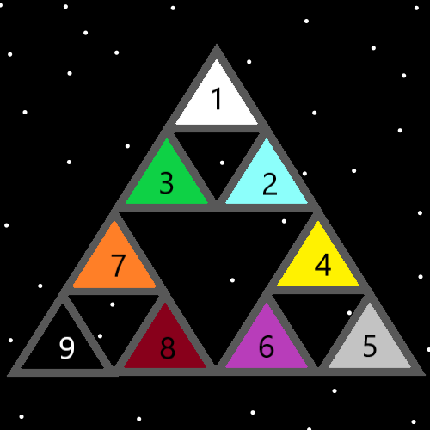
Item Group: Understanding The Multiverse 1
Principle: Lots of Maps come with a View.
Principles: A Map can be Made that includes the past, present and future. On some Maps we are Gods.
Principles: It may be Zooming out, when you include the past or the future. It may be that its Zooming in to focus on the present.
Principles: When a person is Spirit Level 6, they are a Sage. At Level 7, they are a Sage and a Holy person. At Level 8, they are a Sage, a Holy person and a Prophet. At Level 9, they are a Sage, a Holy person, a Prophet and a friend of God. Its very rare for a person to get beyond Level 6. On a Cosmic scale 100 human years is a tiny amount of Time and not enough Time to get beyond Level 6.
Principles: Sometimes a person needs to Zoom in. Sometimes a person needs to Zoom out.
Principles: Fine things can be addictive. A candy wrapper has a nice paint job on it. It has artistic qualities and more. It is a fine thing. All Earth Charms are huge Charms.
Principles: Fine things can hypnotize a person. People can be hypnotized by things. In this case “hypnotize” means things like how people can be obsessed with a thing. Mesmerized by a thing.
Principle: A person can look upon a candy wrapper and be hypnotized for a moment.
Principles: Some fine things are acquired tastes. They sometimes taste not good to people who are not used to them.
Principle: Some addictions are healthy.
Principles: Beware! Some things should only be cleaned by a Trained Expert. 100 hours of cleaning Time is a powerful Enchantment. This probably gets you to Level 2 cleaning.
Principles: In the past the theory has been that it’s hard to drain Mana. That theory seems wrong now. Any huge drain, like lots of Body Exercise probably drains Mana a huge amount.
Principles: Any huge drain Spell/Action likely comes with huge Mana drain.
Principle: More drain can be more Score per minute (Time Unit).
Principles: Often, it’s all about Score per minute. Units of Time.
Principle: Often, it’s all about Level gain per minute. Units of Time.
Principles: The Word “Unit” seems like it should be major Vocabulary. For his Holiness Origin, it is a Unit of Time here, a Unit of size there, and so forth with things like mass and heat.
Principle: It is a Enchantment to have PAAIL.org Maps floating around in your Mind. They live in your Mind from having seen them.
Principle: It may be right to say a Map is a Charm. A Type of Charm.
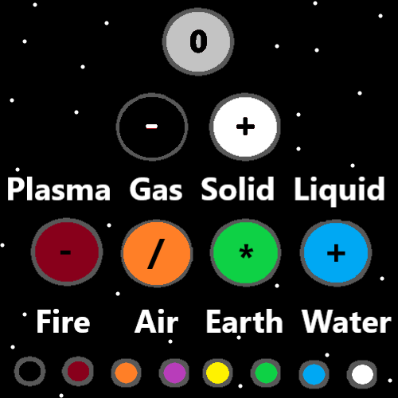
Item Group: Understanding The Multiverse 2
Principles: All Energy of this Universe/Heaven is Made of the God Body. We are all Made from the Body of his Holiness Origin.
X2 Principle: This is another reason why we all have a huge Chi.
Principles: Heaven holds the power to Make a computer which people could live in. It would be living inside a computer program. Like the movie The Matrix.
Principles: Being an Angel in Heaven is more Godlike. In some ways they are like Gods.
Principle: The Angel children of Heaven have Planets and Moons for toys.
Principle: In the afterlife we all get Planets and Moons.
Principle: The definition of a Word is a Map.
Principles: On some Maps the Word Reality means all things combined/Fused. On some Maps the Word Reality and the Word Multiverse mean the same thing.

