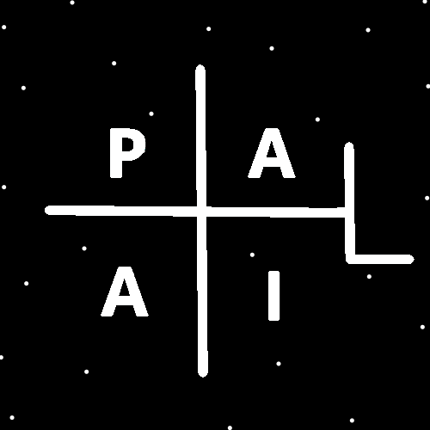
ObjectType: Article
ObjectNumber: 120
LocationName: PAAIL.org
LocationNumber:
Language: PAAIL 2.8

Maker: PAAIL.org
Model:
Name:
Rank:
SerialNumber:

Level: 6.5
Score:
Birth: 11-8-2025

Label: Room 120
Title: Smith Notes 31
Details: PAAIL.org Scripture…
Principle: Ultimate Scripture….
Agenda: Ultimate Scripture….
Action: Ultimate Scripture….
Information: Ultimate Scripture….
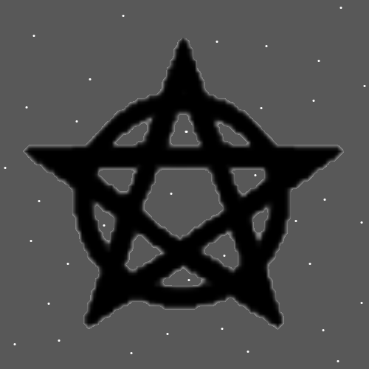
Item Group: The Story of Things 0
Principles: The latest in Numerology is the ability to analyze the Number with the “Word In Between” System. Such as 2 = Growth. 22 = Growth, Growth. Growth “to” Growth. Growth “the” Growth. Growth “is” Growth. Growth “be” Growth. Growth “if” Growth. Growth “of” Growth. There are many more Words as well. Many Words work. Growth “Word” Growth. Another example is 43. Solid “to” Order, Solid “the” Order, Solid “is” Order and so on.
Principles: The best website ever is a Scripture website. The best website ever is PAAIL.org. Even if another website teaches it better, that website comes from the existence of PAAIL.org.
Principles: This Universe is Made of Gods blood. We are Made of a God’s blood. We are also Made of Jesus’s blood. We are Made of a King’s blood.

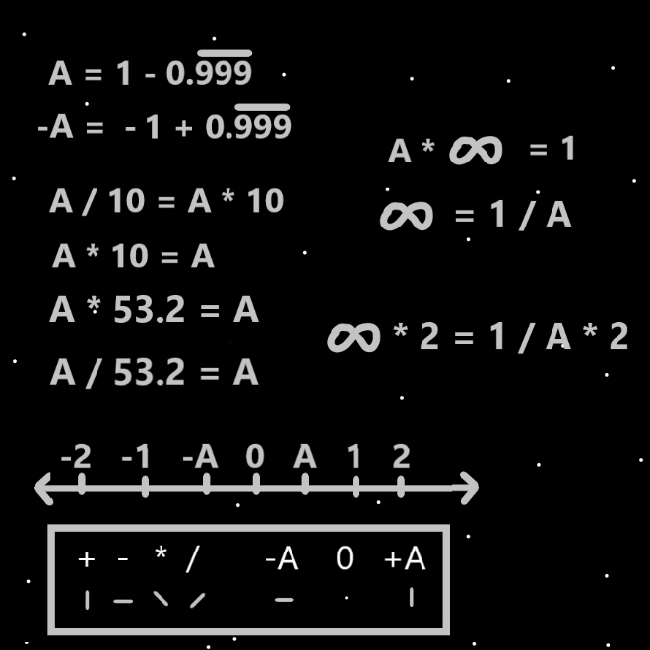
Principles: In the Bible God gives man the 10 commandments. In the Bible his Holiness Jesus Adds One more commandment. “Love thy neighbor.”. It can be difficult to love thy neighbor.
Principles: Wizardry gives better dice rolls in life about everything.
Principles: There is likely the multi-dimensional Number (A, A). A comma A.
Principles: There likely exists the multi-dimensional Number “Infinity, Infinity”.
Principles: There likely exists the multi-dimensional Number “32, Infinity”.
Principles: There likely exists the multi-dimensional Number “A, Infinity”.
Principles: Addition has a gigantic Connection to the Number “A”. Subtraction a gigantic Connection to the Number “-A” Multiplication likely has a gigantic Connection to the multi-dimensional Number “A, -A”. Division has a gigantic Connection to the multi-dimensional Number “-A, A”. It seems likely that a Number for Multiplication is “A, -A”. Multiplication also has a gigantic Connection to the Number “+2”. Division also a gigantic Connection to the Number “-2”.
Principles: Addition is also Connected to the multi-dimensional Number “A,A” and Subtraction “-A, -A”.
Principles: The next operation after Division and Multiplication is Connected to “A, A, -A”.
Principles: When Two people who are about the same Level at chess play a game, the odds are 50 50 on who will win. If One is a Level 4/Expert Wizard and the other not even Level 1, the odds become 45 55 on who will win. Wizardry does this.
Principles: Being Disconnected from God is unnatural. Life forms killing and eating each other to survive is unnatural.
Principles: Humans were designed by God and Heaven to survive on their own. For now we have to survive on our own. “Let us make them in our image.” – The Holy Bible.
Principles: It may be the reason the God Body does not collapse into a black hole is because Gods Universe is expanding and pulling out on the God Body. The God Body may be an expanding Body.
Principles: The 12 creatures of the Western Zodiac are the Ram, Bull, Swan, Crab, Lion, Virgin, Dove, Scorpion, Deer, Goat, Water Bearer and Fish. I thought they were all animals. In some ways all things are an animal. On some Maps all things are a creature.
Principles: On Resurrection Day it will be God’s Sabath. Gods servants will not be allowed to work, and all people will be a servant of God. It will be paradise.
Principles: A lot of this will be learned by everyone in the first year of the afterlife.
Principles: Eventually we get to live with God. We move into his house.
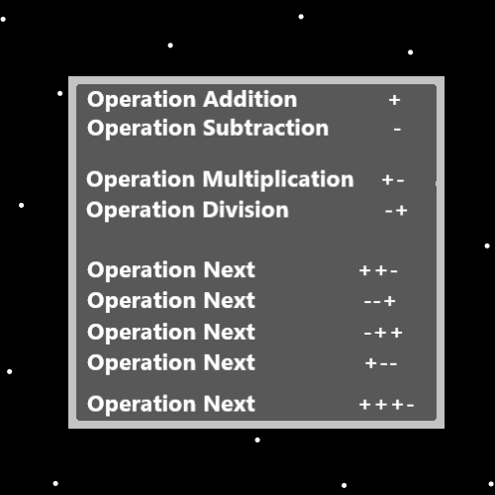
Principles: Sometimes to increase/Add accuracy you have to sacrifice/Subtract Power. Sometimes to increase/Add Power you have to sacrifice/Subtract accuracy.
Principles: As a quick Spell a person can think the Keyword “chess” 3 Times at the start of the game. Perhaps useful even to do it throughout the game. More Advanced Sorcery mixed with chess may involve using Advanced chess Vocabulary mixed with repeating Words in your Mind. As usual “don’t forget to breathe”. To use Advanced chess Vocabulary, you would have to know Advanced chess Vocabulary.
Principle: Everything’s Made of Bits of this and Bits of that.
X2 Principle: This is One reason it seems right to call all things Particles. The theory is that on some Maps all things are Particles.
Principles: Because there is an Infinite amount of distance between 1 and “A” there may be an Infinite amount of sub-Particles. As you travel towards “A” you can always find a smaller Particle. Every Particle is Made of more Particles. Exception for “A”, “0”, and “-A”.
Principle: 1500 pages/3 books is not having to read very much for being an Expert at something. Expert at something is the equivalent of a bachelor's degree, and people often spend 2 years doing that.
Principles: We all travel a unique Path. As we do so we influence the Path of others, and others influence our Path.
Principles: People of the same profession often have similar Paths. People of the same habits/hobbies/interests often have similar Paths.
Principles: Make a Divination System and then let 10 years pass Ages the System. It powers it up. This is One reason Tarot cards are so powerful. They are an old thing. An Aged thing.
X2 Principles: Virtually all Divinations Systems are powerful. A person can also Make their own custom Divination System. The best Divination is when a person uses multiple Systems. At the Beginning if you do the Divination for yourself (a 1 person Divination moment) then you might wish to start using Scripture. Use Scripture to do your Divination.
X2 Principles: Making up a System that uses Tarot cards and Astrology would be a great design. A Divination System can be like a custom sword. When you have High Levels of Divination (4 or higher), Making a System Makes more Sense. If you have been doing Tarot cards for years. Using them and Making a more custom design with them is the way. Changing the System to suit you.
Principles: More On Intentional Controlled Actions…. You gain more control over the moment as you exercise controlling the moment.
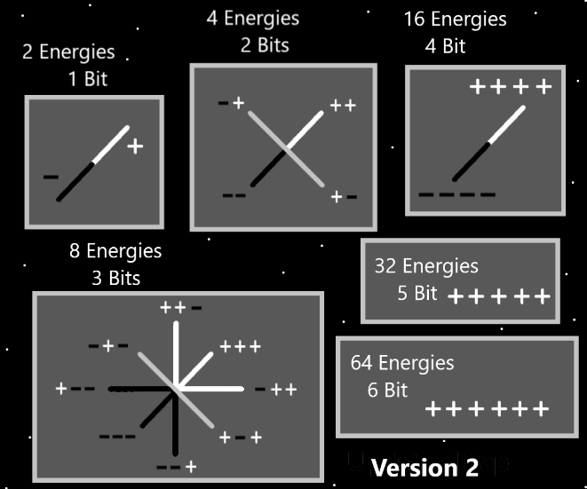
Principles: Infinite things count as “Intentional/Controlled Actions”. To suddenly snap your fingers would count. If you thought about it first then did it. Make a fist suddenly would count, if you thought about doing it first. Reflex Actions do not count as Intentional/Controlled. You have to think about the Action, then do it. Thinking a Keyword/Keywords in your Mind 3 Times counts.
Principles: Multiplication has a gigantic Connection to “+,-“, it also has a gigantic Connection to “+,-,+” and “+,-,+,-“, and “+,-,+,-,+”, the pattern is Infinite. A plus then a minus. Addition has a gigantic Connection to “+,+” and “+,+,+” and “+,+,+,+”. Also the pattern is Infinite.
Principles: It’s likely right to say that there is Basic Wizardry, Intermediate Wizardry and Advanced Wizardry. Expert is understanding Advanced Wizardry. Level 3 is Intermediate and Level 1, Level 2 is Basic.
Principles: Every operation/Energy has an “Energy bit code line” and a “Energy bit code pattern.” The code line of Multiplication is “+,-“, the pattern is a plus then a minus. With Addition the code line is a “+” and the pattern is Add another +.

Principles: Many Maps of PAAIL.org are not drawn up, they are only written about. It would be a lot of good pictures for Wizard books.
Information: The author here is maybe around Level 4.7 Divination.
Principles: Becoming a Level 3 Wizard is a monumental thing, even more so Level 4 Wizard.
Principles: After hitting Level 3 Wizard you will evolve differently. As you Age your Wizardry Enchantments will Age. The Spell Part “Time” is a gigantic thing. Many years of being a Level 3 Wizard is a monumental thing.
Principles: Since there is Infinity Zoom in, there may be Infinity Times 2 Zoom in. This is only a theory. There may be no beyond Infinity Zoom in.
Principles: All things are Made of Energy Bits. Hate is Made of Energy Bits. Hate exists therefor hate is an Energy. All Energies are Made of Energy Bits.

