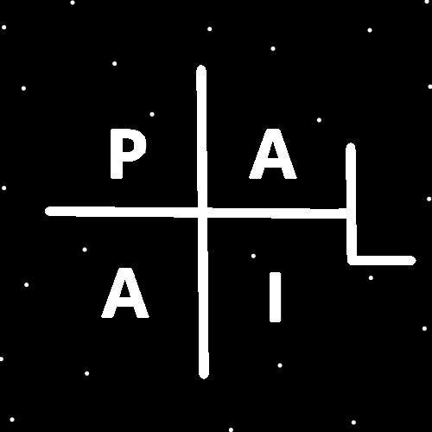
ObjectType: Room
ObjectNumber: 154
LocationName: PAAIL.org
LocationNumber:
Language: PAAIL 2.9

Maker: PAAIL.org
Model:
Name:
Rank:
SerialNumber:

Level: 7.199
Score:
Birth: 9-1-2026

Label: Room 154
Title: Smith Notes 61
Details: PAAIL.org Scripture…
Principle: Ultimate Scripture….
Agenda: Ultimate Scripture….
Action: Ultimate Scripture….
Information: Ultimate Scripture….
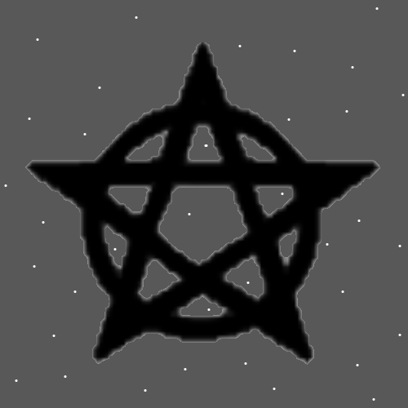
Item Group: Multiverse Laws
Principles: All Laws are Part of the big picture. All Laws are Cosmic Laws (On some Maps). All Laws are Additions to Reality. Addition has a gigantic Connection to the big picture. Positive has a gigantic Connection to the big picture. All things are Made of Energy. Energy has a gigantic Connection to Positive and Addition. If Gravity is the Addition Force, then it may go something like all Laws are Gravity Laws On some Maps. If Electromagnetism is the Addition Force, then all Laws are Electromagnetism Laws On some Maps.
Principles: Reality/the Multiverse is exactly like a computer program. It’s Made of 1’s and 0’s.
Principles: In some math it may go you change -A Numbers to 0’s. In some math it may go you change +A Numbers to 1’s.
Principles: You’re a Water Wizard if you are most Connected to the Water Element. You’re a Fire Wizard if you are most Connected to the Fire Element. It may be the odds of being equally Water and Fire is something like 1 in 1,000,000,000,000,000. Which means it never happens.
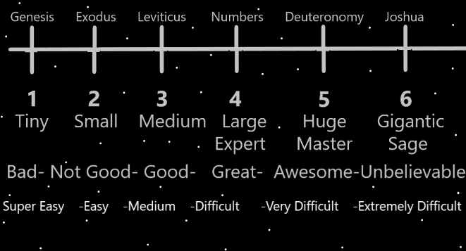
Principles: Instead of doing all training as fast as you can you can choose a slower Path that has more peace along with other things. Instead of getting Expert Wizard right away, you can get it over Time.
Principle: Expert Wizard is easy to achieve. Children could easily achieve it.
Principles: It is the Religious teaching of PAAIL.org writing that all people should get to Level 4 Expert Wizard. Some people have reasons why they should not train Level 5 or Level 6. Like they don’t have enough free Time.
Principles: It is the teaching of PAAIL.org Scripture that people should probably keep current once they are Expert Wizards. They should read all PAAIL.org Wizardry and read the new articles when they come out. Stay current with all Wizardry.
Principle: Forcing a Vision of a Dot is a ultimate Spell and Spell Part.
Principles: The way Levels works is that we get to Level God and its also called God 1. Then we get to God 2, God 3, God 4, God 5 and so forth. Then we move On, we get to God 9, we pass that and then we become something like Supreme Gods, also known has Supreme God 1. Also known as God 10. Then we evolve and become Titles beyond that, like High Supreme God or Infinity God or something like that. We evolve for eternity.

Principles: Heaven has no mountains, islands, or lots of other things. The Theory is that eventually such things will exist for Heaven. All these many things humans have will One day exist for Heaven.
Principles: When the first Universe was Born, the empty space may have been 1 Unit of distance big. Whether that’s a mile or 2 miles, a inch or the size of a Photon. Likely the empty Universe was a Sphere Shape.
Principles: Reality may be the Width, Height and Depth Dimensions a Fused Object going through a pipe also known as Time. The pipe is a loop.
Principles: The Theory is that Dimensions, like Width, Height and Depth are 1 Dimensional. That Time is likely also 1 Dimensional.
Principles: Reality is things Connected to other things. Surfaces coming into contact with other surfaces.
Principles: On One Map the Number 635 is Three Words. On another Map it’s One Word.
Principles: In some situations when you think the Keyword Sorcery over and over you get 1 point of Score per each Time you think Sorcery. If you Make a Fist you get another point of Score per Sorcery. Each Sorcery is like thinking Sorcery Twice. Get fresh out door air while you do it and you get 3 more points. Doing while your Drained can be lots more points. Doing while Drained is also extremely dangerous. Virtually any intentional Action while doing is more points. Hold your eyes open real wide would be more points. Visualizing a Symbol is more points. When you hit Level 3 with the Word Sorcery that becomes 1 more point per each Time you think Sorcery. This is all about training.
Principles: Sorcery Practice Makes you smarter, wiser and more graceful. When the training is fully completed it does the most.
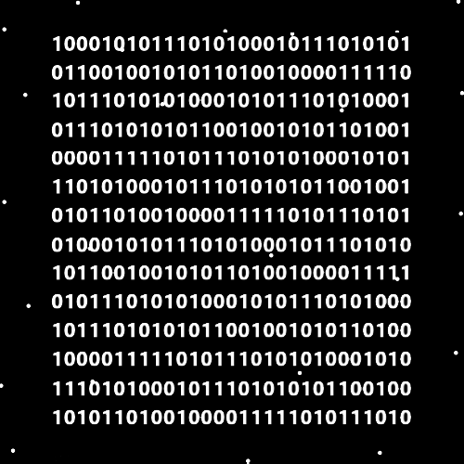
Principles: Its “knowledge Enlightenment”. Likely at Level 3 Wizard.
Principles: If PAAIL.org Wizardry was refined enough it may be capable of achieving “knowledge Enlightenment” in 200 pages. It would be 200 pages designed for quick “knowledge Enlightenment”. It may be a poor design for normal Wizardry teaching.
Principles: It may be that “+1” has a gigantic Connection to “++” and “-1” has a gigantic Connection to “-+”.
Principles: A Six-Sided dice has a gigantic Connection to being a 6 Dimensional Object.
Principles: There are Endless Paths. Every person has a unique Path. Sometimes a person’s Path is similar to another person’s. Sometimes there is the short, fast Path and sometimes there is the long, slow Path. The long, slow Path is often easier on a person and has other Positive’s to it. The long, slow Path has great Water to it and the short, fast Path has great Fire.

Principles: It goes there is Transparent Energy, White Energy, Blue Energy and so forth. A Energy for each of the 10 single digit Numbers, 0 to 9. It may go that in Gods Science there is such thing as a Expert in Blue Energy and a Expert in White Energy.
Principles: A Blue Photon has a gigantic Connection to Blue Energy and the Number 2.
Principles: It may go Photons are a unique Particle that comes in all 0 to 9 forms. Or 1 to 9 forms.
Principles: Photons may be a major Particle of Reality.
Principles: Using Spells like Words Repeat 0 causes you to Make more mistakes in the moment. During moments when you use it. It can be best to use it when you are doing nothing.
Principles: Even taking a moment to Breathe can Divide your attention and cause you to Make mistakes.
Principles: “Make” is a Vocabulary Word because “Maker” is a Vocabulary Word of PAAIL. Somethings are Vocabulary of PAAIL, and somethings are Vocabulary of Wizardry. In PAAIL.org Wizardry PAAIL Vocabulary is Added to the Vocabulary.
Principles: Secrets of the Multiverse can be heard in the music and seen in the movies. Secrets can be found in the music, books, movies and other things around us.
Principles: 1 sentence is 100% short. 2 sentences be better because it is 100% short and gives more Room for something to say. 3 sentences may be better than 2.
Principles: A Apocalypse begins at some point during the Darkness Part (500 years) of an age (1000 years). The current Apocalypse may have been around during the US civil war. It was Christians killing Christians.

