ObjectType: Article  
ObjectNumber: 102

LocationName: PAAIL.org

LocationNumber:

Language: PAAIL 2.8

Maker: PAAIL.org  
Model:   
  
Name:

Rank:

SerialNumber:

Level: 6.0

Score:   
Birth: 4-22-2025

Label: Room 102

Title: Smith Notes 17

Details: PAAIL.org Scripture…

Principle: Ultimate Scripture….

Agenda: Ultimate Scripture….

Action: Ultimate Scripture….

Information: Ultimate Scripture….

Item Group: Understanding The Multiverse 0

Principles: One of the most underused Vocabulary Words is “glory”. It is glorious to be a good person. Higher Levels and Scores are among some of the glory in our lives. Much can be said about “glory”. “Fortune and glory” is a famous phrase.

Principles: Of all things crafted/Made, music is One of the greatest. Making music is magical. Listening to music is magical.

X2 Principle: You can listen to music and ESP Sense the magical Side of music while you listen to the song.

X2 Principle: By “magical” I mean the unbelievable and awesome Reality of music.

X2 Principle: If you have ever Made music, while you listen to music, you can Sense the magical Side of Making music.

Principles: For like 10 songs in a row, I just experienced the “music is an extremely magical thing” ESP Aura experience. It’s a moment where you Sense music itself.

Principles: A person and their gear on some Maps is One Aura. When you add gear to your person you increase the Aura. When you decrease gear you decrease this Aura. In the past it has been mentioned that there is Fire rigs and Water rigs when it comes to gear.

Principles: There is a ultimate hat design for Meditation. It resembles the helmets that Jedi from the Star Wars movies use for training. It cuts off almost all sight around you. Except you want a little light to come in that you can see your chest and lower Body. You should only be able to see your chest and lower Body.

X2 Principle: Using sight Drains brainpower. The special headgear decreases this Drain and shifts that brainpower to better things.

X2 Principle: There are lots of reasons why this headgear is so awesome.

Principles: Connect/Dock are Light, On, Positive, Addition, Multiplication, Fusion, Water, and Earth. Disconnect/Undock are Darkness, Off, Negative, Subtraction, Division, Fission, Fire and Air.

Principles: There is such thing as graceful Docking and graceful Undocking.

Principles: The wealth of a nation is the total value of all owned assets divided by the Number of people in that nation.

Principles: On a Cosmic scale his Holiness Jehovah has a Room that is Large, however his Body is Small. On a Cosmic scale the Stars are Tiny. On a Cosmic scale this Universe is Small.

Principle: Wizardry wires the brain with ultimate Vocabulary Words.

Principles: On some Maps “particle” means chunk of Energy. On some Maps Principles are particles. Wizardry Principles are Wizardry particles. One Type of Wizardry particle.

Principles: Every Energy has Infinite sub Energies. Every particle has Infinite sub particles. There are an Infinite Number of different Wizardry particle Types.

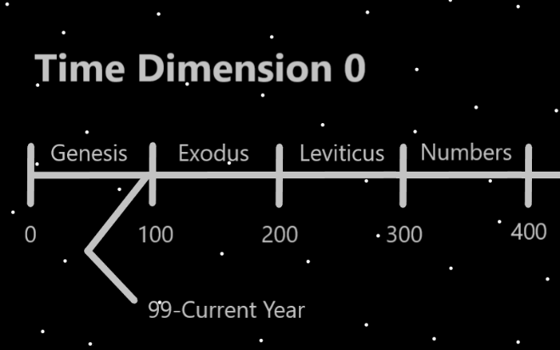

Principles: There are an Infinite Number of chess particle Types. Protons are a particle. There is likely an Infinite Number of proton Types. Every chess move is a chess particle.

Principles: The Sub Energies of the Number 1.0 is the Numbers 1.0 to 1.999 (repeating 9’s). The Sub Energies of 1.1 are 1.1 to 1.1999(repeating 9’s). Every Number has an Infinite Number of sub Numbers.

Principles: The Multiverse is a computer program. Made of 1’s and 0’s on some Maps. +1’s and -1’s on other Maps.

Principles: One of the most powerful Spell Parts is Time.

X2 Principles: The great truth of this can be Sensed while listening to the right songs. Its an ESP experience.

X2 Principles: Some things take years of Time to achieve.

Principles: Divination with Scripture is likely a awesome choice for some Divination moments. This Scripture is likely an awesome choice for Divination sometimes.

Principles: It may be that waves are a Type of particle. It may be that they are always Negative particles. They may always have Negative mass. They may always generate a Negative gravity Field. They may always be bend in particles. They stretch space the opposite direction of protons. If true, then there is the opposite of “waves”, the Positive Type particles. Maybe they should be called “Sphere” particles or something.

Principles: Height, width, depth and Time are likely bend in Negative particles or they are Positive bend out particles. I would guess they are Negative particles and they may have Negative mass. They might have Positive mass. There might be Zero mass particles.

Principles: There might be such thing as flat particles as well.

Principles: A person can see the truth of a Map.

