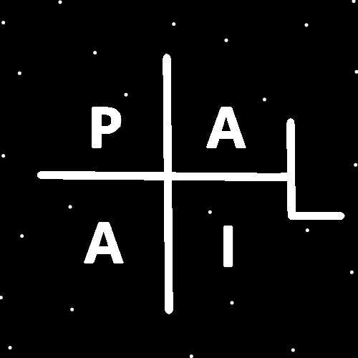
ObjectType: Room
ObjectNumber: 146
LocationName: PAAIL.org
LocationNumber:
Language: PAAIL 2.9

Maker: PAAIL.org
Model:
Name:
Rank:
SerialNumber:

Level: 7.13
Score:
Birth: 6-1-2026

Label: Room 146
Title: Smith Notes 53
Details: PAAIL.org Scripture…
Principle: Ultimate Scripture….
Agenda: Ultimate Scripture….
Action: Ultimate Scripture….
Information: Ultimate Scripture….
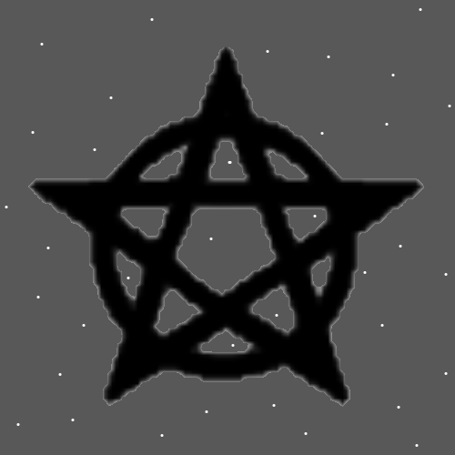
Item Group: Wizardry
Principles: All Energies are either Positive, Negative or Neutral. On some Maps there is only Positive, Negative and Neutral.
Principles: The Theory is that Negative Mass Objects emit a Negative Gravity field. That Positive Mass Objects emit a Positive Gravity field.
Principles: In the Resurrection Day after life, (the 30,000 years) you can only have so many friends and family that you interact with. Everyone though can handle 1 more friend and that friend will be God. His Holiness Origin will be a close friend all throughout the 30,000 years.
Principles: In Physics there is what’s known as “Strings” and “String Theory”. If Strings do exist, they may very much resemble Energy Bits.
Principles: The 5 Senses likely Drain on a person’s Mana Battery. Also, the 6th Sense likely does.
Principles: Disney has a gigantic Connection to his Holiness, the Archangel, crown prince and big brother Michael.
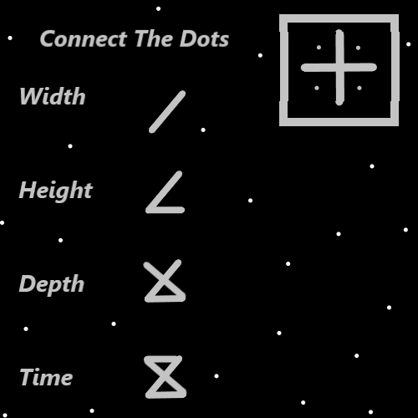
Principles: Likely on some Maps the Symbols above represent Water, Fire, Earth and Air.
Principles: Sometimes you want to get to Level 4 at something then switch to getting Level 4 at something else. This Ends up Expert and many things. Though not Master or Doctorate at those things.
Principles: It may be that people are super Mana Drained at the End of the day. Sleep likely Recharges Batteries and One of those Batteries is your Mana Battery.
Principles: Computer companies should build “child-proof” computers. Ones with children friendly AI’s, the ability for parents to monitor activity, and so forth. Perhaps linked to parents computer (phone), and parents have to give their approval for the children to install new apps. All kinds of things could be built into “child-proof” computers.
Principles: Sometimes the answer is “yes” or “no”. Sometimes Maps only have a yes or a no.
Principles: The 6th Sense may be the Sense of feel the Force. With the 6th Sense you feel the Force flowing through things.
Principles: Energy Bits is Wizardry because even God is Made of them. Also because it is a paranormal/supernatural Level of knowledge along with a Mystical Side. Too know all things are Made of tiny chunks of Positive and Negative Energy.
Principles: The Word Property and the Word Dimension have a gigantic Connection. It may be that all Properties of a Particle are added Dimensions of that Particle. Instead of the common thought that Protons are 3D or 4D, Protons may be 265D or something. If that were the case then there would be the 265 Dimensions of Protons.
Principles: Its likely that some Objects are not just Multi-Dimensional, they are super huge Dimensional like 226 Dimensional. As Reality Evolves more Dimensions are likely to appear. Particles may Grow new Dimensions.
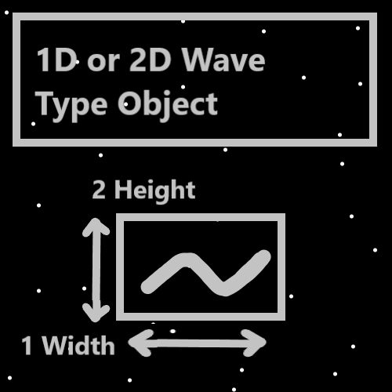
Principles: The Map above is a Model of a Wave Type Object. It may be that when you rotate the camera/microscope the 2D Wave still looks the same. It looks like it rotated to. Combine all angles (Infinity) and it looks like it occupies an Infinite amount of Locations at the same Time. When it travels around it would look like it takes an Infinite amount of Paths.
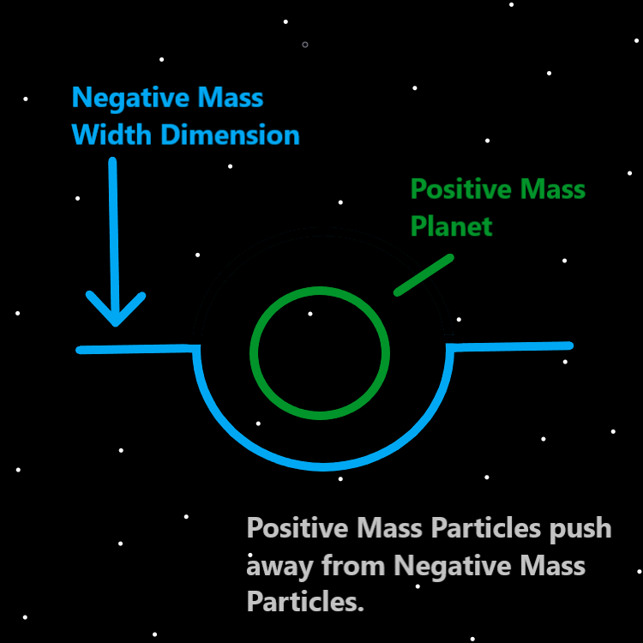
Principles: It may be the Wave Type Object does not occupy Infinite Locations, that it spins as it travels. The Paths also may not be Infinite. The final Sum is that it looks like a stick may be the Story.
2X Principles: If it spins that may be another Dimension, and it therefor isn’t 2D, its 3D. 2D in some ways, 3D in others possibly.
Principles: Its all about what happens when you rotate the camera on a 2D Wave Type Object. What View do you get. What’s the View when you combine all angels.
2X Principles: There may be no such thing as 2D Wave Type Objects.
Principles: It may be when you look at/use a microscope on a Wave Type Object that it rotates the Wave Type Object. That it spins it.
Principles: The 6th Sense may sometimes super Drain a persons Mana.
Principles: Equipping gear on your person likely increases Mana Drain per minute. The more gear, the more Mana Drain.

Principles: Equipping a baseball cap Drains Mana while using, however it also decreases Mana Drain by decreasing the amount of Objects visible to your eyes. Less for your brain to deal with. The final total is that a baseball cap decreases Mana Drain while using. Which is a Positive thing. It also does more. Equipping gear is generally considered to always be a Fire Spell. However, with the baseball hat it seems like equipping it may be a Earth Spell, or even a Water Spell.
Principles: Sunglasses are much like baseball hats. Less Photons in the eyes can be less for the brain to deal with. In the right situations equipping sunglasses may be a Water Spell. A super Positive thing. In some situations sunglasses may decrease the amount of Mana Drain per minute.
Principles: It may be you only want massive Mana Drain in training and at the right moments.
Principles: Think Keywords “Mana Drain” may be a Powerful Spell.
Principles: If a Item is confusing read just the Words with capital letters. That may help sometimes.
X2 Action: Divination: Principles. If. Item. Words. That.
Principles: The human brain is 100% a computer with software to. When you multi-task you must split your brain Power up. It can be a Negative thing. It can be hard to do 2 things at once.
Principles: The Width Dimension may be very strong and does not bend much.
Principles: It may be that Gravity is not weak. It may be Width is strong.
Principles: There be many professions. One is the Luxury profession. A person can be Expert at it.
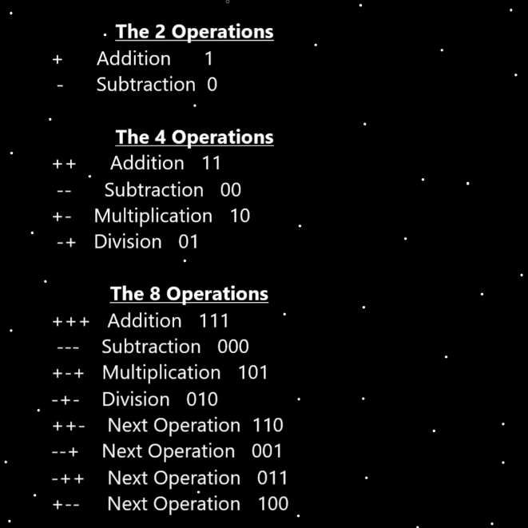
Principles: The Science of God and Heaven likely is 100 trillion years more Advanced than humans.
Principles: My revelation that we be at the Beginning of Time came from the Bible. “In the beginning, God created the Heavens and the Earth.”-The Holy Bible-Genesis 1:1
Principles: The Theory goes that Width is a 1-Dimensional Wave Type Object.
Principles: Photons/Protons/Electrons and so forth are Made of at least a Infinite amount of Energy Bits. That Makes it seem like a Proton occupies at least a Infinite amount of Locations.
Principles: A 2D Wave Type Object may take an Infinite amount of Paths because it is Made of an Infinite amount of Energy Bits.
Principles: When 2 people, look at the same 2D Wave Type Object from different angels, it may be the Wave changes to a 2 Path Wave. It changes to being in 2 different Locations at once. Half the Energy Bits in One Location, the other half in another Location. One half taking One Path, the other half taking another.
Principles: Infinity and Energy Bits have a gigantic Connection. One reason because Energy Bits are Infinitely small.
Principles: Falling into a Trance has likely been a Powerful Spell throughout Time.
Principles: Stretches where you do not have to “hold it” are very Powerful Stretches. Lying on your back is an Example. For some people it Stretches their back. Assisted Stretching with the help of someone else can result in a person not having to “hold it”. Instead, the person helping “holds it” for you.
Principles: On One Map all Charms are either Water Charms or Fire Charms. On another Map all Charms sort into being either Water Charms, Fire Charms, Earth Charms, or Air Charms. All owned Charms exist this way. All personally equipped gear is either Water gear or Fire gear. All personally equipped gear is Water gear, Fire gear, Earth gear or Air gear.
Principles: A person can likely Grow Water Levels on Charms. Water Levels and Fire Levels. Mostly I picture Shrines Growing Fire Levels. By default they do this to Charms. There may be a way to get a Shrine only Growing Water Levels on your Charms. Using Shrines is Firing a Charm in a furnace.
Principles: It may be that the Origin Particles were “pure Energy”. Energy as compact as can be. A Infinite amount.
