ObjectName: Article
ObjectNumber:

Maker: PAAIL.org
Model:
Name: Advanced Wizardry 10
Rank:
SerialNumber:

Level:
Score:
Birth: 3-13-2023

Label: Room
Title: Advanced Wizardry 10
Details: Advanced Wizardry rooms are always the latest in PAAIL.org Wizardry research. They are called rooms because that is paail.org science.

Principle:
Agenda:
Action:
Information:

Location: PAAIL.org
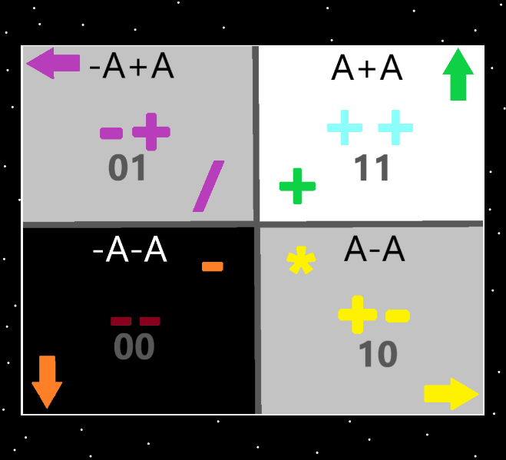
Information: The 4 Quadrants…the top right quadrant is the “addition”, “++”, “11(binary)”, “up” “white/blue/green”, “A+A”, quadrant. The Strong nuclear, weak nuclear, electromagnetism, and gravity forces could be added. Earth, Water, Air and Fire could be added. And others could be added.

Information: The “4 forces” likely unify into the “2 forces”.

Item Group: Physics And Wizardry Fusion
Principle: It is likely that the 4 forces(gravity, electromagnetism, strong-nuclear, weak-nuclear) are made of 2 forces. There are 2 forces that make the 4 forces.
Principle: The 2 forces are like binary. 1s and 0’s. Combinations of them make the 4 forces.
Principle: There are 4 possible, 2 piece combinations. 11, 10, 00, 01.
Principle: 1 – 0.999(repeating 9’s) = A
Principle: It may be that A / 10 = A * 10
Principle: It may be that A * 10 = A.
Principle: It may be that A / 10 = A.
Principle: It may be that A * 10000 = A.
Principle: Since you are always dealing with an infinitely small amount of energy, you may often end up with things equaling A.
Principle: Since you are dealing with an infinitely small number… there may not be a smaller number.
Principle: These are all theories. They be wrong.
Principle: In physics I have heard talk of unifying the 4 forces. They probably unify into 2 forces.
Principle: The universe is probably a point particle matrix after all. Made of A’s. Also known as “Energy Bits”.
Principle: I’m always surprised not to see the 1 pointed seed shape everywhere. It might be that protons stick into neutrons turning the protons into 1 pointed seed shape particles. Then the 1 pointed seed shape is everywhere.
Principle: Particles may always come in one of 3 forms. Convex particles, concave particles, and flat particles. (Bend in particles, bend out particles and flat particles).
Principle: There may be only convex and concave particles. No flat particles.
Principle: The theory is that height, width, depth and time are concave(bend in) particles.
Principle: I have heard there is a difference between particles and waves. I doubt it. Everything is likely a particle. Perhaps waves are a type, and/or shape of particle. Or perhaps all particles are particles and waves.
Principle: Lots of this has been covered before. Though this is more refined and more than worthwhile.
Principle: Likely all, most, or a good deal of particles have a surface.
Principle: You don’t have to bounce a particle off another particle to see it. Just draw the particle on paper.
Principle: All things are likely made of energy bits.
Principle: Once upon a time there were the 2 “neutral energy bits”. Everything that now exists comes from them.
Principle: The 2 neutral energy bits can also be called the 2 origin charms.
Principle: The universe may have layers. The 1 layer, the 2 layer, the 3 layer and so on. The energy bits layer may be the 1 layer. The final layer.
Principle: Zoom levels science is some times layers.
Principle: Likely the energy bits layer is the final zoom in level.
Principle: “Levels” is ultimate science. Levels is also a major part of numerology.
Principle: “Levels” is major vocabulary.
Principle: I know it turns out the four elements thing is true. Fire, water, air, earth….. I don’t know which is the ++ one. Water is my guess.
Principle: I don’t know which quadrants the fire, water, earth, air sort into.
Principle: As for Wizardry Maps… the ones found at PAAIL.org…. they may have slight, or even major mistakes.
Principle: There are an infinite amount of zoom levels. An infinite amount of layers to the multiverse.
Principle: If you try and zoom out from the energy bits layer…. you find an infinite amount of zoom levels before you get to a proton. You never get to the proton.
Principle: If you try and zoom in from a proton layer, to the energy bits layer….. you never get to the energy bits layer. There are an infinite amount of layers between the two.
Principle: Fuse physics and computer science and you get the physics of energy bits.
Principle: Energy bits is likely exactly like circuitry.
Principle: Fuse physics, computer science, and wizardry and you would be fusing 3 things at the same time.
Item Group: Actions/Spells
Action: Read the last book of the Bible… “Revelation”.
X2 Principle: This takes very little time.
X2 Principle: This is a spell.
Action: Read the end of the Koran.
Action: Read the end of the Torah.
Principle: All spells have principles to them. All spells have agendas….. All spells have actions to them, and all this is information.
Principle: It is likely that the end of the Bible, Koran and Torah are secretly some summary data. You can sum up a bunch using the ends of these charms.
Item Group: Advanced Divination 1
Principle: Dream interpretation is divination.
Principle: Divination is reach out and sense the multiverse.
Principle: ESP is reach out and sense the multiverse.
Principle: Divination actions/spells are build divination levels. Divination actions/spells are build ESP levels.
Principle: You can train ESP by doing divination.
Principle: We likely all have huge mana batteries, we just don’t know how to tap into them.
Principle: As usual… everything is a bunch of theories.
Principle: People likely already have high levels of ESP…. many things cause it….all the media on the brain, and advanced public education systems cause it.
Principle: ESP is a sense, and persons senses can be wrong. A persons instinct can be wrong.
Principle: Its probably best science to call “knowing the sun will rise” a sense. Which sense I don’t know. Probably not an ESP sense.
Principle: Most people don’t drain their mana battery much. Though it drains as a part of all actions.
Principle: Body exercise likely drains a lot of mana battery. This is a good thing to drain it a lot. This means exercise it.
Principle: Meditation can likely drain a lot of mana battery. This is a good thing. It is channeling mana energy through big sorcery spells.
Principle: It may be best science to say we divine the physical image of a thing by looking upon it, or touching it. We divine the sound of a thing by tapping it. It may be best science to say using your senses is a divination.
Principle: Dreaming is like divination or is divination.
Principle: Divination is often riddles.
Item Group: Advanced Divination 2
Principle: A movie is a energy. A movie is a Chi.
Principle: Artists and workers on a movie are each an energy, a chi.
Principle: A movie can have a small spiritual score and small spiritual level while still having a huge Chi.
Principle: Most or all good movies have a huge spiritual score and level. It was honest work, and that works.
Principle: Many things can boost the chi level of the movie. The artists involved is one of the biggest factors.
Principle: Massive fame and number of times broadcasted is also other things that will make a movies chi grow huge.
Principle: Many things can grow the chi of a movie.
Principle: The bigger the chi of the movie the bigger the paranormal/super-natural/mystical side of the movie.
Principle: All of these principles apply to music as well.
Principle: The bigger the chi of the movie the better the divination using the movie.
Principle: The bigger the chi of the song, the better the divination using the song.
Principle: Its all about “Levels” and these things have huge levels!!!
Principle: Huge chi levels!!!
Principle: Since we are all elementals, we all have a huge level chi. “Chi Level = Elemental”.
Principle: In the after life we will all have huge sorcery powers. All powerful sorcery levels.
Principle: In the after life we will all have massive divination power. Plain spoken messages…yes….no….and there will be no more riddles.
Principle: Massive divination power would be get correct yes or no answers to any yes or no questions.
Principle: All the movies, music, games, books, stories, and charms are all are beginning of time things. This is partly why they have such a huge chi.
Principle: When doing divination on the song “House of the Rising Sun”. A person can think the lyrics “God I know I’m won.”… instead of “God I know I’m one.”.
X2 Principle: “God I know I’m won”, is a more positive divination reading.
X2 Principle: I hear both versions when I hear this song. You can hear both versions in the song.
Principle: Because this is Advanced Wizardry 10…it will have a connection to the number 10. This is numerology. This is what happens when people use the number 10. Most of the time.
Principle: Big coincidences happen to peoples work…. Like how the first Super Mario game had levels and a score.

