ObjectName: Article
ObjectNumber:

Maker: PAAIL.org
Model:
Name: Advanced Wizardry 11
Rank:
SerialNumber:

Level:
Score:
Birth: 3-13-2023

Label: Room
Title: Advanced Wizardry 11
Details: Advanced Wizardry rooms are always the latest in PAAIL.org Wizardry research. They are called rooms because that is paail.org science.

Principle:
Agenda:
Action:
Information:

Location: PAAIL.org
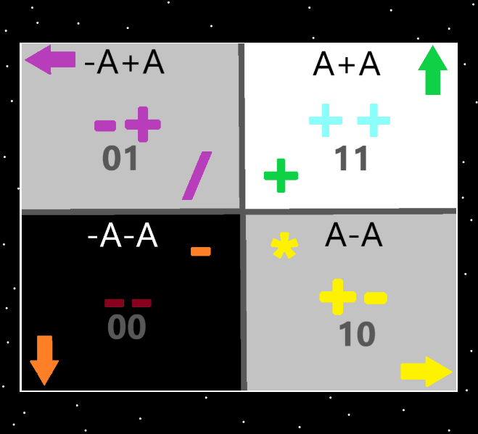
Information: The 4 Quadrants…the top right quadrant is the “addition”, “++”, “11(binary)”, “up” “white/blue/green”, “A+A”, quadrant. The Strong nuclear, weak nuclear, electromagnetism, and gravity forces could be added. Earth, Water, Air and Fire could be added. And others could be added.
Information: The “4 forces” likely unify into the “2 forces”. The 4 forces are made by combinations of the 2 forces.

Item Group: Energy Categories
Principle: All energies sort into one of the 3 energy categories. Positive, neutral or negative.
Principle: All energies sort into one of the 4 energy categories. ++, +-, -+, --….11….10…01…00…(See map above).
Principle: All energies sort into one of the 8 energy categories. The eight directions.
Principle: All energies sort into one of the 10 energies. 0 to 9.
Principle: All energies sort into one of the 0 to 99 energy categories.
Principle: It may be there are a set of 5 energies. A set of 6 energies. 7….11…343…on and on….
Item Group: 4 Dimensional Particles
Principle: The theory goes that at first the multiverse was just the 4 spatial dimensions….an empty multiverse that has space to it.
Principle: The theory is that next appeared a tear at the center, and a 4 dimensional body was born. The multiverse no longer empty space. This would add to 8 particles.
Principle: The theory goes that all, most or a lot…..of particles are 4 dimensional.
Principle: If all particles are 4 dimensional. They all have 4 sides to them.
Principle: The sides of a particle likely bend out, bend in, or are flat.
Principle: There may be particles that bend out on 2 dimensions, but bend in on the other 2 dimensions.
Principle: Bend in is known as concave(I think)….Bend out is known as convex (I think).
Principle: Particles may be convex in some ways, be flat or concave in others. Mixtures of the 3.
Item Group: Wizardry Physics
Principle: There are infinite universe’s…. there is only one multiverse.
Principle: Major wizardry science is understanding things constantly mirror other things.
Principle: 2 things that exist are moons, and tiny baseball sized rocks flying through space. The moons are electrons, and the little baseball sized rocks are particles physicist don’t even know about. These particles could be everywhere.
Principle: It may be that protons punch into neutrons making the proton form a pointy seed shape….not a sphere. When bonded to a neutron.
Principle: It may be all particles have a surface. And particles interacting with other particles is always about surfaces coming into contact with other surfaces.
Principle: Since zooming is major science, you are always zooming in on surfaces. This is zooming science.
Principle: Often zoomed out levels mirror zoomed in levels. Often the zoomed out view, looks like the zoomed in view.
Principle: One practical application of understanding zoom levels is that we are always developing technology that deals with the next zoom level. The next layer.
Principle: All science is about understanding a layer, and being able to manipulate it.
Principle: There are an infinite amount of zoom levels between 1 and “A"( A = 1 – 0.999 repeating 9’s).
Principle: There are an infinite amount of layers between a proton and an “A”. An infinite amount of technology layers.
Principle: Ultimate science is understanding… starting at a proton, you can always zoom in on the protons surface, then zoom in on the surface of that, and then zoom in on the surface of that….on and on for all eternity.
Principle: All science is energy manipulation…controlling energy.
Principle: Protons and electrons mirror planets and moons.
Item Group: Object Systems
Principle: In the after life, the martial arts belt color system will likely be….white to black. White, blue, green, grey, purple, orange, red, and then black.
X2 Principle: The first 3 will be considered beginner, the next 3 intermediate, and the last 3 advanced.
X2 Principle: This would be a 9 object system.
Principle: The days of the week are a 7 object system. Monday, Tuesday, Wednesday, Thursday, Friday, Saturday and Sunday.
Principle: The months of the year are a 12 object system. Because there are 12 months.
Principle: It is likely that you more often find 4 object systems than 5 object systems. More often 5 object systems than 6 object systems.
Principle: It may be that you find 2 object systems more than 3 object systems.
Principle: The energy bit system is confusing….is it a 3 object system, the 2 neutral energy bits(from the origin moment), and the “A” energy bit, plus “-A” energy bit…? Or is it a 1 object system….”energy bits”…..maybe is 2 object system, positive energy bits, and negative energy bits.
Principle: There is the 10 color object system where you include “transparent”.
Principle: People can map things with colorology.
Principle: People can map things with numerology…..0 to 9…..or sometimes 0 to 99.
Principle: Perhaps it started a 2 object system (at the core of all things), the 2 origin particles, and its still a 2 object system (at the core of all things), positive and negative energy bits.
Principle: The biggest unifying thing is that all which exists is a form of energy.
Principle: All things that exist are an energy. All things that exist are an aura. All things that exist are a chi.
Principle: Maybe its good vocabulary to say “all things that exist are a universe”.
Principle: Saying the chi of the multiverse is saying the sides of the multiverse.
Principle: It may be fair to say the word “object” is a major vocabulary word.
Item Group: Wizardry Physics Fusions
Principle: A = 1 – 0.999 repeating 9’s.
Principle: The multiverse is made of “A”, and “-A” particles. The multiverse is made of lines of code….in the form of “A” and “-A” particles.
Principle: “A” and “-A” particles are known as “energy bits”.
Principle: It may be that all lines of code equal an “A” (or “-A”) amount of energy. 8 energy bits would equal an “A” amount of energy…….then it might be
“A * 8 = A”
Principle: The closest thing to a “zero particle” is the A and -A particles.
Principle: The number of “0” is more a part of the multiverse than “1”. The number “1” is more a part of the multiverse than “2”. 2 is more a part of the multiverse than 3. 3 is more a part of the multiverse than 4…….this pattern goes on forever.
Principle: There are the first frames of the multiverse. The 0 frame (the 2 origin particles). The 1 frame (a 4 dimensional empty universe). The 2 frame (2 bodies…the empty space and a ball at the center) which would equal 8.
Principle: There is the 3rd frame, 4th frame and 5th frame to the multiverse.

Item Group: General Wizardry
Principle: Wizardry is not fireballs or lightning. Wizardry in part is boosting your already existing skills.
Principle: Music divination turns the music into a more spiritual experience. Music divination turns the music into a more religious experience.
Principle: Music has a huge chi. Music has a huge spiritual side.
Item Group: Colorology
Principle: The color red looks like the color black. The color red looks like the color orange. The 3 colors look alike.
Principle: White looks like blue. Blue looks like green. The 3 colors look alike.
Principle: Grey is like yellow. Grey is like purple. The 3 colors are alike.
Item Group: Energy
Principle: Understanding a thing is understanding it as an “energy”.
Principle: Understanding a thing is understanding an “energy”.
Principle: Every form of energy has a number.
Principle: A proton is a type of particle, and there is a number for the proton type.
Principle: Each individual proton also has its own unique number, that no other proton shares.
Principle: Math is a form of energy. Math has a number.
Principle: I am not certain which quadrant is the water one. I am not sure about fire, earth or air either.
Principle: I am not certain which quadrant is the gravity quadrant.
Principle: There are the 4 forces. The addition force. The subtraction force. The multiplication force and the division force.
Principle: The biggest, most common virtue of current times is intelligence. These days people have much bigger intelligence levels.
Principle: Every one is very intelligent these days.
Principle: Intelligence is a mind property. People these days have higher mind levels as well.
Principle: If you went over brain scans from people of 1823, you would find there is much less electrical activity in the brain.
Principle: As usual its all about “levels” and these days people have huge mind levels.
Principle: All, most, or a lot of audio/video stimulates more electrical activity in the brain.
Principle: Many things increase electrical activity in the brain. The public education system, learning to read and write, even the nice candy wrappers.
Principle: Learning to read and write increases electrical activity in the brain.
Principle: Little trinkets, and furniture increase electrical activity in the brain. The art part of them a major part.
Principle: The multiverse is full of light, twilight, and darkness. Positive, negative, and neutral.
Principle: We have tons of different batteries. All, most or a lot of actions drain batteries.
Principle: Some actions recharge batteries. Some times an action drains and recharges batteries.
Principle: If a human can write the number in 60 seconds….its a small number.
Principle: There is number for every particle, and a particle for every number.
Principle: The first 3 numbers are 0, A, and -A.
Principle: The first 3 particles are 0, A, and -A.

