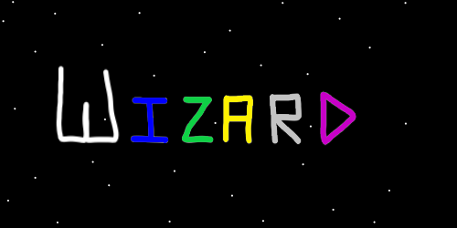
ObjectName: Article
ObjectNumber:
LocationName: PAAIL.org
LocationNumber:

Maker: PAAIL.org
Model:
Name: Advanced Wizardry 13A
Rank:
SerialNumber:

Level:
Score:
Birth: 4-12-2023

Label: Room
Title: Advanced Wizardry 13A
Details: Advanced Wizardry rooms are always the latest in PAAIL.org Wizardry research. They are called rooms because that is paail.org science.

Principle:
Agenda:
Action:
Information:
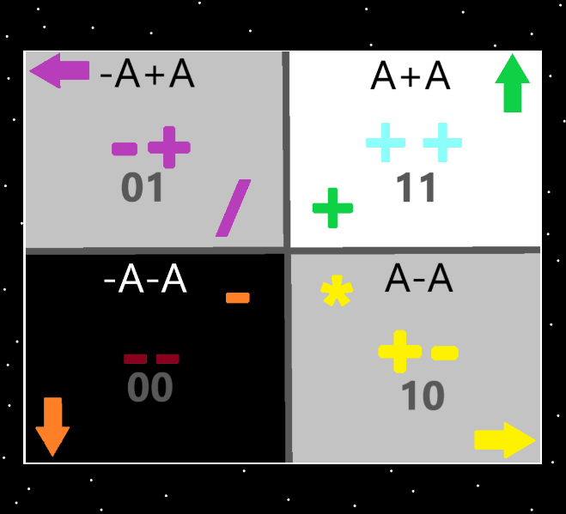
Information: The 4 Quadrants…the top right quadrant is the “addition”, “++”, “11(binary)”, “up” “white/blue/green”, “A+A”, quadrant. The Strong nuclear, weak nuclear, electromagnetism, and gravity forces could be added. Earth, Water, Air and Fire could be added. And others could be added.
X2 Principle: This map could have slight errors.
Information: The “4 forces” likely unify into the “2 forces”. The 4 forces are made by combinations of the 2 forces (exactly like binary) ……. 11, 10, 01, 00. This is not just a coincidence.
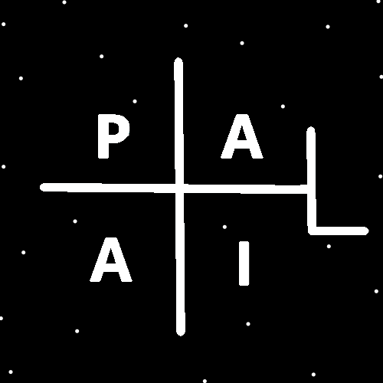
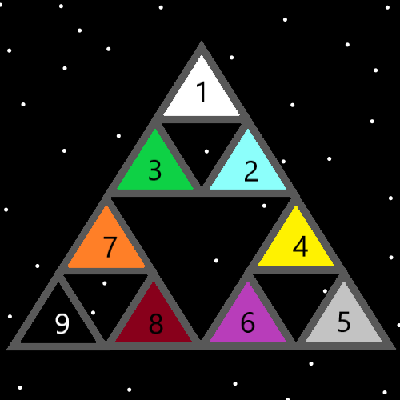
(The Tri-Force V2) A Map
Item Group: Enchanted Maps
Principle: Looking at Wizardry maps enchants the mind. It is good stimulation on the mind.
Principle: Looking at Wizardry maps is good for you.
Principle: Looking at maps is a major thing of Wizardry.
Principle: Maps are a major thing of science.
Principle: Maps are a major thing in PAAIL.
Principle: Looking at maps can be good for a person.
Principle: Wizardry is great inspiration for making maps.
Principle: PAAIL is great inspiration for making maps.
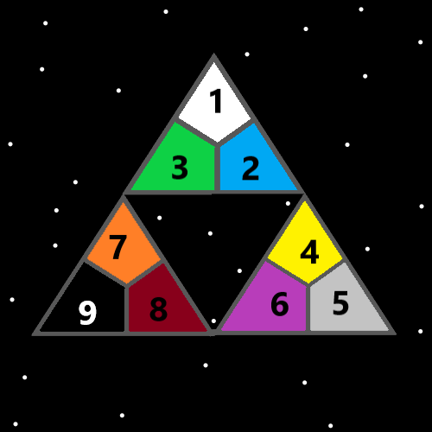
(The Tri-Force V3)
Item Group: Numerology Refined
Principle: A Wizard is a Wizardry Scientist.
Principle: The Wizard ranks are 1 to 9. 1,2,3 is Jr. Wizard. 4 is Expert Wizard, 5 is Master Wizard. 6 might be Sage Wizard, or might be Doctor of Wizardry. Level 6 to 9 is not clear.
Principle: In numerology 7, 8, and 9 are considered the more paranormal, supernatural levels.
Principle: A level 7 computer scientist is a more paranormal, supernatural computer scientist.
Principle: A level 7 anything is a more paranormal, supernatural scientist of that thing
Principle: The theory is that getting to a Doctor in a science is getting to level 6 in that science.
Principle: The theory is that people getting higher than level 6 is rare.
Principle: The theory is that higher than level 6 is rare. Such as enchantments on charms.
Principle: It is rare to see higher than level 6 throughout all things in the multiverse.
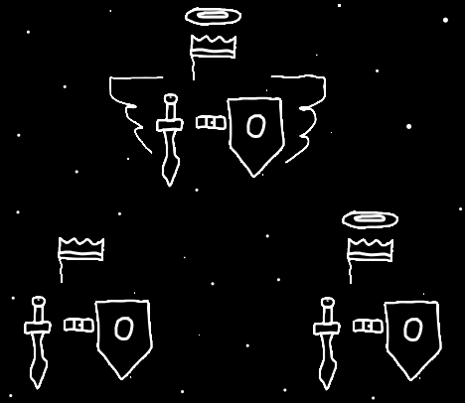
(3 People)
Item Group: ESP Refined
Principle: The truth of the multiverse can be sensed through the music. Its an ESP experience.
Principle: You can sense the truth of all this Wizardry in the music. Its an ESP experience.
Principle: A person can look at Wizardry Maps while listening to music. It can increase the ESP experience.

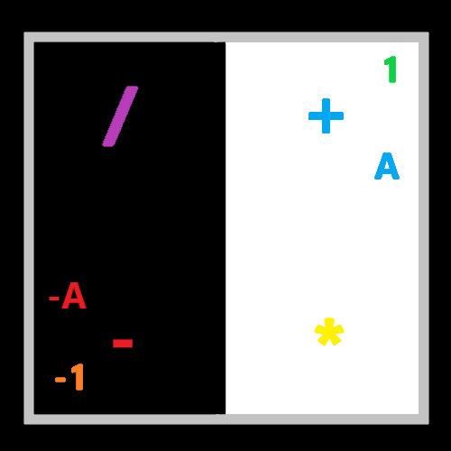
(2 Object Systems)
Item Group: Science Refined
Principle: In normal science, its body exercise, breathing exercise and meditation exercise.
Principle: In PAAIL its body actions, breathing actions and meditation actions.
Principle: In Wizardry its body spells, breathing spells, and meditation spells.
Principle: Maps sometimes have errors.
Principle: Count the points, and count the sides. A square has 4 points, and 4 sides. The circle has 0 points and 1 side. The 1 pointed seed has 1 point and 1 side.
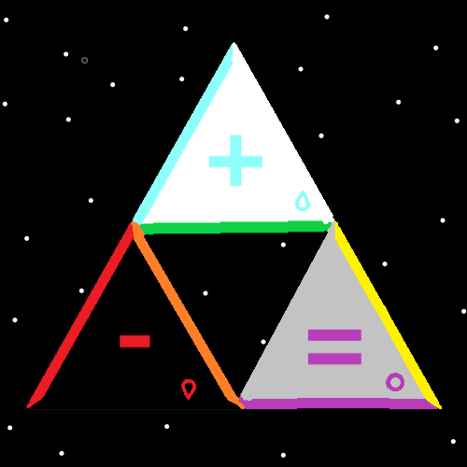
(The Tri-Force V1) – Maps sometimes have errors.
Item Group: Speaking In PAAIL
Principle: In you wanted to stay focused on using PAAIL in thoughts, you could write on a piece of paper “Principle, Agenda, Action, Information”. Then while thinking keep glancing at the paper to burn it into your mind.
Principle: A person can use the write on paper PAAIL technique while doing conversations with others, while debating, maybe while teaching, maybe while giving a speech, or answering questions and during many other situations.
Principle: A person can use the write on paper PAAIL technique to keep the language of their mind a PAAIL language.
Principle: As a spell…. Writing “Principle, Agenda, Action, Information”, on a piece of paper (make it big letters)…..as a spell it burns the words into your mind.
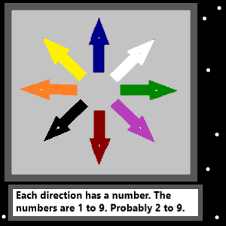
(The 8 Winds)
Item Group: The Powers Collection
Principle: There should be a bunch of vocabulary for all Wizardry, and science. For now I like……”The Powers Collection” is the collection of the first main powers.
Principle: The first of the “powers collection” is the “3 forces”. Positive, Negative, and Neutral.
Principle: The second of the powers collection is the “4 elements”. The addition element, the subtraction element, the multiplication element, and the division element.
Principle: The third of the powers collection is the “8 directions”. Numbered 2 to 9.
Principle: The forth and final power collection is the "10 energies”. 0 to 9.
Principle: This is a bunch of theories. A bunch is vocabulary. Perhaps the word “power” should be used differently. Perhaps a better system could exist. With better vocabulary.
Principle: I call these 4 power groups the main “Powers Collection”.
Principle: Perhaps “positive, negative and neutral” should be named something else…like they should be the 3 elements, and the 4 should be the four forces.
Principle: There is a bunch of Wizardry vocabulary to improve and so forth.
Principle: Note how the Christian cross is like the plus symbol (+). The plus symbol also has a huge connection to his majesty the Christ.
Principle: The plus symbol has a huge connection to positive, and the number 1 also has a huge connection to the word positive. Positive is a category 1 word in numerology.

(The Circle)
Item Group: The Sabbath
Principle: The sabbath is intended to be a rest day. You may choose any day of the week you want for your sabbath. This keeps it rest even more…. Since you get to choose.
X2 Principle: If you choose it, you get a more rest enchantment to your sabbath.
Principle: It is good to have a sabbath.
Principle: If you don’t enjoy something, you often don’t want to do it on your sabbath. This includes prayer and other worship actions.
Principle: You should not go to church on your sabbath if you do not like doing it.
Principle: If your kids hate going to church, you could let their sabbath be on Saturday. If they say they don’t want to go to church on Sunday, you can say they had all Saturday off.
Principle: First prize for religious practice goes to the religions that have meditation at their core.
Principle: First prize for prayer goes to those that are like Muslims praying on their knees, bowing, and touching the ground with head.
Principle: First prize for power and wealth goes to the Christians. This is because they were founded by his holiness, the king of Heaven, Jesus.
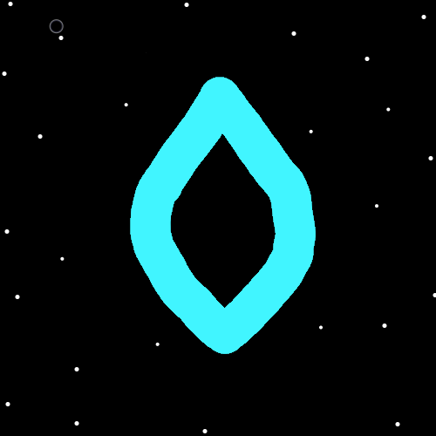
(The 2 Pointed Seed)
Item Group: Energy Wizardry
Principle: All energies sort into the 0 to 99 categories.
Principle: All words sort into the 0 to 99 categories.
Principle: All energies sort into the 0 to 999 categories.
Principle: All words sort into the 0 to 999 categories.
Principle: The pattern goes on forever….all energies sort into the 0 to 9999, and the 0 to 99,999…..the 0 to 999,999…..
Principle: All energies have a name in numbers.
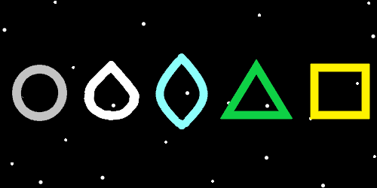
(The Pattern)
Item Group: Colorology
Principle: There are 9 main colors. 10 if you count transparent.
Principle: the 10 main colors are…..transparent, white, blue, green, yellow, grey, purple, orange, red, and black.
Principle: Black is a color. If black was not a color, it could not be a part of the 10 main colors.
Information: The Pattern map is about noticing the pattern…0 points, 1 side. Then is 1 point, 1 side. Then is 2 points, 2 sides…..3 points, 3 sides…4 points, 4 sides.
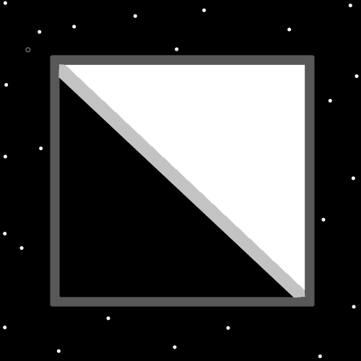
(The Thin Grey Line)
Item Group: Random Wizardry
Principle: In some maps there is an infinitely thin grey line.
Principle: The 0 to 9 people are known as “The Origin Group”. They are also known as “The Zero People”. They have many names.
Principle: The next map (Infinity Is A Thing)…..it seems like the symbol should be red. The number 8 is the number of infinity. 8 has a huge connection to red.
Principle: Sometimes it’s the 4 positive colors….white, blue, green, yellow…the 4 negative colors…..purple, orange, red, black….and the neutral colors, grey and transparent.
Principle: Maps could be drawn where there is the 4 positive colors, 4 negative colors, and the 2 neutral colors grey and transparent.
X2 Information: I thought about trying to draw one. I could not think of one. So figured just create this item.
Principle: Oddly, black is the color for the highest levels of light.
Principle: Oddly, black is the color for the highest levels of positive energy.
Principle: Black is the color for the number +9.
Principle: Red is second place for the highest levels of light. Since its number is +8.
Principle: 1 + 9 = 10….
Energy + End = New Beginning.

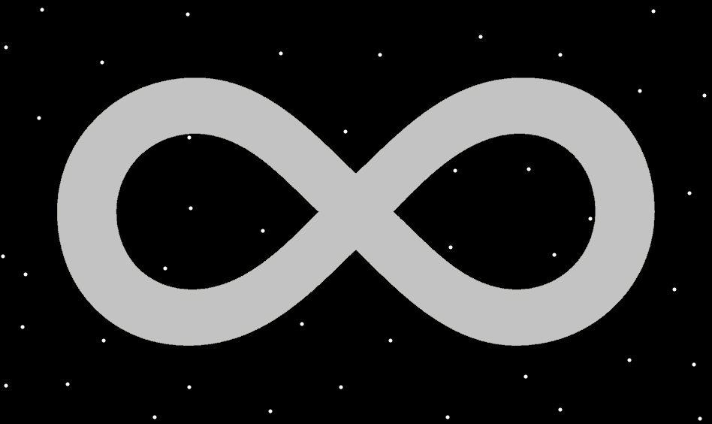
(Infinity Is A Thing)
Item Group: Numerology
Principle: Since it seems like there are an infinite amount of numbers between 1.123 and 2.123…..the theory is that Infinity is an energy that exists.
Principle: Since all energy have a number, the theory is that there is a number for infinity.
Principle: Since the symbol for 1 – 0.999 repeating 9….. is “A”. Perhaps the symbol for infinity is the infinity symbol. The sideways 8.
Principle: Perhaps the sideways 8 infinity symbol should be a thing of math and science.
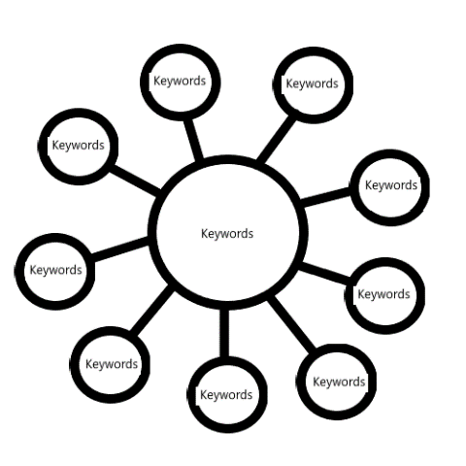
(Sorcery)
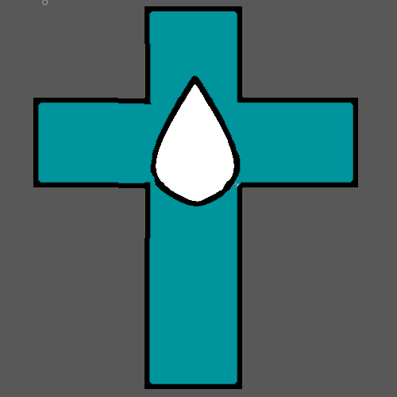
(A Cross And The 1 Pointed Seed)
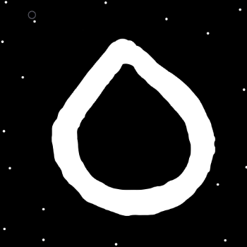
(Seed)
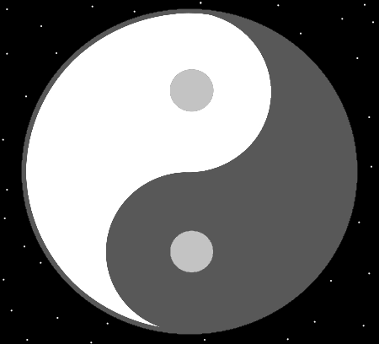
(A Map)

