ObjectName: Article  
ObjectNumber:

LocationName: PAAIL.org

LocationNumber:

Maker: PAAIL.org  
Model:  
  
Name: Advanced Wizardry 14A

Rank:

SerialNumber:

Level:

Score:  
Birth: 4-16-2023

Label: Room

Title: Advanced Wizardry 14A

Details: Advanced Wizardry rooms are always the latest in PAAIL.org Wizardry research. They are called rooms because that is paail.org science.

Principle:

Agenda:

Action:

Information:

(PAAIL Logo)

Item Group: General Wizardry

Principle: If you have read all of PAAIL.org Wizardry you are likely at least a level 4, Expert Wizard. If you also did a bunch of body exercises, breathing exercises, meditation exercises, and Word Write 10x spells, then you are likely a level 5, Master Wizard.

Principle: This map is a fusion of directions and colorology. Each direction has a number, which is numerology.

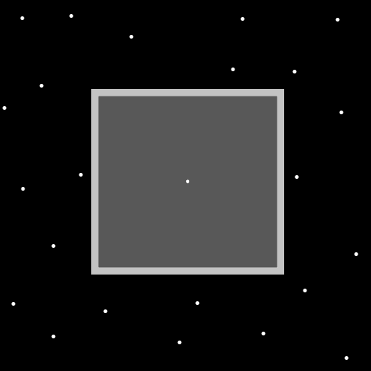

(The Dot)

Item Group: General Wizardry

Principle: The map before this principle, is a map of the symbol dot. The dot is the first symbol, the least complex symbol. It may be the symbol for the word “symbols”, and/or the word “symbol”.

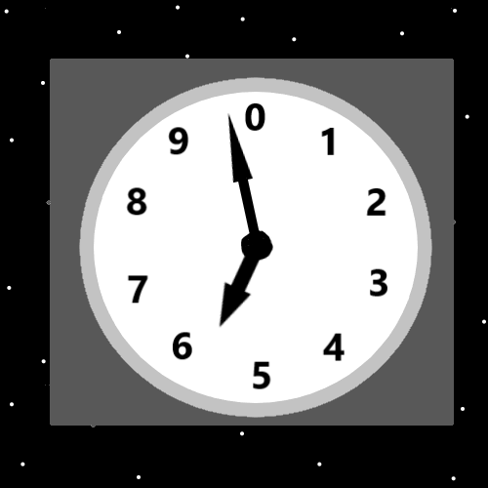

(Cosmic Clock)

Principle: All throughout the multiverse are “cycles”. The multiverse evolves in cycles. Cycles is major vocabulary in Wizardry and other science.

Principle: The pattern is 0 to 9, then another cycle….10 to 19, then another cycle. This pattern is infinite.

Principle: The theory is that height, width, depth and time are loops. 4 particles that have a loop for a surface.

Principle: The theory is that height is 1 dimensional, width is 1 dimensional, depth is 1 dimensional, and time is 1 dimensional.

Principle: The theory is that the 4 spatial dimensions are each 1-dimensional loops.

Principle: The theory is that the 4 main spatial dimensions all bend in…..are concave particles.

Principle: Since there are 4 main spatial dimensions, they likely align with the 4 elements(Also known as the 4 quadrants)….one spatial dimension is the water dimension, AKA(also known as) the “++” dimension. One spatial dimension is the fire dimension, one spatial dimension is the “- -“dimension. One spatial dimension is the gravity dimension. One is the red dimension. One of the 4 spatial dimensions is the binary “11” dimension.

Principle: One of the 4 main spatial dimensions has a unique connection to gravity. One has a unique connection to electromagnetism. One has a unique connection to the strong-nuclear force, one the weak-nuclear force.

Principle: These items are Wizardry in part because they help us see how things mirror other things. And we learn that we find the core 4 elements all throughout the multiverse.

Principle: These items are Wizardry in part because they help us understand the 4 elements.

(Low, Medium, High….. Numerology and Colorology)

Item Group: General Wizardry

Principle: The map before this item, is a great map for showing the colorology and numerology of “Low, Medium, and High”.

Principle: Evolution is a major part of the multiverse. The multiverse evolves.

Principle: All/most/many systems evolve.

Principle: Often evolution happens in cycles.

Principle: Often evolution can be mapped out in colorology or numerology.

Principle: The word “Evolution” is a major vocabulary word in Wizardry, and much other science.

Principle: Maybe the best Wizardry and science vocabulary would be to call, positive, negative, neutral, the 3 elements….and the 4 quadrants the 4 forces. For now…it’s the 3 forces, and 4 elements.

Principle: It seems likely that the 3 forces, create the 4 elements. Or it might be that the 2 forces create the 4 elements.

Principle: It seems likely that the 4 elements create the 8 directions. It may be the 8 directions creates the 10 energies……numbers 0 to 9.

Principle: We all have a chi, we all are a chi.

Principle: We all have a spirit chi. You can also call it a spirit aura.

Principle: Our spirit chi is nested as an object of our chi. Example map:

Persons-Chi:

Spirit-Chi

Mind-Chi

Body-Chi

Principle: We all have many chi’s within us.

Principle: Each chi within us is a side of our chi.

Principle: All people that know how to play chess have a chess chi. Example Map:

Persons-Chi:

Spirit-Chi:

Mind-Chi:

Body-Chi:

Chess-Chi:

Principle: A person has a Chi Level. It’s the sum total of all their chi levels.

Principle: A person has a Chi Score. It’s the sum total of all their scores.

Principle: A person has a spirit level. It’s the sum of all their spirit levels.

Principle: A person has a spirit score. It’s the sum of all their spirit scores.

Principle: The pattern continues with the Mind Chi, and the Body-Chi. Levels, and scores.

Principle: A person that has a chess chi. Has a chess chi spirit, a chess chi mind, and a chess chi body.

Principle: A persons chess chi has levels and scores. Example Map:

Persons-Chi: Level 9, Score 9,

Spirit-Chi: Level 3, Score 3,

Mind-Chi: Level 3, Score 3,

Body-Chi: Level 3, Score 3,

Chess-Chi: Level 9, 61

Chess-Spirit: Level 1, Score 1

Chess-Mind: Level 5, Score 50

Chess-Body: Level 3, Score 10

Principle: It may be that a persons chi level is the average of their Spirit, Mind, and Body Levels.

Principle: All honest actions done by good people have at least a drop of spiritual side to them.

Principle: A persons chess chi, spirit level and spirit score are how much good the person has done through chess.

Principle: A persons chess chi, mind level and score is about the skill level of the person.

Principle: The theory is that a persons chess chi, body level and score are about how much glory the person has had. Winning big competitions and fame. Also spending a lot of time on chess would make a person famous to the multiverse.

Principle: If a person played a ton of chess games in their life they will have higher chess chi body levels and score.

Principle: Getting to level 4 or higher in chess is big chess glory. Expert or higher.

Principle: God has a book of all chess battles.

Principle: Wizards have a Wizardry Chi. Example Map:

Persons-Chi: Level 9, Score 9,

Spirit-Chi: Level 3, Score 3,

Mind-Chi: Level 3, Score 3,

Body-Chi: Level 3, Score 3,

Wizardry-Chi: Level 9, 61

Wizardry Spirit: Level 1, Score 1

Wizardry Mind: Level 5, Score 50

Wizardry Body: Level 3, Score 10

Principle: Sometimes science is not the sum total. Sometimes science is the average of the pieces. These maps may not be 100%.

Item Group: General Wizardry

Principle: There is a high chance of error in the map above. For sure there is plasma, gas, liquid, solid. For sure there is “+ \* / -). For sure there is fire, air, earth, and water. For sure there is colorology. Which one is plasma could be wrong. Which one is liquid could be wrong. Which one is gas could be wrong. Which one is solid could be wrong.

Principle: It is uncertain which symbol goes with plasma ( + - / \* ). One of them does.

Action: It is very worthwhile to go over all the Wizardry Maps of PAAIL.org. It is very worthwhile to understand them. It’s a spell to do so. A powerful spell.

Principle: One famous divination is to look upon something, then ask, “What do I see?”.

Principle: A person could meditate and as a spell part add stare at a map.

Principle: A person could look upon a map, and “What do I see?”. Then after that do “What else do I see?”. And after that do “What more do I see?”. On and on and on.

Item Group: Wizardry Science

Principle: Often it seems the pattern is 2, 4, 8, 16, 32, 64…..The truth is that it starts with a 1. 1, 2, 4, 8, 16, 32, 64….

Principle: The pattern is multiply by 2…..

1 \* 2 = 2

2 \* 2 = 4

4 \* 2 = 8

8 \* 2 = 16

16 \* 2 = 32

32 \* 2 = 64…

Principle: The pattern is 1 becomes 2. 2 becomes 4. 4 becomes 8. 8 becomes 16….

Principle: This is major science in biology, because of the reality of cell division.

Principle: This is major science in computers because of the way computers operate.

Principle: This is major science in other things as well.

Principle: This is major science when it comes to “energy bits”.

Principle: Since you find it is major science with “energy bits”, you find it is major science throughout all the multiverse.

Principle: In a computer science way, you can mirror things and say the multiverse is made up of 1’s and 0’s.

Principle: It might be more accurate to say +1’s and -1’s. I don’t know that much computer science.

Principle: The 3 forces, the 4 elements, the 8 directions, and the 10 energies is Wizardry. In numerology there is also the 100 energies….0 to 99. There is also the 1000 energies….0 to 999.

Principle: There is also the 16 directions. The 32 directions. The 64 directions. The 128 directions. This pattern is infinite. Next is 256. Then 512….on and on.

Principle: The 2 energy bits (A and -A), make the 2 directions. The 2 directions make the 4 directions. The 4 directions make the 8 directions. The 8 directions make the 16 directions. The 16 directions make the 32 directions.

Principle: Some of this science might not be thought of as Wizardry. Though it might be fair to call it “Cosmic Knowledge”….I’m not sure. It is core science, and was divined though Wizardry.

Principle: All throughout the multiverse are the numbers 1, 2, 4, 8, 16, 32, 64, 128, 256, 512, 1024…..

Principle: If you’re a scientist, always be on a lookout for the numbers 1, 2, 4, 8, 16, 32, 64, 128, 256, 512…..they are major numbers of science. The number list is infinite… after 512 its 1024.

Principle: Always be on the lookout for all the numbers that are part of the 1, 2, 4, 8, 16, 32, 64 pattern. There are an infinite amount of them.

Principle: A lot of this knowledge it might be fair to call Numerology….and thus Wizardry.

Principle: It seems likely its fair to call all this Wizardry.

Item Group: More Numbers

Principle: The theory is that A /10 = A \* 10, (in part) is because the theory is that there is no smaller number than A.

Principle: The final zoom level is energy bits.

Principle: The square root of numbers is major science.

Principle: Square roots have a connection to energy bits, and to the pattern of 1, 2, 4, 8, 16, 32, 64, 128……

Principle: Square roots is not the end….there is also cube roots….which means a 3D cube.

Principle: 3D cubes are not the end either. In math there is also a 4th root number. And a 5th root number. And a 6th root number. It goes on for infinity. Next is 7…then 8….then 9….then 10….then…..

Principle: Because square roots have a huge connection to energy bits, square roots is major throughout all the multiverse.

Principle: 2 squared is math. It is written with a 2 and then another little 2 at the up right area. Its called 2 to the power of 2.

Principle: The math process of power may be one of the 8 core operations. Along with addition, subtraction, multiplication, and division.

Principle: There are the 8 core operations. I only know four of them, addition, subtraction, multiplication, and division.

Principle: I suppose its possible that it goes addition, subtraction, multiplication, and division are the 4 processes, and the 8 are another 8 more.

Principle: There are secrets behind this information.

Square root of 4 is 2

Square root of 16 is 4

Square root of 64 is 8

Square root of 256 is 16

Square root of 1024 is 32

Square root of 4096 is 64

Square root of 16384 is 128

Square root of 65536 is 256

Square root of 262144 is 512

Principle: The number 262144 is part of the 1, 2, 4, 8, 16, 32, 64, 128, 256, 512…….pattern.

Principle: All of these numbers are part of the pattern.

Principle: There is the cube pattern.

Cube root of 8 is 2

Cube root of 64 is 4

Cube root of 512 is 8

Cube root of 4096 is 16

Principle: Then onto the next numbers….4th root, and 5th root.

Principle: Because some objects have 5 sides. Some objects are 5D….5 dimensional.

Principle: When you talk about 4th root number, you talk about a 4D object.

4th root of 16 is 2

4th root of 256 is 4

4th root of 4096 is 8

Principle: The pattern seems to be infinite ….you can do the 5th root….10th root 132,123 root. Though I have not looked beyond 5 I think.

Principle: Understanding these things seems very worthwhile in some science.

Principle: It seems likely that energy bits are 1D. Or 0D. Or 2D. My bet 1D.

Principle: It seems likely that energy bits have a surface, and a shape.

Principle: It may be best vocabulary to say all objects are particles and all objects are dimensions.

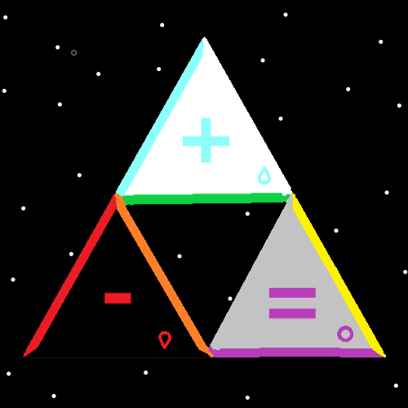

Item Group: Spells With Drawings

Action: Notice the center of the triangle. Notice the center of the 3 triangles. Its empty except for 3 white dots. Notice the up triangle is the positive one. Notice the down right triangle is the neutral one. Notice the down left triangle is the negative one. Notice that “up” is good. Notice that “down right” is neutral. Notice that “down left” is negative. Up = Good. Down right = neutral. Down Left = “Bad”.

Action: Focus on the positive, white triangle at the top. Focus on the center of that triangle. Notice how the up right side is the white side. Notice how the up left side is the blue side. Notice how the down side is the green side. Up Right = Good. Up Left = neutral. Down = Bad.

Action: A Spell that should have a name and more….stare at the Wizardry maps. Really burn them into your brain.

Principle: There are definitely spells with maps.

Item Group: Wizardry Physics

Principle: I saw a rainbow. It seemed like the inner line was purple. The next line was blue. Then it was green, yellow, orange and the outer line was red. There was no white, grey or black.

Principle: Light that we see from rainbows are particles known as photons. The true photon science is that 8 is red. 7 is orange. This is physics and wizardry (numerology) combined.

Principle: Its possible when it comes to photons that its 8 objects (2 to 9)…..and 9 might be red. It might be that 9 is black.

Principle: The maker of this room knows very little physics, and virtually nothing about photons.

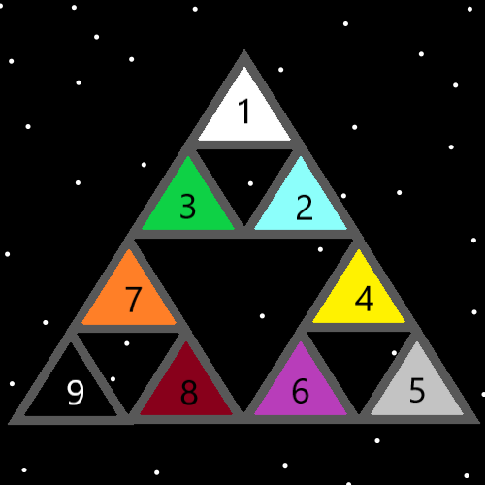

Item Group: Sorcery

Principle: All spells cast, have a chi.

Principle: It might be that all spells have a spirit, a mind, and body.

Principle: The spirt part is simple. What good is done with the spell.

X2 Principle: Almost always there is a drop of spiritual energy in all good people actions/spells.

Principle: The mind and body part of a spell are not as simple.

Principle: I do not really understand the mind and body part of spells.

Principle: A divination spell has a chi.

Principle: A divination spell would have 3 sides. Its spirit side, mind side, and body side.

Principle: There would likely be levels and scores to all these sides.

Principle: Perhaps it is best vocabulary and science to say that all particles have a spirit a mind and a body.

Principle: Perhaps the core of a particle is its mind, and everything outside of that is its body.

Principle: Perhaps the spirit part of a particle is a tiny core of the core. Then it’s the mind lives in the body, and the spirit inside the mind.

Principle: Perhaps there are 3 major sections to particles. The 1st inner most part, the 2nd, middle layer, and the 3rd, outer layer.

Principle: The theory is that a human brain lives in a body, and that the soul is a physical object which resides in the brain.

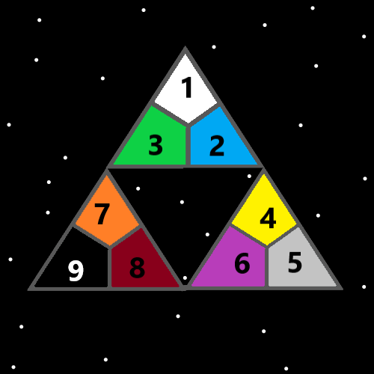

Item Group: Advanced Wizardry

Principle: The 2 energies (A and -A)(positive and negative) make the 4 energies (11, 10, 01, 00). So also the 4 energies make the 8 energies. The 8 energies make the 16 energies. The 16 energies make the 32. The 32 make the 64…… The pattern is infinite.

Principle: All numbers are either positive, negative, or neutral.

Principle: The multiverse is all math and numerology.

Principle: The multiverse is all science. God is a science. Energy is a science. The spiritual side is a science.

Principle: Part of the Human chi is that it has many batteries to it.

Principle: We have a food battery and a sleep battery. Along with many others.

Principle: It is often good to recharge your food and sleep batteries. Food by eating. Sleep by sleeping.

Principle: Part of military science is realizing that not only do troops need food and sleep. They also need rest in the form of entertainment.

Principle: One battery people have is an entertainment battery.

Principle: Often it is good to recharge your entertainment battery.

Principle: The food and sleep battery are more important than many other batteries. Such as the entertainment battery.

Principle: A persons mana battery is never drained much. So it never needs to be recharged.

Principle: No one knows how to tap into their mana battery enough to drain it a lot.

Principle: The most powerful sorcery would be knowing the Adam/Eve language and how to use it.

Principle: There is numerology and colorology to batteries.

Principle: Some actions drain batteries. Some actions recharge batteries. Some do a combination of the 2.

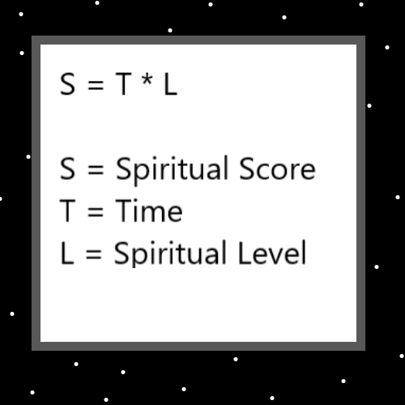

(Divination Action 01: In this map I see that the multiverse is all math.)

Item Group: Advanced Wizardry

Principle: When I look at the map above I see the multiverse is all math.

Principle: Some divination systems work better than others.

Principle: Spells can go on for long amounts of time with lots of different spell parts.

Principle: A 10-minute divination spell has a much bigger chi than a 1-minute divination spell. 10 times bigger.

Principle: A 30-minute divination spell has a bigger chi than a 10-minute divination spell. 3 times bigger.

Principle: Long divination spells are probably powerful spells.

Principle: It may go something like 1 minute is a level 1 spell. 10 minutes is a level 10 spell. 30 minutes is a level 30 spell.

Principle: Its probably that part of your divination outcome will be based on your divination levels. Higher divination levels = greater divination outcome.

Principle: Its probably the more body exercise you do, the better the body exercise helps you. High body exercise levels = positive outcome from body exercise.

Principle: Higher breathing levels = greater outcome from breathing actions.

Principle: Higher meditation levels = greater outcome from meditation actions.

Principle: The most common way to get levels is to do the time and work.

Principle: The theory is…. that at first….. body exercise, breathing exercise, and meditation exercise might not work very well. You have to train them up a little.

Principle: Some principle are stated multiple times throughout the PAAIL.org Wizardry training. There are good reasons for it to be this way.

Principle: Since we are all elementals, we all have a huge chi, and are all a huge disturbance in the force.

Principle: A person sometimes can ESP sense the power in making a fist and holding it.

Principle: A person sometimes can ESP sense the power in bowing.

Principle: A person sometimes can ESP sense the power in breathing actions.

Principle: Sometimes a controlled breathing action is not an exercise, it’s a powerful spell.

Principle: A person sometimes can ESP sense the power in body exercise and meditation exercise.

Principle: ESP is exactly like the other 5 main senses. Like smell, the wind can blow and suddenly you smell something else.

Principle: ESP is exactly like the other 5 main senses. This is a major detail in understanding ESP.

Principle: A person can understand ESP a lot better by going over the 5 main senses.

Principle: Since ultimate sorcery is body gestures such as bow, and make a fist….fluid body movement is priceless.

Principle: Fluid body movement with body action spell parts is priceless.

Principle: Fluid body movement is priceless.

Principle: Fluid movement means flowing movement. The keyword is “flow”.