ObjectName: Article
ObjectNumber:

Maker: PAAIL.org
Model:
Name: Advanced Wizardry 3
Rank:
SerialNumber:

Level:
Score:
Birth: 10-6-2022

Label: Room
Title: Advanced Wizardry 3
Details: Intended for experts and better. This will be research and development mixed in with further education.

Principle:
Agenda:
Action:
Information:

Location: PAAIL.org

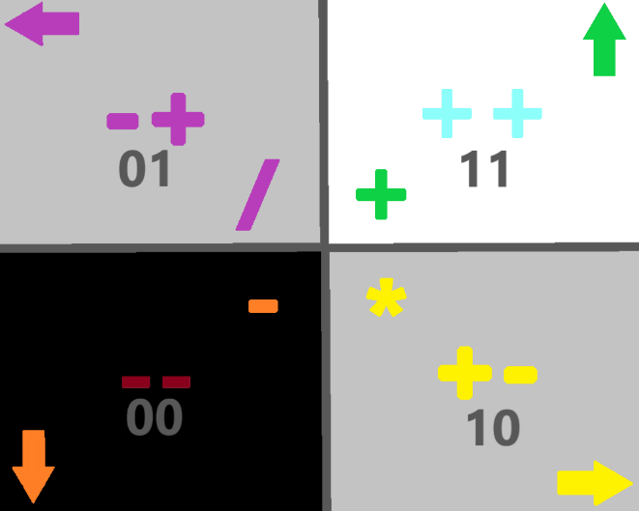

Item Group: Energy
Principle: Since the planet is moving, our star is moving and our galaxy is moving…..we are all moving at like a million miles an hour.
Item Group: Hands/Fingers
Birth: Oct 19, 2022
Principle: Stretching the hands and fingers is an ultimate exercise/action/spell.
X2 Principle: This is priceless when it comes to sorcery.
X2 Principle: Sensing the multiverse and more comes through the hands.
X2 Principle: Hands are like magical wands when it comes to sorcery.
X2 Principle: Higher hand levels from hand exercises results in more mana power, and more power all throughout everything we do.
X2 Principle: People use their hands in virtually everything they do.
Principle: Hand/finger strength exercises/actions/spells are awesome like stretching hands/fingers.
Item Group: Elemental
Birth: Oct 19, 2022
Information: Its hard to know what has been covered in the many pages of PAAIL.org wizardry. Most everything has been covered. There are new things every so often though. My favorite of recent is the lesson of “elementals”….how we are all “elementals”. Origin people describes us well, since we are part of the 0 century. However elementals sounds so much more poetic and mystical, and better, and 100% accurate.
Principle: Knowing everyone is an elemental is sorcery when it comes to understanding other people. Knowing the vocabulary word elementals helps enhance the sense of other people.
Principle: Knowing a person is an elemental can make it easier to sense them.
Principle: Knowing you are an elemental helps you sense yourself….and is therefor sorcery.

Item Group: Information
Birth: Oct 19, 2022
Information: Since I have not finished the sorcery training that PAAIL.org teaches, I am missing a lot of understanding of the sorcery. I take the slow path, not use scrolls, not have personal charm or shrine setup. Not do any of the word write 10x spells. I do use Smith Summons 3 and Smith Summons 4. I take a moment and breathe sometimes. Still… I am training spells still…..it will be different if I ever finish the training of Smith Summons 3 and Smith Summons 4. Right now I am on use the word “Pause”. I do a mix of “Pause Smith Summons 3” and “Pause Smith Summons 4”. I only do a little a day here and there. Because my path is spread out over many months I don’t have to use scrolls or do a lot of time on the word “Pause”. After I finish “Pause” I will move onto the word “Repeat”, then it will be….”Drain”, because in the past I did “Recharge”. After drain comes the word “Power”. After I finish that I will be fully trained….though it seems likely that there will be 1 more to train and that will be “Smith Spells Smith Summons 3”/”Smith Spells Smith Summons 4”. Keyword to think will be Smith Spells.
X2 Information: Doing the spell “Smith Spells Smith Summons 3” grows a huge connection to the Smith Spells Collection. The keywords are “Smith Spells”.
Information: When my training is complete then I will attempt to use the spells. Trying to use them and not be trained is messed up. Its bad training and the spells can go the opposite of what you want. Its not the best path at all.
When I finish my training my understanding will be greatly enhanced. I am a lot lessened by not having finished the training yet. My teachings are lessened by not having finished the training.
I suspect that I will use Smith Spells on my gaming hobby, when I finish the training. I do (rarely) take a moment and do Breathe 1x sometimes while gaming. A couple moments of breathing.
Item Group: Random Thought
Birth: Oct 19, 2022
Principle: It’s a thought that since spell Pause 1x and spell Repeat 1x are part of spell Smith Summons 1, they should come in the spell list before spell Breathe 1x. A thought for future Spell books.

Item Group: Ultimate Spells
Birth: Oct 22, 2022
Principle: It’s a spell to think about the fact you are an elemental. It can trigger an ESP experience.
Principle: It’s a spell to think about the fact some other person is an elemental. It can trigger an ESP experience about that person.
Principle: It’s a spell to think about the fact people are elementals. It can trigger an ESP experience.
Principle: These spells deserve titles and deserve to be added to a Spell Book.
Principle: Its an ultimate spell to pause for a moment, and take a moment to breathe.

Item Group: Sorcery Defined
Birth: Oct 23, 2022
Principle: Knowing numerology and being able to apply it in life is an action/spell. Therefor there is such thing as numerology sorcery, and sometimes numerology is sorcery.
X2 Principle: Understanding the multiverse better, with numerology, is an action. Understanding the multiverse better is an action.
Principle: Knowing colorology and being able to apply it in life is an action/spell. Therefor there is such thing as colorology sorcery, and sometimes colorology is sorcery.
Item Group: Fluid Movement
Birth: Oct 23, 2022
Principle: There is a lot to be said for “fluid” body movement.
Principle: Fluid movement can make a person more graceful.
Principle: My guess is that Bruce Lee had ESP experiences about fluid body movement, and also its connections to water. He sensed the great power in fluid movement.
X2 Principle: If you sense the great power in fluid movement, you too might be experiencing an ESP moment.
Principle: Most likely he made a greater connection between him self and fluid body movement, through water.
X2 Principle: This can be done by meditating on how fluid body movement is like water.
X3 Principle: You could give a name to the spell and call it something like “The Lesson of Water”, or something.....
Item Group: ESP Auras
Birth: Oct 23, 2022
Principle: When it comes to ESP, you often experience more than one aura at a time. You end up experiencing a mix of auras.
Principle: A mix of flavors can turn into what seems like just one flavor.
Principle: A mix of smells can turn into what seems like just one smell.
Principle: ESP is another sense and is much like tasting, smelling, hearing, seeing, and touching.
Principle: An aura is also a property. An aura is also an enchantment.

Item Group: Big Chi
Birth: Oct 23, 2022
Principle: As beginning of time people massive power flows through us all. We all have a huge Chi. The most power flows through people who live at the end of a human age, every 1000 years.
Principle: The Chi is the sum of all properties/enchantments/auras.
Principle: A person can have a small Chi Level, and still have a high Spirit Level.
Principle: A person can have a huge Chi Level, and a small Spirit Level.
Principle: In a way there is the 10 core energies. 0 to 9. Also in a way there is the 100 core energies....0 to 99. And again, in a way, there is the 1000 core energies….0 to 999.
Principle: In a way, there is the 100 trillion core energies. 100 trillion on a cosmic scale is a small number.
Principle: All humans have small numbers for names in numbers and thus we are each one of the core energies.
Principle: The spell of thinking about how you are an elemental. It could come with a meditation that involves thinking about things like you are a core energy.
Principle: It is uncertain if ever was covered guided meditation. You see it in class’s all the time. I call it “guided meditation”.
Principle: think….”I am an elemental. I am a core energy.”….over and over. For entertainment.
Principle: Another good one might be …”I am an elemental. I am a core energy. I am an origin being”….write it down, then read it over and over.
Principle: Only small numbers are core energies. 100 trillion is a small number. Also known as a quantum number.
Principle: We all have massive power flowing through us.
Principle: There are places of power than can cause more power to flow through a person. The place will increase their Chi Level, while it flows through the person. When it stops flowing through the person, the persons Chi Level goes back to where it was.
Principle: Being president of the united states is a place of much more power.
Principle: Sometimes the power wields you. Sometimes you wield the power. Sometimes it’s a mix of the two.
Principle: Chi level is not the important level. The spiritual level is the only important level.
Principle: Chi score is not the important score. Spiritual score is the only important score.
Principle: When energy lines overlap you get places of power.
Principle: Understanding the universe better, is an action. Understanding the universe better through wizardry, is sorcery.
Principle: The information provided by PAAIL.org is at least enough to get to level 6 wizard(purple wizard), and at least enough to get to level 5 sorcerer(grey sorcerer). Such high levels might take years though. Beyond is maybe not possible.
X2 Principle: The information does this when applied right, and with lots of years of study and practice.
X2 Principle: Enchantments can grow on their own. A persons level 5 wizardry enchantment can grow to 6 on its own. It’s the same story with sorcery levels.
X2 Principle: Auras can grow on their own. A persons level 5 wizardry aura can grow to 6 on its own. It’s the same story with sorcery levels.
Information: The author of PAAIL.org Wizardry as of Oct 25th 2022, is a level 5 Wizard, and level 4 Sorcerer. Its newer information to me, knowing that numerology and colorology sometimes is sorcery.

