ObjectName: Article
ObjectNumber:

Maker: PAAIL.org
Model:
Name: Advanced Wizardry 4
Rank:
SerialNumber:

Level:
Score:
Birth: 10-25-2022

Label: Room
Title: Advanced Wizardry 4
Details: Advanced Wizardry rooms are always the latest in PAAIL.org Wizardry research. They are called rooms because that is paail science.

Principle:
Agenda:
Action:
Information:

Location: PAAIL.org

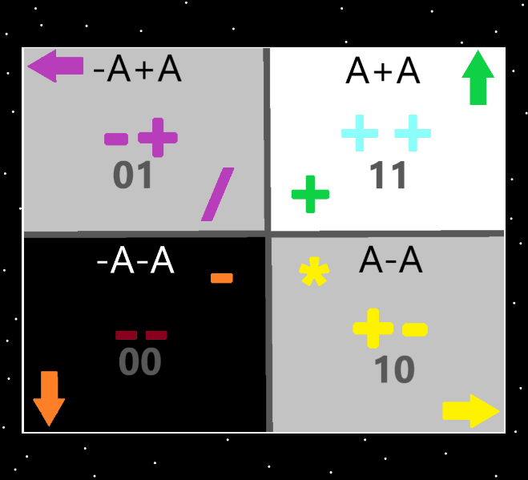
Information: The 4 Quadrants…the top right quadrant is the “addition”, “++”, “11(binary)”, “up” “white/blue/green”, “A+A” quadrant. The Strong nuclear, weak nuclear, electromagnetism, and gravity forces could be added.

Item Group: Charms Research
Principle: Books are one of the bigger chi charms. They tend to have a huge chi, even brand new.
X2 Principle: One reason is they tend to have a good amount of weight. Also known as mass.
X2 Principle: Another is they are big time, rune enchanted. All the text is runes. And all drawings/pictures are runes.
X2 Principle: Another is it may teach a great deal. If its that kind of book.
X2 Principle: There is a huge amount of divination you can do with a book.
X2 Principle: It may have greatly entertained someone…the story.
X2 Principle: They are really good for enchanting things.
X2 Principle: And there are more reasons books have huge chi’s.

Principle: It is a poetic word the word “Tome”. It is Lore to know “Tomes are powerful charms.”
Item Group: Smith Summons Spells
Principle: Once a person completes the training, they can use spell “Body Exercise Smith Summons 3”(and 4) as a part of body exercise.
Principle: Once a person completes the training, they can use spell “Stretch Leg Smith Summons 3”(and 4) as a part of body exercise.
Principle: The last 2 spells might work well… right away… as long as you finished the Smith Summons Spells training.
Principle: Another good spell might be “Meditate Smith Summons 3”(and 4). As a part of meditation exercises.
Principle: As a wizard, it is likely a great spell “Wizard Smith Summons 3”(and 4).
X2 Principle: If you are a level 3 Wizard or higher.
Principle: If you are a level 3 chess player, then you can use “Chess Smith Summons 3”(and 4). If you are level 2 chess player the spell works much less.
Principle: The higher level you are in chess, the more powerful your Chess Smith Summons spell is.
Item Group: Auras Through Music
Principle: The biggest ESP moments tend to happen while listening to music. A person can sense the multiverse through music, with ESP. Which we all have. Some more than others.
Principle: ESP is the sixth sense. That is to say it is a sense. And as a sense it is like the other 5 senses.
Principle: Like some people can hear better than others, or like some people can see better than others….some people have more sixth sense power than others.
Principle: Using music is one of the easiest ways to get an ESP experience. A sixth sense experience.
Principle: ESP is experiencing an aura(or mix of auras). Seeing something is experiencing a visual aura. Hearing something is experiencing an audible aura. This is how all senses work. We experience auras with our senses.

Item Group: Huge Chi Auras and ESP
Principle: Since all the charms are beginning of time charms, they all have a huge chi.
Principle: Since all the charms have a huge chi, you can get a huge chi, aura, ESP experience off of them. You sense how they have a huge chi, and it becomes an ESP experience.
X2 Principle: There are other huge chi things in the multiverse. Not just charms.
Principle: That a charm has a huge chi is a property of that charm. You can then sense that property and sometimes even get an ESP experience doing it. What you end up sensing is “….this charm has a huge chi!”….and instead of just a thought it also comes with a feeling.
Principle: Sensing the “huge chi aura” of charms is one of the easier ways of getting to an ESP experience.
Principle: Some charms have a bigger chi than others. The bigger the chi, the easier it is to get the ESP experience.
Principle: As stated in past articles it is likely the ultimate science is that there are more than six senses.
Principle: Other things that are not charms also have a huge chi that are easier to experience an ESP moment on.

Principle: Sensing shops, markets, stores, restaurants, and other businesses is another easier way to get to an ESP experience. You can end up sensing the combination of all these huge Chi auras, at the same time.
Principle: Shops, markets, stores, restaurants and some other businesses have a huge chi.
Principle: Buildings have a huge chi.
Principle: A thing having a huge chi is a property of that thing. That specific property can be sensed in a normal way, and in an ESP way to.
Item Group: Directions
Principle: There is the 16 directions, the 8 directions, the 4 directions, and there is also the 2 directions. On and off is sometimes a 2 direction situation.
Item Group: Vocabulary
Principle: Vocabulary is a major part of Wizardry research and development. Adding vocabulary, changing vocabulary, and more.
Principle: Since all of these charms are 0 century charms... a vocabulary is that they are “Origin Artifacts”, and also “Origin Charms”.
Principle: All that you see around you are origin artifacts.
Principle: Since we live forever it is vocabulary to say we are all “eternals”.
Principle: More vocabulary would be “elemental artifacts”, and more would be “elemental charms”.
Item Group: Corrections
Principle: During body exercise a person would use “Leg Stretch Smith Summons 1”, and 2…. Maybe not Smith Summons 3, 4, or 5.
Principle: The better choice might be to use “Stretch Leg Smith Summons”, instead of “Leg Stretch Smith Summons”.
Principle: Thinking “stretch leg” over and over might be better than “Stretch Leg Smith Summons 1”. When doing a stretch leg body exercise.
Item Group: Mysticism
Principle: There is an endless amount of mysticism on planet earth.
Principle: There is Christian mysticism, Buddhist mysticism, Hindu mysticism, Hebrew mysticism, Muslim mysticism, and more.
Principle: One theory that is possible is that the Buddha and the Messiah are the same person. That the Buddhist religion predates the actual existence of the Buddha. That it was created by prophets, prophesying about the Buddha before he showed up.
Principle: Part of native American mysticism is spirit animals.
Principle: Part of oriental mysticism is something about a demon we each have that we have to deal with.
X2 Principle: This is partly numerology because we all have a negative number. Example…..his holiness Michaels negative number is “-2”.
Principle: When you are a level 4 wizard you can read into various mysticism and understand it is a more paranormal way. This counts as sorcery.
Principle: Native American mysticism about spirit animals is true. We all have one animal that we are(most of all). And there is more native American mysticism a person can learn as well.
Principle: When you are a level 4 wizard you can “read into things” very easy.
Principle: When you are a level 4 wizard you can see the secrets behind famous mysticism.
Principle: Spirit animals is famous mysticism.
Information: The author here knows very little mysticism. And what does know is mostly Christian mysticism.
Principle: I once saw a quote from the Buddha I think….the secret seemed to be that the quote was all about “meditation exercise”, what to do when doing meditation exercise.
Principle: It might be a secret of buddha quotes, that they are partly about meditation exercise. And they have a huge connection to meditation.
Principle: Its possible Buddhist mysticism has a huge/unique connection to meditation.
Principle: It’s a divination applied to buddha quotes and you end up with messages about meditation. Think in your head “the message is about meditation.”. It’s a spell a person can do.
Information: The author knows very little mysticism may be the correct science.
Principle: In some oriental mysticism dragons can be good things.
Principle: Its fair to say there are an infinite amount of divination spells.
Principle: In the Bible where is speaks of “666”, it says something about it being a mans number. It may be elder angel 666 that is being spoken of. In one meaning of the line.
Principle: When it comes to Bible lines. They all have tons of different meaning to them.
Information: I would give myself a level 2 on my mysticism. Much more than all this exists on the subject.
Principle: It would seem fair to say people believe in different mysticism.
Item Group: The 4 Elements
Principle: Since “the 4 energies” is a thing….it is likely that the mysticism about Earth, Air, Fire, and Water is true. Likely the multiverse is made of Earth, Air, Water and Fire.
Principle: In physics science there is what’s known as the 4 forces. Strong-nuclear, weak-nuclear, electromagnetism, and gravity. Gravity is the Fire force, the Water force, the Air force, or the Earth force.
Principle: It does seem that the 4 elements may partly have something to do with heat. The earth element would be the solid heat level force. The water element would be the liquid heal level force. The air element would be the gas heat level force, and the fire element would maybe be the plasma heat level force.
Item Group: The 3 Family Pets
Principle: There are the 3 sides of the multiverse. The positive, the negative, and the neutral(The light side, the twilight side, and the dark side). None of these sides has a consciousness. Like other things that have no soul, they have no soul.
Principle: The 3 sides of the multiverse are known as the 3 family pets.
Principle: The 3 pets behave very much like they were alive and had souls.
Principle: Most of the time divination is a communion with one of the 3 pets.
Principle: Most of the time light side people get a message from the twilight or light side.
X2 Principle: Reasons include…..the main reason you are a positive person…. the charms always take work for people to make…. Most charms have a big positive chi.
Principle: Twilight side is as good as light side. When it comes to divination.
X2 Principle: Reasons include… because the Twilight side of the force is older and more powerful.
X2 Principle: The twilight side is 0.0 to 0.999. A series of mostly positive numbers.
X2 Principle: There are many reasons.
Principle: The theory goes that the “holy ghost” of the Christian mysticism is the same thing as the light side family pet. One name of the light side family pet is the holy ghost.
Principle: When it comes to how much like living being they are…..you can even speak to them. They speak back. This is what divination does
Principle: Speak with the light side or twilight side is the same. Neither is better.
Principle: Since they are soulless pets, they should have to serve us. And that’s what they sometimes do. You can say they desire to serve us.
Principle: Most divination is you commune with the 3 sides of the multiverse.

