ObjectName: Article
ObjectNumber:

Maker: PAAIL.org
Model:
Name: Advanced Wizardry 6
Rank:
SerialNumber:

Level:
Score:
Birth: 12-1-2022

Label: Room
Title: Advanced Wizardry 6
Details: Advanced Wizardry rooms are always the latest in PAAIL.org Wizardry research. They are called rooms because that is paail.org science.

Principle:
Agenda:
Action:
Information:

Location: PAAIL.org

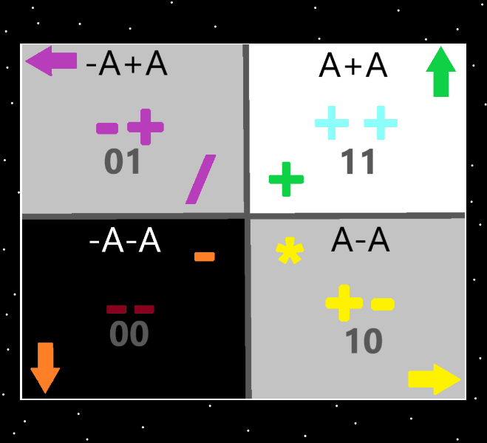
Information: The 4 Quadrants…the top right quadrant is the “addition”, “++”, “11(binary)”, “up” “white/blue/green”, “A+A”, quadrant. The Strong nuclear, weak nuclear, electromagnetism, and gravity forces could be added. Earth, Water, Air and Fire could be added. And others could be added probably.

Item Group: Wizard Physics
Principle: I have heard talk of unifying the four forces. I doubt they unify into one. Instead they unify into 2. Perhaps those 2 then unify into one.
Principle: Maybe the famous formula should be B = 1 – 0.999 repeating 9’s. Since they are called “energy bits”.
Principle: One theory is that when space bends more than 90 degree’s it starts twisting instead of bending.
Principle: There has got to be a use for particle accelerators. Maybe we just need to build one next to a Nuclear Power plant.
Principle: Since cycles repeat and repeat….I would think the first inter stellar ships might start as ships with “oars”, with “sails”, or a combination of the two.
Item Group: More Reading Into Things
Principle: A Wizard can read into things. Books for one.
Principle: Deepak Chopra books that use the word Wizard likely can be read into.
Principle: There are lots of books that use the term Wizard. One sorcery is being able to read into them.
Principle: Deepak Chopra books are older and thus likely a bigger chi than some.
Principle: Its likely all Deepak Chopra books you can read into things with.
Item Group: The Mouse Of God
Principle: The spirit animal of his holiness big brother Michael is the mouse.
Principle: His holiness big brother Michael is the mouse of God.
Principle: You speak Wizard when you are a level 3 Wizard.
Item Group: Forces
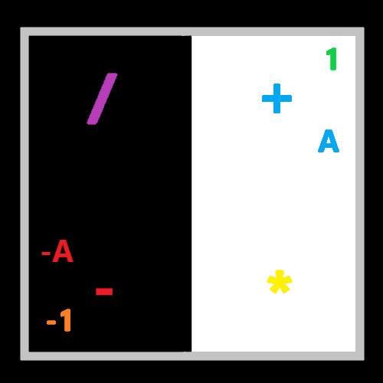
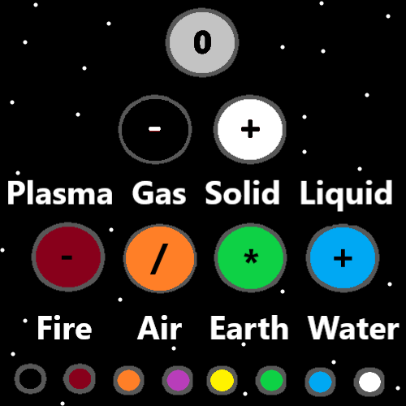
Principle: Just as there are the four forces…there is also the two forces. The four forces come from the two forces. They are made of the two forces.
Principle: The two forces are known as the positive force, and the negative force.
Principle: The two forces come from the one force. The one force is known as the neutral force.
Principle: Before there was the 2 forces, there was the one force.
Principle: Before there was positive and negative energy there was neutral energy. Back at the zero moment of time.
Item Group: Science
Principle: The PAAIL.org teaching of Wizardry is badly organized, badly written and has tons of other bad to it.
X2 Principle: Main cause is that the author is not a teacher and is not qualified to organize a whole area of science.
X2 Principle: Another cause is that the author is a terrible writer.
X2 Principle: Another cause is that its been research and development the year of writing it…(2021 to 2022)
Principle: Experts could use PAAIL.org Wizardry to do a 10 times better system of Wizardry.
Principle: The current state of Wizardry science would be 10 times better if the right experts used PAAIL.org Wizardry to engineer a better state.
Principle: If I were to hire experts for the job, I would think education experts, and general science experts would be the people best qualified.
Item Group: Meditation Spells
Principle: One type of spells are “Meditation Spells”.
Principle: Smith Summons spells are meditation spells.
Item Group: Spell Types
Principle: It would seem there are “spell types”.
Principle: Another type of spell is the “warm up” spell. People do warmups sometimes as a part of body exercise.
Item Group: Carpet Divination
Principle: It is one theory is that Jesus sometimes did divination while drawing in the dirt.
Principle: Some carpets you can do divination with, they have patterns in them, that take on all kinds of shapes. Use your foot and brush over, to get new ones.
Principle: Remember you cant trust the message isn’t from the dark side. Don’t use divination to choose actions…divination is for inspiration.
Principle: Only prophets get divination messages from God. And only sometimes.
Principle: Only prophets get dreams from God. And only sometimes.
Item Group: The Dreamer
Principle: When it’s a light side person a nightmare is always from the dark side. Its best to not write it down, and not think about it.
Item Group: 2 For The Show
Principle: There’s a song that goes “its one for the money. Two for the show.”…this means big brother Michael is all about the show.
Principle: One is for the money because Jesus is all about the souls….they are the money.
Principle: Brother Michael is all about the show, because that’s how you make the money(the souls).
Principle: His holiness big brother Michael is Disney.
Item Group: 19 Energies
Principle: Another system is the 19 numbers. -9 to +9. A total of 19 numbers.
-9 -8 -7 -6 -5 -4 -3 -2 -1 0 1 2 3 4 5 6 7 8 9
Item Group: ESP
Principle: ESP is just another sense. The science of it mirrors the other senses.
Principle: I think it can go a person can get so used to a smell that they stop being able to smell it.
Principle: Some people can smell better than others. Some people can hear better than others.
Principle: Often being in a business that has thousands of dollars in nice stuff is a nice ESP experience.
X2 Principle: There’s the expensive building, and stuff as the aura.
Principle: Its likely that ESP is strong in most people. They just don’t realize it.
Principle: People experience ESP all the time. You can get an ESP experience on anything.
Principle: There’s the “this is a nice object” ESP experience all the time. Most objects are nice objects.
Principle: Some huge ESP experiences can happen with music.
Item Group: Day And Night
Principle: One time measurement is the Adam/Eve time. Year 0 is when Adam was born.
Principle: Adam/Eve time is also known as human time.
Principle: In Adam/Eve time its around 5900. Adam was born around 5900 years ago.
Principle: Every thousand years is known as an “age”. The 1st age is also known as the “Zero” age.
Principle: We are currently on the 6th age of man. Also known as the 5 age.
Principle: Every 1000 years….at the end of an age, the “end times” happens.
Principle: The first half of each age is day, and the second half is night.
Principle: At the end times of the zero age (1st age), an Archangel (and God combined) flooded the humans.
Principle: Reincarnation is a thing throughout the multiverse.
Principle: Every thousand years the first nation, Atlantis reincarnates.
Principle: First it was Atlantis, then it was Egypt, then Babylon, then Rome, and then Rome again. Now it’s the USA.
Principle: It seems likely that World War II was the apocalypse that happens every 1000 years.
Principle: It seems likely that World War II was the Armageddon that happens every 1000 years.
Information: Did you know? The USA is the only nation to ever have nuked another nation.
Principle: There’s no going back now. God will no longer be destroying like he did with Atlantis and Egypt. Instead he is jumping us forward right now.
Principle: The end of this age is God jumping us forward in culture, science, and more. Notice the technology increase of the last 100 years.
Principle: I suppose I never said there is eternal life….there is. We will live forever!
Principle: Eventually we get bigger than Gods. Eventually there is Grand Supreme God Level 10, and what not.
Principle: Since there is always a bigger number, there is always a higher spiritual level.
Principle: Spiritual science is not the same science as Wizardry.
Principle: All science has about the same amount of spiritual side.
Principle: When you measure in days even great people have unsuccessful days. When you measure in years, even great people have unsuccessful years. When you measure in decades a good person always has a successful decade. Spiritually anyway…….
Principle: Every 1000 years we all have a reincarnation. A person who’s story is very similar to our own.
Principle: People who live during an end times live intense lives. People who live at the end of an age.
Principle: We all have secret names. Pei Mei from the movie “Kill Bill”, was known as “the white lotus”. I like that one.
Principle: On accension day the universe does not end. However there does roll the credits of the first century. We all end up in the credits.
Principle: There is an ESP experience watching the credits of a movie sometimes. The credits music can increase the ESP experience even more.
Principle: All good people 30-year old’s have about the same spiritual score. All the good people 80-year old’s have about the same spiritual score.
Principle: Knowing we all have about the same spiritual score can make a person less ambitious.
Principle: Success is 5 minutes here, and 5 minutes there over a decade.
Principle: The main thing is that its honest work.
Principle: There are great systems for all things. There is also the systems God uses, which are 100% the only system. Like for measuring heat, distance, mass, time, and more.
Principle: Once you hit level 3 or level 4 Wizard, you are now a paranormal creature. Your song is now the song from the movie “Men In Black”.
Principle: I don’t know for sure, and I wouldn’t want to bet on it, but there may be leprechauns, werewolves, and vampires, and men in black who deal with them.
Principle: A person who has done the numerology enough can quickly see a number and come up with words for the number.
Information: Example
2363
Growth, Order, Change, Law.
Information: Example
You see a number like 911 and can quickly say….. darkness won won.
Or a number like 187……..substance awareness completion.
Principle: There a chance position is a category 2 word. Like when people use radio’s….”give me your 20”.
Principle: “10 4” sounds like someone saying “victory solid”.
Principle: “-9” equals the famous words “that’s a no no.”. Negative nine(-9) which is the highest level of the dark side.
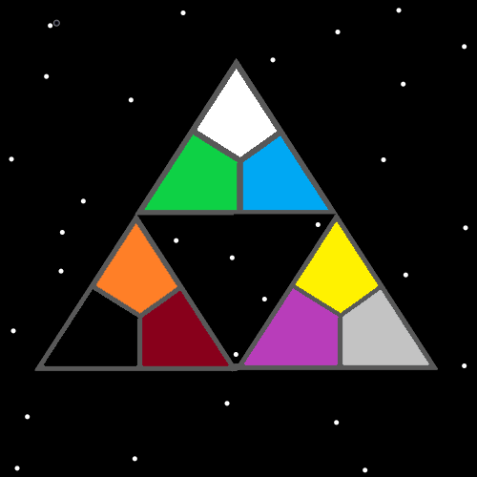

Item Group: Physics Wizardry Fusion
Principle: God used a particle accelerator to make Heaven and Jesus. The gravity field of his body the particle accelerator.
Principle: There’s a good chance there are lots of physics particles flying around that aren’t known about.
Principle: There may be physics particles with a 100 trillion times less mass than an electron.
Principle: Its likely that physicists don’t know all the particles that come off a nuclear power plant.
Item Group: The Mind
Principle: Some major vocabulary when it comes to the mind is….”personality”, “mentality”, “psychological state”, “virtues”, and “flaws”.
Item Group: Charms Go Over
Principle: Shrines and Temples tend to have a bigger chi than other charms.
Principle: The biggest chi charms might be continents and oceans. Those are the biggest parts of Earth maybe.
Principle: Down the list we get to buildings, then vehicles, ships and so forth.
Principle: The more mass a charm has, the easier it is to contain energy within it.
Item Group: Music Divination
Principle: Doing lots of music divination is a transformational art.
Principle: Doing lots of music can be a huge ESP high. Especially while doing music divination.
Principle: Understanding that any category “1” word can be changed into “Jesus” and you get lyrics in the song about Jesus. There are a lot of words that are “category 1 words”.
X2 Information: Examples of words…..energy, beginning, light, won, victory, end, white, start….and a million other words…..
Principle: It really might be that there are so many category 1 words, that virtually all songs with lyrics can be changed into religious songs with the word Jesus in the song.
Principle: This wizard, when I hear the song “one thing leads to another”…..I only ever hear how Jesus leads Michael….and Michael is another. “Jesus thing. Jesus, Jesus thing. Leads Michael another….another.” When I hear those lyrics I only hear how Jesus leads to another….Michael.
X2 Principle: When we do divination on the title of the song, the title changes from “One thing leads to another”….too “Jesus thing leads Michael another.”.
Item Group: Making It Also A Meditation
Principle: Doing push ups and adding a think in your mind “1 Mediation pushup”, “2 meditation pushup”, “3 meditation pushup”, “4 meditation pushup……..this changes a pushup into a meditation. There are endless other words people could choose that would turn a push up into a meditation too.
Principle: It looks like a lot of actions can be changed and turned into a meditation.
Item Group: Science Specialitys
Principle: In science people have specialties. Things they are specialized in.
Principle: The wizard of PAAIL.org has the Cosmic Knowledge specialty. Which means if you learned your wizardry from PAAIL.org, then your specialty is Cosmic Knowledge.

