ObjectName: Article
ObjectNumber:

Maker: PAAIL.org
Model:
Name: Advanced Wizardry 8
Rank:
SerialNumber:

Level:
Score:
Birth: 1-7-2023

Label: Room
Title: Advanced Wizardry 8
Details: Advanced Wizardry rooms are always the latest in PAAIL.org Wizardry research. They are called rooms because that is paail.org science.

Principle:
Agenda:
Action:
Information:

Location: PAAIL.org
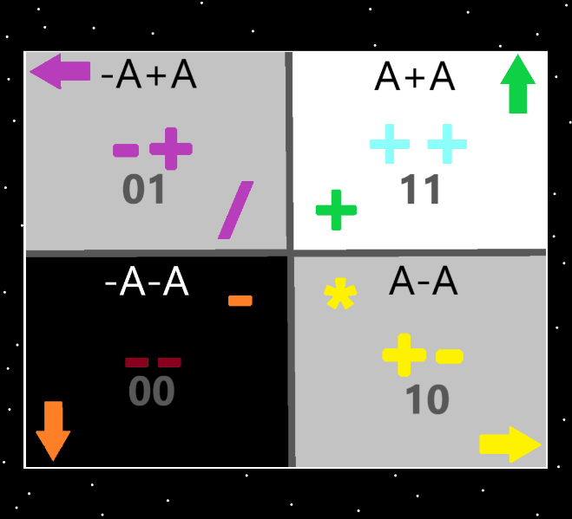
Information: The 4 Quadrants…the top right quadrant is the “addition”, “++”, “11(binary)”, “up” “white/blue/green”, “A+A”, quadrant. The Strong nuclear, weak nuclear, electromagnetism, and gravity forces could be added. Earth, Water, Air and Fire could be added. And others could be added.
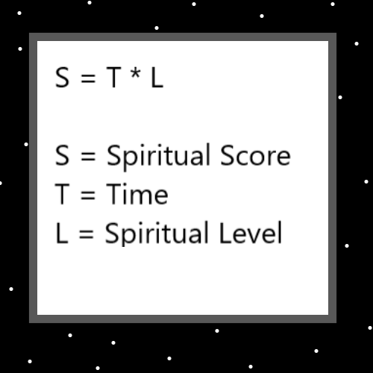
Item Group: Spiritual Score
Principle: (Spiritual Score) = (Time)*(Spiritual Level)
X2 Principle: This formula mostly only works on the zoomed out, 10 year picture.
Principle: Major understanding is knowing zoomed in, and zoomed out. The big picture and the small picture.
Principle: In a zoomed out view we turn into Gods. In a zoomed out way, we are Gods.
Principle: There is the Spiritual Level God. That we ascend unto.
Principle: It seems like its been said already, maybe not. Humans must consume the “life force” of other organic lifeforms….plant, bug, animal, and what not.
Principle: Humans are partly powered by the life force of other organic lifeforms.
Principle: Life Force is a very real thing. It is made by the presence of lifeforms.

Item Group: The 4 Elements
Principle: In a vocabulary there are the 4 elements....perhaps not a very good vocabulary.
Principle: The 4 elements are, earth, water, air, fire.
Principle: The earth element is the solid element. The water element is the liquid element. The air element is the gas element. The fire element is the plasma element.
Principle: One of these elements is the addition element. One is the subtraction element. One is the multiplication element. One is the division element. Which one is which is unknown. Information provided by paail.org may be wrong about which one is which.
Principle: Which of the 4 elements is the addition element is not certain. Its one of them though.

Principle: Some paail.org maps may be slightly off.
Item Group: Particle Physics
Principle: All sorcery and other actions have a particle physics to them. There is no beyond physics. There is a physics to all things.
Principle: All things have a particle physics to them. All things have a particle physics side.
Item Group: Grow and Shrink
Principle: As a part of human reality there is “shrink” and “grow”.
Principle: A person can grow to think more of themselves. A person can also shrink to think less of themselves.
Principle: People grow and shrink in many different ways.
Principle: There is definitely divination techniques that could be researched and developed.
Principle: Doing divination grows divination levels.
Principle: Doing tarot card readings grows tarot card levels over time.
Principle: Doing astrology grows astrology levels.
Principle: Growing understanding of “spirit animals” is gaining levels on the matter.
Principle: Dream interpretation levels is a thing.
Principle: Psychic readings funny enough is a thing people all the time gain levels in. Even though they think its nonsense. It turns out that its not nonsense, its just hard to understand.
Principle: Psychic readings are supposed to be good inspiration, not which actions you should choose.
Principle: The builder of this room has very little psychic reading levels and does not understand it well at all.
Principle: The builder of this room has done a bunch of divination over the years.
Principle: Something that sounds nice is tarot cards that are the same size and model as poker cards. And around 52 of them.
Item Group: Probabilities
Principle: An ultimate scientist method is to realize that we have to give our educated guess in life on things. That we have a probably about everything. Like the fact I say its 1 in a million chance the election was rigged. That’s something like 99.9999% sure the election wasn’t rigged.
Principle: To be 90% certain on this, and 50% certain on that….is the ultimate scientist strategy.
Principle: Often its 99% certain.
Item Group: Hemp
Principle: One of the greater tragedies of US law was the banning of cannabis.
Principle: The theory goes that for many reasons hemp should have always been legal.
Principle: The theory goes that cannabis may have great medicinal value to phycologists, and other medical professionals. That many people could benefit from being prescribed it. Even though it gets you high.
Principle: The differences between alcohol and hemp are huge.
Principle: You cannot overdose on cannabis. You can die if you drink to much.
Principle: If your used to hemp, then it doesn’t impair you as much as alcohol.
Principle: Like alcohol can be good when used right. Cannabis can be good when used right.
Principle: No hemp hangovers either.
Principle: I believe that cannabis can be super helpful to many people. Not just for people prescribed it.
Principle: To a people who don’t understand hemp, it looks like a person smoking opium. The truth it doesn’t get you that high. Less intoxicated than alcohol is what it does.

Item Group: Computer Science
Principle: Computer programming and computer science should mirror physical reality. Partly by using PAAIL science, by using location based organization.
Principle: The computer universe should be thought of as a virtual universe, that mirrors the physical universe.
Principle: Physical location vocabulary should be used in computer science. Such as is found in PAAIL.
Principle: Normal spoken language should also be used in computer science, such as the word “sentence”.
Principle: Some where in computer science there should be the use of the vocabulary word “sentence”. Such as all “statements”, could also be known as “sentence’s”.
Principle: A method/function/subroutine could maybe be also known as a paragraph.
Item Group: Aquired Tastes
Principle: It seems certain that part of psychology, and science is that people have “acquired tastes”.
Principle: If you have ever had black coffee (no cream, no sugar) you might remember its rather bitter. It seems like black coffee is an acquired taste.
Principle: Many things are acquired tastes.
Item Group: Debating
Principle: The ultimate science of debating I think would be derived from a combination of psychology and the law, as in lawyers.
Item Group: Biology
Principle: The human body is made up of what are known as cells. Each cell is another person. Eventually they evolve into Gods.
Principle: When a person experiences body pain, it is likely that the cells are experiencing pain and/or discomfort.
Principle: Local anesthetics (a drug that numbs an area of the human body), maybe knocks out human cells into unconsciousness, or gets them very intoxicated.
Principle: Likely cancer is the equivalent of a human virus. Only cancer is a virus amongst human cells.
Principle: Pain killers might work in that they make cells very intoxicated, resulting in helping the cells deal with the pain.
Principle: Pain killers (Toxins) are big medicine and super dangerous. They kill many many people, every year.
Principle: Its possible the word wisdom is a number 6 word. Its what sages are renowned for.
Principle: The word magi sounds awesome, maybe it should find a place in Wizardry.
Principle: One big grow that a person can experience is how the monumental music matches their lives.
Principle: Real Wizardry is a lot like the music from the movie Harry Potter.
Item Group: Lifeforms
Principle: Every human cell in the body is alive. They all have souls, and eventually will evolve into Gods.
Principle: It might be that DNA strands are alive.
Principle: It might be that things smaller than human cells are alive.
Principle: It might be that each chunk of H20 is another lifeform.
Principle: It might be that the neutron and proton, of a H20 chunk are 2 lifeforms.
Principle: It might be that there are lifeforms smaller than an electron.
Principle: It might be that there are tons of different particles that have 100 trillion times less mass than electrons.
Principle: The pattern may be lifeforms inside lifeforms, inside lifeforms, inside lifeforms.
Principle: It might be that what ever protons are made of are also lifeforms.
Item Group: Movie Divination
Principle: Some ultimate movie divination is seeing the parables/metaphors/analogies of the movie.
Principle: Some movies its all about the parables/metaphors/analogies.
Principle: There is also divination with not movies, like books and more.
Item Group: Science Numerology
Principle: All science has levels. Computer science as an example started at 1.0. Then it grew to 2.0, 3.0, 4.0 and now we are at something like level 52.0.
Principle: There were people who were computer science experts at level 4.0. Now the computer science experts are using level 52.0.
Principle: Wizardry science can also be researched and developed into higher levels of Wizardry.
Principle: Tome Of The Yellow Wizard was sort of a Wizardry 1.0. Add Wizardry Practice 0A, and Wizardry Practice 0B, and you end up with a Wizardry 2.0.
Principle: Add everything else and you end up with a Wizardry 3.0. Even though I am a Master Wizard, the science is only at level 3. This is partly numerology.
Principle: As a Master Wizard I can develop Wizardry 4.0. However experts in science and education could easily do a Wizardry 7.0. Something I cannot do.
Principle: It is a nice blend into numerology to have level 4.0 this and level 8.2 that. Have these levels all throughout science. It is a good system.
Principle: The right experts might be able to make a book titled “Master Wizard In 200 Hours!!”
Principle: If you haven’t noticed yet, I claim to know all the major secrets of the universe. I really believe I have no major questions left and that all the writing covers all the major secrets.
Principle: If we are at Wizardry 3.0, and I developed Wizardry 4.0, I think it would start, with the lessons regarding the importance of body exercise, breathing exercise, and meditation exercises. Then it would move onto the first Actions….1, do some alchemy, make a shrine. Then its enchanting your shrine. Then its enchant your personal charm (probably your phone). Then onto train sorcery with the Smith Spells. Then a blend of Sorcery/meditation/Smith Spells and reading more. The Smith Spells are mediation.
Principle: God being only 99 cosmic years old is extremely young. For many good reasons he makes himself out to be “the all powerful Oz!”. He’s actually the man behind the curtain.
X2 Principle: This is a reference to the movie “The Wizard Of Oz”.
Principle: If God were 800 cosmic years old he would be “the all powerful Oz!”.
Principle: Being that this is Advanced Wizardry 8, it probably has a huge connection to the number 8.

