ObjectName: Article
ObjectNumber:

Maker: PAAIL.org
Model:
Name: Advanced Wizardry 9
Rank:
SerialNumber:

Level:
Score:
Birth: 1-29-2023

Label: Room
Title: Advanced Wizardry 9
Details: Advanced Wizardry rooms are always the latest in PAAIL.org Wizardry research. They are called rooms because that is paail.org science.

Principle:
Agenda:
Action:
Information:

Location: PAAIL.org
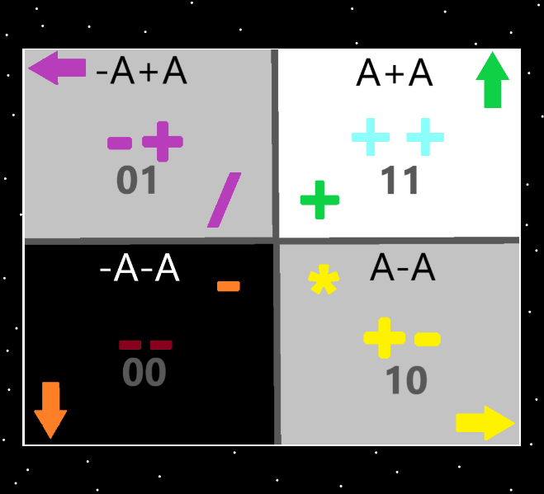
Information: The 4 Quadrants…the top right quadrant is the “addition”, “++”, “11(binary)”, “up” “white/blue/green”, “A+A”, quadrant. The Strong nuclear, weak nuclear, electromagnetism, and gravity forces could be added. Earth, Water, Air and Fire could be added. And others could be added.

Item Group: Numerology
Principle: Because this room is named Advanced Wizardry 9. It will have a connection to the number 9. That is what happens most of the time.

Item Group: Sorcery
Principle: People already know tons of spells that work unbelievably well. Part of understanding sorcery is understanding why they work so well.
Principle: A celebration after you score a touchdown is a spell. It can boost morale, motivation, and energy. It can do this for more than just the person who scores the touchdown.
Principle: A celebration after a touchdown is also like all Actions, it drains the mana battery when you do it. A good thing.
Principle: A person goes up levels on their celebration spell as time goes on. This results in it having a greater effect.
Principle: The theory is that the shrine, personal charm, and smith spells training is a 5% boost on the short term (1 to 2 months). 10% on the medium term (1 year to 2 years). And a 15% to 20% on the long term (4 years).
X2 Principle: Boost to a persons Chi.
X2 Principle: This boost is after you finish training the smith spells. And from also using a personal charm and shrine.
Principle: There probably have been combat wizards over history. They look like “Pei Mei” from the movie “Kill Bill”. Or “Chun” from the movie “Remo Williams”.
Principle: I imagine that the movie “Dune” is a what would have happened (in the distant future) if resurrection day came much later than it is going to.
Principle: A lot in reality seems like coincidences when its not.
Principle: I like to call the Dune weapons that use sound “Force Pistols”, like the Force, from Star Wars. In the movie they also have 3 man teams that fire Force Cannons which can blow up ships.
Principle: I keep thinking that if you ran the Bible through a super computer (looking for hidden messages) it would look like a person intentionally added a bunch of hidden messages in it (even though no one did). This might be the story with all books, not just the Bible.
Item Group: Divination Sorcery
Principle: Divination can be great inspiration, it is also often riddles.
Item Group: The Barrier
Principle: There is what is known as the “barrier”.
Principle: The barrier protects all that is, in this universe, from the energy that emits from Gods body.
Principle: The energy emitting from Gods body would turn a black hole into a puff of smoke.
Principle: The barrier is what surrounds this universe.
Principle: Planet earth has a barrier that protects us from harmful energy emitted by our star.
Principle: Principles regarding Earth and our star are similar to principles of this universe and Gods body.
X2 Principle: As usual things mirror other things.

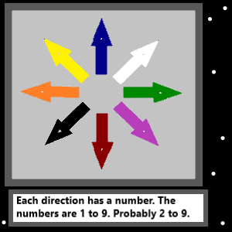
Item Group: The 8 Directions
Principle: The 8 directions each have a color.
Principle: The 8 directions each have a number.
Principle: The numbers are 1 to 8, or 2 to 9.
Principle: If its 1 to 8, then white is probably 1, and 8 is black.
Principle: If its 2 to 9, then white is probably 2, and black is 9.
Principle: I would bet its 2 to 9. The 8 directions.
Principle: The major detail is not that each direction has a color.
Principle: The major detail is that each direction has a number.
Principle: Such knowledge must have use in things like physics and math.
Principle: On a 2D grid you have the 4 quadrants. On a 3D grid you have the 8 quadrants.
Principle: 4D is probably 16 quadrants.
Principle: 5D is probably 32 quadrants.
Principle: 6D is probably 64 quadrants.
Principle: 7D is probably 128 quadrants.
Principle: The list goes on forever….8D is probably 256 quadrants.
Principle: All particles probably have a number of quadrants. All particles probably have a bit number. At least one particle out there is a 256 bit particle.
Principle: The more complex the particle is… the higher its bit number is.
Principle: Since wizardry is to say that all things are a particle… wizardry is to say that all things have a bit number.
Item Group: Stories
Principle: The names of people and places have been changed… however the story remains the same.
Principle: Meditation is ultimate sorcery.
Principle: All meditation is sorcery.
Principle: I think its been mentioned before. Having trained using PAAIL.org text, your wizardry specialty is “Cosmic Knowledge”. Like the author of PAAIL.org.
Principle: A person can do 30 second, even 10 second meditation sessions. Meditation can be used all the time.
Principle: “Take a moment and breathe.” Could be called a meditation.
Principle: The secret of sorcery is that the powerful sorcery is meditation.
Item Group: Wielding
Principle: “Wielding” things is a part of life.
Principle: A person that can play a musical instrument well…has high wielding levels on that instrument.
Principle: Some things cannot be wielded.
Principle: Wielding is a major vocabulary word in Wizardry.
Principle: There are many principles regarding wielding.
Item Group: The 8 Winds
Principle: It seems fitting to call the 8 directions, the 8 winds. This is new vocabulary.
Principle: There is also the 4 winds. They make the 8 winds. From them come the 8 winds.

Principle: There is also the 16 winds. They are made from the 8 winds.
Principle: There are an infinite number of winds. After The 16 winds, it becomes the 32 winds. After the 32 winds, we have the 64 winds……128, 256, 512….that is the pattern.
Item Group: Greater Meaning
Principle: From the Super Mario game we have level, lives and score.
Principle: We all have a spiritual level, and spiritual score. I have yet to figure out the meaning behind “lives”…. “spiritual lives”.
Principle: There is almost always meaning behind every book, movie, song, and game.
Principle: Secrets can be found in the simplest of games.
Principle: On closer examination all these things look like someone put secrets throughout them. Even though no one did.
Principle: Lots of principles are said multiple times. Its hard to keep track of so much material.
Principle: I mostly experience shock with two things. The fact that there is a God, and that I know all the major secrets of the multiverse.
Principle: You know all the major secrets of the multiverse if you have learned all this.
Principle: I was the biggest atheist ever. That’s why I still live in shock that there is a God.
Principle: I like the term multiverse. Its like we all have our own universe.
Principle: In numerology we each have what’s known as our “domain”. Jesus’s domain is 1.0 to 1.999 repeating 9’s.
X2 Principle: This principle has been said before. It connects with the thought that we all have our own universe.
Principle: Since we live at the end of an age (1000 years), the more relevant reading from the Bible, Koran, and Torah is the end of these books.
Principle: If we were beginning of an age people, the more relevant reading would be from the beginning of the Bible, Koran, and Torah.
Principle: The Bible has two parts. The old testament and new testament. This is because all scripture is testimony.
Principle: All the writing of this article is a testimony.
Principle: The only important energy field is the spiritual energy field.
Principle: A new theory is to use the vocabulary of saying that there are the three forces (positive, negative, neutral). That there are the 4 elements (addition, subtraction, multiplication, division). That there are the 8 winds(the 8 directions). And that there is the 10 core energies ( numbers 0 – 9).
Principle: I guess all kinds of divination can be done on everything.
Principle: The Bible speaks of a moment when Jesus was drawing in the dirt. He was probably doing some divination.
X2 Principle: Pretty certain this has been stated too. It mixes with this Item Group well.
Principle: The elder angels are always holy people. They are the larger people. They are born holy on earth.
Principle: Breathe….. and stay hydrated.
Item Group: Zero
Principle: His holiness Origin has a God level Spirit, a God level Mind, and a God level Body.
Principle: The first intelligent lifeform was God.
Principle: If there were other lifeforms born at the same time as God, they could be the single cells of his body. They would experience a primitive existence.
Principle: God might not be the first lifeform. God might be one of the first lifeforms.
Principle: As for the physics four forces. Strong nuclear, weak nuclear, electromagnetism and gravity. One is the Up force. One is the white force. One is the plus, plus force (++). One is the water force. One is the liquid force. One is the 11 force (binary). The list goes on and on….
X2 Principle: It must be better understanding of the four forces to know this.
X2 Principle: It must have a practical application to better understand the 4 forces.
Principle: A person can do psychic readings for people and if they do it for 20 years they will develop a paranormal bunch of levels on it.
Principle: Wizardry can be fused with most all other science. It might be best to be an expert at the other science.
Principle: The author of this article has no expert levels other than Wizardry.
Principle: The author of this article can not fuse Wizardry with much. Not enough levels in other things.

