ObjectName: Article
ObjectNumber:

Maker: Various Artists
Model:
Name: Enchanted Music 0
Rank:
SerialNumber:

Level:
Score:
Birth: 3-15-2023

Label: Room
Title: Enchanted Music 0
Details: Some enchanting music….

Principle:
Agenda:
Action:
Information:

Location:
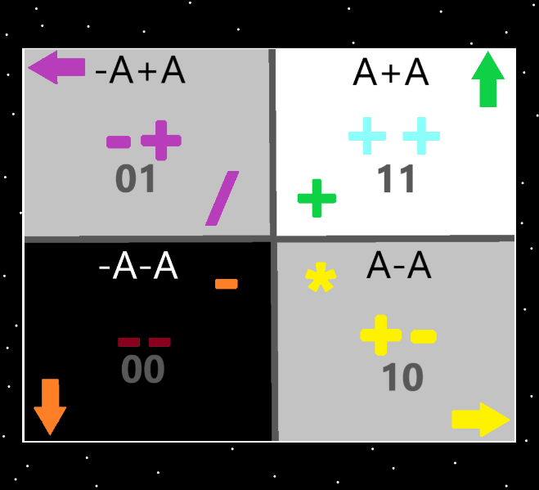
Information: The 4 Quadrants…the top right quadrant is the “addition”, “++”, “11(binary)”, “up” “white/blue/green”, “A+A”, quadrant. The Strong nuclear, weak nuclear, electromagnetism, and gravity forces could be added. Earth, Water, Air and Fire could be added. And others could be added.

Information: The “4 forces” likely unify into the “2 forces”.

Item Group: A Collection Of Music
Principle: Some enchanting music….
Principle: All things have enchantments…
Principle: Music is bi time enchanted.
Principle: I get music from amazon music
Information 1: End Credits (From “Beetlejuice Soundtrack”)
Artist: Danny Elfman
Album: Beetlejuice (Original Motion Picture Soundtrack)
Information 2: Farewell
Artist: Bernard Herrmann
Album: The Day The Earth Stood Still
(Original Motion Picture Soundtrack)
Information 3: Finale
Artist: Bernard Herrmann
Album: The Day The Earth Stood Still
(Original Motion Picture Soundtrack)
Information 4: First Coronation
Artist: Ryuichi Sakamoto
Album: The Last Emperor (Original Soundtrack)
Information 5: Funeral March of a Marionette
Artist: Beethoven’s Wig
Album: Beethoven’s Wig 3: Many More Sing Along Symphonies
Information 6: Halcyon and On and On
Artist: Orbital
Album: Orbital 2
Information 7: Hedwig’s Theme
Artist: John Williams
Album: Harry Potter and The Sorcerer’s Stone

Information 8: I Never Woke Up In Handcuffs Before
Artist: Hans Zimmer
Album: Sherlock Holmes (Original Motion Picture Soundtrack)
Information 9: The Last Emperor (Main Title Theme)
Artist: David Byrne
Album: The Last Emperor (Original Soundtrack)
Information 10: Looking Glass
Artist: Northcore
Album: Desatero
Information 11: M.I.B Closing Theme
Artist: Danny Elfman
Album: Men in Black the Album
Information 12: M.I.B Main Theme
Artist: Danny Elfman
Album: Men in Black the Album
Information 13: Main Titles (From “Beetlejuice” Soundtrack
Artist: Danny Elfman
Album: Beetlejuice (Original Motion Picture Soundtrack)
Information 14: Nara (Theme to Cold Case)
Artist: E.S. Posthumus
Album: Unearthed
Information 15: Panic
Artist: Bernard Herrmann
Album: The Day The Earth Stood Still
(Original Motion Picture Soundtrack)
Information 16: Sleeping Woman
Artist: Luis Perez
Album: Journey to the Heart, Volume 1
Information 17: Song Of Storms (Windmill Hut Theme) [From “The Legend of Zelda:….
Artist: Video Game Players
Album: The Ocarina of Time Collection (Them Songs from “The Legend of Zelda”…
Information 18: Stranger Things Main Theme
Artist: Halloween All-Stars
Album: Halloween TV Themes
Information 19: Theme From Black Sails
Artist: Bear McCreary
Album: Black Sails (A Starz Original Series Soundtrack)
Information 20: Theme From “Leprechaun”
Artist: Matt Fink
Album: Horror Movie Madness – Halloween Edition
Information 21: They Live
Artist: John Carpenter
Album: Anthology: Movie Themes 1974-1998
Information 22: Valley In The Clouds
Artist: David Arkenstone
Album: Valley In The Clouds
Information 23: Washington Men / Indy’s Home
Artist: John Williams & London Symphony Orchestra
Album: Raiders of the Lost Ark
(Original Motion Picture Soundtrack)
Information 24: Fear of the Heavens
Artist: Hiroki Kikuta
Album: Secret of Mana (Original Soundtrack)
Information 25: Romeo and Juliet Suite No. 2, Op. 64ter: I. Montagues and Capulets
Artist: Seattle Symphony Orchestra
Album: Prokofiev Romeo and Juliet Suites Nos. 1 and 2 – Pushkin Waltz No. 2

