PAAIL 2.5
ObjectName: Book
ObjectNumber: 0
Maker: PAAIL.org
Model:2.5

Name: PAAIL 2.5
Rank:
SerialNumber:

Level:
Score:
Birth:7-27-2022

Label: Star
Title: PAAIL 2.5
Details: Short book about PAAIL 2.5.

Principle: PAAIL research and use.
Agenda: PAAIL development.
Action: PAAIL development.
Information: PAAIL 2.5.

Location: Universe General Science.

Item Group 1: PAAIL Start
Principle: PAAIL is worth learning.
Agenda: Learn PAAIL.
Action: Read all the Items.
Principle: PAAIL stands for “Principles, Agendas, Actions, Information, Language.
Principle: Principle 1 of PAAIL 1 is that “PAAIL is a language where we think/speak in Principles, Agendas, Actions and Information.
Principle: Principles, Agendas, Actions, and Information are the main vocabulary words.
Principle: The PAAIL doctrine is a focus on Principles, Agendas, Actions, and Information.
Principle: A PAAIL language is any language system that puts focus on Principles, Agendas, Actions and Information.
Principle: Currently we are on PAAIL 2.4.
Principle: The current theory is that all knowledge of reality should be organized in a physical location way.
Principle: The vocabulary word Multiverse is a vocabulary word of PAAIL.
Principle: Multiverse means all things combined. It means reality.
Principle: Current PAAIL is that we are all part of the Multiverse…. we each have our own Universe.
Principle: Current PAAIL is to say that all science combined is the Multiverse, and that each area of science is(or belongs to) a Universe.
Principle: Current PAAIL is to say that Math is a Universe in science. Current PAAIL is to say that Math is one Universe in the Multiverse.
Principle: In PAAIL 2.4 there are two types of Objects. There are “Locations” and there are “Items”.
Principle: After Multiverse and Universe comes the vocabulary words “Galaxy”, “Star Group”, “Star”, “Planet”, “Region”, “Land”, “Building”, “Room”, “Item Group” and “Item”.
Principle: All science Principles are an Item.
Principle: All science Principles live at some location. They all have a universe, galaxy, star group, star, planet, region, land, building, and item group.
Principle: PAAIL can be used for many things. A person could make a social networking website, and every gets a “Universe”. Use the PAAIL vocabulary for the website. People would start with a universe, add their first galaxy, then their first star group, then star….so on and so on.
Principle: Organizing science is just one use of PAAIL.
Principle: On organizing science we have “Item, Items”. A Item that is about another Item. A Principle, about a Principle.
Principle: A “Item Item” is an Item inside an Item.
Principle: Also inside Items we find…. “Item Universe”(A universe about an Item), “Item Galaxy”(A galaxy about a Item), “Item Star Groups”(Star Groups about a item), and so on and so on.
Principle: In PAAIL we also have “Item, Item Items”…. A “Item” about a “Item Item”.
Principle: There is 4x Items, 5x Items, on and on. You always can always create another layer of Items. A “5x Item” is a “Item, Item, Item, Item, Item”… a Item, about a “Item, Item, Item, Item”, 4x.
Principle: A “5x Item Universe” is a vocabulary term. As is “5x Item Galaxy”, “5x Item Star Group”…so on and so on.
Principle: With the “X Item System” you can always zoom in more and more.
Principle: Current PAAIL has a belief in a collection of Basic Properties for everything. Each Universe has a set of “Basic Properties”. Each Galaxy has a set of “Basic Properties. Each Star Group has a set of “Basic Properties. On and on, they all do. Including Items.
Principle: Currently the Basic Properties list is…
ObjectName:
ObjectNumber:

Maker:
Model:

Name:
Rank:
SerialNumber:

Level:
Score:
Birth:

Label:
Title:
Details:

Principle:
Agenda:
Action:
Information:

Location:

Principle: In this book this is an Item. In this book all Items are either a Principle, Agenda, Action, or Information Item.
Principle: So far the pattern is mostly Principles in my books. I tend to use Information on less important knowledge.
Information: The writing levels of this books author are very low levels.
Principle: Along with being a way to organize knowledge/science, one thought is that PAAIL inspired AI is an option.
Principle: Actions are the big payout. When an Action is done, there is a chance of something accomplished.
Principle: PAAIL can be used to analyze philosophic documents. You can break such documents into Principles, Agendas, Actions, and Information.
Principle: PAAIL can also be used to analyze religious documents, it also can be used to analyze legal documents, such as the United States constitution.
Principle: In this book “Principle:” is the Label Property, and this part is the Details Property.
Principle: One example is the first line from the Bible. “In the beginning God created the Heavens and the Earth.”
Principle: If the one line is an Item….we create Item Items. Items about the Item.
Item Principle: In the beginning God Created the Heavens and the Earth.
-Item Item Principle: There is a beginning.
-Item Item Principle: There is a God.
-Item Item Principle: There is creation.
-Item Item Principle: There is the Heavens.
-Item Item Principle: There is the Earth.
-Item Item Principle: God created Heaven.
-Item Item Principle: God created Earth.
-Item Item Principle: The first line of the Bible speaks of Gods Actions.
-Item Item Item Information: Actions are a main thing in PAAIL.
Principle: Of course PAAIL could be used for understanding, organizing, creation, and development of such documents as well.
Principle: The first development of PAAIL was a thought towards philosophy, then later it seemed good for other things.
Principle: As for books. Is this book better because is comes in this PAAIL format? Maybe not. It seems easier to write the book.
Principle: People seem full of Principles, Agendas, Actions and Information.
Principle: Being able to see the Multiverse in PAAIL improves intelligence by at least 0.1%.
Principle: It seems greater vocabulary sometimes to use the words Principles, Agendas, Actions, and Information. Also principle, agenda, and action.
Principle: It is a thought to use a Location system for website design. One example, a small website could be a “building”, with each page a “Room”. Each room labeled room. The home page is the “Main Entrance Room”.
Principle: Instead of calling it a page. It’s a room.
Principle: Instead of calling it the home page. It’s the Main Entrance, or Main Gate, or something along those lines.
Principle: Large websites should think of themselves as a “Multiverse” and then the main parts are Universe’s. On a social networking site, each person is a Universe.
Principle: For a social network site, a person could start with one universe, then add 1 item in it. A giant single message board. No galaxys, star groups, stars or planets.
Principle: The PAAIL.org website uses a Physical Location System for its design.
Principle: The virtual universe(computer universe) so mirrors the real universe that it is best to use a physical location system all through out programs.
Principle: Instead of using word “Forums” we use the word “Building” titled “Discussion Hall”.
Principle: In the Discussion Hall Building we use the word “Rooms”, not the word “Threads”.
Principle: In each of the rooms we have 1 message board "Item”, which has all the posts.
Principle: A person can use other words for naming their buildings, rooms, and items. These have just been examples.
Principle: A physical locations system can be used in many places throughout everything.
Principle: Physical location systems can be designed throughout everything.
Principle: In programming there are programs used to make programs. Programs for creating programs.
Principle: Programs for creating programs would be improved if they developed a Physical Location System throughout it.
Principle: The trick to Physical Location System is to use the right parable/metaphors/analogies. Such as building, star, galaxy, universe.
Principle: It’s a thought to add “Continent” to the system.
Principle: All Items in this book are either principle, agenda, action or information Items.
Principle: All Items and Locations have Properties.
Principle: In this book you mainly only see the Label Properties, and the Detail Properties.
Principle: In PAAIL one vocabulary word is “View”. In this book many of the Properties are hidden. They are not part of the view.
Principle: A pattern of things nested in things is PAAIL 2.4.
Principle: Looking at a Location, or Item is a “View”. You are a Viewer. You are Viewing. You have Viewed.
Principle: In PAAIL there is the vocabulary word “Map”. This word (along with Maps, Mapping, Mapped, and Mapper) are a part of PAAIL. The “table of contents” in a book is a Map. If you called the book a Star. You have a Map of a Star.
Principle 13: PAAIL can be used in Making Maps. Lots of things can be mapped out.
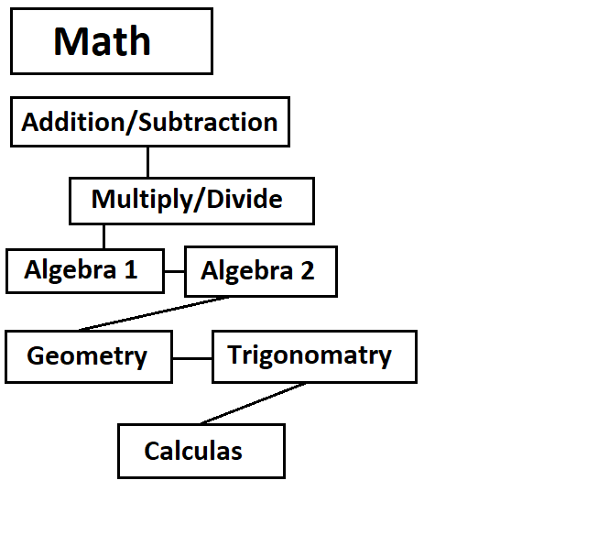
Principle 14: Since everything is about Locations…everything is about Maps, Mapping, Mappers. All Locations can have Maps. All Items can have Maps. Examples…
1 - "I'm mapping my next 2 years at college."
2 - "I'm mapping the best strategy for this game."
3 - "I'm creating a map of the load bearing walls."
4 - "Im creating a map of this Location."
5 - "Im creating a map of this Item."
6 - "I'm creating a map of this programs code."
7 - "I'm creating a map for my next 2 years in college."
8 - "I'm creating a strategy map, for this game."
10 - "Im creating a story line map. For this comic book Im doing."
11 - "Im creating a general map of all math science."
12 - "Im creating a general map of all writing science."
13 - This list could go on and on.......

Principle 15: All Locations, Items, and Properties are “Objects”.
Principle 7: Actions are the big payout. When a robot, AI, or person, does an Action, there is sometimes, something accomplished.
Principle: The SerialNumber property might work well for security reasons.
Principle: PAAIL can be used for many different things. This book is only some uses of PAAIL.
//Vocabulary
Principle: In lots of science there is vocabulary.
0-Principle/Principles/Principled
Agenda/Agendas
Action/Actions
Information
Language
Multiverse
Universe
Galaxy
Star Group
Star
Planet
Region
Land
Building
Room
Item Group
Item
Item Item
Item Universe
Item Galaxy
Item Star Group
Item Star
Item Planet
Item Region
Item Land
Item Building
Item Item
Item Item Item
4x Item
5x Item
ObjectName
ObjectNumber
Maker
Model
Name
Rank
SerialNumber
Level
Score
Birth
Label
Title
Details
Location
Property/Properties
Basic Properties
Nested/Nesting
Location/Locations/Locating/Located/Locater
Map/Maps/Mapping/Mapped/Mapper
View/Views/Viewing/Viewer/Viewed
Object/Objects
Hidden Properties
Zoom/Zooming/Zoomed/Zoom In
/Zoom Out/Zoom To/Zoom 1x/Zoom 2x
Path/Paths
Travel

