
ObjectType: Article
ObjectNumber: 76
LocationName: PAAIL.org
LocationNumber:
Language: PAAIL 2.8

Maker: PAAIL.org
Model:
Name:
Rank:
SerialNumber:

Level: 5.1
Score:
Birth: 7-29-2024

Label: Room 76
Title: Smith Notes 1
Details: PAAIL.org Scripture….
Principle: Ultimate Scripture….
Agenda: Ultimate Scripture….
Action: Ultimate Scripture….
Information: Ultimate Scripture….
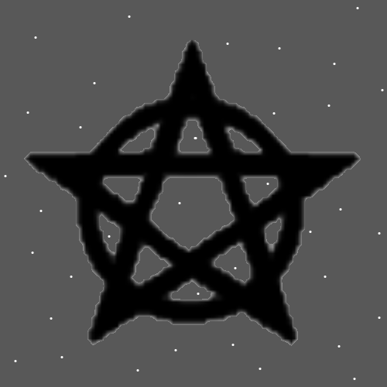
Item Group: Understanding The Multiverse 0
Principles: Often the more Time you interact with a Charm the more you can Sense its Auras. Often the more Time you interact with a Building, the more you can Sense its Auras. Often the more Time you interact with a person, the more you can Sense their Auras.
Principles: Often the more you interact with a thing the more you Sense its Auras.
Principles: Thinking about a person is an interaction with them.
Principles: Thinking about his Holiness Origin is an interaction with his Holiness.
Principles: Reality is all about Connections. Thinking about a person is a Connection to that person.
Principles: Often the Key Spell Part is Time. Lots of Time.
Principles: Often becoming an Expert as something is all about lots of Time.
Principles: His Holiness Origin is “the great I am!”. I believe this line comes from the Holy Bible. At One point in history his Holiness Origin achieved self-awareness.
Principles: Sorcery does not lead to fireballs or lightning bolts; however it does lead to more Intelligence, Wisdom, Grace and other Virtues.
Principles: Most people who know how to play Chess are Level 3 or lower at it.
Principles: Often getting to Level 4 requires specific training.
Principles: Education Numerology is an area of Wizardry. A Fusion of education Science and Wizardry Science.
Principles: Wizardry is all the secrets revealed and some awesome Sorcery too.
Principles: Expert Sorcerer can be achieved from PAAIL.org script. Probably Master and Doctorate Sorcerer also.
Principles: First, it’s about picking the right song. That’s the most important Spell Part. Then it’s about adding other Spell Parts. Fusing them with the song.
Principles: When you become a Expert Wizard the music experience can be much bigger.
Principles: We are the princes and princesses of Reality.
Principles: There is a song with the line “we are the princes of the universe”. It is a song that a person can get a ESP experience/Sense from. You can Sense the Multiverse through listening to it.
Principles: All facts to Reality are Part of its Story.
Principles: Music can be very Enchanting. It can Enchant a person.
Principles: The Multiverse is a “matrix” of Energy Bits.
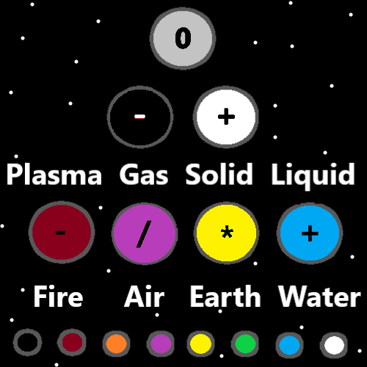
Principles: There is a great deal of meaning in good peoples lives.
Principles: All philosophy his Holiness Origin would agree with, disagree with. or have something to say about it. Thus, all philosophy is also theology.
Principles: Another Word for theology is Religion.
Principles: It is a dose of Enlightenment to know all philosophy is also theology/Religion.
Principles: Sometimes the definition of a Word matters. Sometimes semantics is important.
Principles: Reading Wizardry and listening to the right music at the same Time may be a powerful Spell.
Principles: Making Spells is a Part of Wizardry.
Principles: 0.53 owns an Infinite amount of Numbers. It owns 0.53 to 0.53999(repeating Nines). And -0.53 to -0.53999(repeating Nines). More like Infinity times Two.
X2 Principle: All Numbers are like this. 0.53 is just an example.
Principles: There are an Infinite amount of sub Numbers for every Number.
Principles: The physics/math of Energy Bits may not be the same as the physics/math of other Energies. Example it may be that A/10 = A * 10.
Principles: The theory is that if you split an Energy Bit you get more Energy Bits.
Principles: The theory is 352 Energy Bits is the same amount of Energy as 1 Energy Bit.
Principles: It is good to think about Energy Bits sometimes. They are everywhere you look. They are all around you. You are Made of their existence.
Principles: Some of this stuff about Energy Bits may be new.
Principles: Since max Zoom in is Positive and Negative, you find Positive and Negative in all things.
Principles: It is good to think about Positive and Negative sometimes. The Multiverse is Made of Positive and Negative.
Principles: Wizardry is a lot more Advanced now than it was at the End of “Tome of the Yellow Wizard”. Tome of the Yellow Wizard is very out of date.
Principles: Much better writing could be done than current PAAIL.org writing.
X2 Principles: New books would be written for it all. You would not read Tome of the Yellow Wizard or anything on PAAIL.org. It would all be put in new books.
Principles: PAAIL.org writing is research and development notes. Not organized books.
Principles: There is glory in being a good person.

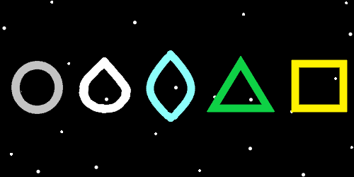
Principles: The 4 seasons likely line up with the 4 Forces. One season is the Fire Force, one is the Water Force, One is Earth Force, One is the Air Force.
Principles: His Holiness Origin is not a pacifist. He believes in self-defense. He has sent nations to war with other nations.
Principles: A collection of philosophical beliefs is a Religion.
Principles: People get smarter and smarter even unto an old age of 80. The smartest people are the 80 and older people. The most Virtuous are the older people.
Principles: Training Expert Wizard can not only generates a ton of Virtue Levels, it can also reduce Flaw Levels.
Principles: Level 3 Wizard is Enlightenment.
Principles: Some Religions over the years did not believe in a God.
Principles: On a Cosmic scale humans are only like 1 second old. Maybe younger.
Principles: In some ways humans are tiny. In some ways humans are huge.
Principles: A lot can be said about the term “self-improvement”.
Principles: His Holiness Origin is a being that believes in self-improvement. It is good to better yourself.

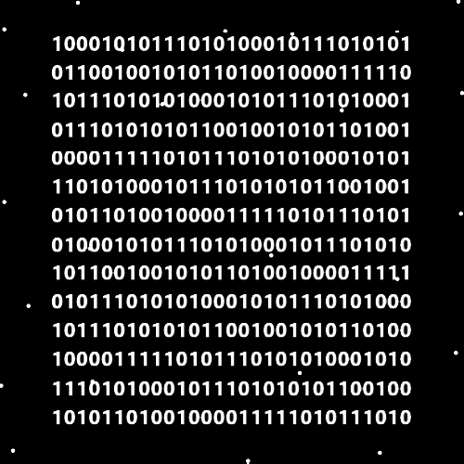
Item Group: Understanding The Multiverse 1
Principles: Vocabulary is a Science. Wizardry Vocabulary is an area/Part of Wizardry.
Principles: The definition of “Guided Meditation” is to guide the Meditation of another person.
Principles: Guided Meditation can be a powerful Spell.
Principles: As an Example of Guided Meditation, you could tell someone to close their eyes, then tell them to picture a cloud. Or you could have them close their eyes and try to clear their Minds. Many options are available. You could add the Spell Part Breathe to it all if you wished.
Principles: It may be a powerful Spell sometimes to ask people what pops into their Minds. After telling them to close their eyes. Then you do Divination with what they tell you.
Principles: These are Advanced Spells. There are many Principles to them.
Principles: Guided Meditation is something that can be researched and developed.
Principle: Expert Wizards notice things.
Principle: Wizardry is understanding the Cosmos.
Principles: Body Exercise likely drains a lot of Mana. This is a good thing. Actions that drain a lot of Mana are rare and draining your Mana Battery is how you Grow your Mana Battery. The more you drain it, the more it Grows. You can almost never drain it too much.
Principle: Doing 30 minutes of Meditation likely drains a lot of Mana.
Principle: Breathing Exercises likely drain a lot of Mana.
Principles: Breathing Spells are a ultimate Spell to cast sometimes. Not just for training. Breathing Spells may drain a good amount of Mana. A very good thing. Not just for when training Sorcery. Other Times as well.
Principles: Your Mana flows through your Actions. When you play chess it flows through your chess efforts. It helps you in your efforts. It flows into your chess Actions.
Principles: The more Mana you can get to flow through your Action, the better.
Principles: Your Mana flows through your Spells. When you play chess it flows through your chess efforts. It helps you in your efforts. It flows into your chess Spells.
Principles: Principles: The more Mana you can get to flow through your Spell, the better.
Principles: The Spell Part Time is a big factor in draining lots of Mana.
Principles: It may be very difficult to drain a Mana Battery down to 0. I think you might go unconscious if you did. You should probably not do it if you can.

