Object Type: Article  
Object Number: 78

Location Name: PAAIL.org

Location Number:

Language: PAAIL 2.8

Maker: PAAIL.org  
Model:   
  
Name:

Rank:

Serial Number:

Level: 5.1

Score:   
Birth: 8-8-2024

Label: Room 78

Title: Smith Notes 2

Details: PAAIL.org Scripture….

Principle: Ultimate Scripture….

Agenda: Ultimate Scripture….

Action: Ultimate Scripture….

Information: Ultimate Scripture….

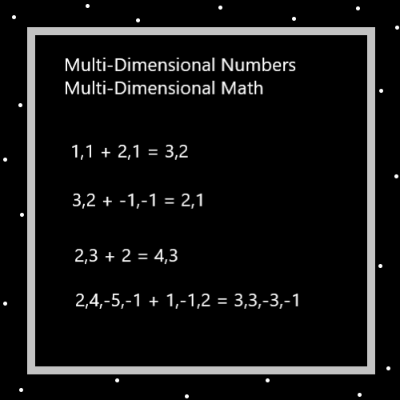

Item Group: Understanding The Multiverse 0

Principle: Sometimes you can Sense a Spell changing you.

Principle: Sometimes you can Sense a Spell Enchanting you.

Principle: Sometimes you can Sense a Action changing you.

Principle: A philosophy that believes in self-improvement has at least One thing going for it.

Principle: A Religion that believes in self-improvement has at least One thing going for it.

Principle: A Theology that believes in self-improvement has at least One thing going for it.

Principle: A Level 3/Green Wizard is strong with the Wizard Side of the Force.

Principle: Expert Wizards sometimes see or hear the Word “One” and think of his Holiness Jesus or the Word “Won”.

Principles: There is at least 1 famous song Titled “One”. An Expert Wizard might hear of his Holiness Jesus in that song.

Principles: I don’t know much Astrology. I know my Astrology Sign is Capricorn. Capricorn is the Goat. This means I have a Connection to the Goat Spirit Animal in some ways.

Principle: I know little about Chakra’s.

Principles: We all have One main Spirit Animal. It is impossible to figure out which Spirit Animal that is though.

Principles: PAAIL.org Wizardry could be 600 pages. It could be 1500 pages. I really don’t know.

Principles: 1500 pages is not a lot of pages for Making a Doctorate Enchantment. 400 Pages is not a lot for achieving Enlightenment.

Item Group: Understanding The Multiverse 1

Principles: Since 0.5 is halfway between 1(On) and 0(Off), 0 Particles may have had 0.5 Energy to them. 0 = 0.5. See Map above.

Principle: The Words for it are not known. However the Story may be that all Reality combined is “1 Mega Unit” of Energy. I used the Word Mega, I could not come up with better.

Principle: The Four Energies, Height, Width, Depth and Time may have Negative mass.

Principle: There may be a physics to something with Positive mass interacting with something that has Negative mass.

Principle: There may be a physics for interactions between Bend In Energies and Bend out Energies.

Principles: All Particles may have mass. “A” Particles may have an “A” amount of mass. The 0 Particle Energy Bits may have had 0 mass.

Principle: All things are Science.

Principles: There are good systems for measuring Time. There is also the One true system for measuring Time. It is the One his Holiness Origin uses. This is the same with all measuring systems. There are true systems for measuring things. Examples, Time, heat, mass, and speed.

Principles: There be what his Holiness Origin calls “1 Unit” of Energy. “1 Unit” of Time. “1 Unit” of speed. “1 Unit” of mass.

Principles: Thus the problems with Einstein’s famous “E = MC Squared”. There is the correct system for measuring mass, and the correct system for measuring speed. If Light had a speed of 1, it would be that “E = M”. Though perhaps Light has some other speed.

Principles: It may be that through Einstein’s famous “E = MC Squared”, we can figure out the true systems of measurement. Also the Kelvin system may help. 0 heat Units to God may be 0 Kelvin.

Principles: It may be that E = M. Energy equals mass. Mass is how much Energy there is in a Particle. These are all theories.

Principles: Matter may have Properties. A Particle with 1 Unit of mass could have a Property where it has a speed of 1 Unit. The amount of Energy would be mass Times speed. E = MS. E equals mass X speed.

Principle: A side note. This Universe goes so fast around his Holiness Origin. We are all traveling at a tremendous speed right now.

Principle: This Universe may be like a space ship going around his Holiness Origin. A bubble space ship going round and round.

Principle: Since the fish and lettuce are family, we cook and eat our family.

Principle: It turns out it is un-natural for life to kill and eat each other.

Principle: It may be that his Holiness Origin does not have to kill and eat life.

Principle: It is the commandment of his Holiness Origin that we kill and eat life.

