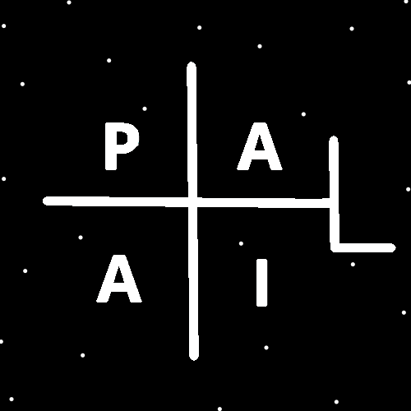
ObjectType: Article
ObjectNumber: 80
LocationName: PAAIL.org
LocationNumber:
Language: PAAIL 2.8

Maker: PAAIL.org
Model:
Name:
Rank:
SerialNumber:

Level: 5.1
Score:
Birth: 8-20-2024

Label: Room 80
Title: Smith Notes 3
Details: PAAIL.org Scripture….
Principle: Ultimate Scripture….
Agenda: Ultimate Scripture….
Action: Ultimate Scripture….
Information: Ultimate Scripture….
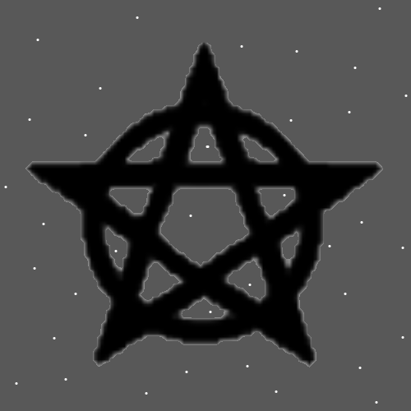
Item Group: Understanding The Multiverse 0
Principles: Particles likely have Properties/Enchantments. A Particles speed is One of its Properties/Enchantments. A Particles heat another Property, and its mass may be another Property/Enchantment.
Principles: Reading the Vocabulary Words of Wizardry is a Part of Wizardry. Reading the Vocabulary Words of Wizardry Enchants a person. Reading the Word “Wizardry” Connects a person to Wizardry.
Principles: A persons ESP powers likely increase when getting to Level 3 Wizard. Even more so when getting to Level 4 Wizard. A person Grows a greater Level of Sensing things. Sensing things is Sorcery.
Principle: Sorcery Levels are likely very Connected to ESP and Sensing things.
Principles: Sorcery Level 3 can be gained from reading. It alone likely increases a person’s Senses. A person can get to Sorcery Level 4 though.

Principles: His Holiness Jesus was a God-like being. His Mind experience was God like. He was not emotional or passionate. He was a being of great inner peace.
Principle: Knowing more about his Holiness Origin Connects a person to his Holiness Origin. Example: knowing his Number is Zero, and knowing his Symbol is the Circle.
Principles: If all of this could be proven it would be taught in public schools and every 18-year-old would end up a Doctorate Wizard from public school. Often getting there at 16 years of age, or even younger.
Principles: There are 1000 Numbers from 0 to 999. On average there are about 7 of these Angels at any given Time. 7 triple digit or smaller people, at any given Time.
Principle: Angels 1 to 99 are very rare.
Principle: All Angels are Holy people. They are Prince’s of Heaven.
Principle: For a Wizard the music is enhanced. The music becomes bigger.
Principle: All good people are soldiers of good. All good people live at war. War with the darkness.
Principle: Every good person life is so huge.
Principle: There are Two firewalls between his Holiness Origin and us people of Earth. One firewall between Earth and Heaven and One firewall between Heaven and his Holiness Origin.
Principle: Eventually we End up as powerful as his Holiness Origin is.
Principles: Evolution is very real. The Multiverse will evolve forever, into more and more Advanced forms.
Principles: Wizardry is powerful in some ways.
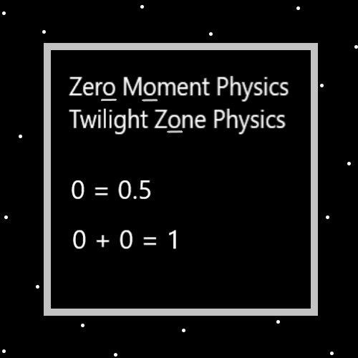
Principle: There are people with Wizardry knowledge that they didn’t know was Wizardry knowledge.
Principles: The Laws of physics can Change. Once upon a Time 0 + 0 equaled 1. Now it equals 0.
Principles: It seems that I remember hearing about the Catholics having tons of buildings, full of Scripture books. It was from this text that the Bible was formed. They chose only some things for the Bible.
Principles: There are lots of Spirituality books out there. Probably most or all count as Scripture.
Principle: Sometimes your read the same Principles multiple Times because they get stated better.
Principle: I do my best to accomplish another interesting article.
Principle: Since thinking is a type of Meditation, a person Grows Meditation Levels when thinking.
Principle: In some ways Number Two is super close to the Number One. In some ways it’s 100% different. Which is a lot. In some ways Number Three is super close to Number Two. In some ways its 50% different. Which is a lot.
Principle: It may be when Zoomed Out that the Numbers 1 and 2 look the same. When Zoomed In they look vastly different.
X2 Principle: Zoomed In is called “Quantum Physics”. Zoomed Out is a different physics.
Principle: It seems that probably Energy Bits is “Quantum Physics”.
X2 Principles: I think this may be a new Principle. Though perhaps obvious.
Principle: Once I wanted to be a pivotal moment in mankind. Now I’m not so ambitious. We all accomplish the same amount of good.
Principles: Writing a Word Connects you to that Word. Writing a Principle Connects you to that Principle. Writing a lesson, Connects you to that lesson. Writing some Scripture from the Bible Connects you to Scripture and it Connects you to the Bible.
Principle: Were One to think the Word “Dot” over and over in their Mind, for many hours, they would stitch that Word throughout their Mind.
Principle: Were One to think the “Dot” Symbol over and over in their Mind, for many hours, they would stitch that Symbol throughout their Mind.
Principles: His Holiness Origin probably has a “Main Symbol”. It is either the Circle or the Dot.
Principles: If there are Multi-dimensional Numbers, all Numbers that start with 0 are owned by his Holiness Origin. They are all “Category Zero” Numerology Numbers.

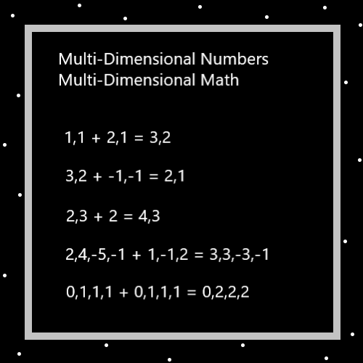
Principle: If there are Multi-dimensional Numbers. There are Numbers that start with the Number “Zero”.
Principles: A major piece of knowledge is the question “What Number category does a Number belong to?”. Is the Number 13 category 1, or category 3? Is 136, a 1,3 or 6?. Is 1369 a 1,3,6 or 9?. It may be that the first Number is its category. This is a major Detail of math. What Number category Numbers belong to.
Principles: There is a math Operation where “1,1,1,1” equals 4. Like how much Units do you have? Or something. This is because 1 + 1+ 1+ 1 equals 4. If it were “1,1,1,2” it would be 5 with the same Operation.
Principles: Math Science is Infinite, just as technology is Infinite. There will always be new technologies developed and new math Science as well. His Holiness Origin will evolve technologically forever. His Holiness will learn new math forever.

Principles: A major Part of math Science is that there is always another Operation to discover. Remember all Operations have a Name in Numbers. We know +1 is addition, -1 is subtraction, +2 is multiplication, and -2 is division.
Principles: Flipping a switch may be an Operation. Meditation may be an Operation. Breathing may be an Operation.
Principle: “N” might also equal Infinity(See Map below).
Principle: It may be fair to say all Actions/Spells are Operations.
Principle: Reading a Principle multiple Times can Make for a better Connection to that Principle.
Principle: All people have a Connection Enchantment to chess. Ranging from 0 to 9. A Connection is a Enchantment.
Principle: All people have a Connection Level with chess. Ranging from 0 to 9.
Principle: Sometimes you want to get to Level 4 at something, then not train Level 5. Because you want to spend your Time training something else. This is the same Story with Levels, 3,5,6,7,8 and 9.
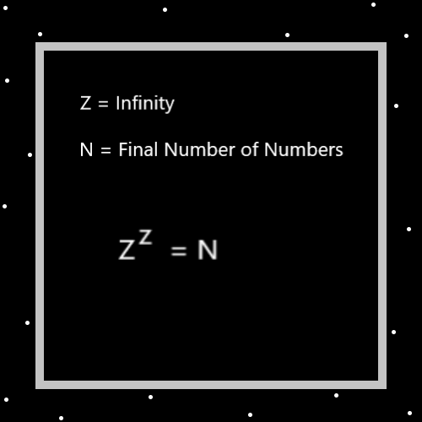
Principle: There is tons of Wizardry that can be found in books across the Planet. Not just at PAAIL.org.
Principle: Beauty is not relative to Ones perspective/View. What his Holiness Origin calls beautiful is beautiful, and what his Holiness says is not beautiful is not beautiful.
Principle: When it comes to art, it’s about the experience more than the quality of the art.
Principle: Sometimes a statement is close enough that it is the truth. Even though it’s not 100%.
Principle: All PAAIL.org Science is theories and sometimes things are not 100%.
Principle: A education Expert that is also a writing Expert, a general Science Expert and Doctor of Wizardry could write all powerful books. Books much better than PAAIL.org.
Principle: Experts could also develop classes at colleges for getting Levels 1,2,3,4,5, and 6 too. Level 4 would be a bachelor's degree, Level 5 would be a master’s degree, and Level 6 the Doctorate.
Principle: “…books will be opened, and the dead will be judged.” – The Holy Bible.
Principle: “….and then hades will give up the dead in it, and then hades and death will be tossed into the fire.” – The Holy Bible.
Principles: To know thyself is to judge thyself. You must judge yourself if you want to understand yourself.
Principle: We are the eternal beings. We live forever.
Principle: All Operations sort into the 4 categories. All Operations are either a Addition, Subtraction, Multiplication or Division category Operation.
Principle: All Operations also sort into Addition and Subtraction. All Operations are either a Subtraction or Addition Operation.
Principle: Multiplication is an Addition Operation. Division is a Subtraction Operation.
Principle: Fusion is Multiplication. Fission is Division.

