ObjectType: Article  
ObjectNumber: 81

LocationName: PAAIL.org

LocationNumber:

Language: PAAIL 2.8

Maker: PAAIL.org  
Model:   
  
Name:

Rank:

SerialNumber:

Level: 5.5

Score:   
Birth: 8-27-2024

Label: Room 81

Title: Smith Notes 4

Details: PAAIL.org Scripture…

Principle: Ultimate Scripture….

Agenda: Ultimate Scripture….

Action: Ultimate Scripture….

Information: Ultimate Scripture….

Item Group: Understanding The Multiverse 0

Principles: Divination can probably be good for the Mind. It Connects Words to other Words in a good way. It builds on the electrical system of the brain.

Principles: The Multiverse is like a tree. It has an Infinite amount of branches and each branch branches off into Infinite branches.

Principle: It may be that his Holiness Origin destroys some branches.

Principles: One great union of math and all other things is that all Operations are an Action/Spell. Meditation has a Name in Numbers. Meditation is an operation. Meditation is a Number.

Principles: Divination Makes branches and Grows branches in the brain/Mind. It Forces a person to think among other things.

Principles: “Let us make them in our image.”-When Adam and Eve were Made – The Holy Bible- Book 1: Genesis.

Principle: The first Part of the Bible (Genesis) and the last Part of the Bible (Revelation) may be worth prioritizing. It doesn’t take long to read them.

Principles: All this writing was never edited by a Expert editor. None of this was done by a writing Expert. It’s all provided by someone who is not a Expert Teacher. Plus, Wizardry is much more Advanced now than it was at the End of Tome of The Yellow Wizard. I researched and developed a huge amount over the years after that book.

Principles: All Numbers have a color, a 2D Symbol, a 3D Symbol, a 4D Symbol, a 5D Symbol, a 535D Symbol, a Particle, a Operation, a Energy Bit Code Line, a direction a Axis, and more. All Numbers have an Action/Spell. All Spells and Actions have a Name in Numbers.

Item Group: Understanding The Multiverse 1

Principles: “The sins of the father can fall unto the son up to the seventh generation.”-The Holy Bible

X2 Principle: This means Heaven never sees it go beyond the seventh generation.

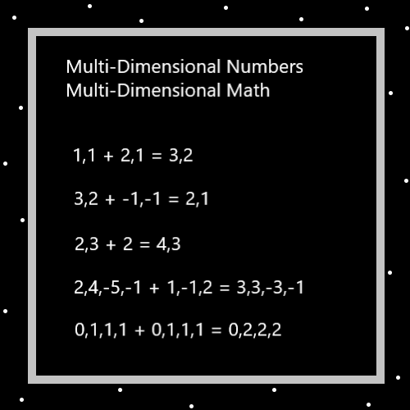

Principles: The Zero moment is a Twilight zone moment. The physical Laws are strange. Example the Zero moment is a huge moment (one of the biggest of moments) and yet its Number is 0.

Principles: An Angel in Heaven is so powerful that they can watch every human Story at the same Time and remember every single Detail. Even the Location of things around the person, down to a millimeter.

Principles: The Clergy of the world have been One of the biggest sources of communion with his Holiness Origin. Scripture is also a big One.

Principles: For a good example of a Incantation we have… ”Focus my Mind on the chess. On the chess board. On the chess pieces.”. You would repeat this a few Times in your Mind.

Principles: Sometimes better Incantations are tougher Ones, harder to memorize Ones. There is also a poetry to Making Incantations. They should seem poetic.

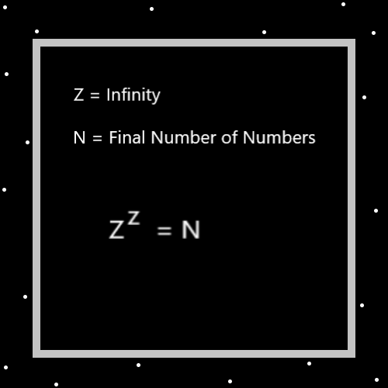

Principles: There are an Infinite Number of Incantations you could Make regarding chess. The example from earlier is just a example of a decent One.

Principles: Every Charm on Earth is a first century artifact. This is just One Part of their huge Chi.

Principles: The Word “Part” and the Word “Enchantment” are very Connected.

Principles: A Object is all of its Parts. A Object is all of its Enchantments.

Principles: Being at peace in life is a great thing. However, being at peace in life is not always possible.

Principles: The reason why there is so many different Religions is that we are very separated from his Holiness Origin.

Principles: His Holiness Origin knows every human Story, including all the Charms around them and where they were located.

Principles: Does his Holiness Origin know every animal Story? Perhaps…

Principles: Does his Holiness Origin know every bug Story? Perhaps…

Principles: Every cell in the human Body is a person. One that eventually Ends up a God.

Principle: “His blood cries to me from the dirt.” -The Holy Bible

Principle: “It will do magic, believe it or not. Bibbiti, bobbiti, boo.” -Disney Cartoon

Principle: Real Sorcery works, even if you don’t believe in it.

Principle: Music is a huge Force.

Principle: Most movies come with music.

Principle: Stories are a huge Force.

Principle: On “Resurrection Day”, we might not get One Planet. We might get a whole solar System. Multiple Planets.

Principle: On “Resurrection Day” the Angels of Heaven and probably his Holiness Origin too, will be our servants.

Principles: Sometimes you can see the meaning of something. The meaning behind Angels always having wings is that as Stars they float around in Heaven.

Principles: On Cosmic year 1 million there will no longer be hydrogen fusion Stars. Instead, there will be new Bodies, far more powerful Bodies.

Principles: The Words “evolution” and “Cycles” are major Science Words. “Cycles” is a Vocabulary Word of Wizardry.

Principles: The Multiverse evolves. It gets more Advanced as the years progress.

Principles: People evolve. They get more Advanced as the years progress.

Principles: Systems evolve. Sometimes they get more Advanced as the years progress.

Principle: The End is here!

Principles: Its been the apocalypse since before World War II. The End of a human Age. The 5500 to 5999. It is unknown what year was the first year of the apocalypse.

Principles: Some Spells/Actions require no training to get benefits from. They work each Time. Other Spells/Actions have to be trained up a bunch before they do anything.

Principle: Doctorate Wizards should have Level 4 Smith Summons. They should have done many hours of it.

Principles: Cleaning Levels can be beneficial in many ways. They Connect a person to the clean Side of the Force. A powerful Side of the Force.

Principles: Medical Experts sometimes clean wounds.

Principles: The Word “clean” has a Connection to the Word “cleanse”. And a Connection to the Word “cleansing”.

Principle: When a person cleans the world, they cleanse the world.

Principle: As children of his Holiness Origin we are all huge beings.

Principle: We are all famous Stars to his Holiness Origin and the Angels of Heaven.

Principle: All of this knowledge is powerful for Scientists who are researching and developing new technology.

Principle: Mirroring a game, the Multiverse is all about Levels and Scores.

Principle: In some ways you can say the Multiverse mirrors a garden. In some ways you can say the Multiverse mirrors a chess game. In some ways you can say the Multiverse mirrors a battlefield. In some ways you can say the Multiverse mirrors a human Body. This list is endless.

Principle: Things mirror other things.