ObjectName: Article  
ObjectNumber:

LocationName: PAAIL.org

LocationNumber:

Maker: PAAIL.org  
Model:  
  
Name: AdvancedWizardry15A

Rank:

SerialNumber:

Level:

Score:  
Birth: 4-22-2023

Label: Room 01

Title: Advanced Wizardry 15A

Details: Advanced Wizardry rooms are always the latest in PAAIL.org Wizardry research. They are called rooms because that is paail.org science.

Principle:

Agenda:

Action:

Information:

Language: PAAIL 2.5

(PAAIL Logo)

Item Group: Advanced Wizardry

Principle: Phycologists could likely make good phone psychic designs that helps people. It could use divination, and it would likely make some money in the process.

X2 Principle: Using tarot cards may work as a design. I imagine there are lots of design options.

Information: I wish I had a bunch of levels and score on listening to phone psychics. I think it would be good inspiration for me.

X2 Principle: This would be good for research and development. People should not necessarily go out and do it.

Principle: Levels and scores. Its all about levels and scores.

Principle: Major batteries Wizardry is that batteries have levels and scores.

Principle: Batteries numerology is a thing. There is also batteries colorology.

Principle: All/most or many 3 object systems align with the 3 forces (positive, negative, neutral).

Principle: “Low, medium and high” is a 3 object system.

Principle: Since it’s the 3 sides, spirit, mind, and body. It may be the spirit side is the positive side. The mind side is the neutral side. And the body side is the negative side.

Principle: It may be the spirit is the large side. The mind is the medium side. And the body is the small side.

Principle: We are all famous to the angels and God. An angel can read all human stories in a human month.

Item Group: Advanced Wizardry

Principle: There’s a famous quote…”On the up and up”. “Up Up” is on the last map.

Principle: Its likely that even level 3 Jr. Wizard is a huge power up for a person’s chi.

Principle: There are an infinite number of maps that can be done.

Principle: “2D” means 2 dimensional.

Principle: Sometimes a 2D object is 4 quadrants. Sometimes a 3D object is 8 quadrants. Sometimes a 4D object is 16 quadrants.

Principle: 2D has a connection to 4. 3D has a connection to 8. 4D has a connection to 16. The pattern is infinite. 5D has a connection to 32……on and on.

Principle: The multiverse goes by many names. One is the force. One is the dragon. You can also call the multiverse the garden, or robot. You can use many words.

Principle: One name of the multiverse is “the computer”.

Principle: The multiverse is a force. It is a dragon. It is a garden, it is a robot.

Principle: The multiverse is a computer.

Principle: One thing that is never written about is evidence to support any of these theories. It would be a negative in these rooms. It would drain the reader’s time, would take a lot of work by the author, and has other negatives.

Principle: If these theories are right, then you would think there is evidence sometimes.

Principle: The only thing this author is an expert at is Wizardry, and maybe PAAIL. There’s not much fusing Wizardry with other science that I can do.

Principle: The latest revelation is that often science is the 3 parts. The outer part, the middle part, and the inner part.

Principle: Protons, neutrons, electrons and photons may all have an outer part, a middle part and a inner part.

Principle: The 3 parts might align with the 3 forces (positive, negative, neutral). The outer part could be the positive, the middle part the neutral, the inner part the negative.

Principle: There’s the big picture, the small picture and the picture in between.

Principle: If you talk about the big picture of time, you include the future.

Principle: If you talk about the small picture you talk about the current moment.

Principle: The big picture, the small picture, its all throughout the multiverse.

Principle: Power is controlling energy.

Principle: Don’t use “Z’s” in keys. If your name has a “Z” in it, skip that letter. The divination spell is still connected to you a lot.

Principle: A “key” is a system in divination. A “key” is an algorithm for doing divination.

Principle: Phone psychics use algorithms. I don’t know if they use divination as part of the algorithm.

Principle: People become hypnotized by things. If it’s a healthy thing, then its healthy to be hypnotized by it.

Principle: People of the same profession often have a huge connection.

X2 Principle: This is a detail of great value to psychologists.

Principle: People of the same profession often have similar connections to the multiverse.

Principle: People of the same profession often have similarities.

Principle: The biggest ESP sense the multiverse can be found through music.

Principle: Music can cause a huge ESP experience.

Item Group: Advanced Wizardry

Principle: The map above could have errors in it.

Principle: Before there was positive and negative energy, there was neutral energy.

Principle: It might be that the only path to zero is through addition or subtraction. Examples:

1 – 1 = 0

-1 + 1 = 0

Principle: Maybe there should be a math to using the zero in multiplication and division. Examples:

0 \* 10 = ?

0 / 10 = ?

0 \* 0 = ?

Principle: Maybe zero multiplied by a number is 0. Example:

0 \* 83 = 0

Principle: Maybe zero multiplied by a number is 1. Example:

0 \* 83 = 1

Principle: Maybe zero multiplied by a number is like multiplied by 1. Example:

0 \* 83 = 83

Principle: Maybe zero multiplied by a number is 0.5 the number. Example:

0 \* 84 = 42

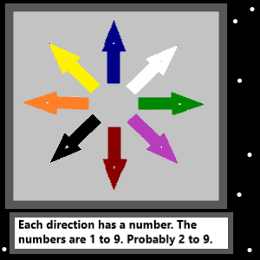

Item Group: Advanced Wizardry

Principle: The map above could have errors. The numbers could also be 1 to 8…..not 2 to 9.

X2 Principle: The colorology could be wrong.

Principle: People who are education experts have an education expert influence to their works.

Principle: People who are education experts have an education expert inspiration to their works.

Principle: People who are computer experts have a computer expert influence/inspiration to their works.

Principle: People who are chess experts have a chess expert influence/inspiration to their works.

Principle: People who are wizards have a wizard influence/inspiration to their works.

X2 Principle: This is a major part of how Wizardry is extremely useful.

Principle: You get a huge impact from all your level 3 and higher levels/skills.

Principle: Level 3 is a step under expert.

Item Group: Advanced Wizardry

Principle: The map above shows 19 colors (including transparent at 0). And also has a opposites color map at the right side.

Principle: The map above is a 19-object system of colors and numbers.

Principle: PAAIL is worth learning. Human existence is principles, agendas, actions and information.

X2 Principle: The PAAIL Book is very short. Its found at PAAIL.org.

Principle: An AI or robot has to perform an “action” in order to do something useful.

Principle: In PAAIL its “actions are super important”. In Wizardry its spells are super important.

Principle: It seems probable that each human cell is a lifeform. It seems possible that whatever cells are made of are lifeforms as well.

Principle: I think I have heard something about DNA strands. It may be that every DNA strand is a lifeform.

Principle: What ever DNA strands are made of could be lifeforms.

Principle: It could be that each chunk of H2O (water) is a lifeform. It could be that each of the 2 hydrogen chunks are lifeforms. Also that the chunk of oxygen is a lifeform.

Principle: It could be each proton, neutron and electron are another bunch of lifeforms.

Principle: The pattern could continue. What protons are made of are lifeforms.

Principle: The definition of lifeform here is consciousness. Beings that evolve into Gods.

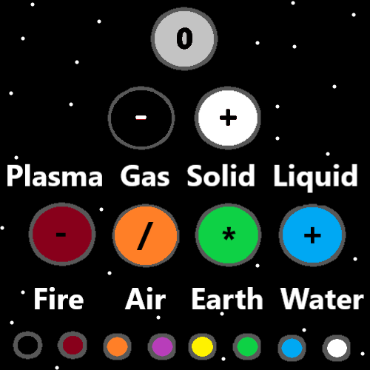

Item Group: Advanced Wizardry

Principle: The map above could have many major errors.

Principle: In the map above, one becomes two. Two becomes four. Four becomes eight.

Principle: There are 3 outcomes for spells. Positive negative or neutral.

Principle: A person can map spell outcomes with numerology and colorology.

Principle: Sometimes the best course is using a currently existing spell. Sometimes the agenda is engineer more positive spells.

Principle: Energy bits. Also known as “A particles”, likely have a form. A drawing could be done of one.

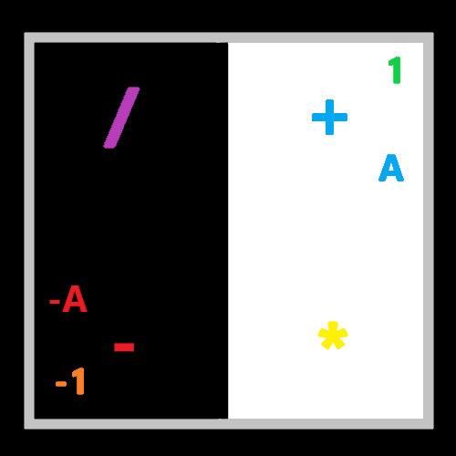

Item Group: Advanced Wizardry

Principle: Sometimes it’s the 2 forces. Positive and negative.

Principle: Numerology and Colorology are great for making maps.

Principle: Using colors that have a lot of contrast can be great for maps.

Principle: Maker is PAAIL science. Making things is major science. It may be that all things have a maker.

Principle: I intentionally use the words make, made, and making all the time.

Principle: Maps is PAAIL science. Maps should probably be considered Wizardry vocabulary.

Principle: PAAIL should be fused with many things. Wizardry is one of them.

Principle: A big principle worth hearing again is….the greatest principles often are not 100% accurate.

Principle: Its great science to recognize accuracy. How there is accurate and inaccurate.

Principle: The force tends to be with good people.

Principle: After having spent endless time using PAAIL for writing…..I would say that this all came out better with me using PAAIL. My writing skills are so bad, this format is much better. The principle after principle format.

Principle: Almost never do we see Agendas, Actions, or Information Items. I would say the maps should be considered Information Items.

Principle: The spells would be the Actions of all this writing. The Agendas would be for levels and more.

Principle: A more advanced design than this one could make these rooms have more Agendas, Actions, and Information.

Principle: When a person hits level 3 at something it becomes a huge impact on their chi.

Principle: When a person hits level 4 at something it becomes a huge impact on their chi.

Principle: Since 5 is 25% bigger than 4. It may be that level 5 is 25% more than level 4.

Principle: It goes the 4 major operations are addition, subtraction, multiplication and division. There is the 8 major operations, which seems major important science. I suspect doing 23 to the power of 16 is one of the 8 operations. Doing powers might be one of the 8 major operations. I expect, addition, subtraction, multiplication, division are part of the 8 major operations.

Principle: Gravity is the addition force, the subtraction force, the multiplication force, or the division force.

Principle: Gravity is the fire element, the water element, the earth element, or the air element.

Principle: Gravity works like this. Space is a surface, like a stretched out piece of cloth. When you put a heavy ball on it, it stretches the cloth down. The surface bends and stretches.

Principle: Principles get refined into better principles as time goes on. This is one reason you read some principles multiple times.

Principle: The 4 main dimensions (height, width, depth, time) may be flat loops. They probably bend in, out, or are flat.

Principle: Its probably all particles have a surface. All particles have a drawing you could draw. A form you could draw.

Principle: I have no idea what an energy bit particle (an A particle) would look like. I suspect there is a drawing a person could do.

Principle: The first level is energy bits. They combine to make the next level which is 2 energy bits at a time. This 2 bits object should have a name for it. There are 4 of them. 11, 10, 01, 00.

Item Group: Advanced Wizardry

Principle: The dot is perhaps the first of all symbols. The dot is the first of all the maps.

Principle: Many PAAIL.org maps could have major errors in them.

Principle: God has the greatest connection to the dot symbol. Its likely the dot is a 0 numerology category number. The dot is a 0 category number.

Principle: Its possible the dot symbol is Gods first symbol. We all have an infinite amount of symbols.

Principle: I did some math and realized the Wizardry of PAAIL.org is like 80 files. If the average was 10 pages per file (which I doubt it is), then that’s 800 pages. 800 pages to Expert or Master Wizard. Having to read some principles multiple times is not so bad.

Principle: I imagine there is a chance a person can get to level 3 Wizard in the first 400 pages.

Information: I wish I knew a bunch of astrology.

Information: I wish I knew a bunch about chakras.

Information: I wish I knew a bunch of other things.

Principle: All mystical like things tend to have a lot to them.

Item Group: Advanced Wizardry

Principle: On some maps the grey area is an infinitely thin line.

Principle: Maybe energy bit particles look like sticks. Get 12 sticks together and you make a cube with them.

Principle: A major zoom in and it might look like the game mine craft. The universe is made out of cubes. 12 energy bit cubes.

Principle: The closest number to “A” is the number 0. Zero particles could be dots, and “A” particles could be lines.

Principle: The physics of the universe will mirror the physics of computers.

Principle: The problem is what do “-A” particles look like. There’s “A” and “-A”, maybe some are white, some are black. This is all a bunch of theories.

