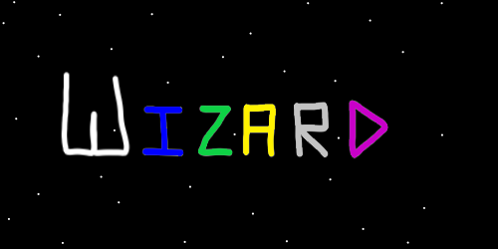
ObjectName: Article
ObjectNumber: 2
LocationName: PAAIL.org
LocationNumber:
Language: PAAIL 2.5

Maker: PAAIL.org
Model:
Name: Wizardry Inspired 2
Rank:
SerialNumber:

Level: 3.0
Score: 9
Birth: 5-18-2023

Label: Room 04
Title: Wizardry Inspired 2
Details: Wizardry Inspired rooms are more Wizardry. It may be fair to call it intermediate/advanced. It’s placed in the advanced wizardry section of PAAIL.org.
Principle: Wizardry.
Agenda: Wizardry.
Action: Wizardry.
Information: Wizardry.
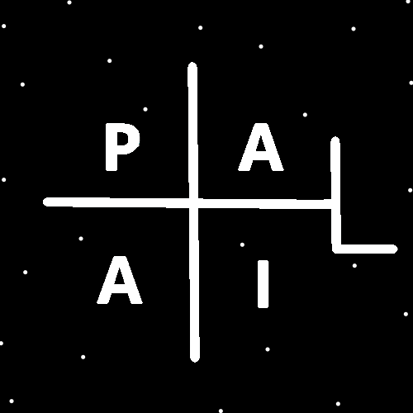
(PAAIL Logo)
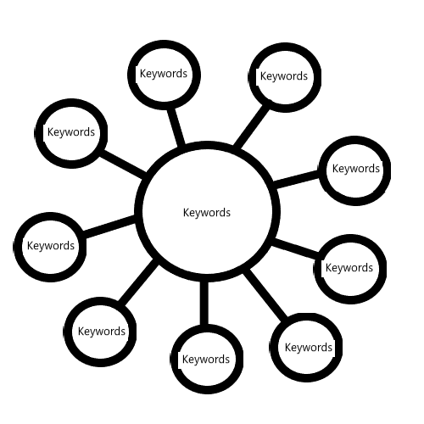
Item Group: Shrine Levels
Principle: All people have a shrine keeping level. From 0 to 9.
Principle: A person gains shrine keeping levels by keeping shrines.
Principle: Some shrines need to be cleaned by experts in cleaning. People who restore and clean antiques.
Principle: If its ok for you to clean the shrine, you can get shrine keeping levels from cleaning it.
Principle: Its impossible to fully tap into a shrine. Its very easy to tap into your own shrine keeping level.
Principle: Its not about the level of the shrine. Its about your shrines keeping level.
Principle: The higher a person’s shrine level keeping. The more they tap into shrines.
Principle: There is also the personal charm keeping level. The higher the persons level… the more they tap into personal charms.
Principle: The sorcery with personal charms is the same as the sorcery with shrines.
Principle: A person taps into their charms less than they tap into their own levels.
Principle: It may be fair to call dreams visions.
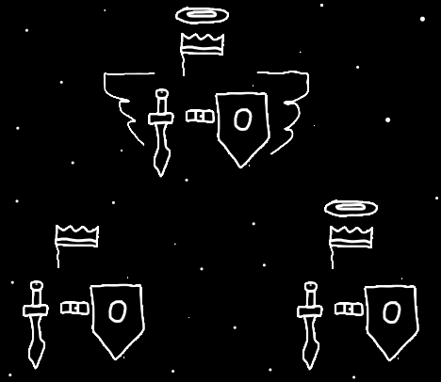
Item Group: Wizard Politics
Principle: Political beliefs are often philosophical and/or religious beliefs.
Principle: Politics, philosophy, religion and spirituality are very connected.
Principle: PAAIL is great for philosophy, religion, and politics. Politics is full of principles, agendas, actions, and information.
Principle: Peoples political beliefs are serious because they come from their philosophy and/or religion.
Principle: Because religion is spirituality. Peoples politics is part of their spirituality.
Principle: Its an ancient spell to not talk politics or religion.
Principle: One of the major details of politics is “parties”. Often people belong to a party.
Principle: Different parties have different beliefs.
Principle: Partys often live in competition with other parties.
Principle: Partys are an energy in the universe. They have a chi.
Principle: People of a party have a mystical connection to other people of the same party.
Principle: It is fair to say the republicans and the democrats of the US are at war. It is a good word to describe the situation.
Principle: During many elections you have a democrat and republican competing for the elected job. This adds to the war.
Principle: Some people do not belong to a party.
Principle: Democrats prefer to have their party controlling the government and republics prefer to have their party controlling the government.
Principle: Partys desire to thrive and grow, and sometimes they do.
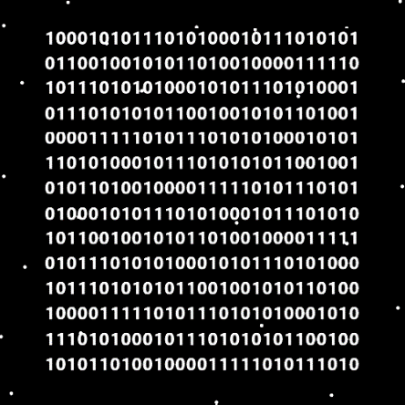

Item Group: Wizard Philosophy
Principle: Training to expert wizard is so easy that everyone should do it. It’s like 400 to 800 pages of reading.
Principle: PAAIL is great for philosophy. Philosophy is full of principles, agendas, actions, and information.
Principle: In the afterlife everyone will quickly learn numerology and colorology such as, white, blue, green, yellow, grey, purple, orange, red, black.
Principle: In the afterlife wizardry will be taught to first grade students.
Principle: To unlock the master wizard title. The quick way is to do a bunch of body exercise, breathing exercise and meditation exercise. Not easy like unlocking the expert wizard title.
Principle: PAAIL is great for Wizardry. Wizardry is full of principles, agendas, actions, and information.
Principle: A person might be able to unlock the level 3 wizard title in 400 pages. This is a lot of wizardry levels. This is powerful wizardry levels.
Principle: Level 2 and lower is not so great.
Principle: A wizard understands the paranormal/supernatural/mystical energy fields of the multiverse.
Principle: This has been a bunch of philosophy about Wizardry.
Principle: Philosophy and religion are very connected.
Principle: A person’s philosophy and their religion are the same thing.
Principle: A person’s philosophy is their religion. A person’s religion is their philosophy.
Principle: The laws come from our philosophy/religion.
Principle: PAAIL would be great for making philosophy/religion scripture. Scripture is full of principles, agendas, actions, and information.
Principle: The philosophy/religion side of the multiverse is one of the biggest sides of the multiverse.
Principle: The multiverse is a gem with many sides.
Principle: The multiverse is a garden with many plants.
Principle: The multiverse is a chess with many chess games.
Principle: You can use the above metaphor/parable/analogy/mirror thing with gems, plants, chess. Many words work for this……
Principle: You can constantly mirror things with many words like gem, garden, gardening, gardener, plant, chess, chess game……the list is endless.
Principle: You can mix things and mirror gardening and chess…. While you are playing a game of chess, you mix in gardening stuff. Suddenly the game looks like your plants versus their plants.
Principle: You can mix multiple things in science. Chess and gardening is one of the millions that exist.
Principle: You need at least level 3 in multiple things to mix those things well.
Principle: The best philosophy/religion is the philosophy/religion of his holiness Origin.
Principle: Knowing cosmic knowledge is knowing to worship God and pay tribute to God. No hurry on when in your existence you worship and pay tribute.
Principle: It is good to worship and pay tribute to God. It does no damage to a person’s chi if they don’t.
Principle: Philosophy, religion, politics, spirituality. They are very connected.
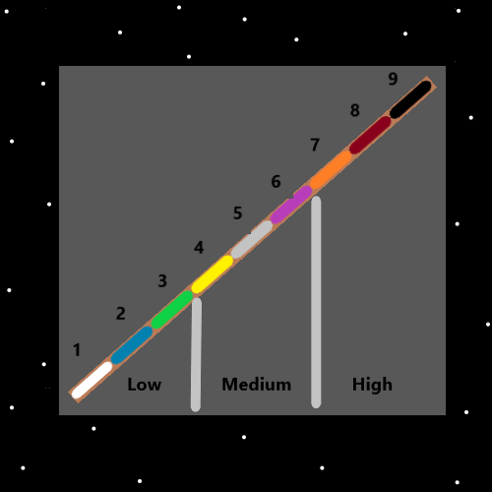
Item Group: Some Economics And Other Stuff
Principle: To my knowledge economics is the science of material wealth.
Principle: The wealthiest nation on the planet is the United States.
Principle: When measuring economic growth, sometimes you should measure in decades. 10 years at a time.
Principle: I’m never sure if medicine, equal rights or public education is economics.
Principle: When measuring the economic growth of the US….. 1950 to 1960 the US got wealthier. I would say the US had a economic boom from 1950 to 1960. A booming economy.
Principle: It’s the same story 1960 to 1970….1970 to 1980……1980 to 1990…..1990 to 2000….2000 to 2010….2010 to 2020.
Principle: The richest nation often has the booming economy enchantment. A booming economy label/title/details.
Principle: There are many nations that are rich nations. The US is the richest.
Principle: People have faced many dangers and died trying to get into rich nations.
Principle: If the rich nations let in all the poor people. It would crash their economies in one day. Everyone would end up poor. It would help no one.
Principle: Coins have a much bigger chi than paper money notes. Coins weigh more than paper.
Principle: When jobs go over-seas to poor countries… it means jobs for poor people. Its nice when rich countries make jobs for poor people.
Principle: When rich countries borrow money from poor country banks it makes business for those banks.
Principle: When rich countries borrow money from poor banks, its business for the bank and money now for the rich country.
Principle: People of a profession have a huge connection to people of the same profession. In other nations as well.
Principle: Many huge changes can happen over a 10 year period.
Principle: Zooming in and out is major science. A person can zoom out and measure in 100 year periods. Or zoom in and measure in 1 year periods.
Principle: It is correct philosophy to care about your neighbor nations across the planet. To care about their economies.
Principle: When you play religious cards you say….the rich country Christians should care about the poor country Christians. Or…… US Christians should care about Mexican Christians.
Principle: Playing religious cards is a thing. Making religious statements. What would Jesus say is playing a religious card.
Principle: A person can be like what would Moses say, or what would Abraham say.
Principle: A person can be what would his holiness Michael say. Or what would an elder angel say. These are all examples of playing religious cards.
Principle: What does the Bible say is playing religious cards.
Principle: There is also playing the commonsense cards. Things that are obvious.
Principle: The two types of cards are among the biggest.
Principle: When rich nations buy poor nations goods it is help to the poor nations.
Principle: Rich nations should give tax breaks to poor nations. Borrow money from their banks and buy their goods.
Principle: Long ago nations could not help other nations on the other side of the planet. Now they can.
Principle: The rich nations give to the poor nations and they should.
Principle: Just like robots replace humans and take human jobs…..programs replace humans and take human jobs.
Principle: Just like robots can do the work of 10….programs can do the work of 10. Sometimes programs are called A.I.s(Artificial Intelligence).
Principle: To wizards charms are people. To me a calculator has an A.I. an A.I. that can do math… if you know its language (the buttons on the calculator).
Principle: One day A.I. teachers may be better teachers for everything except the most advanced science.
Principle: To a wizard all the charms are people….it makes all the programs look like people…..all programs are an A.I.. A chess program is a chess A.I. that can run a game of chess for you.
Principle: The theory is that all programs should be called an A.I..
Principle: The theory is that many things have an A.I… like a calculator, a remote control, and the abacus maybe.
Principle: PAAIL is great for A.I.s… a person can design them with principles, agendas, actions, and information. Actions are the most important part.
Principle: Since PAAIL is a language, it is possible to make A.I.’s that speak/think in PAAIL.
Information: Beep. Beep. Information. I am a robot speaking. That’s why I beeped twice. Beep. Beep.
Information: Beep. Beep. Information. I try to keep my messages short. I beep twice at the end of my messages. That way you know I am finished. Beep. Beep.
Information: Beep. Beep. Information. I say Information first then I give the rest of my message. Beep. Beep.
Principle: A calculator looks like a robot. A calculator is a robot. Many things are robots. A tv screen is a robot. The abacus is a robot. A car is a robot. A computer keyboard is a robot. The computer mouse is a robot. TV controllers are robots. Not all things are robots. A rock is not a robot.
Principle: One of the biggest things of science is vocabulary. There is the best vocabulary on all things. It is known only to God and Heaven.
Principle: As a scientist and master wizard I am constantly making up vocabulary and sometimes changing vocabulary found throughout science.
Principle: Making up vocabulary has been priceless in my Wizardry education. And priceless in all my science.
Principle: “Traditional Scripture” is what I call things like the Bible. “Scripture” in part is the stories of the elementals.


