ObjectType: Article  
ObjectNumber: 06

LocationName: PAAIL.org

LocationNumber:

Language: PAAIL 2.5

Maker: PAAIL.org  
Model:   
  
Name: Wizardry Inspired 04

Rank:

SerialNumber:

Level: 3.0

Score:   
Birth: 6-01-2023

Label: Room 06

Title: Wizardry Inspired 04

Details: Wizardry Inspired rooms are more Wizardry. It may be fair to call it intermediate/advanced. It’s placed in the advanced wizardry section of PAAIL.org.

Principle: Wizardry.

Agenda: Wizardry.

Action: Wizardry.

Information: Wizardry.

(PAAIL Logo)

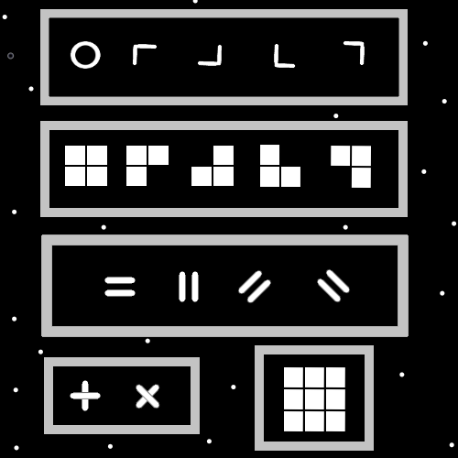

Item Group: The Spatial Tapestry

Principle: Max zoom in on the spatial dimensions (height, width, depth, time) gets to energy bits. It probably looks like a tapestry that came out of a loom. Each dimension an individual tapestry.

Principle: It may go that first there are the 1 line forms/symbols. Then there are the 2 line forms/symbols.

Principle: After the 2 line forms there may be the 3 line forms.

Principle: When you get to 3x3 squares you get many symbols/forms. Look at the map above, the bottom right section.

Principle: The numbers “A” and “-A” live in close proximity on a number line. They are similar because of this. Even though they are also opposites is some ways.

Principle: It may be the only difference between “A energy bits” and "-A energy bits” is that the “A”s are vertical and “-A”s are horizontal.

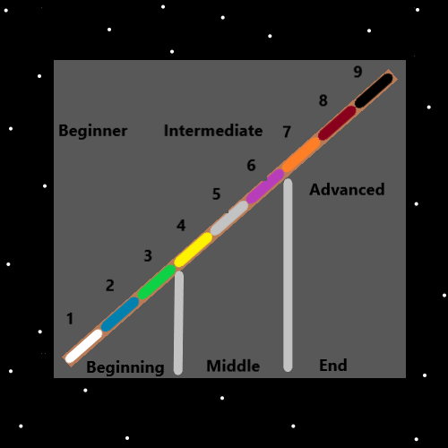

Item Group: Math

Principle: The main 2 operations are addition and subtraction.

Principle: The main 4 operations are addition, subtraction, multiplication, and division.

Principle: There is such thing as the main 8 operations.

Principle: It may be that there is the main 16 operations. The main 32 operations, the main 64 operations

Principle: It may be that 2 to the power of 2 is 1 of the main 8 operations.

Principle: It may be that 57 to the power of 86 is 1 of the main 8 operations.

Principle: It may be that there are an infinite number of operations.

Principle: Operations are one of the biggest math details.

Principle: It may be that some operations don’t exist yet as a part of the multiverse, however will one day.

Principle: It may be that all operations are an algorithm.

Item Group: Physics

Principle: In physics there is the 4 forces. Gravity, electromagnetism, the strong nuclear, and weak nuclear forces.

Principle: The 4 forces come from the 2 forces. The “addition force” and the “subtraction force”.

Principle: 2 of the four forces are addition forces and 2 of the four forces are subtraction forces.

Principle: There are the 3 zoom levels in physics. The small picture zoom level, the big picture zoom level and the in between zoom level. The small picture is also called the quantum view. The big picture the cosmic view.

Principle: Particle accelerators can be used to mirror the big bang.

Principle: You would think particle accelerators would have a huge amount of practical, and important use. They may one day.

Principle: All particles have a surface. All particles have a form.

Principle: All particles have a symbol, and a number.

Principle: A painting of a cow and a photograph of a cow are both pictures of a cow.

Principle: If you can’t see it in a microscope, you can still use a computer and screen to generate a physical form view of it.

Principle: There are an infinite number of dimensions. Not just height, width, depth, and time. The spiritual side of the multiverse is a dimension. Planet Earth is a dimension of the multiverse.

Item Group: Biology

Principle: Biology deals with life.

Principle: Human cells are lifeforms. They are alive.

Principle: Sensing the cells of your body is a spell. Sense the life forms that make your body.

Principle: Medical experts are always saying eat right and get exercise. Some times junk food and no exercise have psychological benefits. Mind benefits with a sacrifice to the body.

Principle: Sometimes eating right is eating junk food. Sometimes the right amount of exercise is zero.

Principle: Pain and/or discomfort may be caused by cells in the body experiencing pain and/or discomfort.

Principle: Local anesthetics may cause cells to be knocked unconscious. Substances that numb an area.

Item Group: Random

Principle: Some wars have helped God. Some wars have not.

Principle: The biggest alchemy is the shrine charm, personal charm, and collectable charms.

Principle: The vocabulary word is charm… that seems better than constantly saying “physical object”.

Principle: The charms of our lives. Instead of the physical objects of our lives.

Principle: Since our body is a physical object our body is a charm. We live in a charm.