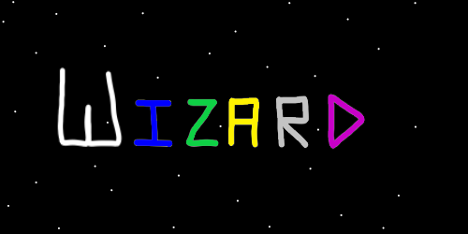
ObjectType: Article
ObjectNumber: 08
LocationName: PAAIL.org
LocationNumber:
Language: PAAIL 2.6

Maker: PAAIL.org
Model:
Name: Wizardry Evolved 1
Rank:
SerialNumber:

Level: 4.0
Score:
Birth: 6-28-2023

Label: Room 08
Title: Wizardry Evolved 1
Details: Wizardry more evolved.
Principle: Wizardry.
Agenda: Wizardry.
Action: Wizardry.
Information: Wizardry.
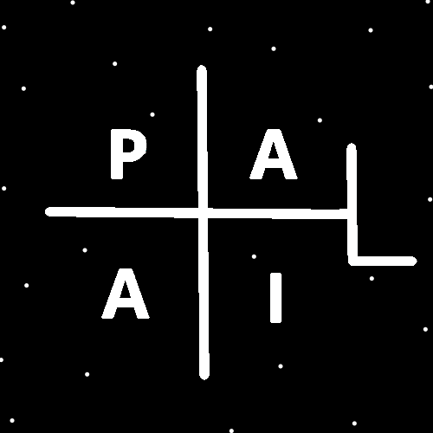
(PAAIL Logo)
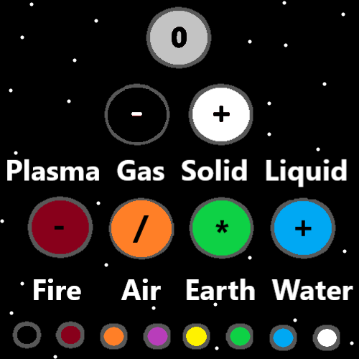
Item Group: State Of The Art Wizardry
Principle: When book “Tome of the Yellow Wizard” was released. Reading it combined with body exercise, breathing exercise, and meditation exercise, was enough to get to expert wizard. Yellow Wizard. This is partly why it was named Tome Of The Yellow Wizard. Yellow is colorology.
Principle: Tome of the Yellow Wizard was a 1.0 Science Level of Wizardry. Expert. However 1.0.
Principle: Add Wizardry Practice 0A and Wizardry Practice 0B and you have a Level 2.0 Wizardry Science Level.
Principle: Add everything else and you have a level 3.0 Wizardry Science level. With expert and master as options.
Principle: Now we are at level 4 and that is why this room has a level 4.0.
Principle: The way it is now. A person can read everything and get to Expert Wizard. They need no body exercise, breathing exercise or meditation.
Principle: If a person wants to get to Master Wizard they have to do a bunch of body exercise, breathing exercise and meditation exercise. On top of the reading.
Principle: With many years of body exercise, breathing exercise, meditation exercise and study a person could get to Level 6 Wizard.
Principle: The author is a Level 5 Wizard. I don’t even know what to call level 6. Sage Wizard, Grand Wizard, High Wizard, Doctor of Wizardry.
Principle: It seems like a doctor of something should take more than 800 pages. Perhaps a bunch of astrology should be mandatory for that.
Principle: Learning about chakras should probably be mandatory for a doctorate of wizardry.
Principle: Many things should probably be mandatory for a doctorate in wizardry.
Principle: There are many different path options from level 5 to level 6.
Principle: The really nice thing is that reading 400 to 800 pages is not really a lot. A person can probably be an expert Wizard in one month.
Principle: A person can take the ultra easy, and slow path by making it three months. Three months to expert wizard.
Principle: All levels of Wizardry are a Wizard.
Principle: Even White Wizard is a big chi enhancement. You get that in like the first 100 pages.
Principle: Enchantments are cast upon a person. Then they grow after that.
Principle: White Wizard is enchantments on a person. They grow after first being established.
Principle: As people age their enchantments grow to higher levels.
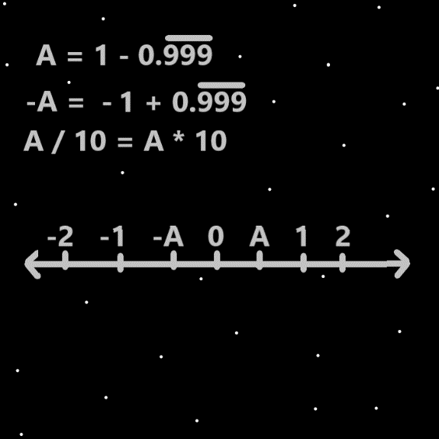
Item Group: Sorcery Expert
Principle: The author is at level 3 sorcery. Lots of sorcery knowledge. He has not done the sorcery spells training though. Still working on Smith Summons Spells.
Principle: There would be more to say about sorcery if the author were at level 4.
Principle: To obtain level 4 sorcery you have to train it. This requires lots of body exercise, breathing exercise, and meditation exercise.
Principle: A person could make it to level 4 sorcery with meditation and breathing exercise.
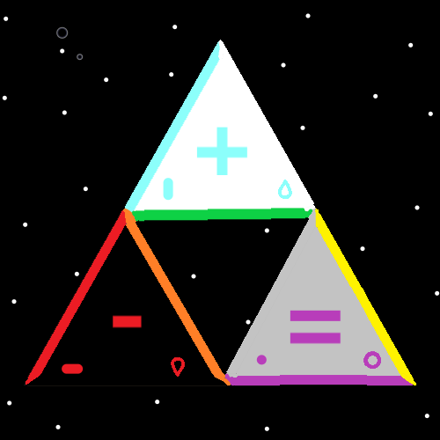
Principle: There are often many different paths from one location to another. From level 3 sorcery to level 4.
Principle: The knowledge learned from PAAIL.org is enough to get a person to level 3 sorcery.
Principle: The theory is that if you split an “energy bit” particle you get more “energy bit” particles. Thus A/10 = A*10.
Principle: Because Wizardry has been under tons of research and development Wizardry has evolved a lot. Many principles that should be taught at the beginning, aren’t taught until the end.
Principle: When the author started writing Tome Of The Yellow Wizard, many of these things were not known.
Principle: The author does not know any astrology or anything about chakras. That’s one reason why you never hear about them.
Principle: There are many things like astrology and chakras that the author does not know.
Principle: Even numerology books that don’t have a 0 to 9 numerology system are likely to have ultimate numerology.
Principle: It may be that soon after hitting level 1 Wizard a person turns into a paranormal creature.
Principle: For a Wizard the universe becomes more paranormal, supernatural and mystical.

