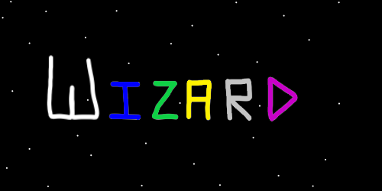
ObjectType: Article
ObjectNumber: 08
LocationName: PAAIL.org
LocationNumber:
Language: PAAIL 2.6

Maker: PAAIL.org
Model:
Name: Wizardry Evolved 2
Rank:
SerialNumber:

Level: 4.0
Score:
Birth: 7-5-2023

Label: Room 09
Title: Wizardry Evolved 2
Details: Wizardry more evolved.

Principle: Wizardry.
Agenda: Wizardry.
Action: Wizardry.
Information: Wizardry.
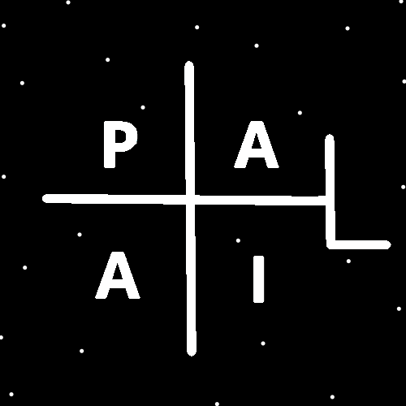
(PAAIL Logo)
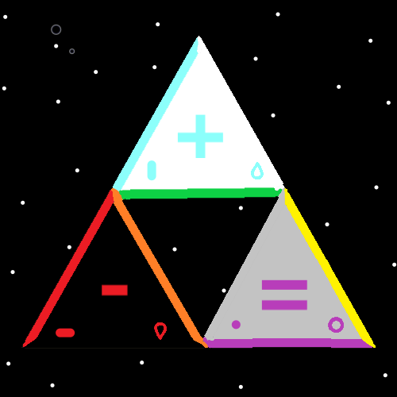
Item Group: Visions Evolved
Principle: The latest and greatest in Wizardry is understanding that when you think of a rock you are having a vision of a rock.
Principle: Controlling your visions is a spell.
Principle: Thinking of a rock is a vision spell.
Principle: Picturing a rock while meditating would be adding a spell part to the meditation.
Principle: Adding visions is a powerful spell part.
Principle: A person could add picture a chess piece while they do chess spells.
Principle: Visions is big sorcery.
Principle: These vision principles are rather new principles.
Principle: I’m liking the vocabulary of toxin induced visions to be called Vivid Visions.
Principle: Massive hallucination visions could also be called vivid visions.
Principle: Rare circumstances can lead to Vivid visions. There are other ways than toxins that cause them.
Principle: If you don’t have a legal environment for using toxins you should never do it. It is extremely dangerous and bad karma.
Principle: Medical doctors know tons of legal ways to generate Vivid Visions. Some ways don’t even include toxins.
Principle: Fevers can induce Vivid Visions. Often bad ones. Never use this method.
Principle: Once in my life I was crouching. I stood up too fast. The blood rushed to my head. I blacked out for a couple of seconds. I had a Vivid Vision. It was exactly like a dream you can remember very well. Danger, don’t intentionally do this, unless you have a medical doctor for safety.
Principle: Dreams seem like a vision. It may be fair to call dreams visions. It may be fair to call them Vivid Visions.
Principle: Always abandon dream interpretation of bad dreams. Never do it.
Principle: I suppose if there is dream interpretation, and dreams are visions. Then there is vision interpretation.
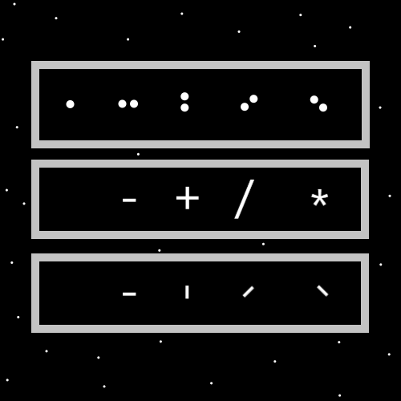
Item Group: Higher Levels
Principle: The higher your Wizardry level the higher your paranormal, supernatural, mystical experience.
Principle: Wizardry levels increase your ESP levels.
Principle: The higher your ESP levels the more paranormal, supernatural, mystical experience.
Principle: More ESP levels makes the music and other art a more paranormal, supernatural, mystical experience.
Principle: Wizardry is the ultimate powerup to a persons chi.
Principle: When a person has spent a year being a white wizard they grow huge enchantments.
Principle: There is enchanting charms. There is enchanting people. There is enchanting yourself.
Principle: Training Wizardry is enchanting yourself. Like you would enchant a charm.
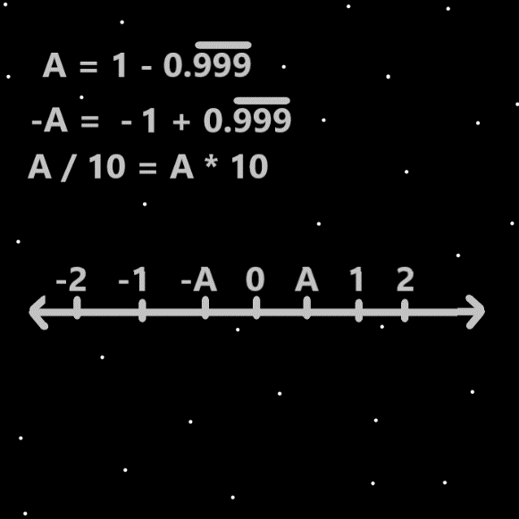
Item Group: More Physics
Principle: Understanding major details like “energy bits” can be paranormal, and thus supernatural.
Principle: Understanding major details like “energy bits” is cosmic knowledge. It has a huge mystical side to it.
Principle: Understanding “energy bits” is physics. It is also Wizardry.
Principle: Understanding the core of all things is positive and negative energy bits… is understanding at the core of all things is positive and negative.
Principle: The first dimension, width. Is the subtraction dimension.
Principle: The 2nd dimension, height, is the addition dimension.
Principle: The 3rd dimension, depth, is the division dimension.
Principle: The 4th dimension, time, is the multiplication dimension.
Principle: At first the Principle Agenda for the author was to gain Wizardry levels. Writing all these articles has been a ton of research and development of Wizardry.
Principle: Principle Agenda is a new term in PAAIL. It means the highest agenda.
Principle: Many things were learned after writing the first book “Tome of the Yellow Wizard”.
Principle: At the end of writing Tome of the Yellow Wizard, Wizardry was at Level 1.0. Now it is at 4.0.
Principle: Energy bits is basic science. All people should understand energy bits.
Principle: If I were to give my advice to the world. The best I can come up with is train Expert Wizard.
Principle: A person can take a long path of training Wizardry. 2 hours a week of reading. For 4 years might be enough to get Expert Wizard.
Principle: The principle agenda is train expert wizard. Master Wizard is not so important.
Principle: I really don’t know how long it takes to train expert wizard. It seems like not much to me though. It seems like training Expert Wizard takes no time at all, and is very easy to learn.
Principle: Even low white wizard has a huge impact.
Principle: I think white wizard is read the first 100 pages of “Tome of the Yellow Wizard”.
Principle: It is likely that there are already an infinite amount of dimensions.
Principle: The first 4 dimensions line up with the 4 process’s. Addition, subtraction, division, and multiplication.
Principle: The first 8 dimensions lines up with the first 8 operations.
Principle: If I were a math expert I might know what the 8 operations are. I think it works the first 4 are….addition, subtraction, division, and multiplication.
Principle: At max zoom in level. The universe is a bunch of code. Exactly like we are living in a computer program.
Principle: When there are no apples in the basket, there is a line of code that makes it so.
Principle: The multiverse has an infinite amount of code to it.
Principle: Every detail that is true, has a line of code that makes it true.
Principle: Throughout all the Wizardry writing of PAAIL.org. You find principles stated multiple times. Though this seems bad. The truth is that the Principles improve over time, and are worth reading multiple times.
Principle: Looking at ultimate symbols is good on the brain. Such as the circle, or the plus symbol. Many maps provided have ultimate symbols.
Principle: All of the core symbols are ultimate symbols. Such as the horizontal line, or the vertical line, or the division symbol.
Principle: The 1 pointed seed is a core symbol.
Principle: 100 pages and poof you’re a white wizard.
Principle: A year after hitting white wizard a persons enchantments have had time to grow. Enchantments age. They grow.
Principle: Hitting white wizard unlocks a bunch of enchantments.
