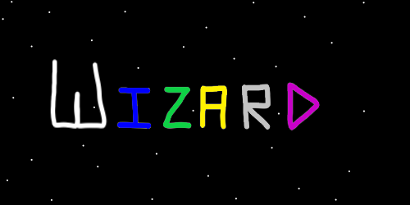
ObjectType: Article
ObjectNumber: 10
LocationName: PAAIL.org
LocationNumber:
Language: PAAIL 2.6

Maker: PAAIL.org
Model:
Name: Wizardry Evolved 3
Rank:
SerialNumber:

Level: 4.0
Score:
Birth: 7-7-2023

Label: Room 10
Title: Wizardry Evolved 3
Details: Aged Wizardry. Wizardry more evolved.

Principle: Wizardry.
Agenda: Wizardry.
Action: Wizardry.
Information: Wizardry.
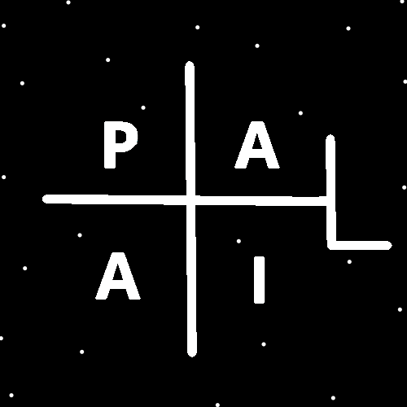
(PAAIL Logo)
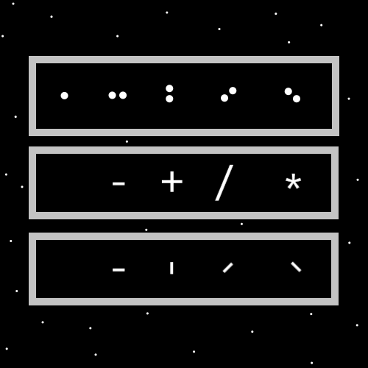
Item Group: Wizardry Evolved 0
Principle: It occurred to me that believing these things amounts to a religion. Since it has religious science, such as the belief in his holiness Origin.
Principle: Be a Wizard! Read Wizardry at least 1 hour a week.
Principle: Private schools could focus more on body exercise, breathing exercise and meditation exercise.
Principle: The author gains Wizardry levels by doing all this writing. Its one reason he likes to do it.
Principle: Jesus was an alien.
Principle: Aliens walk amongst us.
Principle: People are abducted by aliens.
Principle: A ton was learned after the writing of Tome of the Yellow Wizard.
Principle: It would be better if Wizardry training starts with the ultimate sorcery. Smith Summons spells. Word Write 10x Spells. Personal charms. Shrine charms. Collectable charms.
Principle: If I were to rewrite it all I would make the first 200 pages, ultimate sorcery and the biggest of the cosmic knowledge.
Principle: As it is. The ultimate sorcery doesn’t come until after Tome of the Yellow Wizard. And the best sorcery shows up way down the road.
Principle: Since the author is only a level 3 sorcerer it is still under much research and development.
Principle: The author has taken the longest of paths, and is still training the Smith Summons spells, and has done no Word Write 10x spells.
Principle: Do what I say. Not what I do.
Principle: The only time I do Smith Summons spells is when I am training them. After I finish training them I will use them at other points in my life.
Principle: All major secrets of the multiverse have been revealed.
Principle: The most important side is the spiritual side. The spiritual side has been explained in great detail.
Principle: I live in shock about two things. There is a God, and that I have heard all the major secrets. I don’t really have any more questions.
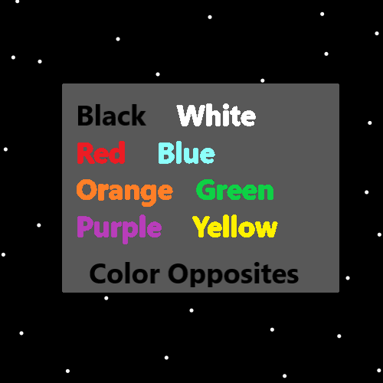
Item Group: Wizardry Evolved 1
Principle: Three vocabulary terms are, “solo meditation”, “group meditation”, and “guided meditation”.
Principle: Solo meditation is when you meditate all alone. Group mediation is when it is more than one person. Guided meditation is when someone assists others during meditation.
Principle: Guided meditation can happen when there is just 2 people involved. It can happen when there are many people involved.
Principle: A person could listen to an audio track that does guided meditation for the person. This would in some ways be a solo meditation.
Principle: Group meditation is more powerful. If you add a peace and quiet spell part to it, it becomes more peaceful and quiet. This counteracts the large disturbance it is.
Principle: “Meditation Guide” should be vocabulary for Wizardry. Also “Meditation Guides”.
Principle: Sometimes solo meditation is the best choice. Sometimes group meditation is the best choice. Sometimes one guide and one person doing the meditation is best.
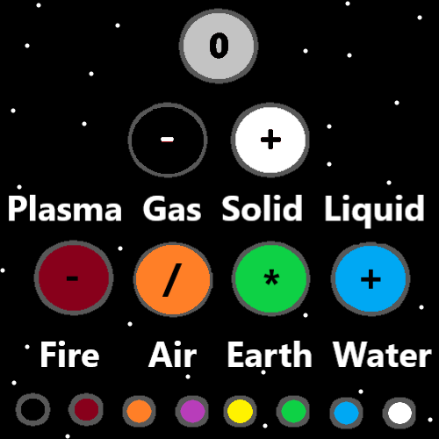
Item Group: Alchemy Evolved 0
Principle: Caffeine is a more paranormal, supernatural, mystical substance.
Principle: Mix some caffeine powder into some water and you do alchemy.
Principle: Mix some caffeine powder into any drink is doing alchemy.
Principle: Some people intake too much caffeine. Some people intake too little.
Principle: Caffeine is a powerful tool.
Principle: Many drinks may be improved by adding caffeine.
Principle: Caffeine should likely be called a toxin.
Principle: There is no time travel and there never will be time travel. There might sometimes be events that look like time travel.
Principle: All toxins are likely powerful, paranormal, supernatural substances. Most of them strong with the dark side and very bad to use. Don’t use those. It always goes bad.
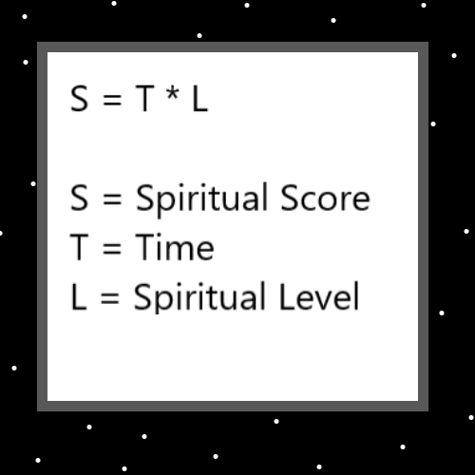
Item Group: The Story
Principle: “In the beginning, God created the Heavens and the Earth.”. The first sentence of the Bible. It serves as teaching, and as evidence of certain details.
Principle: One teaching is that there is such thing as the beginning.
Principle: One teaching is that there is a God.
Principle: One teaching is that God created both the Heavens and the Earth.
Principle: One teaching is that both the Heavens and the Earth were created during the beginning.
Principle: From the information provided we can make educated theories about more.
Principle: One theory is that God existed before Heaven and Earth. If God created them, it would seem he came before them.
Principle: One theory is that it is important to know all these principles. That’s why it’s the first sentence of the Bible.
Principle: The theory is that it’s important to know there is a beginning.
Principle: The theory is that its important to know there’s a God.
Principle: The theory is that its important to know there is a Heavens and Earth.
Principle: The theory is that its important to know that God created the Heavens and the Earth.
Principle: The theory is that the first sentence of the Bible explains things to us.
Principle: The multiverse is a story. It starts at the beginning of the beginning. The Origin moment.
Principle: Stories are one of the ultimate fine things. We all love movies. Some love books. Many stories have been told around a campfire.
Principle: As for evidence. This all becomes evidence for theories.
Principle: If this universe is Heaven. Then God existed before this universe.
Principle: If God created this universe, and God has a body. Gods body likely exists outside of this universe.
Principle: If there is a God body, then it likely is smaller or bigger than this universe.
Principle: The author has spent much time on theories and very little time writing about the evidence of it all. The evidence does exist though.
Principle: That’s where theories come from. Evidence.
Principle: The author could have spent tons of time writing the evidence. It wouldn’t have been as entertaining or to the point.
Principle: Writing evidence would have been less Wizardry level gain for myself, and less level gain per page for people reading.
Principle: There are the three realms. The Heaven realm, the Earth realm, and Gods realm, whatever it be called.
Principle: Some powerful spells are things like get some fresh air. Or go for a walk.
Principle: If you have read all PAAIL.org Wizardry, then a long while back you hit level 4, expert, yellow wizard.
Principle: A person should read all Wizardry from PAAIL.org. And keep reading it as more comes out.
