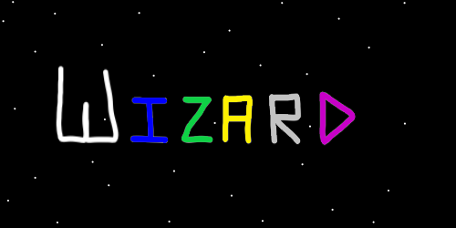
ObjectType: Article
ObjectNumber: 11
LocationName: PAAIL.org
LocationNumber:
Language: PAAIL 2.6

Maker: PAAIL.org
Model:
Name: Wizardry Evolved 4
Rank:
SerialNumber:

Level: 4.0
Score:
Birth: 7-14-2023

Label: Room 11
Title: Wizardry Evolved 4
Details: Aged Wizardry. Wizardry more evolved.

Principle: Wizardry.
Agenda: Wizardry.
Action: Wizardry.
Information: Wizardry.
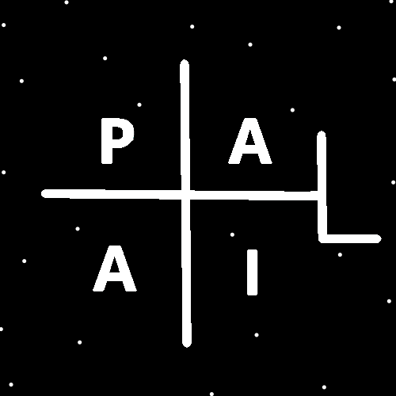
(PAAIL Logo)
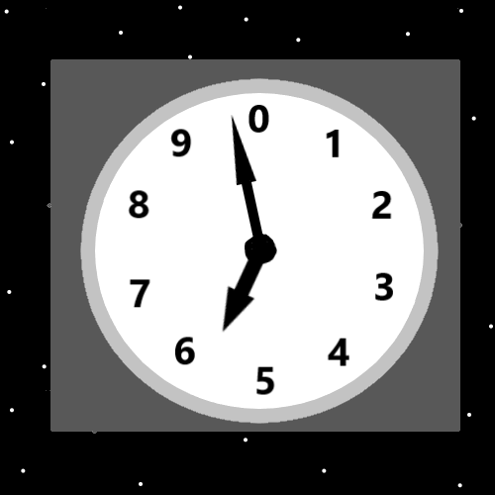
Item Group: Wizardry Evolved 0
Principle: Wizardry is paranormal, supernatural, mystical science. Wizardry is paranormal, supernatural, mystical powers.
Principle: Paranormal, supernatural, mystical powers is a great powerup to everything a person does.
Principle: Wizardry is a big powerup to people who learn it. Even low levels of Wizardry like White Wizard.
Principle: If White Wizard is 100 pages. Then it takes very little time to unlock the White Wizard title.
Principle: Once a person gains the White Wizard enchantment. It takes time for enchantment levels to grow. At least a month.
Principle: Under the right circumstances a person is what you could call an “Aged White Wizard”. Meaning its been at least a month and they are still only at level White.
Principle: Ageing things has been mentioned before. Its something in alchemy and in other things as well.
Principle: There is such thing as an “aged yellow wizard”, an “aged expert wizard”. Someone who has been a level 4 wizard for a year.
Principle: The author is running out of stuff to write. We are starting to hear a summary of things and a repeat of things.
Principle: One of the biggest principles is teaching the power of body exercise, breathing exercise, and meditation exercise.
Principle: Training Wizardry adds to a persons mind properties. It boosts a persons mind level.
Principle: Training Wizardry boosts mind levels.
Principle: All honest work boosts about the same amount of spirit levels.
Principle: Body exercise can boost body levels.
Principle: When you touch something (and some things you are not supposed to touch)….when you touch something you go into it, and it into you…like Legos. This makes a huge connection between you and the item.
Principle: Seeing an item also makes a huge connection to an item. Hearing it as well. Sensing it in any makes a huge connection.
Principle: The spiritual side of the multiverse is the only side that matters.
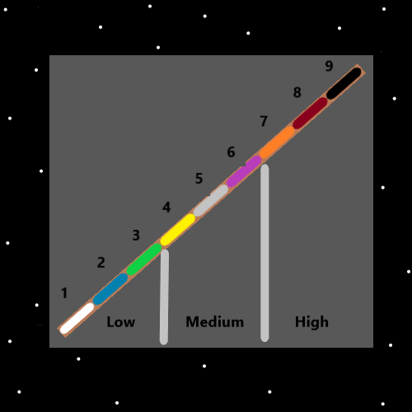
Item Group: Wizardry Evolved 1
Principle: Bowing, breathing, and making fists drain mana. They are useful as a part of divination.
Principle: If you’re like the author you have learned the Sorcery knowledge that gives you level 3 Sorcerer. Amateur Sorcerer. Green Sorcerer.
Principle: If you have finished the training. Smith Summons Spells, Word Write 10x spells. Done the alchemy for your Shrine, your personal charm, your collectable charms. If you have done all that, you are level 4 Sorcerer, Expert Sorcerer, Yellow Sorcerer.
Information: The author is currently a level 3 sorcerer.
Principle: Lots of body exercise, breathing exercise, and meditation exercise, along with the knowledge can get a person to Expert Sorcerer also.
Principle: The end of the road in Wizardry is probably level 6. Levels 7, 8 and 9 are uncommon levels all throughout reality.
Principle: Sometimes level 6 is also known as level 60.
Principle: All humans have a huge chi. All people are at least level 1 Sorcerers. Though not level 1 Wizards.
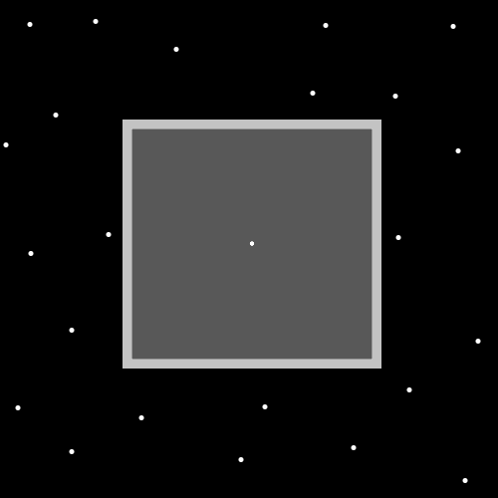
Item Group: Wizardry Evolved II
Principle: In numerology 7, 8, and 9 are known as the paranormal, super natural numbers.
Principle: Wizardry is the paranormal super natural science.
Principle: All science has a numerology number. Wizardry is a category 9 science.
Principle: Wizardry is an all powerful science.
Principle: The internet is likely a 6 or 7.
Principle: The dot symbol is the symbol of the zero moment. The origin moment. It has a huge connection to his holiness Origin.
Principle: Wizardry as said is a huge inspiration when fused with other science.
Principle: The physics inspirations that you have read (such as energy bits, and the 4 elements) these inspirations come from being a Wizard.
Principle: All the physics principles are inspired by me being a Wizard.
Principle: The author is a green sorcerer. Meaning beginner.
Principle: Green in colorology means beginner.
Principle: Sometimes people use the word green to describe someone being a beginner.
Principle: It is no coincidence that the word green is used to describe a person as beginner, and that in colorology it means beginner.
Principle: The theory that the universe goes back to a zero moment is physics. It was inspired by me being a Wizard. And it may be right to describe it as Cosmic Knowledge.
Principle: If you don’t remember the theory is that the zero moment is before the existence of time.
Principle: Thinking about it all, and how so much of this adds up to a religion. I hope you convert.
Principle: Wizardry is a science. Some of it is not religious details.
Principle: As for Expert Wizard or Master Wizard. Master Wizard is get yourself to level 4 Sorcerer. Expert Wizard is only level 3 Sorcerer.
Principle: Of course there are levels within levels. Sorcery is a level inside your Wizard level.
Principle: Doing the level 4 sorcerer training. Body exercise, breathing exercise, and meditation exercise. It can be extremely good for the spirit, mind, and body.
Principle: If you have read and largely memorized all PAAIL.org Wizardry. Congratulations…. You are an Expert Wizard.
Principle: If you did all the sorcery training on top of the reading….congratulations you are a Master Wizard.
Principle: If you made it to level 4 Sorcery. Congratulations you are an Expert Sorcerer.
Principle: Since Wizardry is entirely engineered by me, we have a problem. The problem is I am not a General Science expert, not a Education Expert, and my writing skills are terrible.
Principle: It may be that this writing format is worse than a normal book. Which has chapters, paragraphs, and sentences.
Principle: Many principles weren’t learned until after Tome Of The Yellow Wizard. Principles that should come at the beginning of Wizardry teaching.
Principle: The entire Wizardry science could use a rewrite. Tome of the Yellow Wizard is sort of out of date. So is Wizardry Practice 0A and 0B.
Principle: The sorcery training should probably be at the beginning of Wizardry (Smith Summons Spells/Word Write 10x Spells). So should the charms alchemy. Shrine charm. Personal charm. Collectable charms.
Principle: Its not about the levels of your shrine. Its about the levels you gain by keeping shrines. Switching to new shrines all the time is fine.
Principle: The higher your shrine levels, the more you tap into your shrine.
Principle: Its not about the levels of your personal charm. Its about the levels you gain by keeping personal charms. Switching to new personal charms all the time is fine.
Principle: The higher your personal charm levels, the more you tap into your personal charms.
Principle: Its not about the levels on your charms. Its about being able to tap into your charms. This is done with your own chi levels.
Principle: Charms sometimes do need enchantments though. If you play chess you want to add the chess enchantment to your shrines and personal charms.

