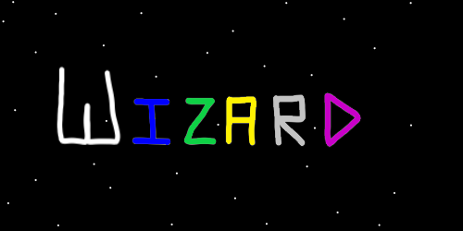
ObjectType: Article
ObjectNumber: 12
LocationName: PAAIL.org
LocationNumber:
Language: PAAIL 2.6

Maker: PAAIL.org
Model:
Name: Wizardry Evolved 5
Rank:
SerialNumber:

Level: 4.0
Score:
Birth: 7-23-2023

Label: Room 12
Title: Wizardry Evolved 5
Details: Aged Wizardry. Wizardry more evolved.

Principle: Wizardry.
Agenda: Wizardry.
Action: Wizardry.
Information: Wizardry.
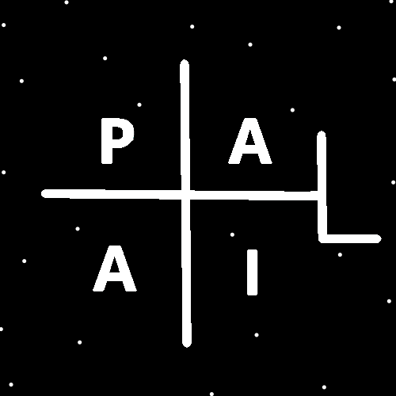
(PAAIL Logo)
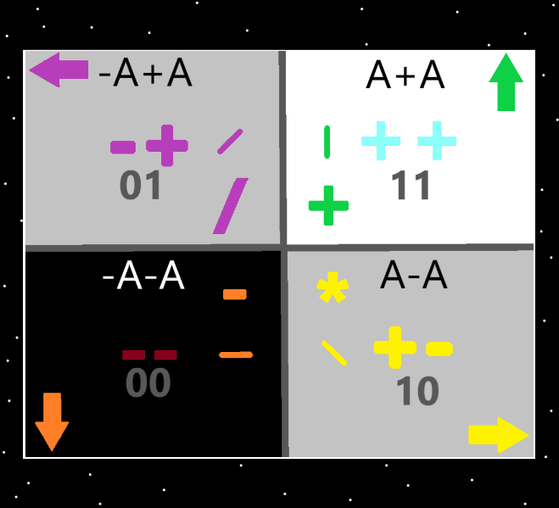
Item Group: Evolution 0
Principle: If you have read it all. Then you have learned all major secrets of the multiverse.
Principle: As said before. I am often shocked by the fact there is a God and that I have learned all the major secrets of the multiverse.
Principle: There are an infinite amount of secrets to the multiverse. There is only a limited number of “major secrets”.
Principle: It feels like I left out the fact we live forever. We do, we live forever.
Principle: His holiness Light is our true father. His holiness Origin is our true grandfather.
Principle: There are two types of tiny toons on earth. The students and the teachers.
Principle: Humans are tiny tunes because on a cosmic scale their lives are so short.
Information: “That’s all folks!”-Porky Pig.
Principle: If you are an expert at chess you are in the ultimate book of chess. A real book that exists right now. It resides in Heaven.
Principle: If you are expert at chess and you have a chess collectable. That item is listed in the ultimate book of chess.
Principle: Its almost criminal for a expert at chess to not have a chess collectable item.
Principle: A chess board and pieces would be your collectable if that’s all you have. You really want something more though. Like a second board and pieces or something else.
Principle: People equip all kinds of things. Your home is something you have equipped. All your stuff is something you have equipped.
Principle: Its not about the levels of your equipment. It never matters, because you cant fully tap into them.
Principle: Certain charms, and older charms do have higher levels. You still never can tap into them.
Principle: Its all about your charm wielding levels. Not the levels of your charms.
Principle: Some scissors are better than others. They cut better. Its fair to say some scissors have a higher level in that regard. Some times levels of the charm do matter.
Principle: An angel can read the ultimate book of chess in 10 minutes of their time. Cosmic time.
Principle: Angels can do more math in their head than super computers of earth.
Principle: Angels can count from 0 to 1 million in a few seconds of their time. Cosmic time.
Principle: In Heaven its trillions of people and yet it feels like a small family. That’s Gods family.
Principle: The heavenly family size will increase for all eternity as well. It will always stay the size of a small family.
Principle: As time passes more powerful bodies will exist. Bodies more powerful than the current star bodies.
Principle: We will be hopping bodies for all eternity. Getting new bodies every so often.
Principle: The greater power from new bodies will allow for the family size to grow and yet stay a small family experience.
Principle: I love the latest that the symbols for subtraction, addition, division and multiplication have been discovered by me.
X2 Information: Symbols
- I / \
Principle: These are the symbols of the 4 elements.
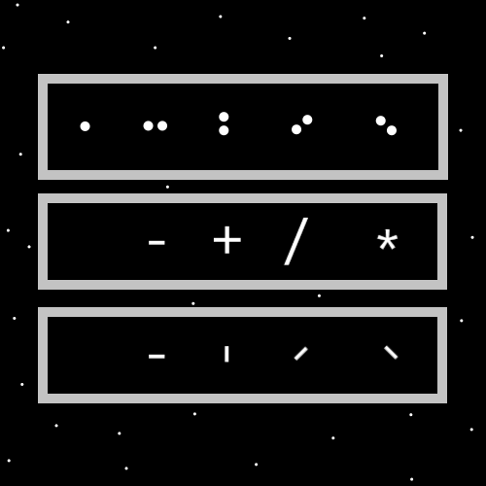

Principle: Its possible that the division symbol is \ and the multiplication symbol is /.
Principle: Its good for the mind to know about the 4 elements and their symbols. Earth, air, fire and water. Addition, subtraction, multiplication, and division. 11, 10, 01, 00……..++, +-, -+, --….
Principle: If you can believe it. I sometimes feel like I understate how empowering Wizardry is.
Principle: Wizardry is easy to learn, it takes very little time, and is a huge powerup to the chi. A huge powerup to the mind.
Principle: The thing I always wonder about is if protons, neutrons, and electrons are alive. My educated guess….50% chance at least one is.
Principle: I have tried to make Wizardry education Wizardry science. Some things have religious implications though.
Principle: Like God has many names the 4 elements have many names. They are known as the 4 elements, the 4 operations, sometimes known as the 4 forces, and other names as well.
Principle: Its likely the 4 elements have been known as the 4 powers.
Principle: I heard the word cosmology recently. It seems like a vocabulary word you would find in Wizardry.
Principle: I am starting to like the PAAIL format. I would hate the difficulty of making chapters, paragraphs and sentences.
Principle: With PAAIL format you have the ability to leap off onto any tangent, anytime you want.
Principle: I’m the biggest mad scientist of them all!
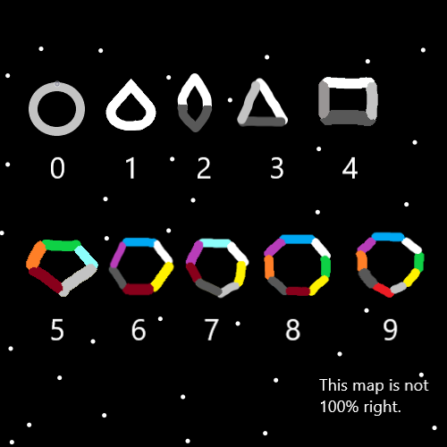
Principle: We’re all a little loony.
Principle: Eventually there will be no animals. Plants probably. No animals.
Principle: A person deserves better than being put in an animal body.
Principle: All this Wizardry writing could likely be used for some nice divination. This room for instance. There are tons of key options. You could do every word in this room….with the letter a.
Principle: Better divination would be to use your initials.
Principle: Another divination you could do would be to use the word “power” with this room. Or use the word “Wizardry”.
Principle: Picking the right book can be a major part of divination. If you want divination about particle physics you use a particle physics book. If you want divination about chess, you use a chess book.
Principle: Since this writing is about Wizardry it is especially good for doing divination about Wizardry.

Principle: Since this writing is paranormal Wizardry writing it is probably good for doing divination on everything. Even chess and particle physics.
Principle: If you made an AI that throws out random divination. It would be like what God says to the prophets. Riddles.
Principle: If you made an AI that throws out random divination. Sometimes it would come from the light side, or twilight side. If you’re a good person, most of the time is probable.

