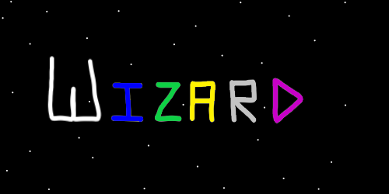
ObjectType: Article
ObjectNumber: 13
LocationName: PAAIL.org
LocationNumber:
Language: PAAIL 2.6

Maker: PAAIL.org
Model:
Name: Wizardry Evolved 6
Rank:
SerialNumber:

Level: 4.0
Score:
Birth: 7-23-2023

Label: Room 12
Title: Wizardry Evolved 6
Details: Aged Wizardry. Wizardry more evolved.

Principle: Wizardry.
Agenda: Wizardry.
Action: Wizardry.
Information: Wizardry.
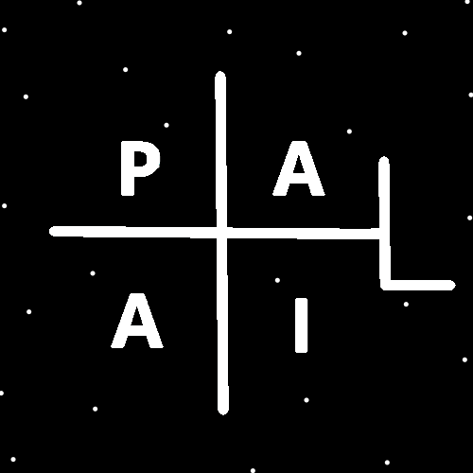
(PAAIL Logo)
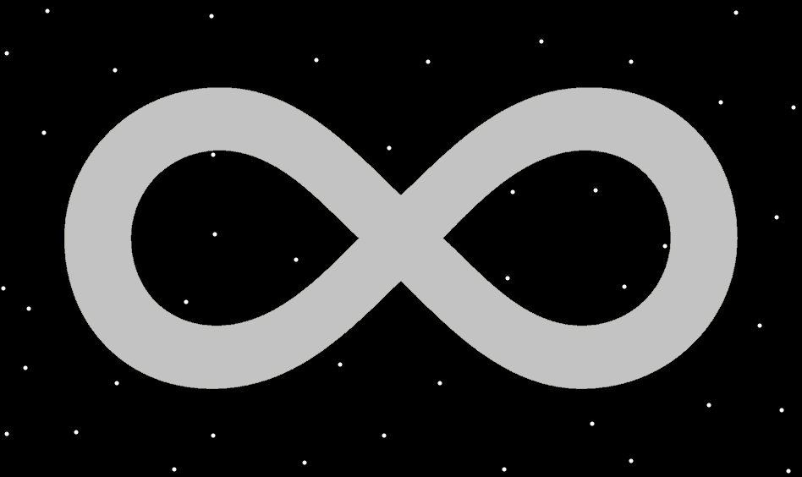
Item Group: Evolution 0
Principle: Staring into the infinity symbol brings energy to the mind.
Principle: Symbols and other pictures stimulate more brain activity. They can be good for the mind.
Principle: A lot of sorcery increases brain activity. There is neurology to sorcery.
Principle: There are psychological details to sorcery. A sorcery psychology.
Principle: Breathing exercises influence the mind.
Principle: Breathing exercises are sorcery. Breathing exercises are also psychology.
Principle: To a sorcerer, breathing exercises can be all powerful sorcery. To a psychologist they can be a great exercise.
Principle: The first, biggest spell part is the keywords part. Think a keyword for instance.
Principle: The second biggest spell part may be breathing exercises.
Principle: One major spell part is that you repeat the spell over and over. The repeat part of the spell. It takes time to cast spells.
Principle: One major spell part is spending a lot of time casting the spell. Time is a major spell part.
Principle: If you play first person shooter games, your keywords might be “camp”, “be a camper”, “keep camping”. Because you don’t camp enough or want to be king of the campers.
X2 Principle: The theory is that the more you think about camping the more likely you are to do it.
X2 Principle: The theory is that there is also a sorcery paranormal side to thinking keywords.
X2 Principle: There is psychology sides along with sorcery sides.
X2 Principle: An exercise such as think “camp” over and over has a psychology side and is a powerful sorcery spell.
Principle: Thinking keywords drains a lot of mana.
Principle: You always want to drain lots of mana. People have huge mana bars.
Principle: Its impossible to tap into your huge mana bar and drain a lot of it. You always have your mana battery super full.
Principle: The agenda is to drain your mana battery as much as you can. More drain equals more power output.

Principle: Some of these principles have been stated before. However I feel it is good to go over them again.
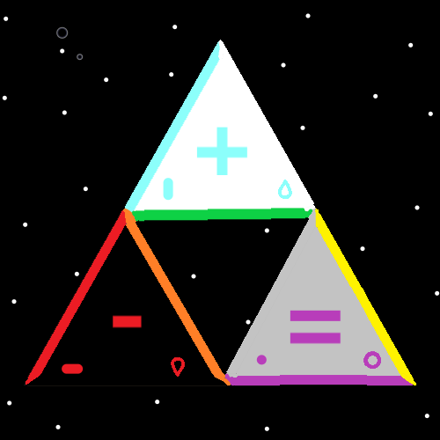
Item Group: Evolution 1
Principle: The Bible states that God made the Earth in six days. This likely means six cosmic scale days. Millions, billions or trillions of human years.
Principle: When you read scripture as an Expert Wizard, you see secrets in the scripture.
Principle: “…and there was evening, and there was morning, the first day.” The multiverse is full of cycles. The light period, then the dark period. One cycle. A light period, a dark period another cycle.
Principle: “…and God said let there be light, and there was light. God saw that the light was good and he separated the light from the darkness.” This is part of the first page of the Bible. It reveals the secret that reality is all about light and darkness.
Principle: The whole beginning of the Bible speaks over and over about light and darkness.

Principle: God is the man behind the curtain in the movie the Wizard of Oz. He often presents himself as this all powerful, to be feared person. The truth is he is much more like a nice old man.
Principle: God has many reasons to portray himself as a person to be feared. One is that people do not cross him as much, and another reason is people do what he says without time consuming questions.
Principle: Gods reality is much more sorcerer like. There’s technology, however it is fused with massive sorcery too.
Principle: I have heard a rumor that Shiva lives in perpetual meditation, binding the cosmos together. It is likely true.
Principle: God may live in a partial trance. Sort of like a dreaming God. Caused by meditation that God does.
Principle: Earth is likely 6.9 cosmic days old. From when 2 planets first collided to make Earth.
Principle: There are two “firewalls” between Earth and God. The term comes from computer science.
Principle: The two firewalls between Earth and God keep the viruses of Earth from spreading to God. It is the purpose of the firewalls.
Principle: The two firewalls between God and Earth have been mentioned before. They are also known as the two barriers.
Principle: The first firewall exists between Heaven and Earth. It protects Heaven from Earth. It surrounds Earth.
Principle: The second firewall exists between Heaven and God. It surrounds Heaven. It protects God from Heaven and thus from Earth.

Principle: The two firewalls also do other things. The Earth firewall protects humans from fatal energy being emitted by our sun. And the Heaven firewall protects Heaven from damaging energy emitted by God.
Principle: As time goes on the wording of principles gets better. This is one reason why some principles are stated multiple times.
Principle: The two barriers has been mentioned before, however I don’t think the fact that they are also known as the two firewalls has been written before.
Principle: The separation between us and God protects us from God and protects God from us.
Principle: If you haven’t noticed I make up Wizardry vocabulary terms all the time. Vocabulary is always a major part of a science.
Principle: Wizardry is not a difficult thing to learn. It takes very little time at all.
Principle: I envision that a 100 years from now there may be 16 year old Master Wizards everywhere.
Principle: I wouldn’t be surprised if its easy to get 14 year olds to Master Wizard. A little work a week from ages 10 to 14. That’s four years.
Principle: In the afterlife the separation between us and God will end.
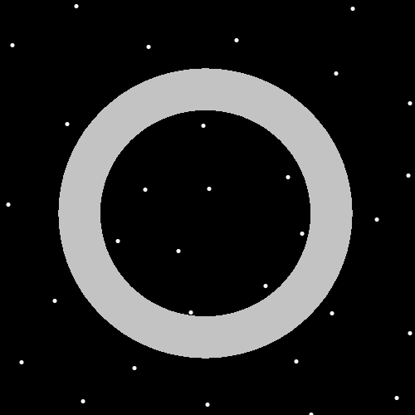
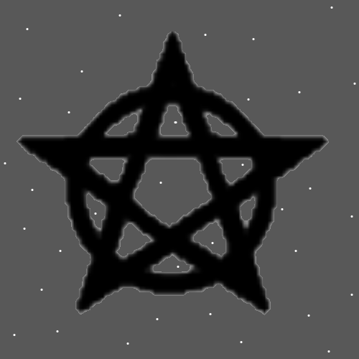
Item Group: Evolution 2
Principle: The pentagram is a circle and a star. Gods symbol and a symbol for angels. Like saying “God and his angels”, or “God and Heaven.”.
Principle: The pentagram is a powerful symbol, and very associated with Witchcraft. Witchcraft has a huge connection to Wizardry. Thus the pentagram has a huge connection to Wizardry.
Principle: The pentagram is the symbol of Wizardry. The best I know of anyway.
Principle: The color black is strangely the color for the highest levels of light. A black pentagram is just fine. I love my black pentagram drawing.
Principle: Also note the circle is the shape of the star bodies and Gods body. A sphere, a circle like shape.
Principle: We have all seen a magic wizard hat with moons and stars. A solid black one, with little white dots is a good pattern too.
Principle: Moons and stars are cosmic bodies.

