ObjectType: Article  
ObjectNumber: 15

LocationName: PAAIL.org

LocationNumber:

Language: PAAIL 2.6

Maker: PAAIL.org  
Model:   
  
Name: Wizardry Evolved 8

Rank:

SerialNumber:

Level: 4.0

Score:   
Birth: 7-29-2023

Label: Room 15

Title: Wizardry Evolved 8

Details: Aged Wizardry. Wizardry more evolved. Wizardry more researched and developed.

Principle: Wizardry.

Agenda: Wizardry.

Action: Wizardry.

Information: Wizardry.

Item Group: Evolution 0

Principle: At the core of all things…. All things that exist are a form of energy.

Principle: The one thing all things have in common is that they are all energy.

Principle: All science is understanding energy.

Principle: Energy is an important word. It is Wizardry vocabulary.

Principle: All power is about manipulating energy.

Principle: PAAIL is an ultimate invention. Its creation was inspired by Wizardry.

Principle: Some Wizardry is inspired by PAAIL.

Principle: Since I am a level 3 computer gamer, a level 3 general science person, a level 5 PAAIL person, level 3 sorcerer, level 3 computer programmer and level 5 Wizard…. Everything is inspired by these levels.

Principle: The PAAIL 2.5 book is very short and worth reading. It can be found at PAAIL.org.

Principle: At the core of all things is human principles, human agendas, human actions, and human information.

Principle: The latest PAAIL 2.6 basic properties list can be found in newer Wizardry rooms. Ones like this one. The beginning of this room starts with the list.

Principle: I think this writing format may be the ultimate writing format. Its much easier reading just one Principle Item at a time.

Principle: When doing teaching writing, its much easier to write one principle at a time.

Principle: PAAIL addresses the importance of Action, by making it one of the 4 core vocabulary words.

Principle: PAAIL addresses the importance of Principles, by making them one of the 4 core vocabulary words.

Principle: PAAIL addresses the importance of Principles, because all science is principles and one of the most important things is a persons principles.

Principle: PAAIL addresses the importance of Agendas. Actions often come from Agendas.

Principle: PAAIL addresses the importance of Information. All principles are information. A bunch of information about Actions or Agendas is information.

Principle: Often a map is information, however it does not really seem like a Principle.

Principle: When Tome of The Yellow Wizard was finished, you could get to Expert Wizard, however Wizardry science was still at a 1.0.

Principle: At the end of Wizardry Practice 0A and 0B, we had a Wizardry science of level 2.0.

Principle: Keep going and you get to level 3.0. These days, if you have read it all, you are at level 4.0 on the science. Still Master Wizard, however the Wizardry Science Level is at 4.0.

Principle: I realize lots of principles are getting said over and over. We are at the end of the story. This has been go over things a little more. Probably I will be repeating things much less from now on.

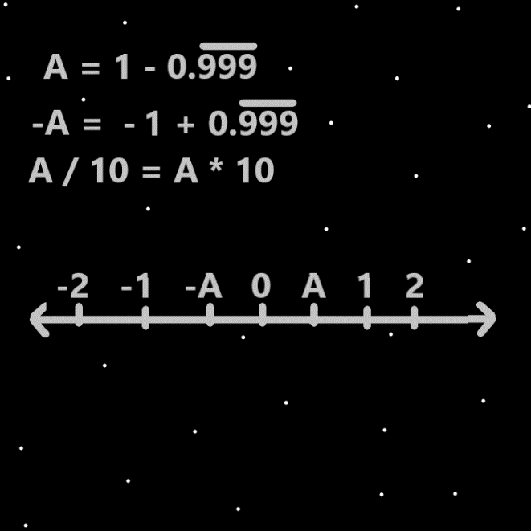

Item Group: Evolution 1

Principle: It should be noted that the pentagram symbol is a super famous symbol. Perhaps the most famous symbol of Witchcraft. Thus the most famous symbol of Wizardry.

Principle: One of my favorite maps is the solid black square, with little white dots. It’s a drawing of a bunch of stars.

Principle: Once the universe was full of mystery’s. Once the universe was mysterious. That is no longer the story.

Principle: Pretty much the whole story has been told. Cosmic years 0 to 99. 99 is the current cosmic year. Also the future has been told.

Principle: Some ultimate knowledge is to understand that the multiverse is a story.

Principle: One effect of becoming an Expert Wizard. The multiverse stops being mysterious.

Principle: Remember Expert Wizard is gained by just doing the reading of it all. You only have to do the shrine, personal charm, collectable charms, smith summons spells, word write 10x spells….if you want to get to Master Wizard.

Principle: You only need the reading of it all for Expert Wizard. No body exercise, breathing exercise, or mediation exercise.

Principle: The Sorcery is done to achieve Master Wizard. You also end up with Expert Sorcerer.

Principle: A person can envision a person breathing and it is a spell part.

Principle: Envisioning is a Spell Part that is rather new and has not been really gone over a great deal. Its not even in any PAAIL Spell Parts Lists.

Principle: Envisioning a person breathing connects you to the breathing side of the multiverse and drains mana.

Principle: Every action drains on a persons mana battery at least a little.

Item Group: Evolution 2

Principle: The following is about Energy Bits. I’m not sure if it has all been covered. Its very new knowledge.

Principle: The symbol for the “A” energy bit is the vertical line “I”.

Principle: The symbol for the “-A” energy bit is the horizontal line “-“.

Principle: Since all particles have a surface and a form. The form of energy bits may be that they are sticks.

Principle: It may be the “sticks”(energy bits) resemble circuitry when viewing a bunch of them at once.

Principle: The final max zoom in level may resemble a bunch of circuitry.

Principle: The knowledge of the energy bit symbols is super new. The horizontal line and the vertical line.

Item Group: Evolution 3

Principle: 1 is the number for positive one, and negative 1.

Principle: The latest revelation is that 1 is the number for addition and subtraction. “+1” for addition and “-1” for subtraction.

Principle: Another new revelation is that the number 2 is the number for multiplication and division. “+2” the number for multiplication and “-2” the number for division.

Principle: And another revelation is that there may be “two” operations for each whole number. Two operation for the number 3, two for the number 4, two for the number 5, and so on.

Principle: There are an infinite amount of processes and two for each whole number.

Principle: There may be an operation for the number zero. Perhaps not.

Principle: It may be that there are “zero” operations for the number “zero”.