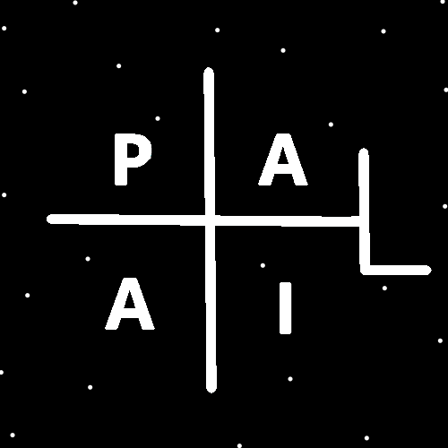
ObjectType: Article
ObjectNumber: 17
LocationName: PAAIL.org
LocationNumber:
Language: PAAIL 2.6

Maker: PAAIL.org
Model:
Name: Wizardry Evolved 9
Rank:
SerialNumber:

Level: 4.0
Score:
Birth: 8-3-2023

Label: Room 17
Title: Wizardry Evolved 9
Details: Aged Wizardry. Wizardry more evolved. Wizardry more researched and developed.
Principle: Aged Wizardry.
Agenda: Aged Wizardry.
Action: Aged Wizardry.
Information: Aged Wizardry.
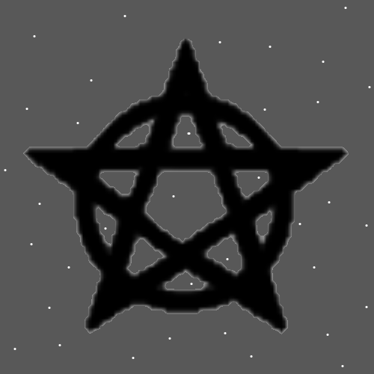
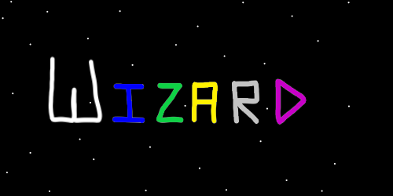
Item Group: Evolution 0
Principle: It may be that there is an operation for every number except zero.
Principle: There may be an operation for the number 5.3472. Which has decimals in it.
Principle: There may be an operation for the number -5.3472.
Principle: Another new thing is that each operation has an opposite. Addition is the opposite of subtraction and multiplication is the opposite of division.
Principle: If I were a math expert I could likely figure out more than the four operations, addition, subtraction, multiplication and division.

Principle: I suspect 2 to the power of 2 is an operation. Also known as 2 squared. This is not a new principle. It seems a good time to repeat it here though.
Principle: Sitting on the ground during Meditation is adding a Spell Part to the Meditation. It makes you more grounded.
Principle: Meditation chambers sometimes have seats.
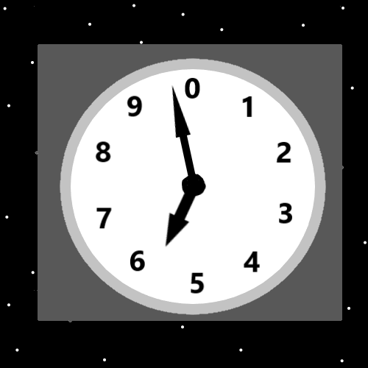
Item Group: Evolution 1
Principle: Pause is a powerful Spell. A person can do an intentional pause for a moment, before an Action.
X2 Information: Similar Principles have already been written. It seems worth while to write this principle again.
Principle: Some principles are worth writing multiple times. Worth reading multiple times.
Principle: The above clock with 10 numbers. It best represents a “Cycle”. The multiverse is full of “Cycles”.
Principle: The clock having two hands Makes Cycles within Cycles.
Principle: A person could add a third hand to the Cosmic Clock.
Principle: The theory is that Adam and Eve were born around 3900 BC.
Principle: I put the clock at 5900’s. I expect we are living at a year, in the Adam and Eve time of the 5900’s.
Principle: Though all Principles are Information. It seems like you would call a Map an Information Item, not a Principle Item.
Principle: There may have been cave men before Adam and Eve.
Principle: I’m certain God started with a monkey blueprint when Making Adam and Eve.
Principle: I’m certain God started with a monkey Map when Making Adam and Eve.
Principle: From the Bible you get the impression that Humans didn’t evolve one day. Instead the Bible gives the impression God Made Humans one day.
Principle: It is the sixth day of Creation.
Principle: The Bible prophesies God will rest on the seventh day.
Principle: Now that you’re a Leveled up Wizard, reading scripture means seeing the secrets of the multiverse.
Principle: A person can a do a bunch of Divination with scripture and keep the Divination activity scripture themed.
Principle: Use your name and the Bible and you can do scripture Divination about yourself. Scripture about yourself.
Principle: Use the word “God” and the Bible and you can do scripture Divination about God. Scripture about God.
Principle: Use the word “Multiverse” and the Bible and you can do scripture Divination about the Multiverse. Scripture about the Multiverse.
Principle: Of course virtually all words work.
Information: The author is sorry that principles are repeated. It is the process.
Information: I think it has been about 2 years since I first started writing Tome Of The Yellow Wizard. A lot has been learned since then.
Principle: The Wizardry science has evolved.
Principle: When you first Make a Charm it starts out “Hot”. It takes time for it to “Cool”.
Principle: Charms cool by Ageing. Give a Charm time and it cools.
Principle: Cooled Charms have Higher Levels.
Principle: Cooling usually takes very little time.
Principle: When a person hits Level 4 Wizard they are very hot. They need time to cool.
Principle: A year after a person hits Level 4 Wizard the person is cooled, and their Enchantments have had time to Grow.
Principle: Two years after hitting Level 4 Wizard a person has had much time for their Enchantments to Grow.
Principle: Wizardry is all powerful when it comes to a persons Chi. Powerful for the Mind and the Body.
Principle: A Wizards work does not accomplish more spiritually, however does Make a person understand the spiritual Energy field.
Principle: If a person asked me to explain the universe(multiverse) I would want to start with the beginning of the story. The zero moment.
Principle: After that I would want to tell about the empty universe after the zero moment. Then about the birth of the God Body in the empty universe.
Principle: It is unknown if God was alive at the beginning of the God Body. It is certain he occupies the Body.
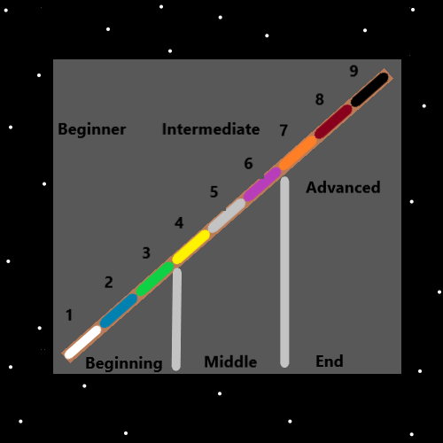
Principle: The Multiverse is slightly older than God. Milliseconds, seconds, minutes, days, months…..its not really known.
Principle: The Origin of God is the Origin.
Principle: The Multiverse Made God. Not God Made the Multiverse.
Principle: God did Make this Universe though.
Principle “…and then what?”. Resurrection Day came and we all lived happily ever after.
Principle: As for teaching Wizardry. I would rather a teaching program that includes the Sorcery training right away. All the Basic Spell training, Standard Spell training, Alchemy Spells and Advanced Spell training.
Principle: As for teaching Wizardry. I would rather teach Make a Shrine right away. I call that a part of the Sorcery training.
Principle: As for teaching Wizardry. I would like ultimate Cosmic knowledge the very first. God and so forth. Then the Sorcery training. Then mix Sorcery training with reading knowledge.
Principle: If a person only wants Expert Wizard, they can do just the reading part. No Sorcery training. You still have to learn the Sorcery knowledge though.
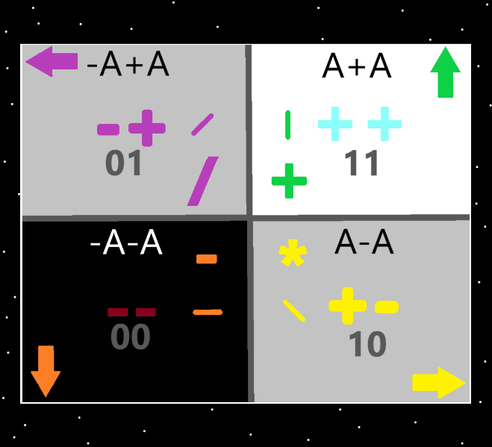
Principle: A persons Wizardry Level comes from many things. Reading a Wizardry book gains Wizardry Levels. Doing Sorcery gains Levels as well.
Principle: You gain 0.2 Levels of Wizardry doing this, and you gain 0.3 Levels of Wizardry doing that. This is an example of understanding Levels.
Principle: Doing all the Sorcery training is gain 1.0 Levels of Wizardry. It combined with everything else is how you unlock Grey Wizard. Level 5 Wizard. Master Wizard.
Principle: There are often multiple Paths up the mountain.
Principle: There are often multiple Paths from one place to another.
Principle: The word “Universe” sounds like all verse’s combined. The word “Multiverse” sounds the same. I still like the Vocabulary “Multiverse”. Then its we all have our own Universe. Rather than we all have our own Galaxy.
Principle: For many reasons I like the Vocabulary word “Multiverse”.

Principle: Often many Vocabulary words are capitalized. This list includes PAAIL Vocabulary, and general science Vocabulary because of PAAIL. Words like “Galaxy” or “Vocabulary”.
Principle: Learning the “particle physics” of the PAAIL.org Wizardry training helps a person see better and is Wizardry training, not just “particle physics” training.
Principle: Learning the “particle physics” of the PAAIL.org Wizardry might be fair to call Cosmic Knowledge.
Principle: Understanding things like the 4 elements is Wizardry. Understanding things like “Energy Bits” is Wizardry.
Principle: Understanding symbols is Wizardry.
Principle: Understanding that everything is Made of Energy Bits is Cosmic Knowledge.

