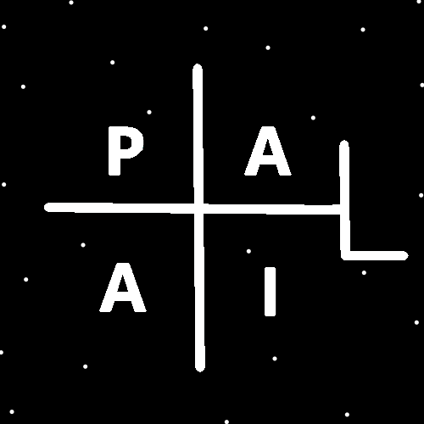
ObjectType: Article
ObjectNumber: 18
LocationName: PAAIL.org
LocationNumber:
Language: PAAIL 2.6

Maker: PAAIL.org
Model:
Name: Wizardry Evolved 10
Rank:
SerialNumber:

Level: 4.0
Score:
Birth: 8-7-2023

Label: Room 18
Title: Wizardry Evolved 10
Details: Aged Wizardry. Wizardry more evolved. Wizardry more researched and developed.
Principle: Aged Wizardry.
Agenda: Aged Wizardry.
Action: Aged Wizardry.
Information: Aged Wizardry.
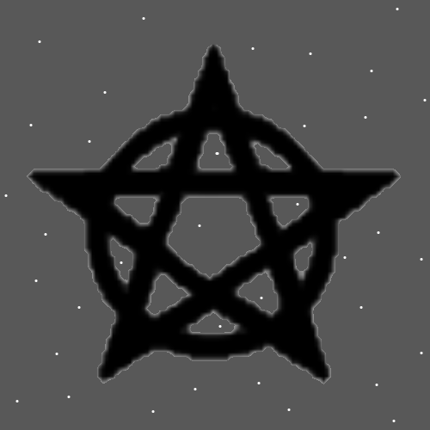
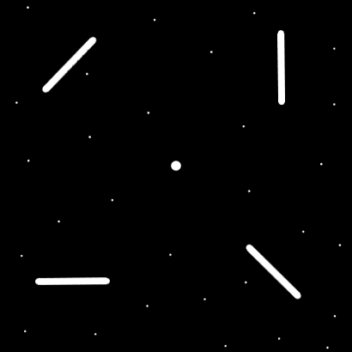
Item Group: Evolution 0
Principle: Enlightened in 400 to 800 pages of reading. That’s what PAAIL.org does. It unlocks the Enlightened Title.
Principle: If it takes you 4 years to read. Its worth the time to read it.
Principle: It seems like I may have forgot to mention that Expert Wizard is also Enlightenment.
Principle: You might also have to be a good person to be Enlightened.
Principle: It may be there is Spiritual Enlightenment, Mind Enlightenment, and Body Enlightenment.

Principle: It may be that Spiritual Enlightenment is when you are a good person. It may be that Mind Enlightenment is when you know the major secrets(Cosmic Knowledge). It may be that Body Enlightenment is when your Body is healthy.
Principle: It is Spiritually Enlightened to be a good person.
Principle: It may be that Wizardry is Enlightenment of the Mind and can be used for better Enlightenment of the Body.
Principle: There are Levels of Enlightenment. There are always Levels in everything.
Principle: It may be that there is Master Enlightenment, and it may be that there is Expert Enlightenment.
Principle: Any Enlightenment Level less than 4 is not very Enlightened.
Principle: Level 4 about a thing is very Enlightened about that thing.
Principle: It is likely fair to say there is Enlightenment about specific things. Enlightenment about Chess.
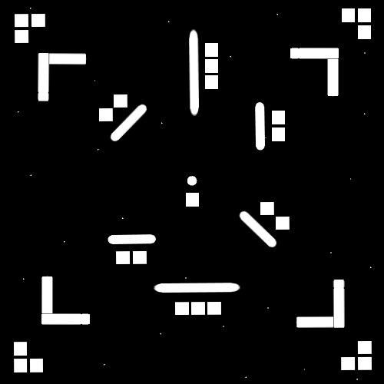
Principle: In the Map. The inner area is the dot symbol. The next layer is the 4 line symbols.
Principle: The outer layer is four 2 line symbols. The next layer would be symbols with 4 squares.
Principle: The most powerful symbol is likely the circle, or the dot. I bet circle.
Principle: Because it is the beginning of time. In most ways the number 0 is greater than the number 1000.
Principle: The plus symbol is 2 lines. This makes it low complexity. All low complexity symbols are very powerful.
Principle: A Wizard sees a Halo in a drawing and thinks “The Symbol of God”.
Principle: We are not clumsy, however life is. Its full of oops.
Principle: Training Wizardry adds a bunch of virtue to a person.
Principle: Training Wizardry makes you smarter, wiser, and more graceful. It makes you more reasonable, rational, and objective.
Principle: There are more virtues you gain Levels on as well.
Principle: The virtue gain is one major reason why everyone should train Expert Wizard.
Principle: I see Expert Wizard as easy to learn. Not many pages to read. And all powerful.
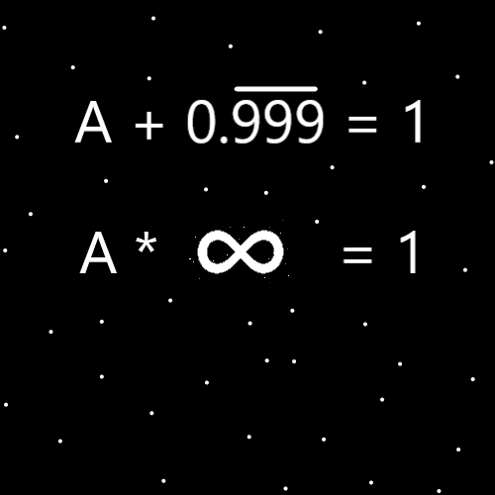
Item Group: Evolution 1
Principle: “A” multiplied by Infinity equals 1.
Principle: People have been doing Meditation for 1000’s of years now. Often sitting, trying to clear their mind, doing breathing or something like that.
Principle: The more improved Meditation is to add Keywords.
Principle: Adding think a Keyword to a Meditation session removes a peace and quiet Spell Part. There is less peace and quiet when you add think a Keyword.
Principle: A person can add the Keyword “peace” to their Meditation session and regain a peace and quiet Spell Part. This makes up for the loss of peace and quiet which happens when you add using Keywords to your Meditation session.
Principle: PAAIL.org is the real authority on Wizardry. However Mystics and more have been writing tons of books over the years. PAAIL.org is not the only place you can find Wizardry knowledge.

Principle: Once you have trained Expert Wizard you can now read books about astrology, numerology, chakras and more and be able to see the secrets while reading them. Secrets only an Expert Wizard would see.
Principle: If you speak multiple spoken languages and have unlocked Expert Wizard you are likely able to see many secrets. Like how in German “nine” means no, and in English “nine” means the number 9.
Principle: Once a person gets to Expert Wizard, they start to see all the secrets throughout everything. Even things like computer games. Secrets in the computer games.
Principle: Secrets in the movies. Secrets in the music. Secrets in the books. Secrets in the games. An Expert Wizard starts noticing all the secrets.
Principle: Note how one of the first Super Mario games had Levels and Scores.
Principle: The author has been making a computer game. It’s a fantasy, medieval, MMO. I think it also is a survival game. The game has a Food Bar, a Sleep Bar, a Drink Bar, and an Entertainment Bar.
Principle: The inspiration from my own game is to say that we probably have a Food Battery, Sleep Battery, Drink Battery and Entertainment Battery.
Principle: “We have a Food Bar” is inspiration from my game. Not the game has a “Food Bar” because of inspiration from Wizardry.
Principle: My game makes me see more. Most games work like that.
Principle: Though my game is inspired by Wizardry… Also my Wizardry is inspired by the game.
Principle: I always wanted Food Bar because then food crafting, and farming are major things. It’s not because of Wizard knowledge.
Principle: Angels in movies and paintings have had wings because the stars are the Angels. In space they float around. They fly around.
Principle: As a Wizard you will notice things like the wings on Angel paintings.
Principle: One of the biggest Wizard Actions is noticing things. One of the biggest Wizard Spells is noticing things.
Principle: Noticing things in Scripture is likely a super huge one.
Principle: Noticing things is sometimes called reading into things.
Principle: Notice the Christian cross is much like a plus symbol. One of Lord Jesus’s symbols is the plus symbol.
Principle: Notice things….
Principle: Noticing things in movies and music is a super huge Spell.
Principle: Noticing things is a Spell. Noticing things is an Action.
Principle: Notice that noticing things is a huge Spell.
Principle: Notice that noticing things is a huge Action.

