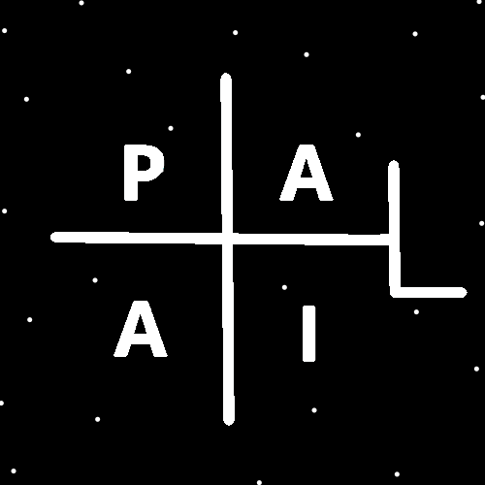
ObjectType: Article
ObjectNumber: 19
LocationName: PAAIL.org
LocationNumber:
Language: PAAIL 2.6

Maker: PAAIL.org
Model:
Name: Wizardry Evolved 11
Rank:
SerialNumber:

Level: 4.0
Score:
Birth: 8-12-2023

Label: Room 19
Title: Wizardry Evolved 11
Details: Aged Wizardry. Wizardry more evolved. Wizardry more researched and developed.
Principle: Aged Wizardry.
Agenda: Aged Wizardry.
Action: Aged Wizardry.
Information: Aged Wizardry.
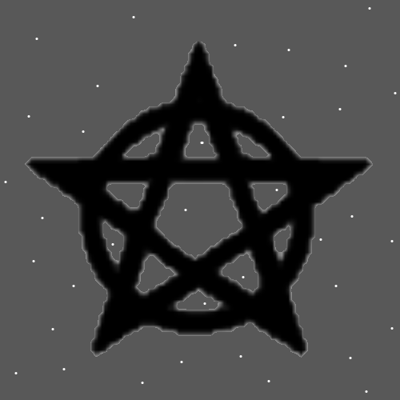
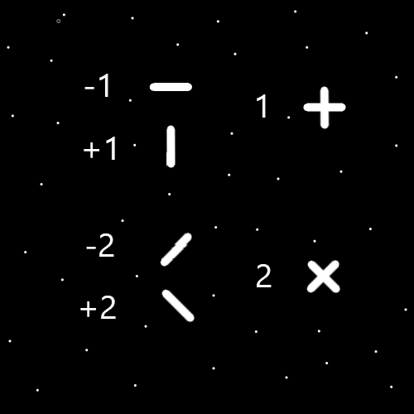
Item Group: Evolution 0
Principle: The number 1 has a huge connection to the plus symbol.
Principle: The number 2 has a huge connection to the “X” symbol.
Principle: -2 is the number for division.
Principle: +2 is the number for multiplication.
Principle: When you combine the +1 symbol with the -1 symbol you get the plus symbol.
Principle: When you combine the +2 symbol with the -2 symbol you get the “X” symbol.
Principle: Understanding these things is partly Numerology.
Principle: There is also symbology. The knowledge of symbols.
Principle: Understanding the ultimate symbology helps understand the forms of particles and other things.
Principle: Knowing the ultimate Symbols is good for the Mind.
Principle: The Symbols side of Wizardry is good for the Mind.
Principle: A new Vocabulary term is “Wizard Symbology”.
Principle: Wizard Symbology is such things as knowing God’s symbol, the circle.
Principle: Understanding Numerology and Symbology likely has uses in Math, Physics, and other things.
Principle: Likely the word “Cosmology” should be Vocabulary of the Wizard.
Principle: Wands would work because they would be light and easy to draw symbols in the air. If you knew how to use a Wand.
Principle: Staffs would weigh more and be more powerful than a Wand, however writing symbols would be much harder.
Principle: The most powerful Charm would be a Crown if you could actually tap into Charms. Fully tapping into Charms never happens.
Principle: Lightning bolts and fireballs could be done with a Wand, Staff or Crown, if Heaven showed you how to do it.
Principle: Lightning bolts and fireballs is not something you figure out.
Principle: Science is full of things you can not figure out.
Principle: The term “guardian angel” comes from the fact that we all have 1 main angel that is assigned to our lives.
Principle: On the main Map that has all the Wizardry Rooms. I added a Symbol to each room, starting with a Pentagram Symbol. This is not only decorative it also makes looking at the Map better for the Mind.
Principle: Often decorative is good on the Mind.
Principle: Time is a Spell Part. How long you do the Spell is a Part.
Principle: The theory is that some movies are prophecies about the future.
Principle: The theory is that many movies are a what if God went a different direction.
Principle: As for different directions I like the movie Dune. I call the special guns they use “force pistols”. The guns that require using magical words. They also have “force cannons” that can shoot down ships.
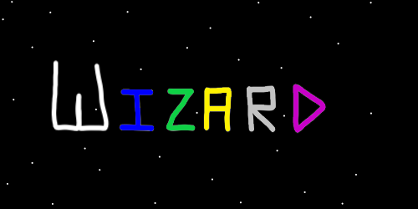
Principle: If I could choose the color of my walls and ceiling, I would choose solid black, with little white dots for stars. I think the pattern is called a “star field”.
Principle: Structure, organization and routine can be a good discipline.
Principle: Saying “I am won with the universe” is the same as saying “I am Jesus with the universe”. Because won can be swapped with Jesus.
Principle: Saying “I am won with the force” is the same as saying “I am Jesus with the force”. Because won can be swapped with Jesus.
Principle: There is of course also the line “I am one with the force”. One with the universe.
Principle: The “end times” happens every 1000 years. At the end of an Age (1000 human years).
Principle: The first 500 years of an Age is the day, and the last 500 years the night. Though there are twilight zones as well.
Principle: I suspect that World War 2 was the Armageddon of this Age.
Principle: It is more accurate to say “the end is here”. Not “the end is near”.
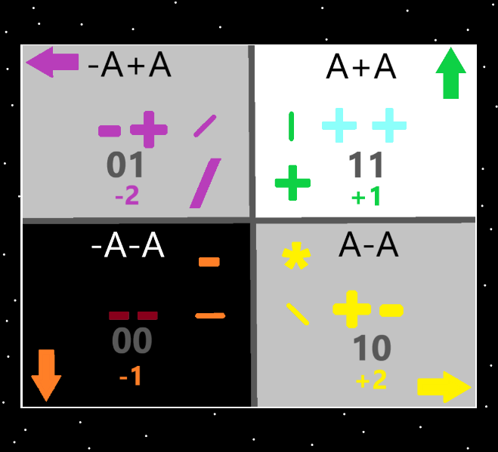
Item Group: Evolution 1
Principle: The Map above has been updated with the numbers “+1, -1, +2, -2”.
Principle: The Force known as Gravity is either the +1 force, the -1 force, the +2 force, or the -2 force.
Information: The above Principle about Gravity is a new Principle.
Principle: I’ve figured out the first Wand training you would do if Wands were a usable thing.
Principle: Wands cannot be used because you would have to know the right Keywords.
Principle: Day 1 training with Wands would be using the right Keywords, and using the first Wand Gesture.
Principle: The first Wand Gesture is to thrust the want forward. Like you would with a sword. This Gesture is called “Thrust”.
Principle: The first Wand Gesture is also making the symbol the “Dot”. The first Wand movement is make a Dot.
Principle: The first Wand movement is make the Dot Symbol in the air. Do this by thrusting the Wand forward.
Principle: For hours and hours a person would do thrust the Wand. Back and forth thrusting the Wand for hours. Making the Dot Symbol.
Principle: The next Symbol with Wand training is the Minus Symbol.
Principle: To do the Minus Symbol you thrust and make the Dot, then move the Wand to the right. This makes the Minus Symbol in the air.
Principle: Doing the Minus Symbol is also a Gesture with the Wand.
Principle: After hours of the Dot a person would move on to doing hours of the Minus.
Principle: After the Minus Symbol comes the vertical line. Then the forward slash “/”. Then the back slash “\”.
Principle: After many hours of Wand training a person would move onto the Circle. Making Circles with the Wand.
Principle: This would be all the beginning Wand training.
Principle: Wands are not a thing that can be tapped into. Its still interesting to know how the Basics of Wands training would work.
Principle: Thrusting the Wand forward is also known as making the Dot Symbol in the air.

