
ObjectType: Article
ObjectNumber: 20
LocationName: PAAIL.org
LocationNumber:
Language: PAAIL 2.6

Maker: PAAIL.org
Model:
Name: Wizardry Evolved 12
Rank:
SerialNumber:

Level: 4.0
Score:
Birth: 8-13-2023

Label: Room 20
Title: Wizardry Evolved 12
Details: Aged Wizardry. Wizardry more evolved. Wizardry more researched and developed.
Principle: Aged Wizardry.
Agenda: Aged Wizardry.
Action: Aged Wizardry.
Information: Aged Wizardry.
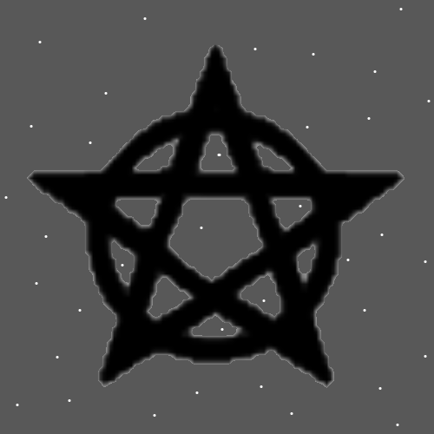
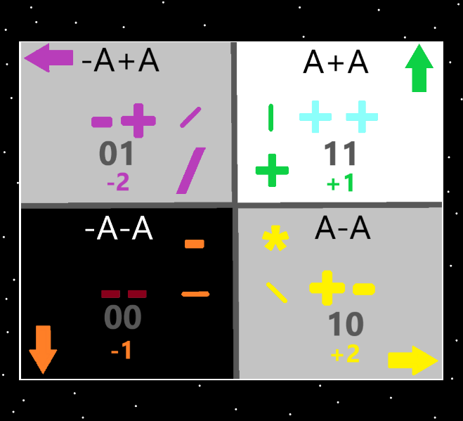
Item Group: Evolution 0
Principle: The following Principles about Wands are not really useful, unless you are doing a movie and want some good inspiration.
Principle: The following Principles about Wands is still real Sorcery Science and that seems enough reason to teach them.
Principle: The following Principles about Wands are also interesting.
Principle: A Wand works like a Pen.

Principle: The mechanics of a pen and the Wand are very similar.
Principle: Thrust the Wand forward and make the Dot. Then move the Wand to the right and your Dot turns into a line. Pull back the Wand and you have finished your Symbol. Like pushing down with a pen, drawing a line, and then pulling the pen away from the paper.
Principle: The first step is always thrust and make the dot. The next step is make the Symbol, and the final step is pull back, the opposite of thrust forward.
Principle: These Principles seem like they may be great inspiration for a movie that’s has magic Wands, Staffs, and so forth.
Principle: Were a person to use just their hand for Sorcery. The mechanics would also resemble the Wand.
Principle: Hand Gestures may be something a person can Tap into.
Principle: Though no one is ever going to get Wands working. People may be able to get major Sorcery going with their hands.
Principle: Make the Dot by pushing your hand forward. Then, with your hand, draw the Symbol in the air. Then pull back your hand. Then push your hand forward again and do the next Symbol.
Principle: The Principles about Sorcery with the hands. It may be all powerful Sorcery.
Principle: Figuring out Wands has resulted in figuring out “Hand Gestures”.
Principle: The Instructor figured out Wand Gestures before figured out Hand Gestures.
Principle: The short version. Push your Hand forward. Then draw the Symbol. Pull Hand back. Push Hand forward. Then draw Symbol. Pull Hand back.
Principle: The understanding of Hand Gestures is probably all powerful Level 4 Sorcery.
Principle: Hand Gestures work just like a Wand would.
Principle: A person has an easier time Tapping into their Hand than they would a Wand.
Principle: A person can make two Symbols at a time by using two Hands.
Principle: One ultimate pattern might be to Make a Fist with one Hand, then use the other Hand for drawing Symbols.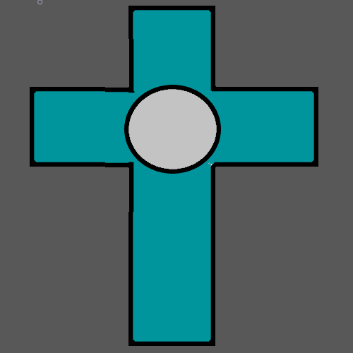
Principle: Ultimate Level 4/Level 5 Sorcery is to thrust your Hand Forward and Make the Dot Symbol.
Principle: We can’t use Wands. We can use our Hands.
Principle: Ultimate Level 4/Level 5 Sorcery is to spend time training the Dot. A person could also use an Energy Scroll while they do it. Do the Dot with your Hand.
Principle: I picture the Dot being done, like a person doing a palm strike forward.
Principle: After you train the Dot, its on to the Symbol the horizontal line. Then the vertical line. Then the forward slash, then backslash. Then the circle.
Principle: This has been a bunch of new Principles. And its Sorcery.
Principle: It’s the latest Research and Development of Wizardry.
Principle: To do a Pentagram you push your hand forward, then make a circle, then pull your hand back, then push your hand forward, then draw the star, then pull your hand back.
Principle: Since the circle is an all powerful Symbol, its probably great for Hand Sorcery.
Principle: You always have to make the Dot. Like pressing a pen against paper. The Dot is always the first step.
Principle: This is all super new(like 30 minutes), so the writing about it is very bad.
Principle: When training the Circle Symbol, you Make the Dot, then Make the Circle, then pull back. Then Make the Dot, then Make the Circle, then pull back……….
Principle: Waving your Hand in Circles is one Gesture. Making the Circle Symbol is a different Gesture. Making the Circle Symbol involves pulling your hand back.
Principle: These Principles may be super great for Meditation.
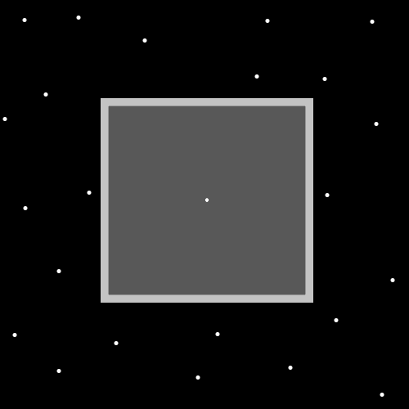
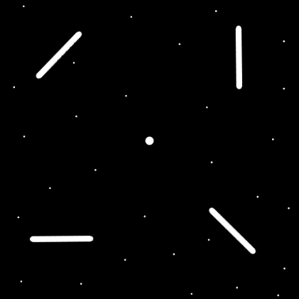
Principle: A person could have tons of Gear, like a Wand. The most powerful would not be a Wand, it would be a setup of a Crown, Scepter, and Staff combo.
Principle: However no one can ever Tap Into a Crown, Scepter or Staff. Unless Heaven taught you how.
Principle: As is… the Spell books of PAAIL.org only have the Hand Gestures, “Make a Fist”, “Put your Palms Together”, and “Palm Fist”.
Principle: Its really neat that figuring out Wands, led to figuring out Hand Gestures.
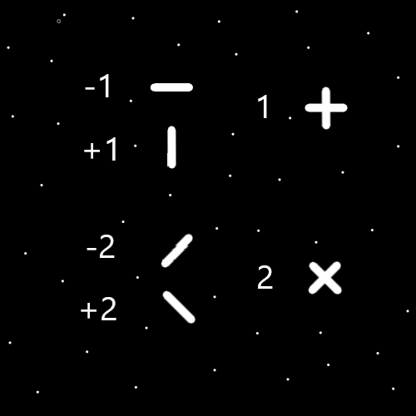
Principle: Making a Plus Symbol can be two pen strokes. First you draw one line, then pull back, then you draw the other.
Principle: Some Vocabulary is that you are “drawing Runes with your Hands”.
Principle: The Circle is one of the biggest Symbols and is also very connected to his holiness God.
Principle: The multiverse can sometimes be summed up as a bunch of Math, and Numerology.
Principle: Knowing the first Symbols like the Dot, horizontal line, vertical line, forward slash line, back slash line, Circle, and Plus sign is knowing the first Hand Gestures when training Hand Gestures Sorcery.
Principle: When using a Wand, you would draw with the tip of the Wand. With the palm of your hand pointed out(like palm strike), the center of your palm is the tip.
Principle: You write with the center of your palm. The center of your palm is the tip.
Principle: You do not have to do palm strike. There is other ways. Its always the center of the palm though.
Principle: A person could try and do with one finger. I have no idea about it.
Principle: When a person has a super capable right hand, one that can write very well. When they have a super powerful right hand and super weak left hand it does massive off balance to the person.
Principle: Fixing your off hand can be priceless. Less off is the Agenda.
Principle: Principles about the “off hand” have been done before. I think it worth mentioning again.
Principle: Most time Welders should probably not do Exercises on their off hand, while they are doing welding.
Principle: It may be best to never do “off hand Exercises” when doing actual work.

