ObjectType: Article  
ObjectNumber: 21

LocationName: PAAIL.org

LocationNumber:

Language: PAAIL 2.6

Maker: PAAIL.org  
Model:   
  
Name: Wizardry Evolved 13

Rank:

SerialNumber:

Level: 4.0

Score:   
Birth: 8-14-2023

Label: Room 21

Title: Wizardry Evolved 13

Details: Aged Wizardry. Wizardry more evolved. Wizardry more researched and developed.

Principle: Aged Wizardry.

Agenda: Aged Wizardry.

Action: Aged Wizardry.

Information: Aged Wizardry.

Item Group: Evolution 0

Principle: We cannot figure out the Adam and Eve language. We can figure out some of the ultimate Symbols.

Principle: On a Cosmic Scale a Symbol with 1000 lines is low complexity.

Principle: Just like the Circle Symbol, all Symbols that are low complexity are Core Symbols. Major Symbols.

Principle: The first Form of Energy is the Dot. The second Form of Energy is the Line.

Principle: Because the Dot is the first Symbol, you will find the Dot everywhere.

Principle: Writing always includes Making the Dot. When you first press the pen against the paper you Make the Dot.

Principle: Punching something with a fist is doing the Dot Symbol. The Dot is where you hit at the end of the punch.

Principle: A seed is a Dot. Many things start with the Dot.

Principle: The Zero moment is a Dot moment. The beginning of the big bang is a Dot moment.

Principle: The birth of God is a Dot moment. You can represent Gods birth using the Dot Symbol.

Principle: The Dot Symbol is the Symbol of Gods birth.

Principle: The first Hand Sorcery training is doing the Dot Symbol over and over.

Principle: Doing the Dot Symbol Hand Sorcery over and over, with your off hand, is a great way to improve your off hand.

Principle: After training the Dot Symbol Hand Gesture. A person should move onto the 4 Line Symbols Hand Gestures.

Principle: After that a person should move onto the Plus Symbol Hand Gesture. After that the X Symbol Hand Gesture.

Principle: Eventually you move onto doing Circle Symbol Hand Gestures.

Principle: Hand Gestures is also known as Making Symbols in the air.

Principle: All Hand Gestures start with the Dot.

Principle: After the Circle Symbol comes the 1 pointed seed Symbol. Then the 2 pointed seed Symbol. Then the triangle.

Principle: After the triangle you do the square. After the square move onto something like the Pentagram.

Principle: When you get to the Pentagram you will have High Levels from all your training.

Principle: A lot of new Wizardry has been researched since Tome Of The Yellow Wizard. Teaching about the Dot Symbol should come at the beginning of Wizardry training.

Principle: Hand Sorcery by Making Symbols in the air is a very real thing.

Principle: Making Symbols in the air is also known as Hand Gestures.

Principle: A person can Make 2D Symbols or 3D Symbols.

Principle: For training, before the Circle, a person should train the Basic Two Line Symbols. Those Symbols can be found below this Item.

Principle: There are 10 Line Symbols in the Map below. Note the long vertical line and long horizontal line. They are also Symbols a person can do.

Principle: The Dot Symbol is the first Symbol that a person should learn.

Principle: The Dot is an all powerful Symbol.

Principle: Since the Dot Symbol is the first Symbol, the Dot Symbol is the biggest Symbol. The greatest of all the Symbols.

Principle: The 2nd biggest Symbol is the Line. The 2nd greatest of all the Symbols is the Line.

Principle: If Wizardry were better taught. Learning about the Dot would probably come in the first 200 pages.

Principle: PAAIL.org Wizardry education could be refined a great deal.

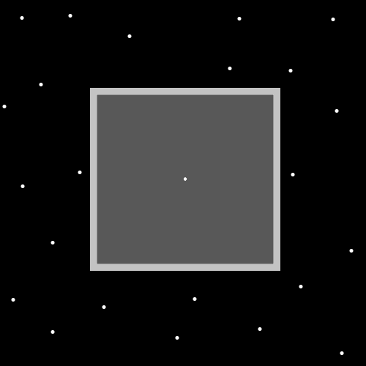

Principle: There is a famous game known as “Connect the Dots”. Life is full of connecting the Dots.

Principle: Making Dots on a piece of paper, then drawing lines that connect them, is likely a great way of writing Runes. It might also be a great strategy for Making artwork.

Principle: There is a famous phrase…”…connect the Dots.”. There are secrets behind this famous phrase.

Principle: Often famous phrases have secrets to them. Often a Wizard can see the secrets.

Principle: Often things have secrets to them. Often a Wizard can see the secrets.

Principle: In regard to PAAIL.org. Lots of stuff you learn at the end. Are things that would be better taught in the beginning. This is because Wizardry has been researched and developed a great deal. Many Principles were not known at the end of “Tome of The Yellow Wizard”.

Principle: The night sky is often filled with Dots.

Principle: Since the Dot is the first Symbol it is found all throughout the Multiverse.

Principle: The Zero Particles, of the Origin Moment, are also known as the Dot Particles. The two “Nuetral Energy Bits”.

Principle: The current theory is that “Nuetral Energy Bits” no longer exist.

Principle: A Wizard can Connect the Dots more.

Principle: The Dot may be Gods main Symbol. The Circle might be Gods main Symbol. God could have multiple “main” Symbols.

Principle: Like God has many names. You find Energy with many different names. The Zero Particles also have the name the Origin Particles, the Twilight Particles, the Dot Particles, the Nuetral Energy Bit Particles…..

X2 Principle: Enchantments are also known as Properties, Attributes, Parts…..

X2 Principle: Spells are also known as Actions.

Principle: Like most things. Doing Hand Symbol Writing Gestures Sorcery……Drains Mana.

Principle: Spells have a Global Level. This is based on the many people that have done the Spell over the years.

Principle: A person can never Tap Into a High Global Level Spell. However it is interesting to know about Global Spell Levels.

Principle: A Spell with a Low Global Level is perfectly fine.

