ObjectType: Article  
ObjectNumber: 23

LocationName: PAAIL.org

LocationNumber:

Language: PAAIL 2.6

Maker: PAAIL.org  
Model:   
  
Name: Wizardry Evolved 15

Rank:

SerialNumber:

Level: 4.0

Score:   
Birth: 8-20-2023

Label: Room 23

Title: Wizardry Evolved 15

Details: Aged Wizardry. Wizardry more evolved. Wizardry more researched and developed.

Principle: Aged Wizardry.

Agenda: Aged Wizardry.

Action: Aged Wizardry.

Information: Aged Wizardry.

Item Group: Evolution 0

Principle: Scientists know of the four forces. Gravity, Electromagnetism, the Strong Nuclear, and Weak Nuclear.

Principle: I’m surprised there is no such thing as the 8 forces. It might be that there is the 8 forces. Another layer that Scientists don’t know about.

Principle: If there were 8 forces. 2 would belong to the addition force. 2 would belong to the subtraction force. 2 would belong to the multiplication force, and 2 would belong to the division force.

Principle: If there are 8 forces, like there is the 4 forces, it would probably be a major science detail.

Principle: It may be that to fully understand the 4 forces, you must first understand the 8 forces.

Principle: The physics of it would be that the 4 forces divided and created 4 new forces.

Principle: Perhaps it is the future, that one day the 4 forces will divide, and then there will be 8 forces. Perhaps a person can make this happen now.

Principle: Perhaps there is nothing really to be learned here. Its all super theoretical.

Principle: It could be that humans can actually Make the -3,+3,-4,+4 Forces. Make a Force. Like Making Gravity.

Principle: As has been explained, all Forces, like Gravity, have an Operation and a number, like -1 or +1, or +2, or -2.

Principle: It seems likely that if you count the future, that there are an infinite amount of Forces, and that Gravity is just one of the first 4.

Principle: It could be that Gravity of cource sorts into one of the 4 Forces. However Gravity could be the Number +376 Force. I chose +376 because it is a random number.

Principle: All Forces likely sort into 1 of the 4 categorys. Addition, Subtraction, Multiplication, Division.

Principle: All Forces are either an Addition Force, a Subtraction Force, a Division Force, or a Multiplication Force.

Principle: All Energies are either an Addition Energy, a Subtraction Energy, a Division Energy, or a Multiplication Energy.

Principle: All things are Math. All things are Addition, Subtraction, Division, or Multiplication.

Principle: All Operation sort into one of the 4 categories. Addition, Subtraction, Division, or Multiplication.

Principle: It a lot of ways Math might have four main areas. One area would be the -1 area. One would be the +1. One the -2, and one the +2.

Principle: It a lot of ways Math might have four main areas. One area would be the Plasma area. One would be the Gas. One the Solid, and one the Liquid.

Principle: It a lot of ways Math might have four main areas. One area would be the 1,1 area. One would be the 1,0. One the 0,0, and one the 0,1. This is the binary example.

Principle: It a lot of ways Math might have four main areas. One area would be the up area. One would be the right. One the down, and one the left. This is the directions example.

Principle: It may be that in a lot ways, there are 4 different, main Zoom Levels.

Principle: Force is another word for Energy.

Principle: We all have a Force. We all are a Force. We all have an Energy. We all are an Energy.

Principle: Since all Operations have a Number. And we all have a name in Numbers. We all have an Operation.

Principle: The Operation of his Holiness One is Addition. Though also his Holiness can claim Subtraction as well.

Principle: We all have 2 Operations. Our Positive one an our Negative one.

Principle: We all have a main Positive Number, and a main Negative Number.

Principle: It may be possible to turn space into other forms of Energy.

Principle: If you turned space into Energy. You would be Subtracting space. This might be a way to shorten the distance from here to there.

Principle: Starships might work by turning space into other Energy.

Principle: Its possible there is a center to this Universe(Heaven) and there you find a super huge star Body.

Principle: Its possible the only galaxies with living stars are the nearby galaxies.

Principle: Its possible the center of this Universe is nearby.

Principle: All stars are alive is the theory. However pictures of distant Galaxies. The pictures are of the past. It takes time for the light to get here.

Principle: There be a center of this Universe(Heaven)… is the theory.

Principle: The four Forces sort into the two categories. The Positive category and the Negative category.

Principle: Addition and Multiplication are Positive category Forces. Subtraction and Division are Negative category Forces.

Principle: All Energies sort into the 0 to 999 categories. All Energies sort into the 0 to 9 categories. All Energies sort into the 8 categories. All Energies sort into the 4 categories. All Energies sort into the 3 categories(Light, Twilight, Darkness). It may be that all Energies sort into the 2 categories, Positive and Negative. Light and Darkness.

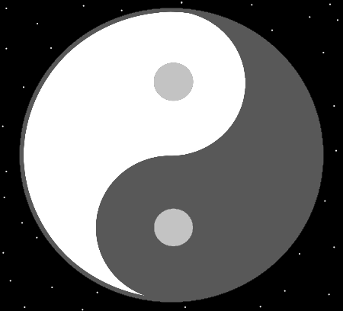

Principle: All Operation have either a Negative Number or Positive Number. All Operations are either Positive Operations or Negative Operations.

Principle: It may be that there are 2 main sides to Math. The Positive side and the Negative side.

Principle: It may work the first side is the 2-object side. Positive and Negative. Then it’s the 2 sides Make the 3 sides. The 3 sides then make the 4 sides. The 4 sides then Make the 5 sides. Then the 5 sides Make the 6 sides…..and on and on. If correct, then all Energies sort into one of the 6 Energy categories.

Principle: All Energies sort into the 16 categories. All Energies sort into the 32 categories. All Energies sort into the 0 to 999,999 categories.

Principle: It may be there is no such thing as a Zero Operation. The Zero Operation might have only existed at the Zero Moment.