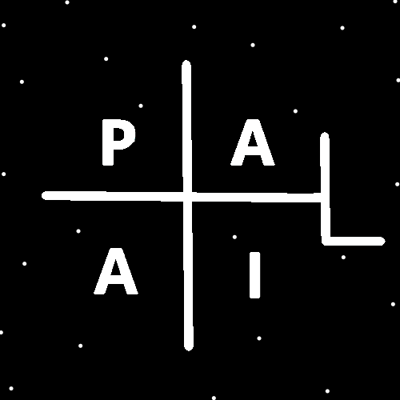
ObjectType: Article
ObjectNumber: 24
LocationName: PAAIL.org
LocationNumber:
Language: PAAIL 2.6

Maker: PAAIL.org
Model:
Name:
Rank:
SerialNumber:

Level: 4.0
Score:
Birth: 8-22-2023

Label: Room 24
Title: Aged Wizardry 0
Details: Aged Wizardry. Wizardry more evolved. Wizardry more researched and developed.
Principle: Aged Wizardry.
Agenda: Aged Wizardry.
Action: Aged Wizardry.
Information: Aged Wizardry.
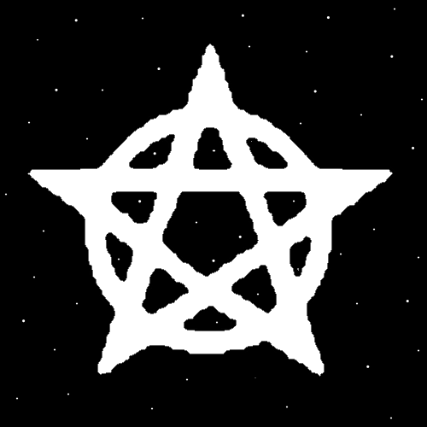
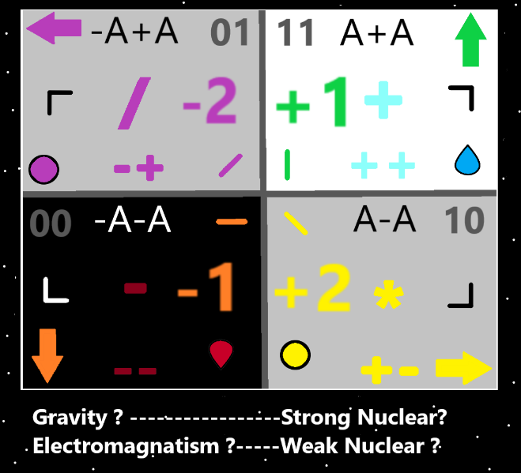
Item Group: Evolution 0
Principle: PAAIL Wizardry training I think has been around for about 2 years now. Some things were known before the 2 years. Many things were learned during the 2 years.
Principle: The list of wrong religious beliefs is endless.
Principle: The PAAIL.org Wizardry comes with the Cosmic Knowledge Specialty. The Cosmic Knowledge gives one an Enlightened Mind about what religious beliefs are wrong.
Principle: Enlightened about what religious beliefs are wrong is Enlightened about his Holiness Origin.
Principle: Enlightenment about his Holiness Origin is a supreme Enlightenment.
Principle: Knowing the Number of his Holiness Origin is good. Its Zero. Knowing his Symbol the Circle. His color, transparent. These things are good to know. Knowing “Origin” is one of his names is good.
Principle: Knowing more about his Holiness Origin Makes a greater Connection between a person and his Holiness.
Principle: It is good to know Origins age. Its 99 Cosmic years.
Principle: Its good to know Origin is still young. He would say, that like us, he in many ways is also young.
Principle: Its likely true that God is 99.9 or even 99.999, Cosmic years old. About to be 100 is Gods Age.
Principle: The war with the darkness ends on Gods 100th birthday.
Principle: For God the entire Earth story is 7 of his days. Cosmic days. Human time its some billions or trillions of years.
Principle: There may be a Zero Operation in Math. I’m not a math expert. My guess is that there is an Operation for every number, including the Number 0.
Principle: After writing in a PAAIL format for so long. I can’t imagine writing in normal, chapters, paragraphs, sentences fashion.
Principle: It may be that writing education books in PAAIL format is the best way to go.
Principle: When it comes to future soldier robots, I always pictured walking, rolling things. Now I picture flying around soldiers.
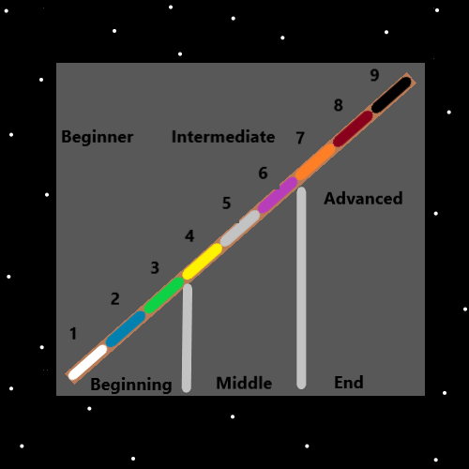
Principle: A better munition than bullets is the slower speed mini rocket. Same size as a bullet, however it can change direction in flight, causes no recoil when fires off, can be rigged with explosives and fired from flying robots.
Principle: Flying robots that shoot mini, explosive tipped rockets.
Principle: According to the news and so forth we are getting closer to C3P0 from star wars. C3P0 can do a job better sometimes than a human.
Principle: A robot teaching a principle has an easier time saying it the same way every time.
Principle: Robot teachers may be the future one day. Robots will likely take more than factory jobs, they will take over jobs like teaching.
Principle: Two legged robots will never work. They will always be like humans, capable of falling. Use 4, or 6, or 8 legs.
Principle: One design thought for AI’s is that they always start by Making two “beep” noises. Then start talking after the beeps. At the end of their message, they then beep twice.

Principle: A beep beep noise before the AI talks, lets a person know the AI is going to talk. It gives the person a chance to be quiet, or even say “don’t speak robot” and Make the AI not speak.
Principle: Two beeps at the end of the message tells the person the messages are over.
Principle: The beeps also provide a space for a human to process the message in their Mind and a space for the computer to do any processing.
Principle: I can’t think of much to write, so this is what we get.
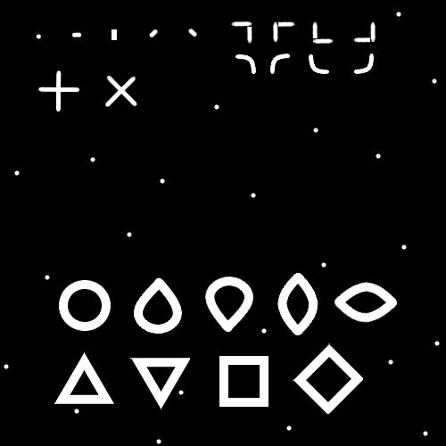
Item Group: Evolution 1
Principle: Gods existence is an all-powerful Sorcerer.
Principle: Shiva lives in perpetual Meditation, binding the Cosmos together.
Principle: Gods biggest Spell is his Meditation. The Meditation that God does is his biggest Action.
Principle: Meditation is the biggest Spell/Action of the Multiverse.
Principle: Some religions and many peoples do not do any Meditation at all. This is in error.
Principle: Thinking about something is often called Meditating on the matter. People think about things and become informed about those things. It can be said people Meditate on things and become Enlightened about those things.
Principle: Often through Meditation, Enlightenment can be achieved.
Principle: Many great things have been accomplished by peoples thoughts. Many great things have been accomplished by peoples Meditation.
Principle: Some of these Principles should be taught at the beginning of Wizardry training. As it is… they are taught at the end.
Principle: If I started over, when I get to the Origin moment. I would mention its also known as the Dot Moment, and that it has a Symbol. The Dot Symbol.
Principle: When teaching about the Zero Moment and the big bang, it would definitely be right to include teaching about the Dot Symbol.
Principle: PAAIL.org writings are good for you. Though it may seem like its not all Wizardry. It is all Connected to Wizardry.
Principle: If you can only Meditate 1 hour a month that is acceptable. By this I mean the sit in chair or on floor and clear your mind or something like that, type of Meditation.
Principle: A person can break their 1 hour of Meditation into 6 ten minute sessions. 10 minute sessions are much better than 5 minute sessions.
Principle: Ultimate stretch exercises and Body exercises can be easy to figure out. Often the secret is doing the exercise for at least 5 minutes. Its all about spending a lot of time on the Spell/Action.
Principle: Often the biggest trick to gaining Levels in things is putting in the time to get the Levels.
Principle: Time is one of the ultimate Spell Parts.
Principle: An easy way to increase the Power of the Spell. Do it for a long time.

