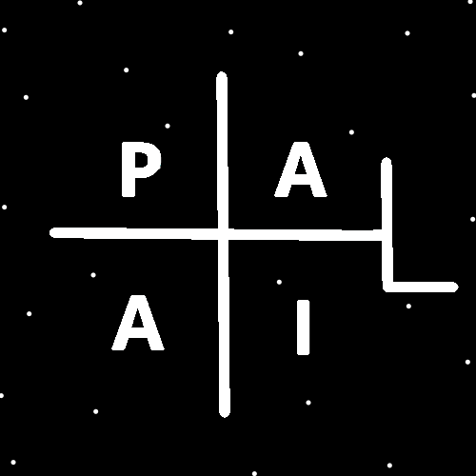
ObjectType: Article
ObjectNumber: 25
LocationName: PAAIL.org
LocationNumber:
Language: PAAIL 2.6

Maker: PAAIL.org
Model:
Name:
Rank:
SerialNumber:

Level: 4.0
Score:
Birth: 8-30-2023

Label: Room 25
Title: Aged Wizardry 1
Details: Aged Wizardry. Wizardry more evolved. Wizardry more researched and developed.
Principle: Aged Wizardry.
Agenda: Aged Wizardry.
Action: Aged Wizardry.
Information: Aged Wizardry.
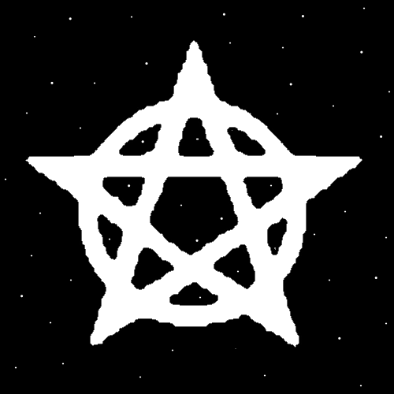
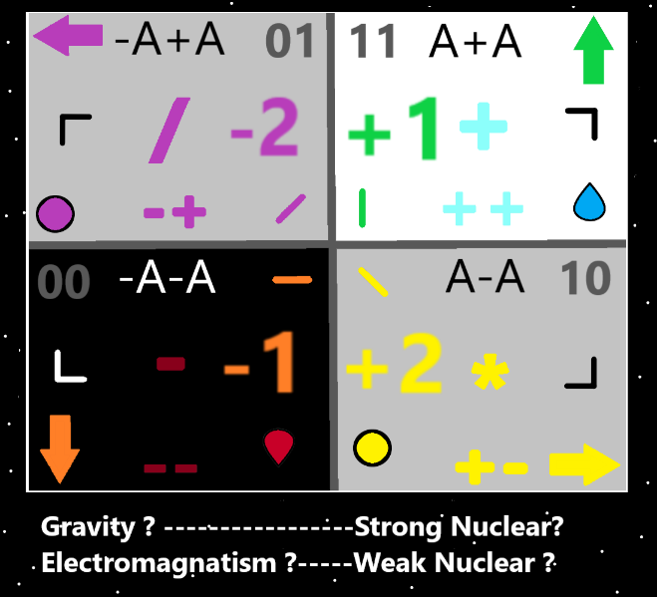
Item Group: Evolution 0
Principle: Many Principles were learned after Tome Of The Yellow Wizard.
Principle: Many Principles were learned after Wizardry Practice 0A and 0B.
Principle: Wizardry has advanced a great deal since Tome Of The Yellow Wizard.
Principle: Wizardry has advanced a great deal since Wizardry Practice 0A and 0B.
Principle: Many Principles that should be at the beginning, don’t come until the end.
Principle: When doing Hand Sorcery. Write big Symbols. When doing the Circle Symbol, Make big Circles.
Principle: Doing big Triangles is eventually a training stage on Hand Sorcery.
Principle: Hand Sorcery has a place in Meditation.
Principle: Remember Hand Sorcery is Hand Gestures. It is also described as writing Symbols in the air.
Principle: Remember that Hand Sorcery is like using a pen. You first push the pen down, then make the Symbol, then pull the pen away. Then repeat.
Principle: Before a Divination session a person could use Hand Sorcery. And a person can do Hand Sorcery during Divination. Such as Making Fists or Making Symbols. Or Putting Palms together, or other options.
Principle: Making a big Triangle Symbol is likely a very powerful Spell.
Principle: Symbols Hand Writing Sorcery is a new thing in PAAIL.org Wizardry and is still being developed.
Principle: Right now you will find no PAAIL.org Spell Book that has Hand Symbol Writing. Eventually I will add it to a Spell book.
Principle: Writing Symbols slowly is likely a graceful virtue gain thing. And has other benefits as well.
Principle: Writing a big Triangle in the air should likely take 3 to 4 seconds. This Makes it a slowly done Symbol.
Principle: A person can Make a Fist with one Hand and write in the air with the other.
Principle: When a person drains their Mana battery, the Energy flows into other batteries. This is the purpose of the Mana battery.
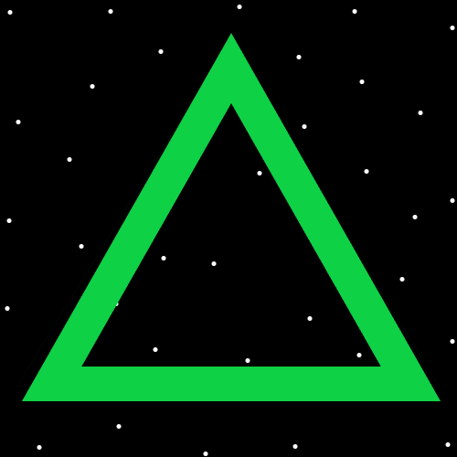
Principle: Doing the Triangle Symbol is 3 lines. One for each of the 3 Energies. Light, Twilight, and Darkness.
Principle: When starting training of writing Symbols. A person should write very slowly. Like learning to use a pen.
Principle: When a person has trained up writing Symbols they can write much faster.
Principle: When a person has trained up writing Symbols they should be able to do it faster and still be fluid/graceful.
Principle: Part of Wizardry training could be writing Symbols on paper. For instance, the Circle, a person could write 10 times and get an Enchantment from doing it.
Principle: The Enchantment would come from doing all the basic Symbols, and a bunch of other Symbols. You have to do more than just the Circle.
Principle: Doing write Symbols on paper training is likely 0.2 Levels of Wizardry gain.
Principle: Doing write Symbols on paper training is other Enchantment gains as well.
Principle: You have to use the ultimate Symbols. Which have been taught throughout PAAIL.org training.
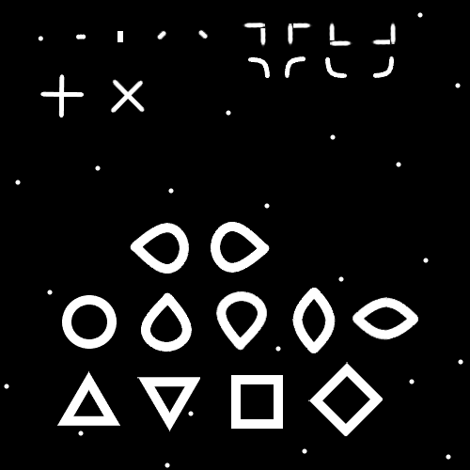
Item Group: Evolution 1
Principle: Some Principles are worth repeating.
Principle: The following is to be very clear about certain things.
Principle: I think there is a place called the Baseball Hall of Fame. Such a building is a Temple. A Temple devoted to Baseball.
Principle: There is a place called the Rock & Roll Hall of Fame. This place is a Temple. A Temple devoted to Rock & Roll.
Principle: It’s a major detail about places that some are Temples.
Principle: A Temple can have multiple Enchantments. The Rock & Roll Hall of Fame has the Rock & Roll Temple Enchantment.
Principle: Temple Enchantments are a type of Enchantment. They make a place a Temple.
Principle: Temple Enchantments are a huge Enchantment. The biggest of the building Enchantments.
Principle: Buildings are of course one of the bigger Chi Charms.
Principle: Stories are an ultimate thing.
Principle: Movies are stories. Books are stories. Educational books are stories about science.
Principle: You can sum a persons life by saying it is a story.
Principle: Reality is a story.
Principle: The Multiverse is a story.
Principle: God has a story.
Principle: As for Reality. There is a beginning of the story.
Principle: As for Reality. Its still the beginning of the story.
Principle: With Cosmic Knowledge we know the beginning of the beginning is the Zero Moment.
Principle: If I were to tell the story of the Multiverse I would start with the Zero Moment.
Principle: Its Cosmic Knowledge knowing that stories are a major thing.
Principle: Cosmic Knowledge is Enlightenment.
Principle: Cosmic Knowledge is knowing the story of Reality. Knowing the story of the Multiverse.
Principle: Cosmic Knowledge and Sorcery are ultimate powers.
Principle: Spiritual Enlightenment is common. Enlightenment of the Mind is rare.
Principle: The Spiritual side of the Multiverse is the biggest side of the Multiverse. Understanding it is Cosmic Knowledge.
Principle: The square shape is unique looking and so is the five-sided diamond shape. All shapes 6 sided and higher look the same. The seven side shape looks just like the 6 sided. The 8 sided shape looks a lot like the 6 sided. The 42 sided shape looks like the 6.
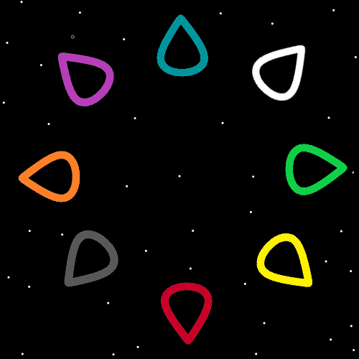
Item Group: Evolution 2
Principle: Hand Symbol Sorcery is like using a brush. The center of the palm of your hand is the brush.
Principle: A person could use one finger. This would be like using a much smaller brush and is not the right way to go.
Principle: It may be that after tons of training a person can use one finger.
Principle: All Hand Sorcery starts with a Dot. You have to Make the Dot Symbol when you first Make any Symbols.
Principle: I think its been made clear. To train Hand Symbol Sorcery you start by Making the Dot Symbol over and over.
Principle: There are the eight Seed Symbols. They are in the Map above.
Principle: The 8 Energies. It may be there is the 1,2,3,4….6,7,8,9 ones. This would mean there is no Number 5 of the 8 Energies. There is no Grey of the 8 Energies.

