
ObjectType: Article
ObjectNumber: 26
LocationName: PAAIL.org
LocationNumber:
Language: PAAIL 2.6

Maker: PAAIL.org
Model:
Name:
Rank:
SerialNumber:

Level: 4.0
Score:
Birth: 9-2-2023

Label: Room 26
Title: Aged Wizardry 2
Details: Aged Wizardry. Wizardry more evolved. Wizardry more researched and developed.
Principle: Aged Wizardry.
Agenda: Aged Wizardry.
Action: Aged Wizardry.
Information: Aged Wizardry.
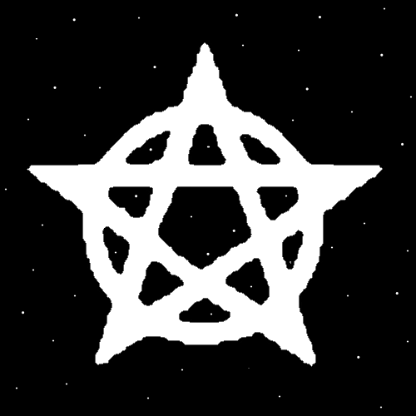
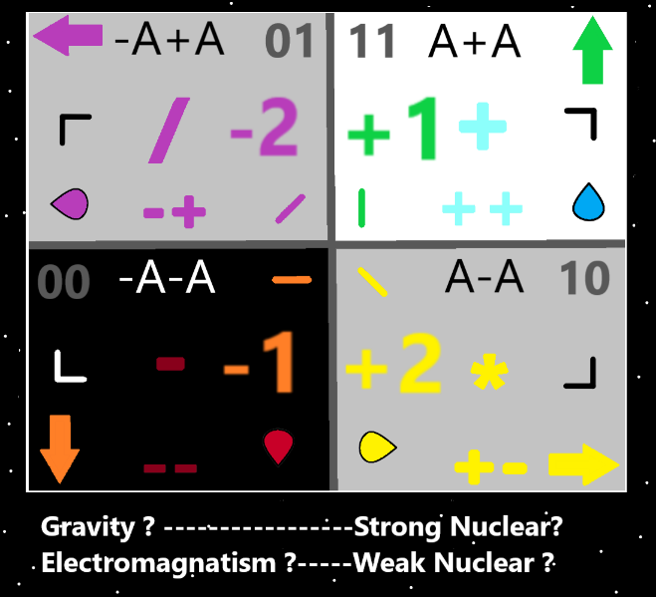
Item Group: Evolution 0
Principle: I feel like I write short articles and repeating things sometimes isn’t that bad. Some things are worth hearing many times.
Principle: Reading Principles you have read before further imprints the Knowledge to your Mind.
Principle: The Map above has been updated to include the right Yellow Seed and left Purple Seed.
Principle: In some ways there are 3 Spiritual groups. The Elder Angel group. The Light side humans Group and the Darkside group.
Principle: All the Light side humans have about the same Spiritual Score.
Principle: The oldest humans have the highest Spiritual Levels and Spiritual Scores.
Principle: Its possible our Spiritual Scores increase after we die.
Principle: Its possible that we accomplish very little until after our deaths.
Principle: A more knowledgeable Wizard realizes there is no big hurry about doing Tithes to God. You can always do your Tithe to God in the afterlife.
Principle: A more knowledgeable Wizard tends to be less ambitious. Knowing we all have about the same Spiritual Score.
Principle: Ambition with 5 minutes of time is especially too ambitious. Often very little can be accomplished with 5 minutes of time.
Principle: Ambitions with years of time is much better. When you are going to be ambitious.
Principle: Structure, organization and routine are some of the greater disciplines. What’s best for a person, changes from person to person.
Principle: Discipline is not always an option in life. It is desirable though.
Principle: I once wanted to live a life of “Earth Organized”. Now I realize that is hopeless. Life is so often “Earth Disorganized”.
Principle: It always about getting enough work done and enough rest done.
Principle: A person can read Wizardry an hour a week and it is super worth it.
Principle: It’s fair to say one name of the 4 Energies is the “4 Seeds”.
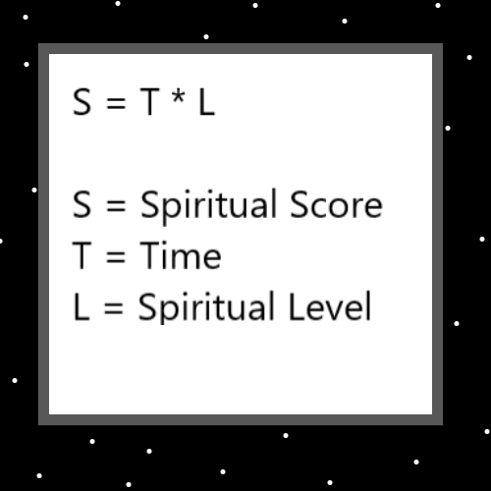
Principle: It’s fair to say one name of the 8 Energies is the “8 Seeds”. Also known as the 8 directions.
Principle: Its fair to say there is the 16 Seeds.
Principle: Its probably fair to say there is the 10 Seeds. 0,1,2,3,4,5,6,7,8,9.
Principle: It seems likely that every Energy is another Seed.
Principle: My educated guess is that on Resurrection Day its going to be God speeds up all humans 10x. You wont notice the difference, however it is there.
Principle: My educated guess is that its going to be a 30,000 year experience from Resurrection Day to Accension Day.
Principle: The power of Heaven is endless when it comes to humans. They can make a perfect movie and put 100 billion words of thought into Making it.
Principle: In the afterlife there is going to be Heaven Credits. I call it “game money”.
Principle: Anything Heaven can Make is free of charge. No cost at all.
Principle: The biggest use of the game money will probably be gambling.
Principle: Everyone will get like 10,000 Heaven Credits a week. When you turn 18 years of age you get 1 million Heaven Credits. Things like that.
Principle: A lot of jobs/hobbies wont travel into the afterlife. Some people will want to cook and thus there will be the cooking job/hobby.
Principle: There will be no work in the afterlife. Its Gods rest day and the law is that all people must rest on the rest day.
Principle: Its currently a Saturday for God. One of his Sundays is very near.
Principle: The 7 ages of man(Adam and Eve Time). 0 to 7000. Maps out as the 7 days. Since the current year is 5900s, we are on Friday. On a human scale today is Friday. Soon to be Saturday.
Principle: Sunday is Resurrection Day. The year 7000, Adam and Eve time.
Principle: Friday sounds like “fry day”. There is always meaning to things like this.
Principle: Saturday reminds me of the Word Saturn. The planet. Which reminds me of science fiction.
Principle: Sunday sounds like “Sun Day”. Resurrection Day is our Sun Day.
Principle: There are tons of secrets hidden in famous quotes.
Principle: There are tons of secrets in famous phrases.
Principle: Monday is like “mono day”. Mono means “one”. His holiness lord Jesus’s day.
Principle: Tuesday is like “two’s day”. His holiness lord Michaels day.
Principle: Thursday sounds like “thirsty”. I see no secrets in the Word. That doesn't mean they aren’t there.

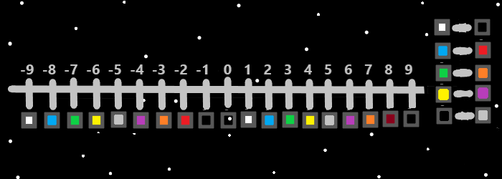
Principle: A Wizard see’s the Words “God” and “Good” are very similar and there is meaning behind this.
Principle: Likely training Level 4 Expert Wizard will Make a person ESP Power Levels go up.
Principle: Wizards have Higher Levels of ESP Sense.
Principle: If a person were to just train White Wizard, it would take time for their Wizard Enchantments to grow. It would take some time before they would see benefits.
Principle: Dose is like the Word Growth. Both are Numerology 2 Numbers. Dose even sounds similar to Growth.
Principle: Since the Word “dose” in English means “a dose of something” and in Spanish means the Number 2. This means the Number 2 and the Word “dose” likely have a Connection. Like a dose of something is a category 2 Number.
Principle: I learned that “dose” is a Numerology 2 Word because of learning about the Word “dose” in Spanish.
Principle: Days of the week and other languages, its all been an effort to show how to “Read Into” things. I’m trying to show how you can Read Into things.
Principle: A lot of what I have learned comes from Reading Into things.
Principle: My discovery that there are Spiritual Levels and Spiritual Scores, comes from the video game Super Mario.
Principle: Major Enlightenment came from Meditation on the video game Super Mario.


