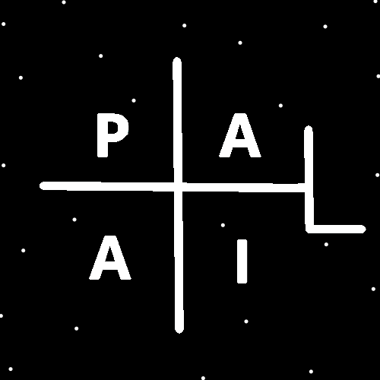
ObjectType: Article
ObjectNumber: 28
LocationName: PAAIL.org
LocationNumber:
Language: PAAIL 2.6

Maker: PAAIL.org
Model:
Name:
Rank:
SerialNumber:

Level: 4.0
Score:
Birth: 9-8-2023

Label: Room 28
Title: Aged Wizardry 4
Details: Aged Wizardry. Wizardry more evolved. Wizardry more researched and developed.
Principle: Aged Wizardry.
Agenda: Aged Wizardry.
Action: Aged Wizardry.
Information: Aged Wizardry.
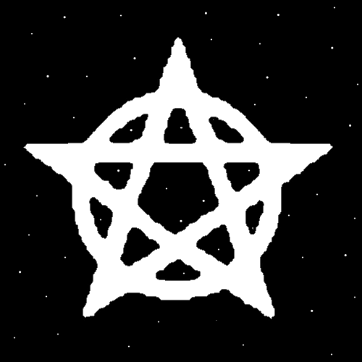
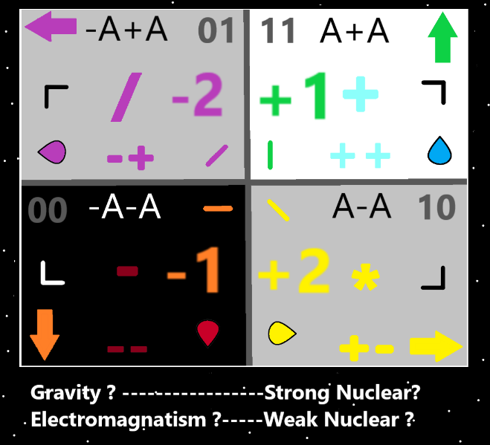
Item Group: Evolution 0
Principle: Its possible that Protons are not Sphere Shapes. They could be 1 million sided Shapes.
Principle: It’s possible that all Particles have a Number of sides. A Number of facets.
Principle: It may be that all Energies have a Number of sides. A Number of facets.
Principle: Huge understanding of Energy can be Cosmic Knowledge.
Principle: If a person were a full time student of Wizardry then they can get Master Wizard in 6 to 12 months.
Principle: Once a person gets to Master Wizard, the Doctorate in Wizardry is another 2 years of Body Exercise, Breathing Exercise, Meditation Exercise, and Sorcery Exercises. Full time student.
Principle: A full time student of Wizardry can get from Level 0 to Doctor of Wizardry in 3 years.
Principle: PAAIL.org Wizardry is now at a Doctorate teaching Level. Even though the author is only a Master Wizard.
Principle: There is enough Wizardry teaching on PAAIL.org to get a Doctorate in Wizardry.
Principle: The PAAIL.org Wizardry Science has advanced a great deal over the last 2 years.
Principle: Music is perhaps the easiest way to get an ESP experience.
Principle: I love writing in PAAIL format. My writing would be 10 times worse if I did the normal Chapters, Paragraphs, Sentences format.
Principle: PAAIL is awesome. Not as awesome as Wizardry. Still it is awesome.
Principle: After generating a whole Science Area with PAAIL. I think PAAIL is awesome for Science.
Principle: Theres a passage in the Bible that says “the stars will fall from the sky”. It may refer to what’s called “light pollution”, what happens in major cities. Where you can no longer see stars at night.
Principle: One of the Secrets of Scripture is that when you read seemly Negative Scripture, its actually Positive. You just have to be Positive with the Words.
Principle: Its possible that “light pollution” is a good thing. Producing lots of Photons at Night is a good thing.
Principle: Its possible there are many good things to “light pollution”.
Principle: Sometimes what sounds like Darkness Scripture is actually jokes.
Principle: The movie “Star Trek” translates into “Angel Trek”. I suspect that most the time for Elder Angels the metaphor is that they have their own ship.
X2 Information: I think this has been said before. I repeated it because it’s a good example of reading into things.
Principle: Most people do not have the free time to be a full-time student of Wizardry. Fortunately, it works just fine doing only a few hours a week. Maybe even one hour a week is enough.
Principle: Level 3 Wizard is so huge. It is Enlightenment.
Principle: We all have a Food Battery Level and a Drink Battery Level.
Principle: Food often has liquids in it. Food refills a persons Food Battery. It often also refills a person's Drink Battery.
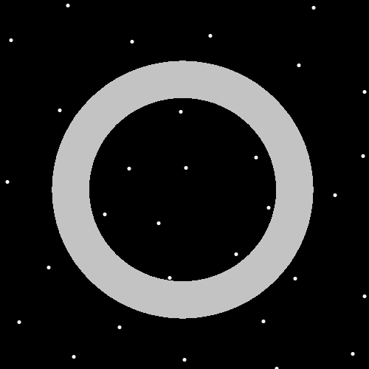
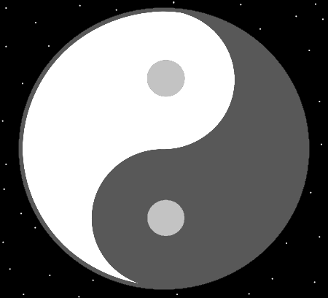
Item Group: Evolution 1
Principle: Many Enchantments start a small Seed and then Grow over Time, all on their own.
Principle: Many Enchantments Seed Grow Time.
X2 Principle: This is Divination from the above Principle Item.
Principle: Many Enchantments start as a Dot.
Principle Many Enchantments Dot.
X2 Principle: This is Divination from the above Principle Item.
X2 Principle: The Divination Key is “that you use the capitalized words”. “Many” “Enchantments” and “Dot”.
Principle: Every time you see the Yin Yang Symbol its good on your brain. Good on your Mind.
Principle: Christians benefit more from the Yin Yang Symbol than Buddhists. Buddhists benefit more from seeing Christian crosses than Christians.
X2 Principle: It can be a lot like Stretching yourself in a different Direction is what’s best.
Principle: For a Christian, seeing the Yin Yang Symbol helps them better understand the Buddhists. Better Sense the Buddhists.
Principle: For a Buddhist, seeing the Christian cross Symbol helps them better understand the Christians. Better Sense the Christians.
Principle: People can Sense whole Religions through Symbols.
Principle: People can Sense many things from Symbols.
Principle: One can Sense the Zero Moment from looking at the Dot Symbol.
Principle: One can Sense God by looking at a Circle.
Principle: Maps found on PAAIL.org are great for Sensing the Multiverse.

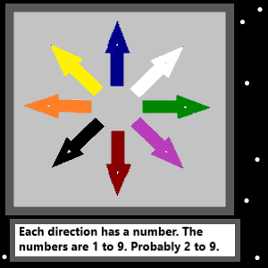
Item Group: Evolution 2
Principle: The above Map is wrong. The Numbers are not 1 to 9. They are -4, -3, -2, -1, +1, +2, +3, +4.
Principle: The previous Map is probably wrong on the Colors as well. Purple for starters should probably be “Left, Up”.
Principle: One understanding is that there are the 4 Forces, each with 2 Sides, resulting in the 8 Forces. Each of the 4 Forces has 2 Sides. A Positive side and a Negative Side.
Principle: I recently updated PAAIL.org to include some of the bigger stuff in the first page of reading about Wizardry. Its found right at the start of the downloads Land (page).
Principle: I can’t remember. What are peoples biggest questions again?
Principle: On the website I tried to answer peoples biggest questions in the first page. I suggest all read it. It’s a quick read at the top of the downloads page. It’s a handful of messages from PAAIL Bot.
Principle: I was an Atheist for a time. The existence of God is always the biggest secret to me.
Principle: I feel like I have explained the entire Universe at this point. All of Reality. All of the Multiverse.
