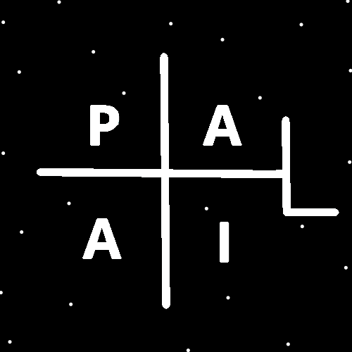
ObjectType: Article
ObjectNumber: 29
LocationName: PAAIL.org
LocationNumber:
Language: PAAIL 2.6

Maker: PAAIL.org
Model:
Name:
Rank:
SerialNumber:

Level: 4.0
Score:
Birth: 9-10-2023

Label: Room 29
Title: Aged Wizardry 5
Details: Aged Wizardry. Wizardry more evolved. Wizardry more researched and developed.
Principle: Aged Wizardry.
Agenda: Aged Wizardry.
Action: Aged Wizardry.
Information: Aged Wizardry.
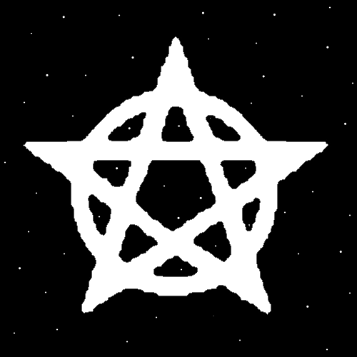
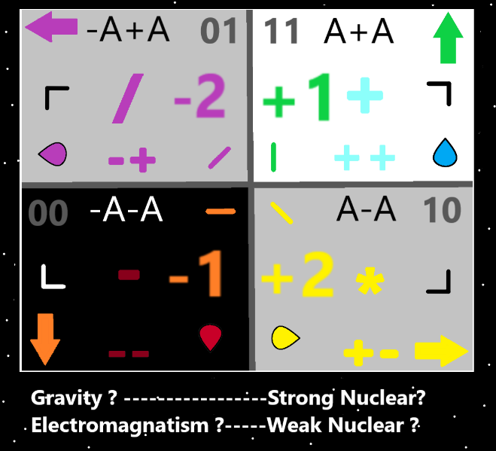
Item Group: Evolution 0
Principle: The Force Gravity has an opposite. Its either, Electromagnetism, the Strong-Nuclear, or the Weak-Nuclear Force.
Principle: I’m surprised there is no such thing as the 8 Forces in Physics. Maybe they just haven’t been discovered yet.
Principle: If the 8 Forces exist, then two of them are Gravity Forces. Two of them are Electromagnetic Forces. Two are Strong-Nuclear Forces, and two are Weak-Nuclear Forces.
Principle: If the 8 Forces exist, then it might go there is the Positive Gravity Force, and the Negative Gravity Force.
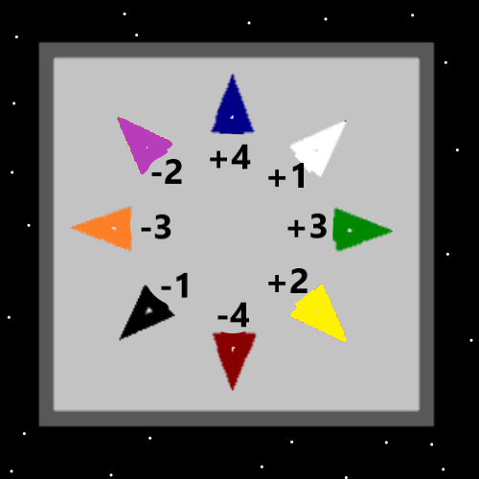
Item Group: Evolution 1
Principle: The above Map may have errors.
Principle: The Numbers are for certain. -4-3-2-1+1+2+3+4. Where each number goes is not certain.
Principle: The Colors are likely right. White, Blue, Green, Yellow, Purple, Orange, Red and Black. No Grey. However, they could be in the wrong positions.
Principle: There is a Mathematics and Numerology to the 4 Forces in Physics. Gravity and such. The Numerology/Mathematics is that the 4 Forces are Numbered -1+1-2+2.
Principle: Understanding Energy can be Cosmic Knowledge. Understanding Energy Bits and so forth is Cosmic Knowledge and Physics.
Principle: Understanding the Numbers of the 4 Forces is an understanding of Numerology, Mathematics, Physics and Cosmic Knowledge.
Principle: Energy Bits is Basic Science. If it were proven then it would be taught to 5th graders.
Principle: If Wizardry were proven you would teach it all throughout 1st grade to 12th grade.
Principle: The difficult truth is that PAAIL.org Wizardry is the one true Religion. If you believe it you have converted to it.
Principle: When you learn an Expert amount of Theology, an Expert amount of Wizardry and Fuse them together you likely get too see tons of secrets in the Scripture.
Principle: Understanding the 4 Forces it might (might) be that there is actually the 8 Forces, not 4. One Negative Gravity Force, One Positive Gravity Force.
Principle: In some ways there is the 4 Forces. In other ways it’s the 8 Forces.
Principle: The theory is that there may be such thing as Negative Gravity and Positive Gravity.
Principle: It could be that +1 is Positive Gravity. -1 is Negative Gravity. I have no idea which Number Gravity is.
Principle: It could be Gravity is +1 and -1 is Electromagnetism.
Principle: Of course the theory is that there may be Negative Electromagnetism, and there may be Positive Electromagnetism. The same with the Strong Nuclear Force and Weak Nuclear Force.
Principle: If its Positive Gravity is +1 and Negative Gravity is -1… its Gravity is known as the 1 Force. Because its +1 and -1.
Principle: Electromagnetism may be the +1 and -1 for all I know.
Principle: It could be the 4 Forces are the 4 Axis’s each with a Positive and Negative side. Resulting in the 8 Forces. Electromagnetism could be the 1 Axis (-1 and +1) and Gravity the 2 Axis (-2 and +2).
Principle: Some of these Principles contradict each other. Its all theories is partly why.
Principle: The discovery of the Numerology of the first 8 Directions….-4-3-2-1+1+2+3+4…is a new discovery. That is the cause for this latest article being a bunch of Physics.
Principle: The Knowledge is Basic Science, Numerology, Math, Physics and Cosmic Knowledge. All very good for a person.
Principle: I hope I have answered all major questions. I cant see any I have missed.
Principle: It seems like asking the biggest questions and your going to end up talking about the Spiritual Side of Reality. Which has been covered in great detail.
Principle: What is the meaning of life? The meaning of our lives is our “Spiritual Score”… how much we help God. This is the short story.
Principle: Why are we here? We are here to accomplish a “Spiritual Score” (help God) and because we rolled Beginning of Time Numbers. Everyone has a name in Numbers. This is the short story.
Information: The previous 2 Items were only found on the Website, at the start of the Downloads Land. It seemed right to add them here.
Principle: Previously I have said that the question “What is the meaning of life?”, is a bad question. Honestly I don’t even know what people mean when they ask that question.
Principle: The truth is that when you know the major secrets, only then do you know the major questions. Like “is there a God?”.
Principle: God is the biggest part or one of the biggest parts of Reality.
Principle: I suppose I have failed to mention that our Spiritual Scores have a huge impact on Reality. That everyone has a huge impact on Reality.
Principle: All us Elementals have a huge Chi. All humans are Elementals.
Principle: We are called Elementals because our Numbers are Core Numbers. A 100 digit Number is a Core Number. Only small Numbers are Elemental Numbers. 100 digits is small.
Principle: Like 0 to 9 are Elemental. 0 to 99 are Elemental and 0 to 999 are Elemental, and 0 to 9999 are Elemental….it keeps going, 0 to 99,999 , 0 to 999,999 and on and on.
Principle: On a Cosmic Scale the Number 999,999 is microscopic. It is a Quantum Scale Number.
Principle: Quantum Scale means small scale. There is the Big Picture and the Small Picture. The Quantum Scale is the Small Picture.
Principle: Energy Bits is the Quantum Level.
Principle: If Positive Electromagnetism is +1 and Negative Electromagnetism is -1, then in some ways there is just plain Electromagnetism which in Numerology is the Category 1. Both Negative Electromagnetism and Positive Electromagnetism are Category 1.
Principle: It is very possible that there is no such thing as Positive Electromagnetism. In which case Electromagnetism in Numerology/Math/Physics is either -1,+1,-2 or +2.
