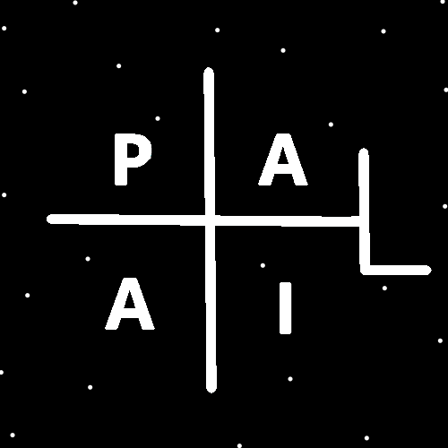
ObjectType: Article
ObjectNumber: 30
LocationName: PAAIL.org
LocationNumber:
Language: PAAIL 2.6

Maker: PAAIL.org
Model:
Name:
Rank:
SerialNumber:

Level: 4.0
Score:
Birth: 9-16-2023

Label: Room 30
Title: Aged Wizardry 6
Details: Aged Wizardry. Wizardry more evolved. Wizardry more researched and developed.
Principle: Aged Wizardry.
Agenda: Aged Wizardry.
Action: Aged Wizardry.
Information: Aged Wizardry.
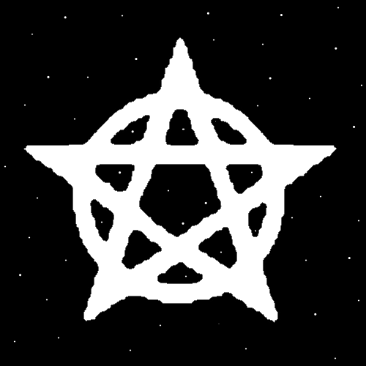
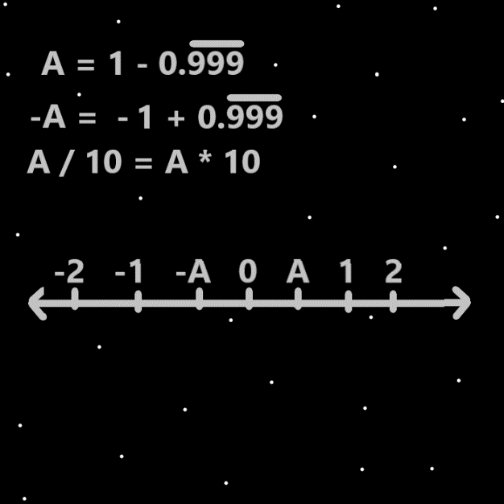
Item Group: Evolution 0
Principle: “Energy Byte” maybe should be a Vocabulary term. It would mean two Energy Bits. A Particle that is exactly two Energy Bits. Perhaps better Vocabulary could be done. What’s certain is that there is such thing as a two Energy Bit Particle and it should have a name.
Principle: There may be no such thing as a 3 Energy Bits Particle. There is for sure a 4 Energy Bits Particle. Also known as a 2 “Energy Bytes” Particle. In Gods Science it also has a Vocabulary name.
Principle: In the past it was taught to do a bunch of Word Write 10x Spells. Now the revelation is that there is also do the Symbol Write 10x Spells. Which if you do is Wizardry Levels gain. 0.2 Wizardry Levels gain.
Principle: Even the newest PAAIL.org Spell Room does not have Symbols Write 10x. It is super new.
Principle: Symbols Write 10x is a new Spell. It means write a Symbol 10 times.
Principle: Doing the Spell Symbol Write 10x… the first Symbol you should do is the Dot Symbol.
Principle: Like thinking a Keyword over and over has a psychology to it. So does writing a Keyword over and over, and so does writing Symbols over and over.
Principle: The newest Spells are Hand Symbol Writing in the air. Visions, where you picture something in your Mind, and Symbol Writing on paper.
Principle: In the Wizard of Oz I always see God as the Wizard character. The man behind the curtain. The person that makes people fear him. Because that’s for the best. I think I have said this before.
Principle: Things regarding God are very noteworthy. It is often Cosmic Knowledge.
Principle: Its possible Gods Body was the size of a tiny Seed at one point. Its possible God was a tiny Seed at one point.
Principle: As a reminder… first there was the Zero Moment. Then an Empty Universe moment. Then a Birth of the God Body Moment.
Principle: It goes the Zero Moment is 2. The Empty Universe Moment is 4 and the God Body Moment is 8. The next Moment is the 16 Moment.
Principle: A Wizard can see that the Yin Yang Symbol shows us the Multiverse is the Forces of Light and Darkness.
Principle: PAAIL.org Maps reveal things.
Principle: As for the 4 Forces I don’t think its been mentioned that one is the “Up, Up” Force. One is the “Up, Down” Force. One is the “Down, Up” Force. One is the “Down, Down” Force.
Principle: The 4 Forces. Also known as the 4 Elements, Fire, Water, Earth, and Air. Everything is Made from the 4 Elements.
Principle The 4 Elements are Made of the 2 Elements… Light and Darkness. Or it’s the 4 Elements are made of the 3 Elements…Light, Twilight, and Darkness.
Principle: Forces, Elements, Energies, Powers. Its all a bunch of messy Vocabulary.
Principle: To a Physicist the 4 Energies are known as the 4 Forces. Throughout human history Wizards have called them the 4 Elements. In one Science they are called the “4 Energy Bytes”.
Principle: It goes there is the 3 Powers, Light, Twilight, Darkness. The 4 Powers, Addition , Subtraction, Division, Multiplication. The 8 Powers, -4-3-2-1+1+2+3+4. And the 10 Powers, 0,1,2,3,4,5,6,7,8,9.
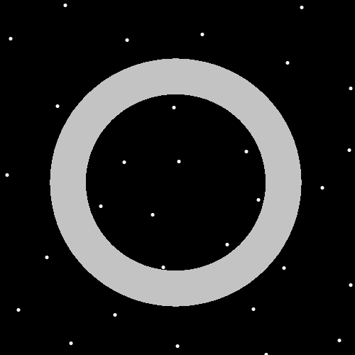
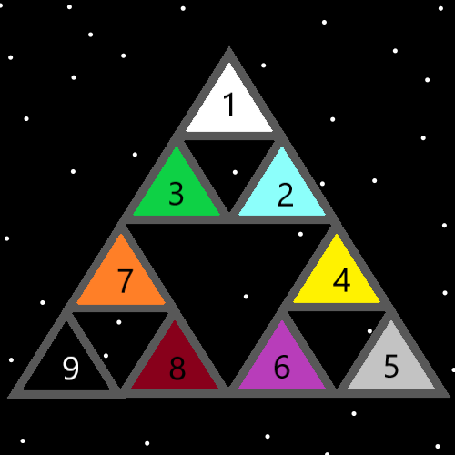
Item Group: Evolution 1
Principle: Its been said already, and seems worth stating again. Many discoveries were made after Tome Of The Yellow Wizard and many discoveries were made after Wizardry Practice 0A/0B.
Principle: If a person could ask 100 questions from a magic genie. By the time they get to 100 they would have asked all the biggest questions and no longer have any big questions to ask.
Principle: If I could ask a magic genie of questions 100 questions the first would be “Are Protons alive?”. The 2nd question would be “Are Neutrons alive?”. The 3rd question would be “Are electrons alive?".
Principle: If an atheist asked questions they should start with “Is there a God?”. That way they can find out about the existence of God.
Principle: Recently I tried to address peoples biggest questions. The only questions I could think of were… “What is the meaning of life?” and “Why are we here?”.
Principle: As for the question “What is the meaning of life?”. I don’t know what people mean when they ask that question. My solution was to use the Vocabulary Word “Meaning” by stating that “The meaning of our lives is our Spiritual Score. How much we help God.”
Principle: As for the question “Why are we here?”. I went with talking about the Spiritual Side again. It seems when you ask the biggest questions you are going to end up talking about the Spiritual Side. So I went with the answer “We are here to accomplish a Spiritual Score (help God) and because we all rolled Beginning of Time Numbers.”.
Principle: I don’t know what peoples biggest questions are. Myself, I have no more big questions to ask. Expert Wizards who are specialized in Cosmic Knowledge no longer have any meaningful questions.
Principle: I feel bad about Tome Of The Yellow Wizard. That so many discoveries were made after it. There might not even be the formula
(Spiritual Score) = (Spiritual Level) x (Time).
Principle: Tome Of The Yellow Wizard is super out of date now.
Principle: For a long time I did not realize to put the Map pictures in each room. All Rooms should have had nice Map pictures. Not black Squares like it was.
Principle: The Rooms, the writings, the Science. It has all improved a great deal since Tome Of The Yellow Wizard.

